Student Grievance Redressal System
A Web-Based Platform for Campus Complaint Management
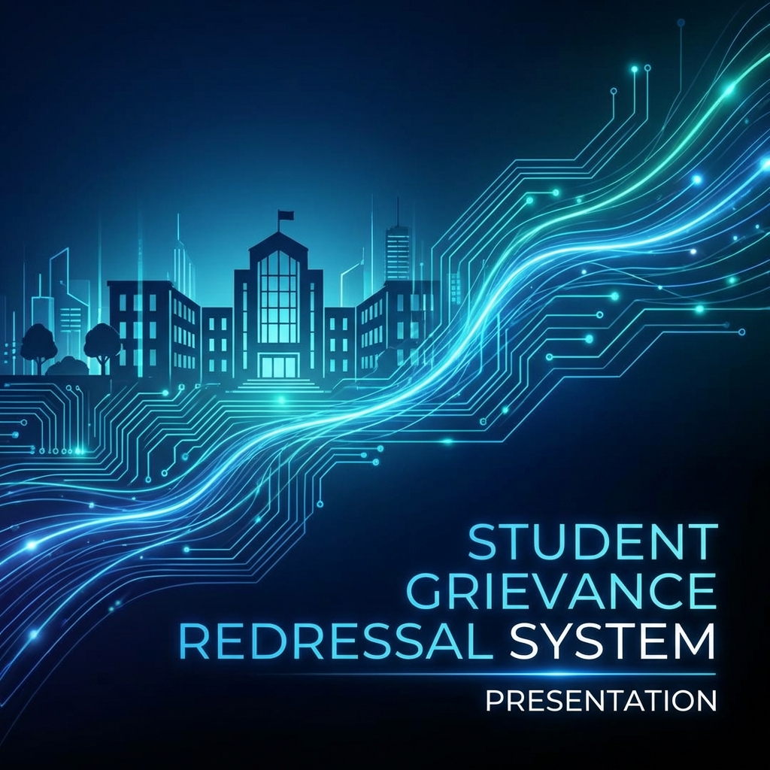

1. Abstract
The Student Grievance Redressal System is a digital solution designed to streamline the handling of student complaints in educational institutions. By replacing manual paper-based processes with an automated web platform, the system ensures transparency, faster resolution times, and better accountability. Built using a modern tech stack (FastAPI, SQLite, and Glassmorphism UI), it provides dual interfaces for students and administrators to manage the entire grievance lifecycle securely.

2. Introduction
In any educational institution, addressing student concerns regarding academics, infrastructure, or administration is crucial for a healthy campus environment. Conventional methods of grievance handling often suffer from delays, lack of transparency, and difficulty in tracking progress. This project proposes an Integrated Student Grievance Redressal System that bridges the gap between students and the college administration using technology.

3. Problem Statement
Existing manual systems face several challenges:
- Slow Resolution: Physical files take time to move between departments.
- Lack of Transparency: Students often don't know the status of their submitted complaints.
- Data Management: Difficulty in maintaining historical records and generating reports.
- Privacy Concerns: Reluctance to report sensitive issues due to a lack of anonymity.

4. System Objectives
- To provide a secure and user-friendly portal for students to lodge grievances.
- To enable real-time tracking of complaint status (Pending, In-Progress, Resolved).
- To automate the workflow for administrators to review and respond to issues.
- To ensure data security using JWT authentication and modern password hashing.

5. System Design & Architecture
The system follows a Client-Server architecture:
- Frontend: Developed using HTML5, CSS3 (Glassmorphism), and Vanilla JavaScript for a premium user experience.
- Backend: A RESTful API built with FastAPI, providing high performance and robust data handling.
- Database: SQLite database managed through SQLAlchemy ORM for efficient data storage.

System Workflow
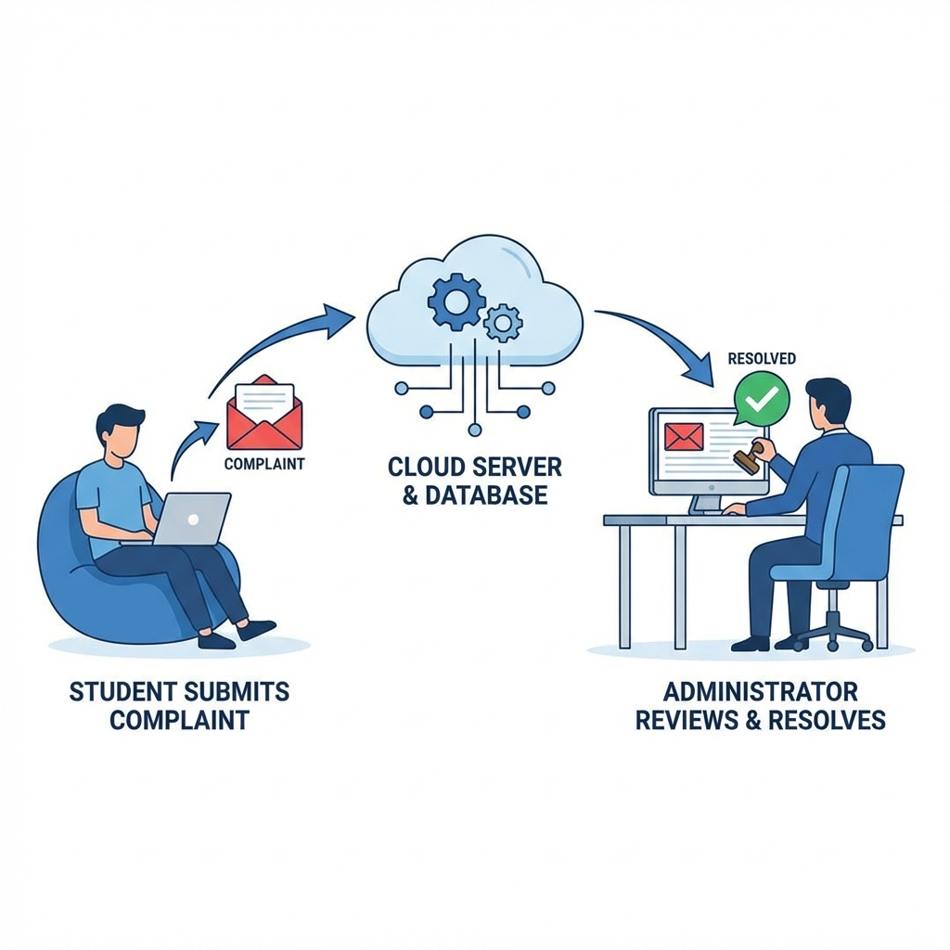

6. Module Descriptions

6.1 Student Module
Features include registration, secure login, dashboard overview, complaint submission with department categorization, anonymous reporting toggle, and status tracking history.

6.2 Administrator Module
Features include a centralized dashboard, full visibility of student complaints, status management tools, and a remarking system for official responses.

7. Security Features
Security is prioritized through:
- Argon2/Bcrypt Password Hashing.
- JWT (JSON Web Token) for stateless session management.
- Role-Based Access Control (RBAC) to separate student and admin permissions.

8. Conclusion
The Student Grievance Redressal System successfully digitalizes university complaint management. It creates a more responsive and transparent environment, ensuring that every student's voice is heard and every issue is addressed systematically.

