Assignment 10 :: Use terraform to launch 3 ec2 instance and EKS cluster

Step 1 :: Create a EC2 instance and install terraform in it

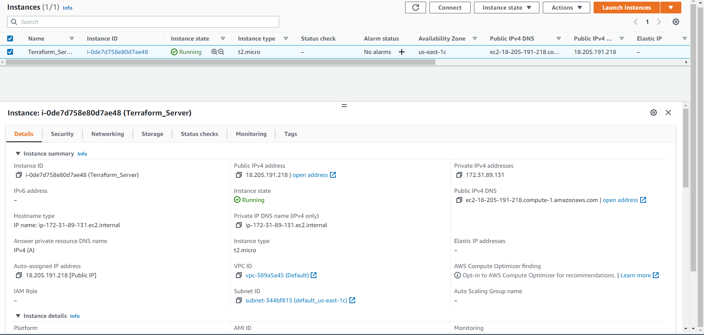

# hostnamectl set-hostname terraform_server

# yum update -y

# yum install -y wget unzip

# wget <https://releases.hashicorp.com/terraform/0.12.2/terraform_0.12.2_linux_amd64.zip>

# unzip ./terraform_0.12.2_linux_amd64.zip -d /usr/local/bin

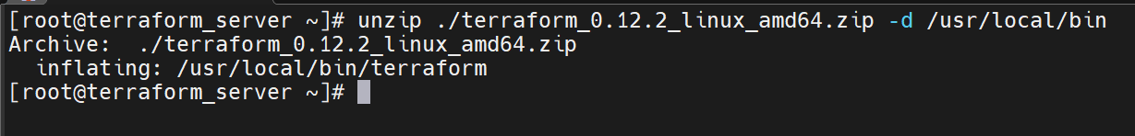

# terraform -v

Step 2 :: Create an IAM role with AmazonEC2FullAccess Policy

Step 2.1 : Goto IAM dashboard and select “Create role” under Roles page

Step 2.2 : Attach the created role to the created terraform instance

Step 3 :: Create terraform files

# cd ~

# mkdir terraform-dir

# cd terraform-dir

# cat variables.tf

# cat main.tf

Step 4 :: Execute Terraform Commands

# terraform init

# terraform plan

.

.

.

# terraform apply

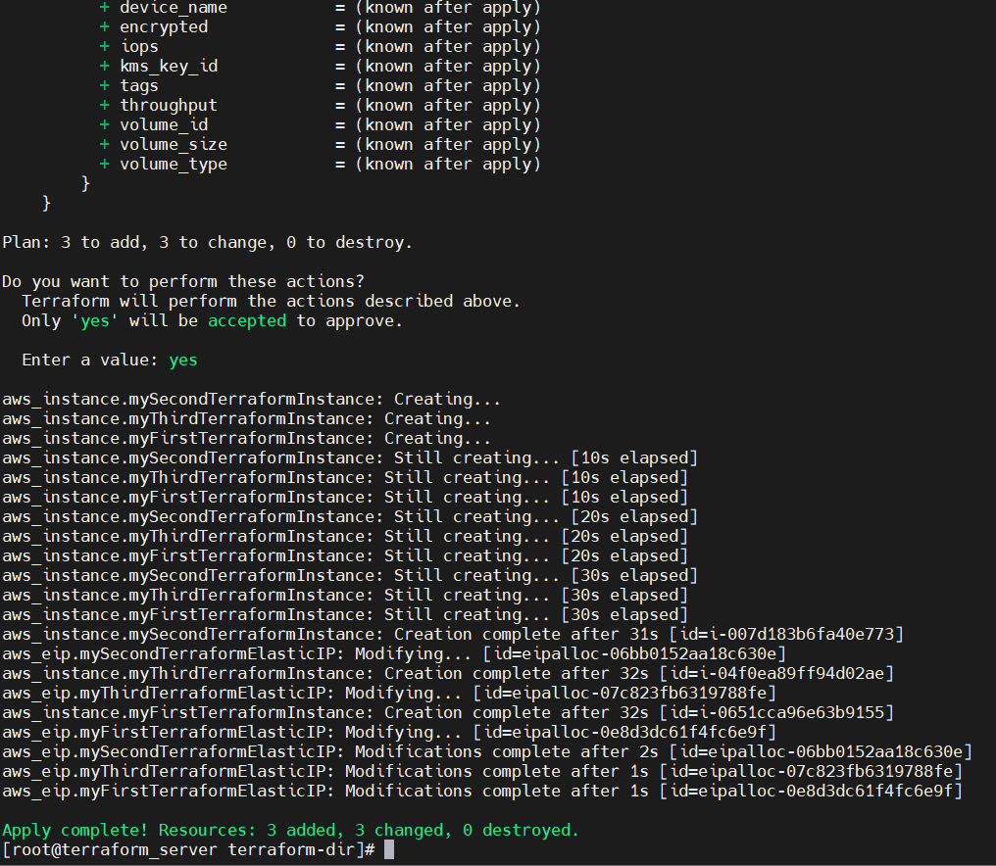

Result :: Successfully created three EC2 instances

Trying to connect to one of the instances

**EKS Cluster using terraform**

Step 1 :: Install AWS CLI and aws-iam-authenticator

Step 1.1 : Install aws cli

$ curl "https://s3.amazonaws.com/aws-cli/awscli-bundle-1.16.312.zip" -o "awscli-bundle.zip"

$ unzip awscli-bundle.zip

$ sudo ./awscli-bundle/install -i /usr/local/aws -b /usr/local/bin/aws

Step 1.2 : Install aws-iam-authenticator

$ curl -o aws-iam-authenticator <https://s3.us-west-2.amazonaws.com/amazon-eks/1.21.2/2021-07-05/bin/linux/amd64/aws-iam-authenticator>

$ curl -o aws-iam-authenticator.sha256 <https://s3.us-west-2.amazonaws.com/amazon-eks/1.21.2/2021-07-05/bin/linux/amd64/aws-iam-authenticator.sha256>

$ openssl sha1 -sha256 aws-iam-authenticator

$ chmod +x ./aws-iam-authenticator

$ mkdir -p $HOME/bin && cp ./aws-iam-authenticator $HOME/bin/aws-iam-authenticator && export PATH=$PATH:$HOME/bin

$ echo 'export PATH=$PATH:$HOME/bin' >> ~/.bashrc

$ aws-iam-authenticator help

Step 2 :: Configure AWS Command Line using Security Credentials

* Go to AWS Management Console --> Services --> IAM --> User --> Select user : abushad
* Click on Security credentials tab
* Click on Create access key
* Copy Access ID and Secret access key
* Go to command line and use
  + $ aws configure
  + $ aws eks list-clusters

Step 3 :: Install and configure kubectl CLI

Step 3.1 :: Install kubectl CLI

$ curl -o kubectl <https://amazon-eks.s3.us-west-2.amazonaws.com/1.21.2/2021-07-05/bin/linux/amd64/kubectl>

$ chmod +x ./kubectl

$ mkdir -p $HOME/bin && cp ./kubectl $HOME/bin/kubectl && export PATH=$PATH:$HOME/bin

$ echo 'export PATH=$PATH:$HOME/bin' >> ~/.bashrc

$ kubectl version --short –client

Step 4 :: Creating EKS Cluster

$ mkdir terraform_eks

$ terraform init

$ terraform plan

$ terraform apply

$ aws eks update-kubeconfig --name terraform-eks-hari --region us-east-1

Now copy the selected content in above image and paste it in below file

$ vi ~/.kube/config

After pasteing edit the below line

From :: client.authentication.k8s.io/v1beta1

To :: client.authentication.k8s.io/v1alpha1

Result ::

$ kubectl get all

$ kubectl version --short

$ kubectl create deployment nginx --image=nginx

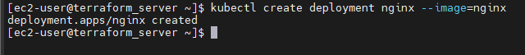

$ kubectl create deployment httpd --image=httpd

$ kubectl get all -o wide

$ kubectl get pods -o wide



