Assignment 2 :: Configure VPC with 4 subnets

Step 1 :: Create a VPC with 2 Public and 2 Private subnets

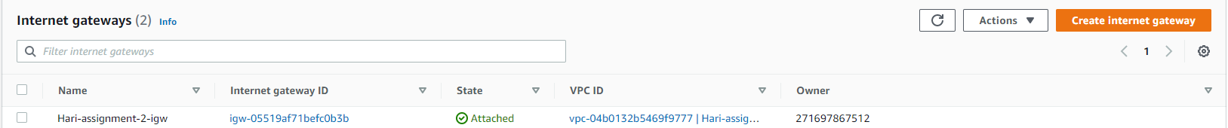

Step 1.1 :: Editing Public subnets to auto assign IPv4 address

Subnet 1

Subnet 2

Step 2 :: Creating EC2 instance

Step 2.1 :: Create 2 instances in Public Subnet and 2 in Private subnet

Webserver 1 :: 3.235.58.150

Webserver 2 :: 3.232.95.119

Webserver 3 :: Reachability from server 1

Webserver 4 :: Reachability from server 1

