Assignment 4 :: Configure Autoscaling with 60% threshold CPU utilization metrics

Step 1 :: Create a template to launch instances automatically

Note: I have added a bash script to create an instance with pre-installed http and print its fqdn. (Need to add in “Advance Details” Tab)

#!/bin/bash

yum install -y httpd

systemctl enable --now httpd

echo “Hello World from $(hostname -f)” > /var/www/html/index.html

Step 2 :: Select the VPC and Subnets required

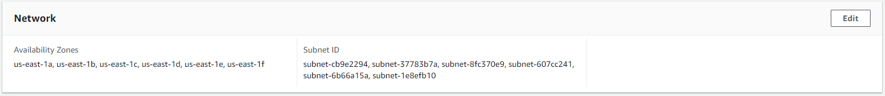

Step 3 :: Attach the existing Load Balancer or create a new Load Balancer and attach the same here. I have attached the existing one.

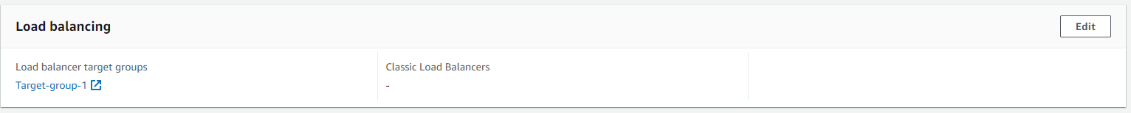

Step 4 :: Set the desired Group Size. I have set

Desired Capacity – 1

Minimum Capacity – 1

Maximum Capacity – 5

Step 5 :: Skip the remaining and submit. We will get the ASG as below

Step 6 :: Click on the Automatic Scaling tab and create policies as below

Result :

Increasing the CPU Utilization

# yes > /dev/null & 🡪 Run in terminal to increase the CPU utilization

It automatically created a new instance and added to Target Group as well

