Assignment 5 :: IAM- create group called as globallogic and assign permission to launch EC2 instance only in us-east-1(any available region) with specific duration in daytime.

Step 1 :: Create Custom Policy from AWS console

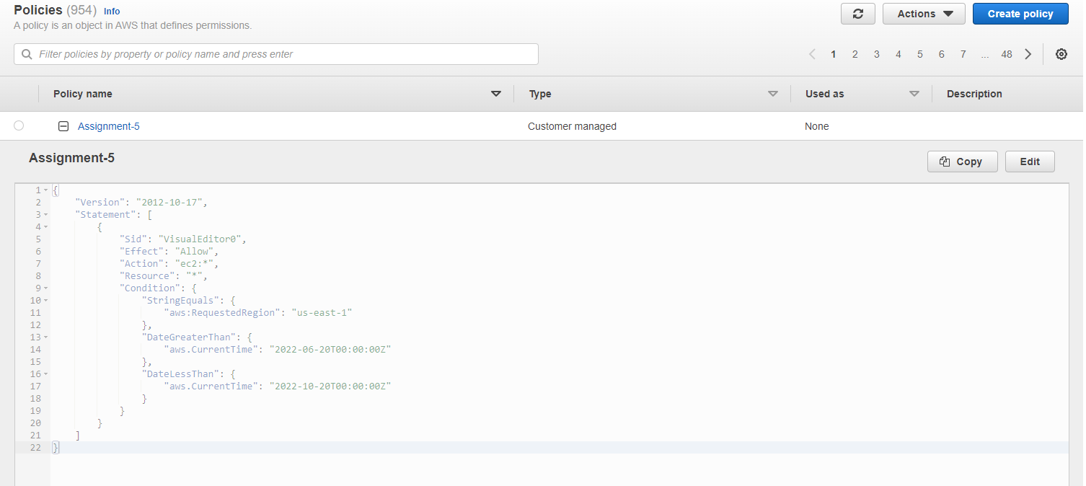

Step 2 :: Created User group named “globallogic” using custom policy “Assignment-5” created in step 1.

Step 3 :: Creating a test username “globallogictestuser” with custom policy

While creating the user, adding it to group “globallogic” created in step 2.

Step 4 :: Created AWS Access Key ID and secret access key

Step 5 :: aws configure using AWS Access Key ID for user “globallogictestuser”

Step 6 :: Creating EC2 instance via AWS CLI

**This confirms that IAM user can launch the instances**

**Negative Case:**

Changing the date lower than today and try the same launch instance

