Assignment 8 :: Deploy EKS cluster using GUI and CLI on AWS. Deploy deployment using httpd image on EKS.

Step 1 :: Install AWS CLI

Step 1.1 :: Check for aws version

Step 1.2 :: Configure AWS Command Line using Security Credentials

* Go to AWS Management Console --> Services --> IAM
* Select the IAM User: hari.gopalakrishnan@globallogic.com
* Click on Security credentials tab
* Click on Create access key
* Copy Access ID and Secret access key

* Run “**aws configure**”

* Test if aws cli is working fine

Step 2 :: Install kubectl CLI

Install and check the version

* **mkdir kubectlbinary**
* **cd kubectlbinary**
* **curl -o kubectl.exe** [**https://amazon-eks.s3.us-west-2.amazonaws.com/1.16.8/2020-04-16/bin/windows/amd64/kubectl.exe**](https://amazon-eks.s3.us-west-2.amazonaws.com/1.16.8/2020-04-16/bin/windows/amd64/kubectl.exe)
* Update the system Path environment variable
  + C:\Users\hari.gopalakrishnan\kubectlbinary
* Verify the kubectl client version
  + **kubectl version --short –client**
  + **kubectl version --client**

Step 3 :: Install eksctl

* **@"%SystemRoot%\System32\WindowsPowerShell\v1.0\powershell.exe" -NoProfile -InputFormat None -ExecutionPolicy Bypass -Command "[System.Net.ServicePointManager]::SecurityProtocol = 3072; iex ((New-Object System.Net.WebClient).DownloadString('https://community.chocolatey.org/install.ps1'))" && SET "PATH=%PATH%;%ALLUSERSPROFILE%\chocolatey\bin"**
* **choco install -y eksctl**
* **eksctl version**

Step 4 : : Creating a cluster

**eksctl create cluster --name=hari-cluster-cli --region=us-east-1 --zones=us-east-1a,us-east-1b --without-nodegroup**

Step 5 :: Create nodes to the eks cluster

Step 5.1 :: Create a ssh key

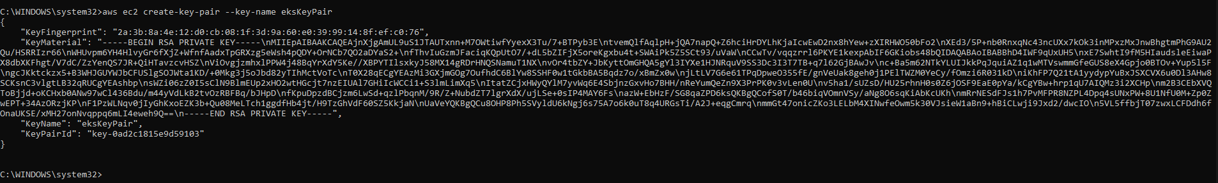

Step 5.2 :: Create nodes

**eksctl create nodegroup --cluster=hari-cluster-cli --region=us-east-1 --name=eks-cli --node-type=t3.medium --nodes=2 --nodes-min=2 --nodes-max=4 --node-volume-size=20 --ssh-access --ssh-public-key=eksKeyPair --managed --asg-access --external-dns-access --full-ecr-access --appmesh-access --alb-ingress-access**

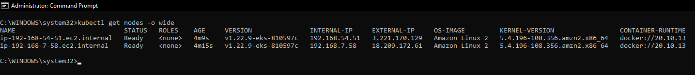

Step 5.3 :: Create a httpd pod and check its status

**kubectl run httpd --image=httpd**

**kubectl get pods -o wide**

