L3 Assignment 1 :: Configuring HTTP LoadBalancer for application using Ingress

Table of Contents
Step 1 :: Create an instance with t2.medium and storage 60 GB 2
Step 2 :: Install Docker 5
Step 3 :: Install Kubectl 5
Step 4 :: Install Kind 5
Step 5 :: Create a cluster using Kind 6
Step 6 :: Create an Ingress-Controller 7
Step 7 :: Create two deployments in the cluster and expose them 8
Step 8 :: Create an Ingress 9
Step 9 :: Update /etc/hosts to access the web 9
Step 10 :: Result :: Access the web pages 9

Step 1 :: Create an instance with t2.medium and storage 60 GB

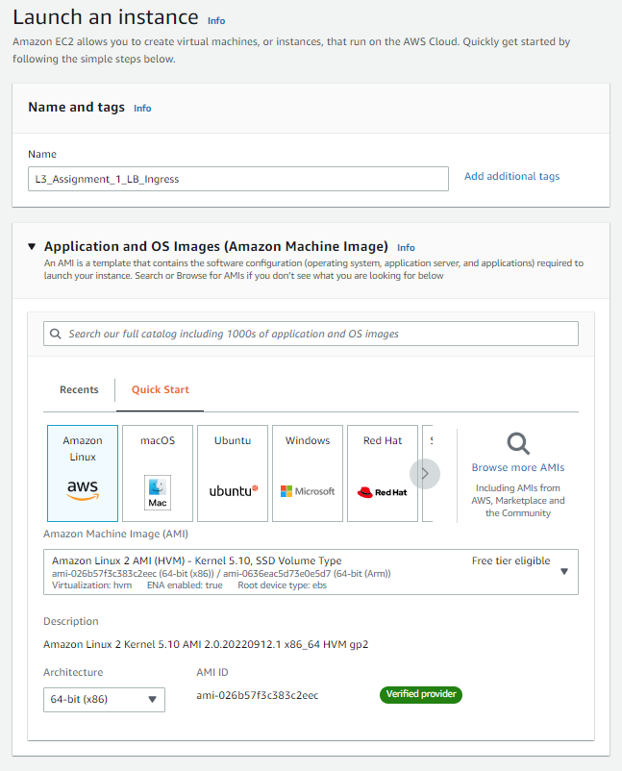
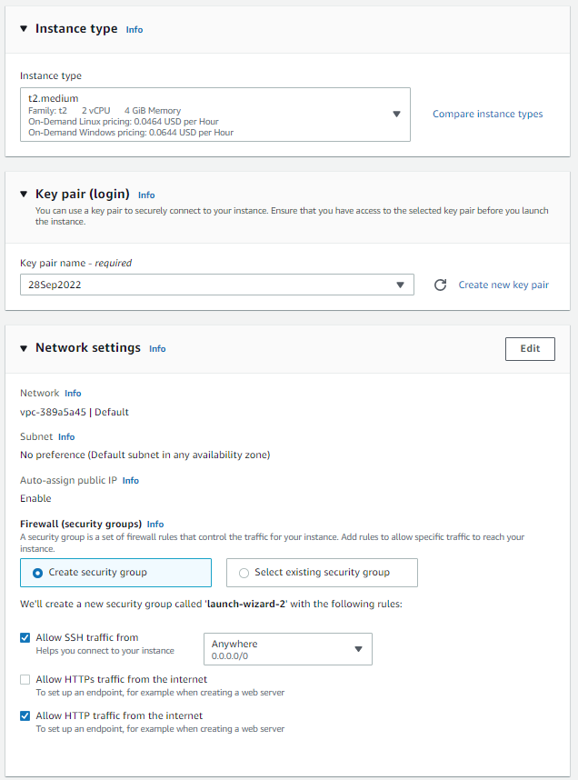

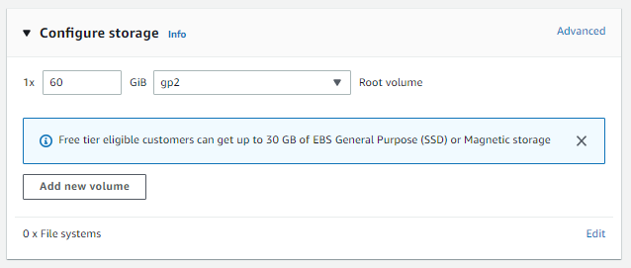

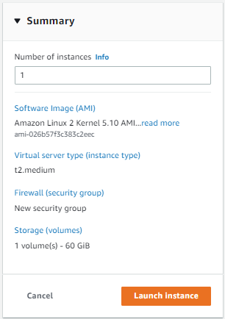

Step 2 :: Install Docker

# yum update
# yum install -y docker
# systemctl enable docker.service
# systemctl start docker.service
# systemctl status docker.service

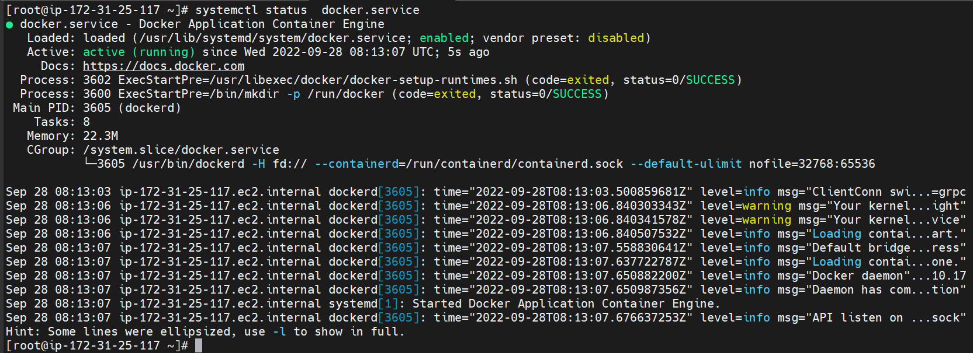

Step 3 :: Install Kubectl

# curl -o kubectl https://s3.us-west-2.amazonaws.com/amazon-eks/1.23.7/2022-06-29/bin/linux/amd64/kubectl
# curl -o kubectl.sha256 https://s3.us-west-2.amazonaws.com/amazon-eks/1.23.7/2022-06-29/bin/linux/amd64/kubectl.sha256
# openssl sha1 -sha256 kubectl
# chmod +x ./kubectl
# mkdir -p $HOME/bin && cp ./kubectl $HOME/bin/kubectl && export PATH=$PATH:$HOME/bin
# echo 'export PATH=$PATH:$HOME/bin' >> ~/.bashrc
# kubectl version --short --client

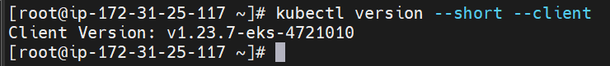

Step 4 :: Install Kind

# curl -Lo ./kind https://kind.sigs.k8s.io/dl/v0.15.0/kind-linux-amd64
# chmod +x ./kind
# mv ./kind /usr/local/bin/kind
# kind version

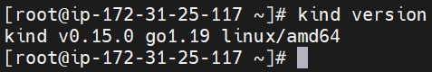

Step 5 :: Create a cluster using Kind

# vi kind-config.yaml

kind: Cluster
apiVersion: kind.x-k8s.io/v1alpha4
nodes:
- role: control-plane
- role: worker
- role: worker
- role: worker

# kind create cluster --config kind-config.yaml –name=assignment-1-lb-ingress

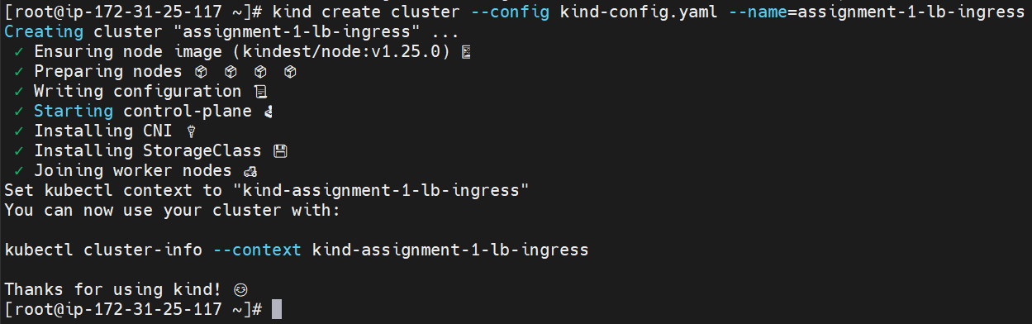
# kubectl get all
# kubectl get node -o wide

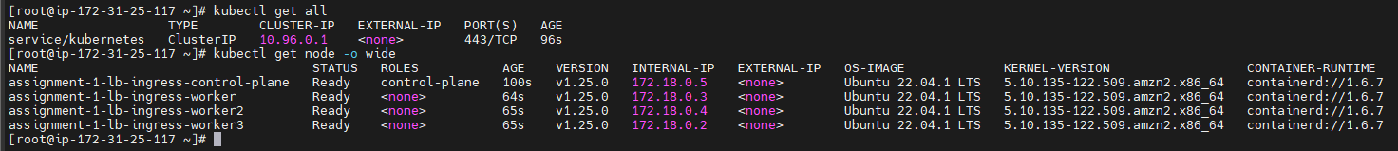
# docker ps -a

Step 6 :: Create an Ingress-Controller

# vi ingress-controller.yaml
# kubectl apply -f ingress-controller.yaml
# kubectl get all -n ingress-nginx

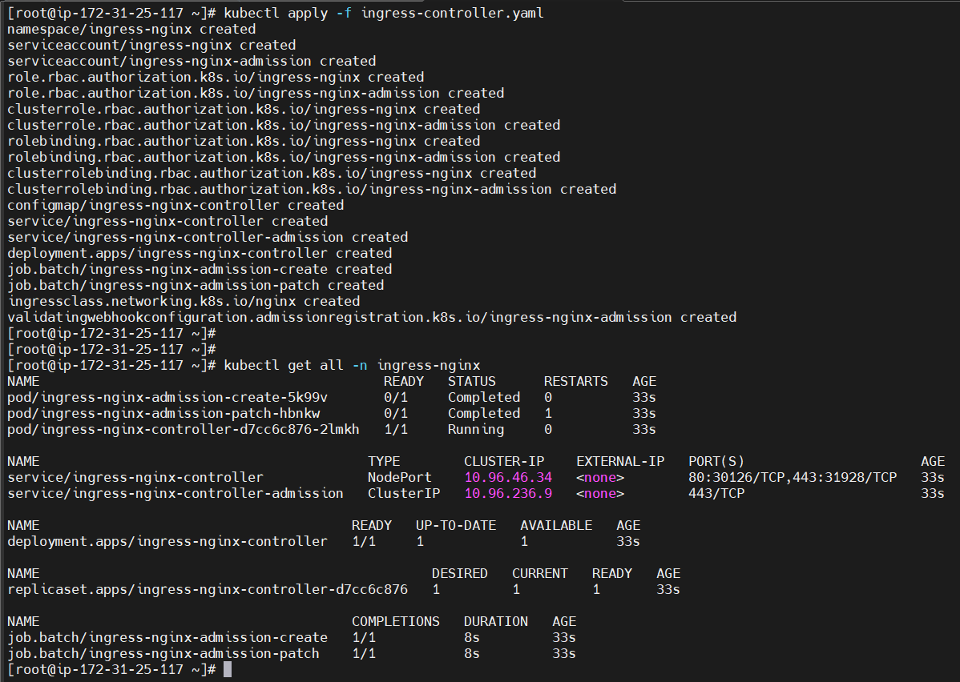
# kubectl get pods -n ingress-nginx

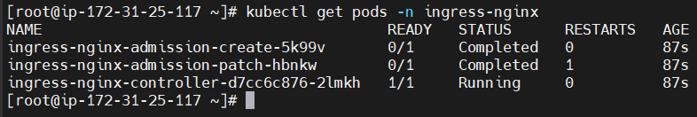

Step 7 :: Create two deployments in the cluster and expose them

# kubectl create deployment web-1 --image=gcr.io/google-samples/hello-app:1.0
# kubectl create deployment web-2 --image=gcr.io/google-samples/hello-app:2.0
# kubectl get all

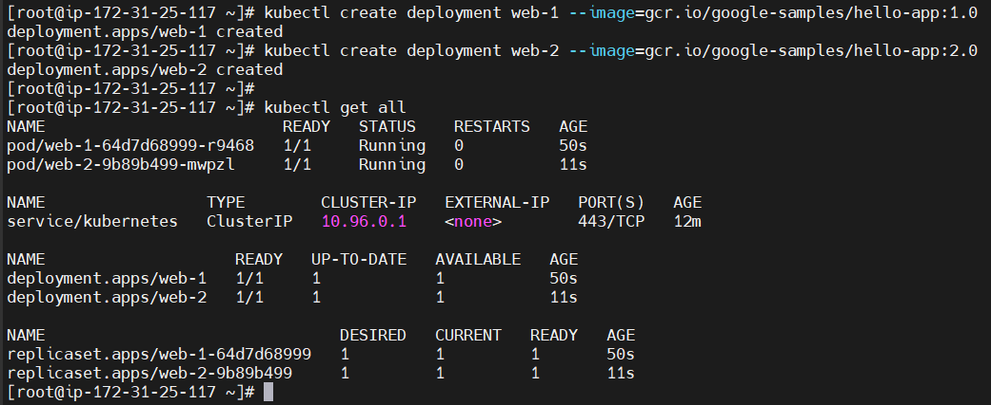
# kubectl expose deployment web-1 --type=NodePort --port=8080
# kubectl expose deployment web-2 --type=NodePort --port=8080
# kubectl get all

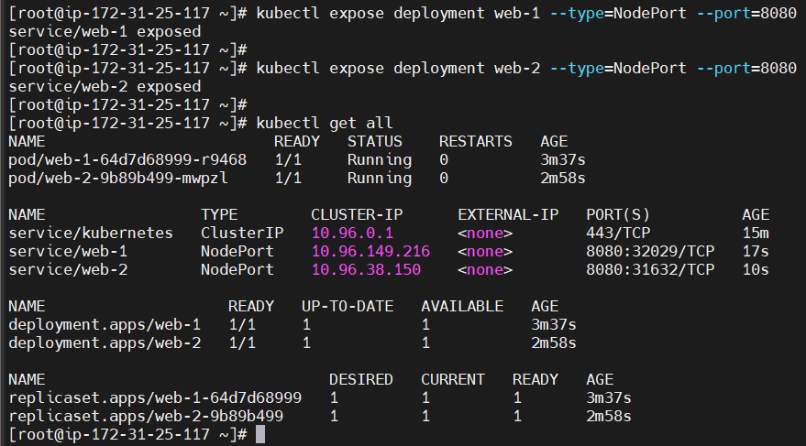

Step 8 :: Create an Ingress

# vi ingress.yaml
# kubectl apply -f ingress.yaml

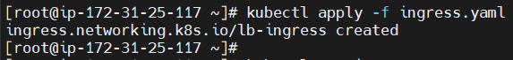
# kubectl get ingress

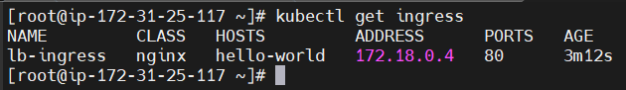

Step 9 :: Update /etc/hosts to access the web

Copy the Address and HOSTS displayed in ingress (# kubectl get ingress)

# vi /etc/hosts

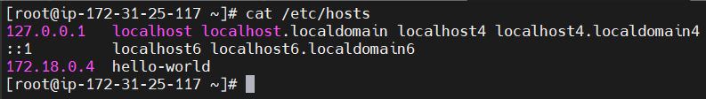

Step 10 :: Result :: Access the web pages

# curl hello-world/v1
# curl hello-world/v2

