Assignment 1 :: Write a step by step process to create kubernetes kind cluster. Also write process to containerize any sample application. Steps to deploy that application on kind cluster.

Table of Contents
Assignment 1 :: Write a step by step process to create kubernetes kind cluster. Also write process to containerize any sample application. Steps to deploy that application on kind cluster. 1
Step 1 :: Create an instance with t2.medium and storage 60 GB 2
Step 2 :: Install Docker and Docker-Compose 2
Step 3 :: Install Kubectl 2
Step 4 :: Install Kind 3
Step 5 :: Create a cluster using Kind 4
Step 6 :: Creating a sample application using dockerfile 5
Step 6.1 :: Create a docker file 5
Step 6.2 :: Placing the necessary scripts 5
Step 6.3 :: Creation and pushing an image to docker hub 6
Step 7 :: Deploy the application in Kind Cluster 7
Step 8 :: Result 8

Step 1 :: Create an instance with t2.medium and storage 60 GB

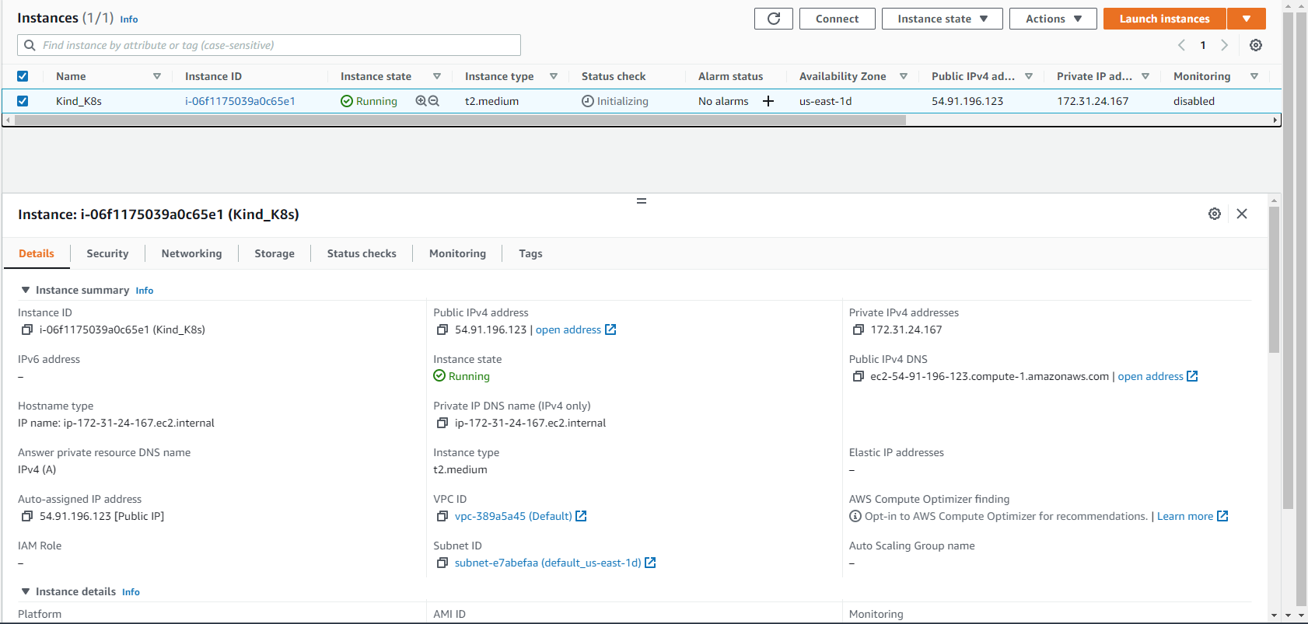

Step 2 :: Install Docker and Docker-Compose

# yum update
# yum install -y docker
# yum install -y python3-pip
# pip3 install docker-compose
# systemctl enable docker.service
# systemctl start docker.service
# systemctl status docker.service
# docker -v
# docker-compose -v

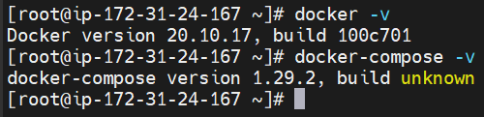

Step 3 :: Install Kubectl

# curl -o kubectl https://s3.us-west-2.amazonaws.com/amazon-eks/1.23.7/2022-06-29/bin/linux/amd64/kubectl
# curl -o kubectl.sha256 https://s3.us-west-2.amazonaws.com/amazon-eks/1.23.7/2022-06-29/bin/linux/amd64/kubectl.sha256
# openssl sha1 -sha256 kubectl
# chmod +x ./kubectl
# mkdir -p $HOME/bin && cp ./kubectl $HOME/bin/kubectl && export PATH=$PATH:$HOME/bin
# echo 'export PATH=$PATH:$HOME/bin' >> ~/.bashrc
# kubectl version --short --client

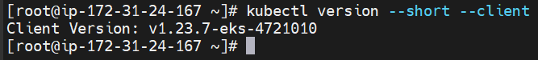

Step 4 :: Install Kind

# curl -Lo ./kind https://kind.sigs.k8s.io/dl/v0.15.0/kind-linux-amd64
# chmod +x ./kind
# mv ./kind /usr/local/bin/kind
# kind version
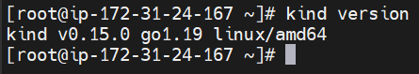

Step 5 :: Create a cluster using Kind

# vi kind-config.yaml

kind: Cluster
apiVersion: kind.x-k8s.io/v1alpha4
nodes:
- role: control-plane
- role: worker
- role: worker
- role: worker

# kind create cluster --config kind-config.yaml --name=assignment-1a

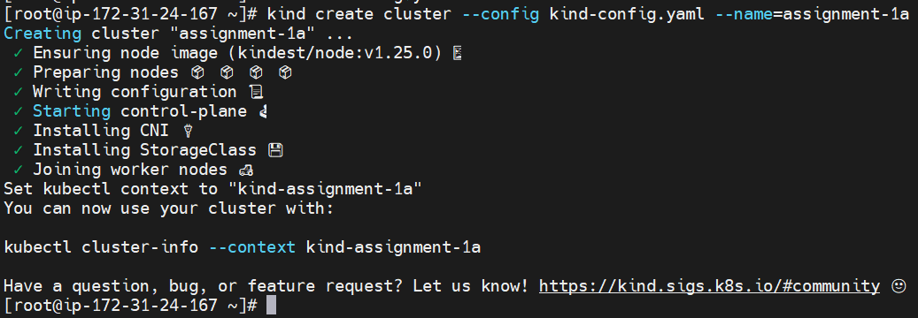
# kubectl get all
# kubectl get node -o wide

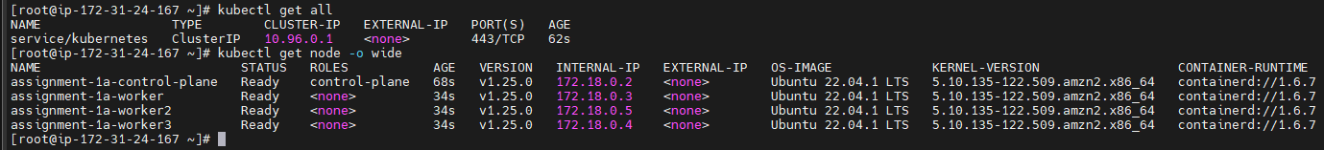
# docker ps -a

Step 6 :: Creating a sample application using dockerfile

Step 6.1 :: Create a docker file

# vi Dockerfile

FROM python:3.7
COPY . /tmp
RUN pip install flask
EXPOSE 8080
CMD ["python", "/tmp/myapp.py"]

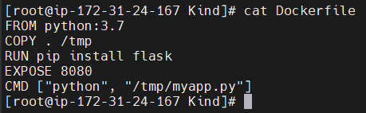

Step 6.2 :: Placing the necessary scripts

Create myapp.py where the Dockerfile is available

# vi myapp.py

from flask import Flask
import os
app = Flask(__name__)
@app.route('/')
def hello():
return('Hello from container..\n')
if __name__ == '__main__':
app.run(host='0.0.0.0', port=8080, debug=True)

Step 6.3 :: Creation and pushing an image to docker hub

# docker build -t webapp .

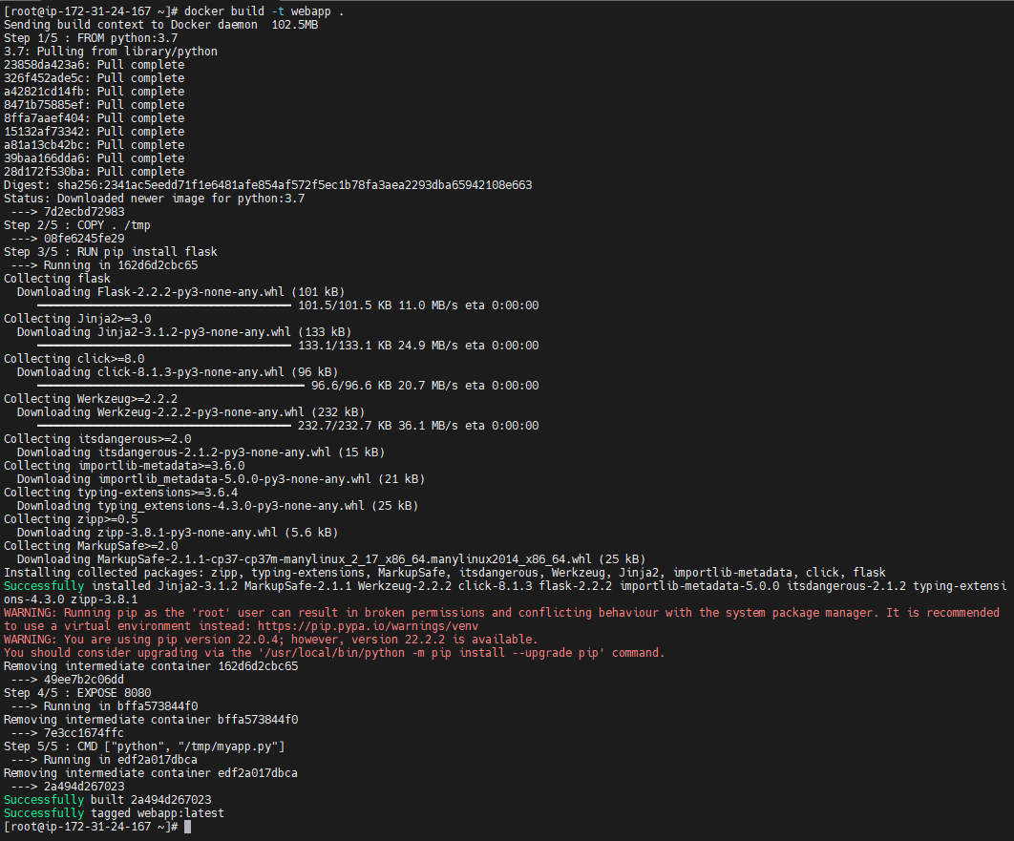
# docker images

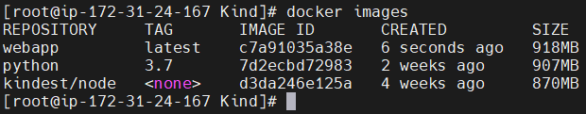
Push the image to docker hub
# docker login
Enter username and password of docker hub
# docker tag <image-id> hariharan410/webapp:latest
# docker push hariharan410/webapp:latest

Step 7 :: Deploy the application in Kind Cluster

# kubectl run mywebapp --image=hariharan410/webapp --restart=Never --dry-run=client -o yaml > web-app.yaml

# cat web-app.yaml

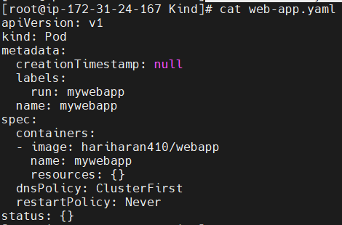

# kubectl apply -f web-app.yaml

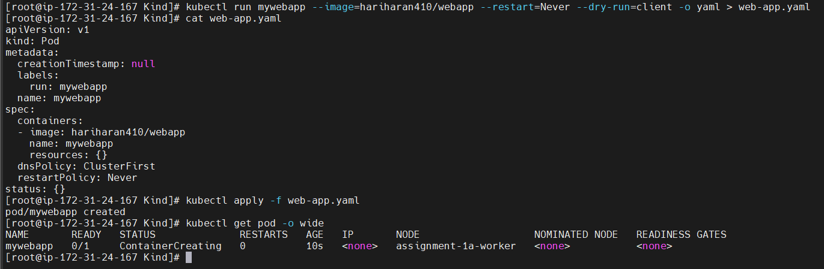
# kubectl get pod -o wide

# kubectl expose pod mywebapp --type=NodePort --port=8080 --name webservice

# kubectl get all -o wide

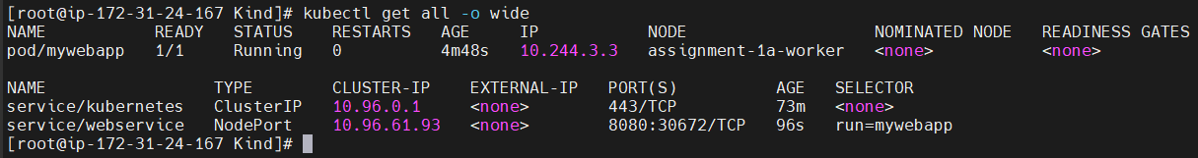

Step 8 :: Result

# kubectl get all -o wide
# kubectl get node -o wide
# curl 172.18.0.3:30672

