Assignment 2 ::
Create a deployment called webapp with image nginx with 5 replicas.
Get the deployment you just created with labels.
Output the yaml file of the deployment you just created.
Get the pods of this deployment.
Scale the deployment from 5 replicas to 20 replicas and verify.
Get the deployment rollout status.
Get the replicaset that created with this deployment.
Get the yaml of the replicaset and pods of this deployment.
Delete the deployment you just created and watch all the pods are also being deleted

Table of Contents
Task 1 :: Create a deployment called webapp with image nginx with 5 replicas. 2
Task 2 :: Get the deployment you just created with labels. 3
Task 3 :: Output the yaml file of the deployment you just created. 3
Task 4 :: Get the pods of this deployment. 3
Task 5 :: Scale the deployment from 5 replicas to 20 replicas and verify. 4
Task 6 :: Get the deployment rollout status. 4
Task 7 :: Get the replicaset that created with this deployment. 4
Task 8 :: Get the yaml of the replicaset and pods of this deployment. 5
Task 9 :: Delete the deployment you just created and watch all the pods are also being deleted 6

Task 1 :: Create a deployment called webapp with image nginx with 5 replicas.

# kubectl create deploy webapp --image=nginx:1.7.9 --replicas=5 --dry-run=client -o yaml > webapp.yaml

# kubectl apply -f webapp.yaml
# kubectl get node -o wide
# kubectl get pod -o wide

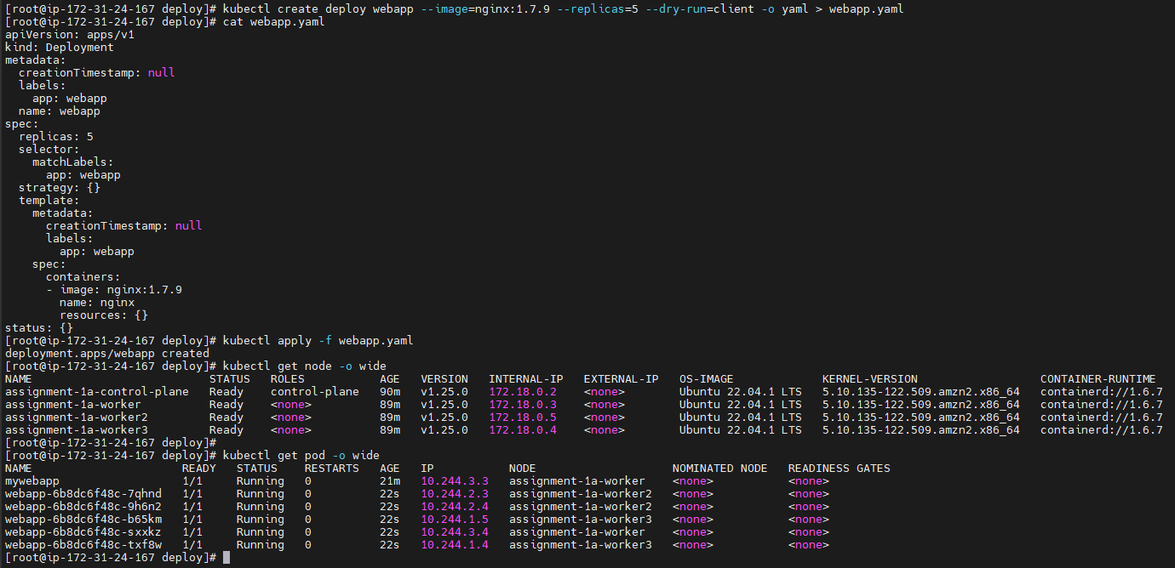

Task 2 :: Get the deployment you just created with labels.

# kubectl get pod --show-labels

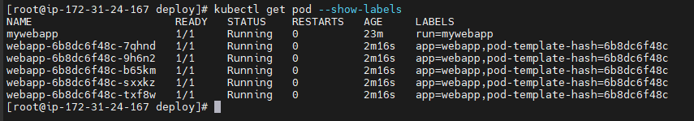

Task 3 :: Output the yaml file of the deployment you just created.

# cat webapp.yaml

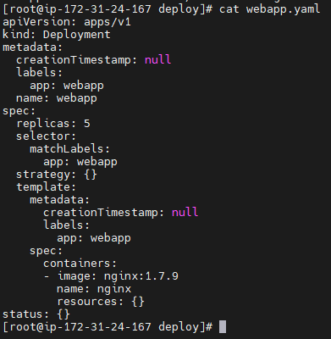

Task 4 :: Get the pods of this deployment.

# kubectl get pods -o wide

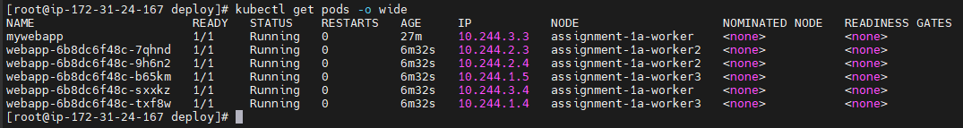

Task 5 :: Scale the deployment from 5 replicas to 20 replicas and verify.

# kubectl scale deploy webapp --replicas=20
# kubectl get all -o wide

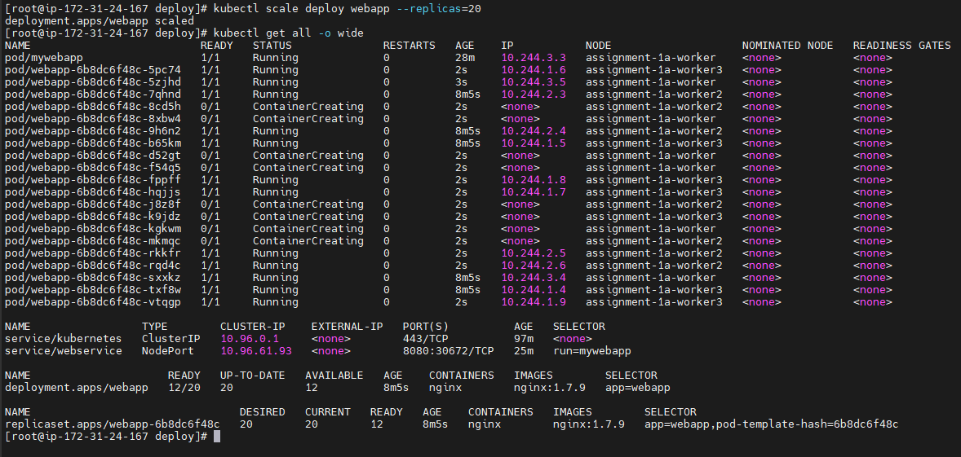

Task 6 :: Get the deployment rollout status.

# kubectl rollout history deploy webapp

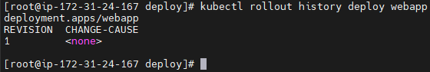

Task 7 :: Get the replicaset that created with this deployment.

# kubectl get rs

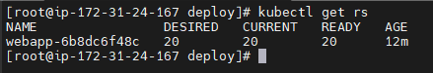

Task 8 :: Get the yaml of the replicaset and pods of this deployment.

# kubectl get rs webapp-6b8dc6f48c -o yaml > rs.yaml

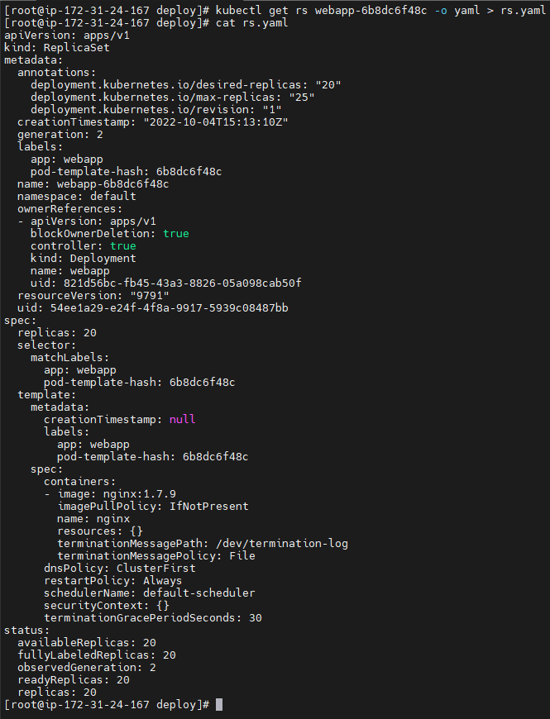

# kubectl get pod webapp-6b8dc6f48c-5pc74 -o yaml > pods.yaml

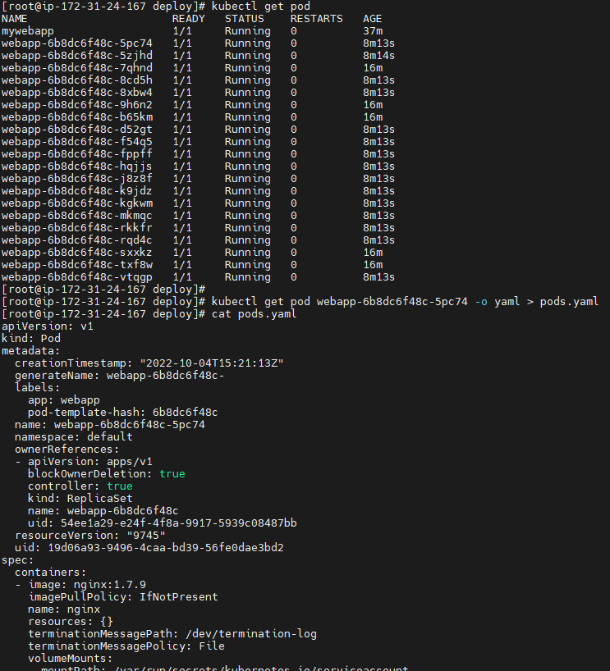

Task 9 :: Delete the deployment you just created and watch all the pods are also being deleted

# kubectl delete deploy webapp

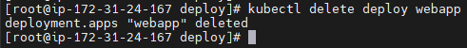

# kubectl get all -o wide
# kubectl get pod -o wide
# kubectl get rs -o wide

