Configure apache2 server using Ansible roles

Table of Contents
Configure apache2 server using Ansible roles 1
Step 1 :: Creating EC2 instances 2
Step 2 :: Installing Ansible 2
Step 3 :: Configuring Ansible in all nodes 5
Step 4 :: Setup PasswordLess login 7
Step 5 :: Managing inventory file on Master 8
Step 6 :: Perform Ping test from Control Node to Manage Nodes from ansadmin user 8
Step 7 :: Creating a role named apache 8
Step 8 :: Creating a template 9
Step 9 :: Creating tasks 9
Step 10 :: Creating the main playbook 10
Step 11 :: Running the role 11
Step 12 :: Result 11

Step 1 :: Creating EC2 instances
Create three EC2 instances and name it as below
- Ansible_Control_Node
- Ansible_Manage_Node_1
- Ansible_Manage_Node_2
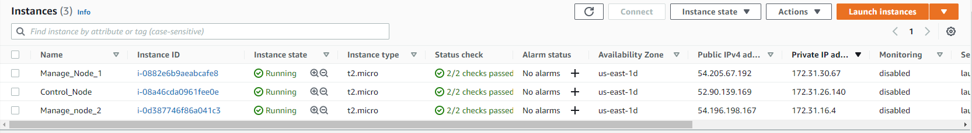

Step 2 :: Installing Ansible
Install Ansible in Ansible_Control_Node
Update the rhel repo to latest

# yum update -y

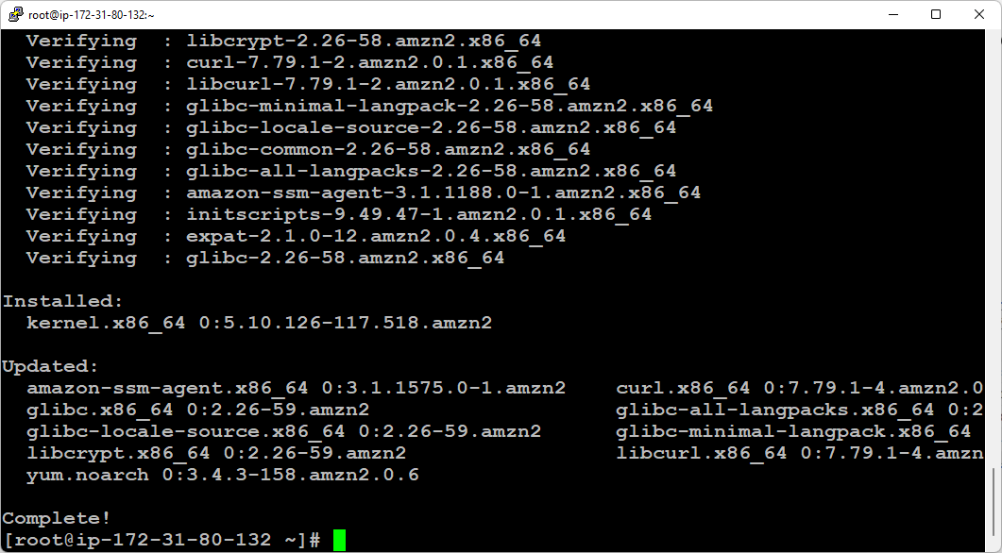

Install Ansible using EPEL Repository

# wget https://dl.fedoraproject.org/pub/epel/epel-release-latest-7.noarch.rpm

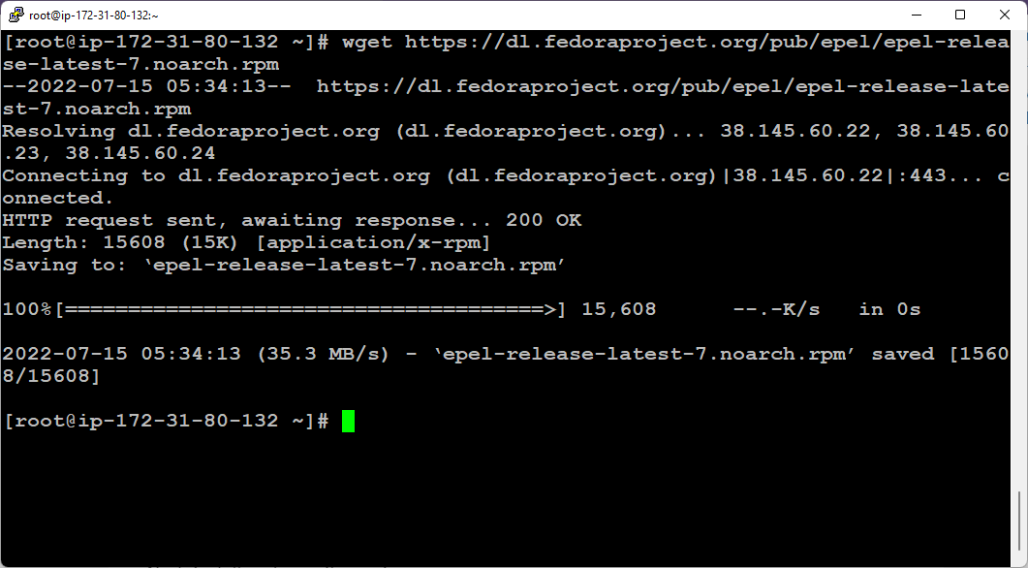

# yum install -y epel-release-latest-7.noarch.rpm

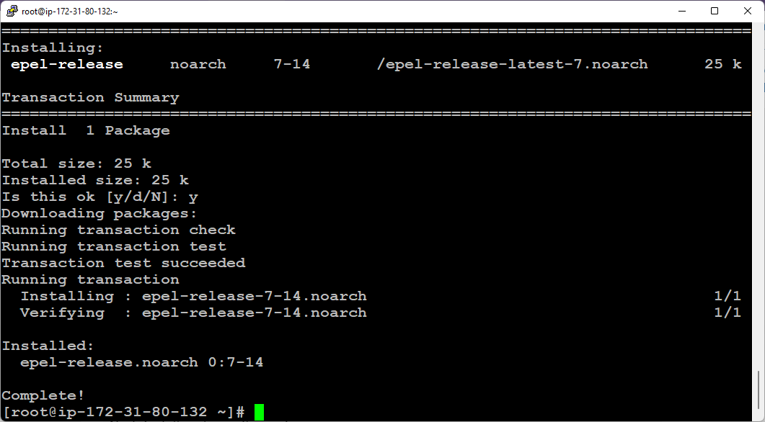

# yum update -y

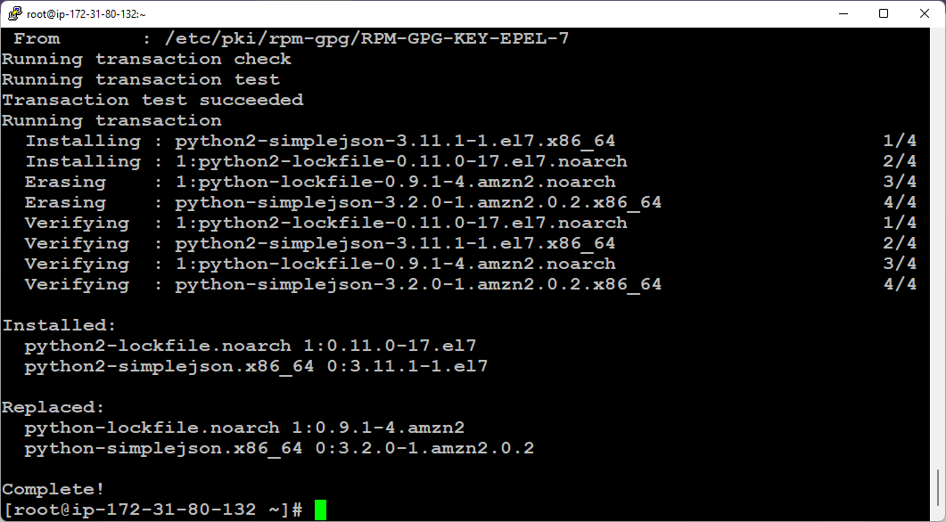

# yum install python python-devel python-pip openssl ansible -y

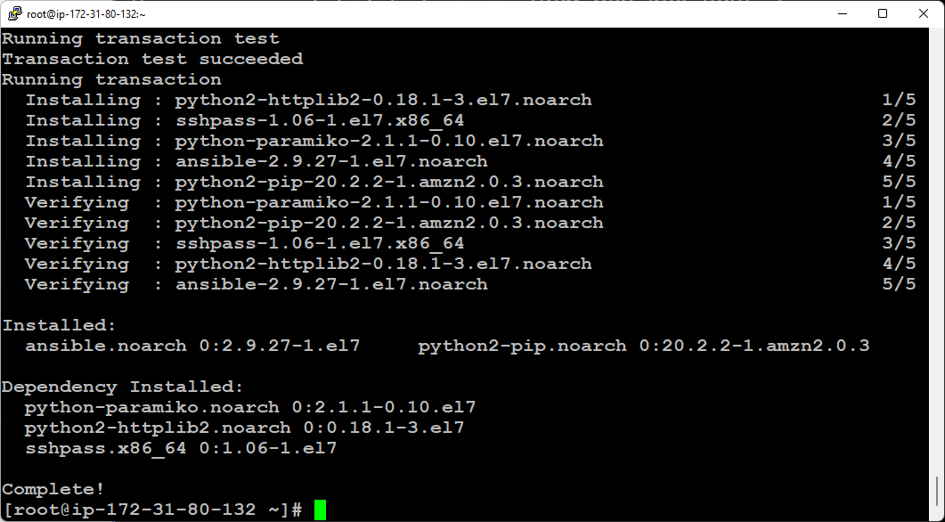

# amazon-linux-extras install ansible2

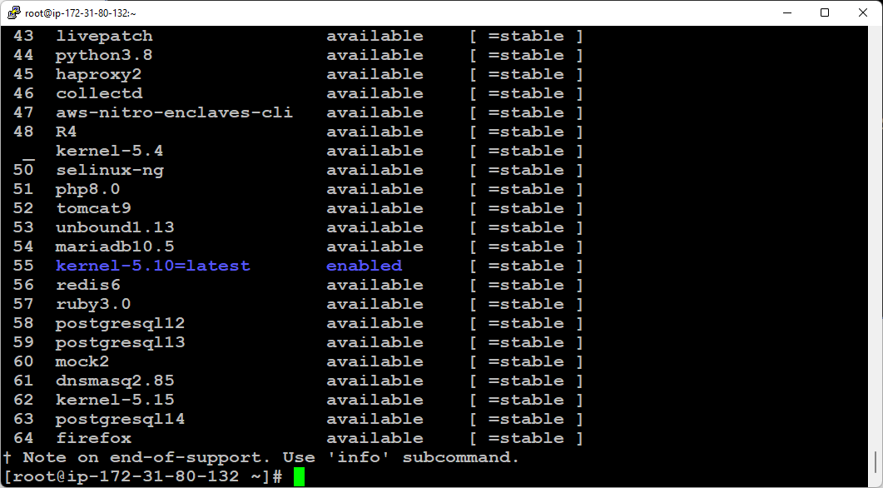

# ansible --version

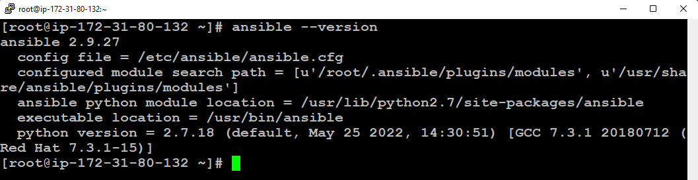

Step 3 :: Configuring Ansible in all nodes
# useradd ansadmin
# passwd ansadmin

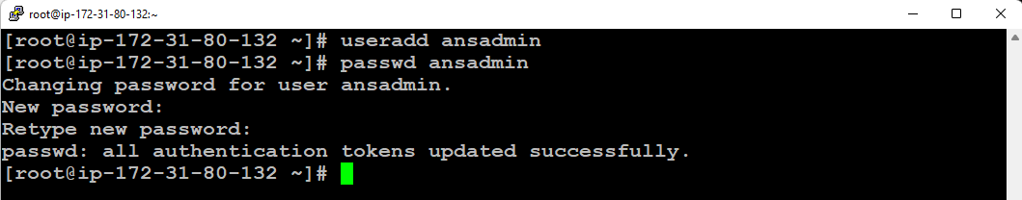

# visudo
Add below line
ansadmin ALL=(ALL) NOPASSWD: ALL

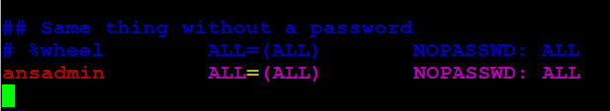

# vi /etc/ssh/sshd_config

Uncomment the below line
“PasswordAuthentication yes”

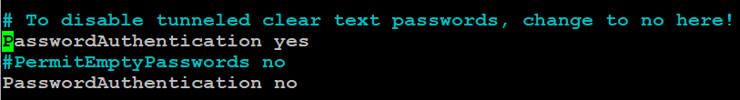

# service sshd restart

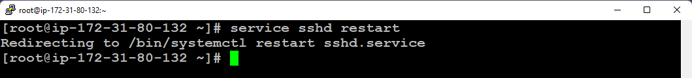

Step 4 :: Setup PasswordLess login

Setup PasswordLess login to all the Manage Nodes from Control node via ansadmin user
# su - ansadmin
$ ssh-keygen

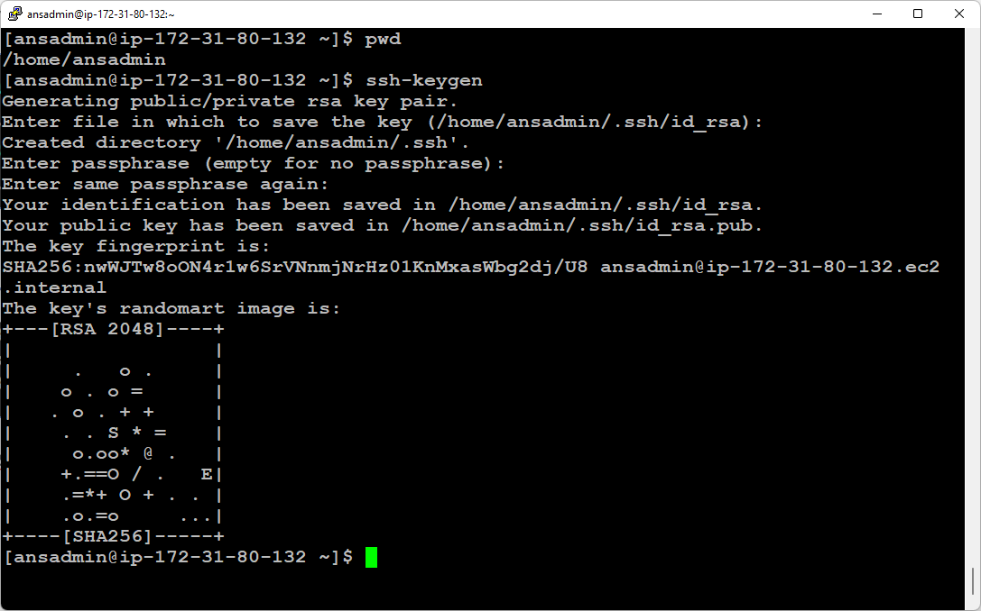

Copy the public key to Manage Nodes

$ ssh-copy-id -i /home/ansadmin/.ssh/id_rsa.pub ansadmin@172.31.30.67
$ ssh-copy-id -i /home/ansadmin/.ssh/id_rsa.pub ansadmin@172.31.16.4

Test the PasswordLess login from control node to manage nodes

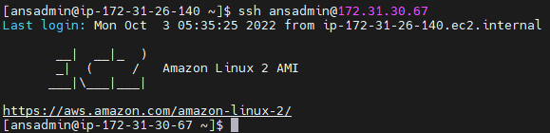

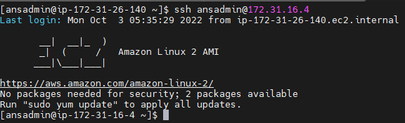

Step 5 :: Managing inventory file on Master
Add the below lines at end of file /etc/ansible/hosts

# vi /etc/ansible/hosts

172.31.30.67
172.31.16.4

[webserver]
172.31.30.67

[dbserver]
172.31.16.4

Step 6 :: Perform Ping test from Control Node to Manage Nodes from ansadmin user

$ ansible all -m ping

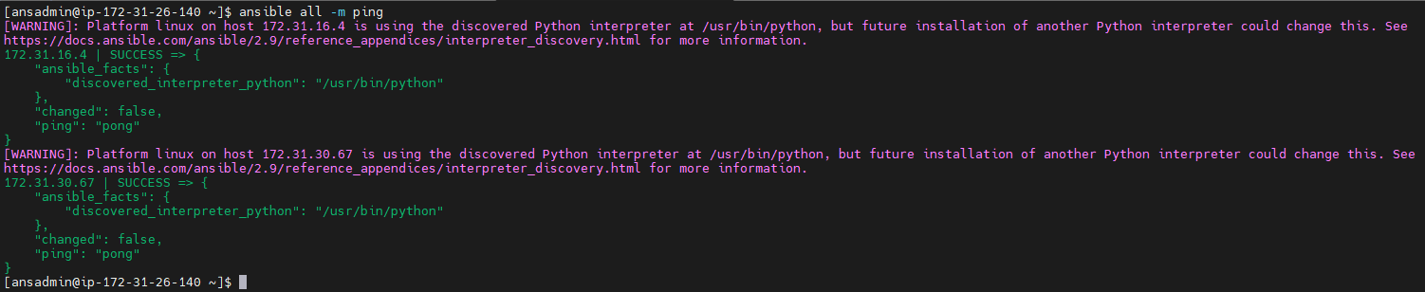

Step 7 :: Creating a role named apache
Create a role named apache via ansadmin user
$ ansible-galaxy init roles/apache

$ ls -al roles/apache/
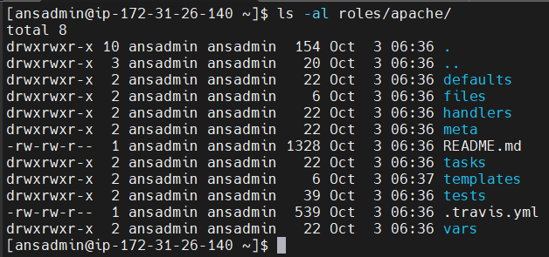

Step 8 :: Creating a template
Create a template to print fqdn and ip address of the server
$ vi roles/apache/templates/template.j2
My hostname is {{ ansible_fqdn }} on {{ansible_default_ipv4.address}}

Step 9 :: Creating tasks
Create a tasks yaml file to install and configure apache server
$ vi roles/apache/tasks/main.yml
- name: install httpd package
yum:
name:
- httpd
- firewalld
state: present
- name: start service httpd
service:
name: httpd
state: started
enabled: yes
- name: start service firewalld
service:
name: firewalld
state: started
enabled: yes
- name: firewall rule
firewalld:
service: http
state: enabled
permanent: true
immediate: yes
- template:
src: template.j2
dest: /var/www/html/index.html

Step 10 :: Creating the main playbook
$ vi apache_role.yml
---
- name: apache deploy
hosts: all
roles:
- apache

Step 11 :: Running the role

$ ansible-playbook apache_role.yml

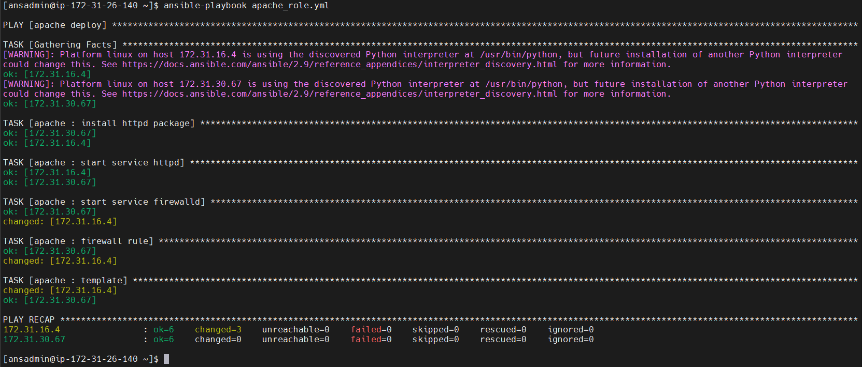

Step 12 :: Result

Manage_node_1

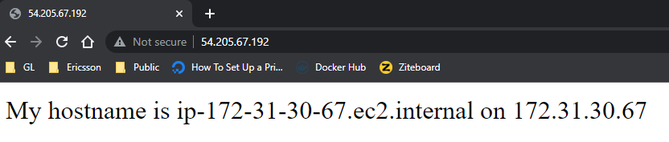
Manage_Node_2

