- Create a Play book to install Apache server on the destination server with yum module install only if the OS is 'RedHat' or 'CentOS' and version 7 and apt module on Ubuntu server
  - Create an Ubuntu machine and install python on it, apt module is used instead of yum in Ubuntu and name of software is apache2 not httpd
- Create a play book to create testuser1 and testuser2 on all the hosts (use loop)

Table of Contents
Step 1 :: Creating EC2 Instances 2
Step 2 :: Install Ansible in Control_Node 2
Step 3 :: Configuring Ansible in all nodes 2
Step 4 :: Setup PasswordLess login to all the Manage Nodes from Control node via ansadmin user 3
Step 5 :: Managing inventory file on Master Node 3
Task 1 :: Create a Play book to install Apache server on the destination server with yum module install only if the OS is 'RedHat' or 'CentOS' and version 7 and apt module on Ubuntu server 4
Task 2 :: Create an Ubuntu machine and install python on it, apt module is used instead of yum in Ubuntu and name of software is apache2 not httpd 7
Task 3 :: Create a play book to create testuser1 and testuser2 on all the hosts (use loop) 8

Step 1 :: Creating EC2 Instances
Create 4 instances as below

Control_Node --> AWS Linux
Manage_Node_RedHat --> AWS Linux
Manage_Node_SUSE --> SUSE Linux
Manage_Node_Ubuntu --> Ubuntu

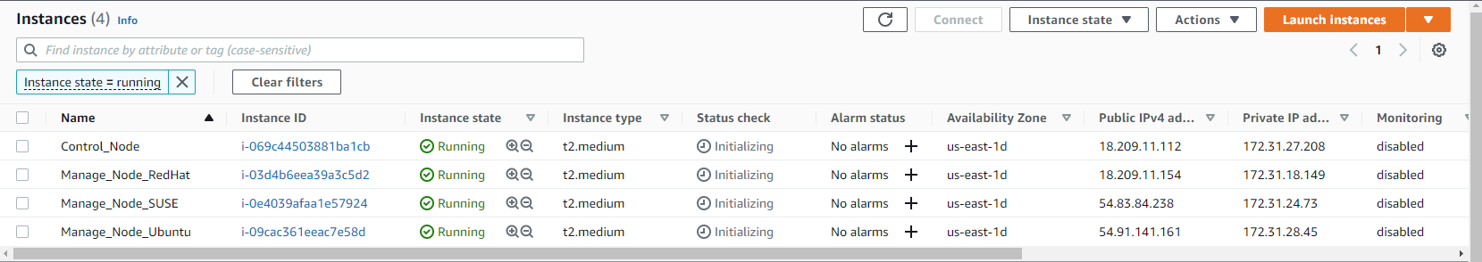

Step 2 :: Install Ansible in Control_Node
# ansible --version

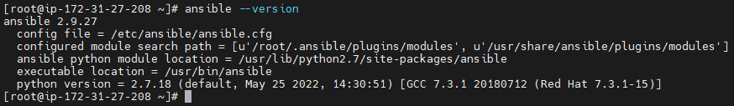

Step 3 :: Configuring Ansible in all nodes
# useradd ansadmin
Note: use “useradd -m ansadmin” in case of Ubuntu and SUSE servers
# passwd ansadmin
# visudo
Add below line
ansadmin ALL=(ALL) NOPASSWD: ALL

# vi /etc/ssh/sshd_config
Uncomment the below line
“PasswordAuthentication yes”

# service sshd restart

Step 4 :: Setup PasswordLess login to all the Manage Nodes from Control node via ansadmin user
# su - ansadmin
$ ssh-keygen
$ ssh-copy-id -i /home/ansadmin/.ssh/id_rsa.pub ansadmin@172.31.18.149
$ ssh-copy-id -i /home/ansadmin/.ssh/id_rsa.pub ansadmin@172.31.24.73
$ ssh-copy-id -i /home/ansadmin/.ssh/id_rsa.pub ansadmin@172.31.28.45

Step 5 :: Managing inventory file on Master Node
Add the below lines at end of file /etc/ansible/hosts

$ sudo vi /etc/ansible/hosts

[Redhat]
172.31.18.149
[Ubuntu]
172.31.28.45
[Suse]
172.31.24.73

Perform Ping test from Control Node to Manage Nodes from ansadmin user

$ ansible all -m ping

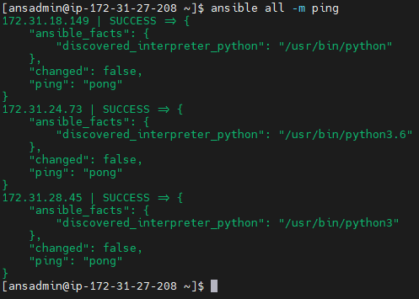

Task 1 :: Create a Play book to install Apache server on the destination server with yum module install only if the OS is 'RedHat' or 'CentOS' and version 7 and apt module on Ubuntu server

$ cat apache.yaml
- name: Developing a webserver
hosts: all
become: yes
remote_user: ansadmin
tasks:
- block:
- name: Install http in all RedHat Servers
yum:
name: httpd
state: present
- name: Start HTTPD in RedHat Servers
service:
name: httpd
state: started
enabled: yes
when: (ansible_facts['distribution'] == "Amazon" and ansible_facts['distribution_major_version'] == "2")
- block:
- name: Install apache2 in all Ubuntu Servers
apt:
name: apache2
state: present
- name: Start apache2 in Ubuntu Servers
service:
name: apache2
state: started
enabled: yes
when: (ansible_facts['distribution'] == "Ubuntu" and ansible_facts['distribution_major_version'] == "22")
- block:
- name: create a directory
file:
path: /devweb
state: directory
group: ansadmin
mode: 02775
setype: httpd_sys_content_t
- name: create file
file:
path: /devweb/index.html
state: touch
- name: copy the contents
copy:
content: "Welcome to Devops Training Session\n"
dest: /devweb/index.html
- name: link a file
file:
src: /devweb
dest: /var/www/html/devweb
state: link
when: (ansible_facts['distribution'] == "Amazon") or (ansible_facts['distribution'] == "Ubuntu")

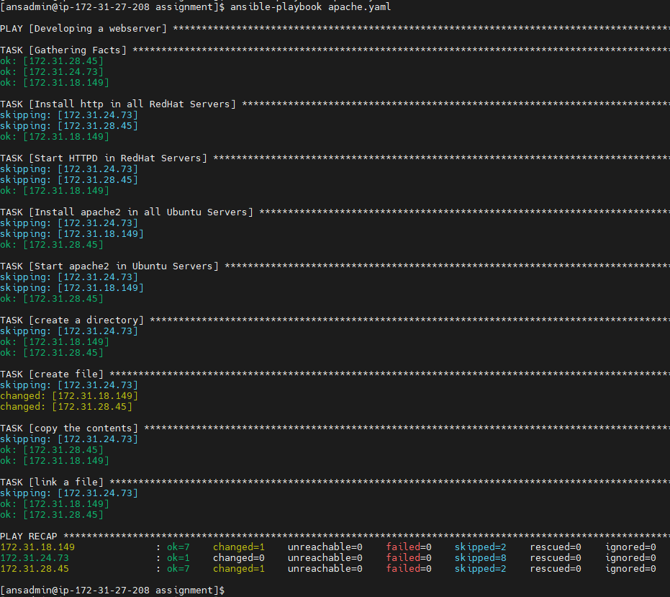
Result From RedHat Server

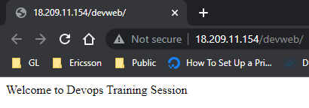

Result from Ubuntu Server

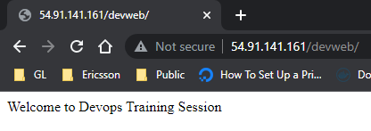

Result from SUSE Server

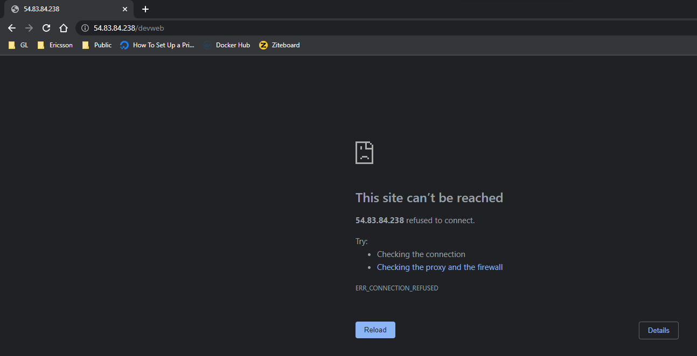

Task 2 :: Create an Ubuntu machine and install python on it, apt module is used instead of yum in Ubuntu and name of software is apache2 not httpd

$ cat python.yaml
- name: Installing Python
hosts: all
become: yes
tasks:
- name: Install python3 & apache2 on Ubuntu
apt:
name:
- python3
- apache2
state: present
when: ansible_os_family == "Debian"

- name: Install python3 & httpd on RedHat
yum:
name:
- python3
- httpd
state: present
when: ansible_os_family == "RedHat"

- name: Install python3 in SUSE
zypper:
name: python3
state: present
when: ansible_os_family == "Suse"

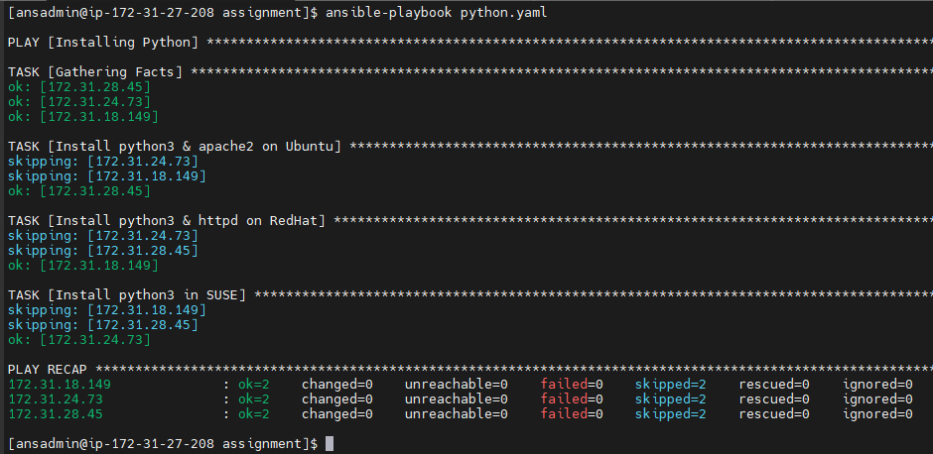

Task 3 :: Create a play book to create testuser1 and testuser2 on all the hosts (use loop)

$ cat user_loop.yaml
- hosts: all
become: true
vars_files:
- user_details.yaml
tasks:
- name: more complex items to add several users
user:
name: "{{ item.name }}"
uid: "{{ item.uid }}"
groups: "{{ item.groups }}"
state: present
with_items: "{{ user_details }}"

$ cat user_details.yaml
user_details:
- {name: 'testuser1', uid: 1002, groups: ['ansadmin']}
- {name: 'testuser2', uid: 1003, groups: ['ansadmin']}

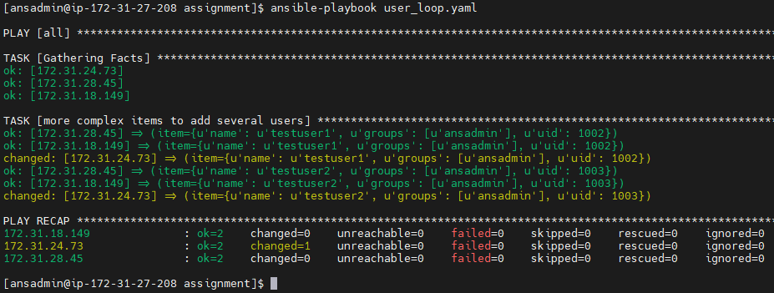
RedHat Server ::

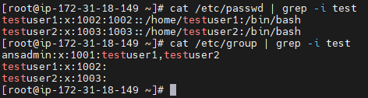

Suse Linux Server

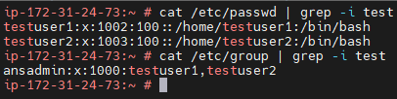

Ubuntu Server ::

