Assignment 3 :: Setup Docker Containers as Build Agents for Jenkins

Table of Contents
Assignment 3 :: Setup Docker Containers as Build Agents for Jenkins 1
Step 1 :: Preparing EC2 Instances 2
Step 1.1 :: Prepare 2 instances 2
Step 1.2 :: Install Jenkins in Master Node 2
Step 1.3 :: Install Docker in both Master and Slave machines 2
Step 1.4 :: Configure Docker in Slave Machine 3
Step 2 :: Configure Jenkins Server with Docker Plugin 3
Step 3 :: Run a job 5
Step 4 :: Result 5

Step 1 :: Preparing EC2 Instances

Step 1.1 :: Prepare 2 instances

OS :: Ubuntu 20.04
Security_Group :: All Traffic
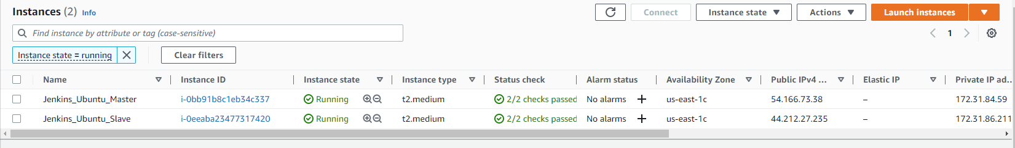

Step 1.2 :: Install Jenkins in Master Node

$ sudo apt -y update
$ sudo apt install openjdk-11-jdk -y
$ wget -q -O - https://pkg.jenkins.io/debian/jenkins.io.key | sudo apt-key add -
$ sudo sh -c 'echo deb https://pkg.jenkins.io/debian-stable binary/ > \
/etc/apt/sources.list.d/jenkins.list'
$ sudo apt update -qy
$ sudo apt install jenkins -qy
$ sudo systemctl start jenkins
$ sudo systemctl enable jenkins
$ sudo systemctl status jenkins
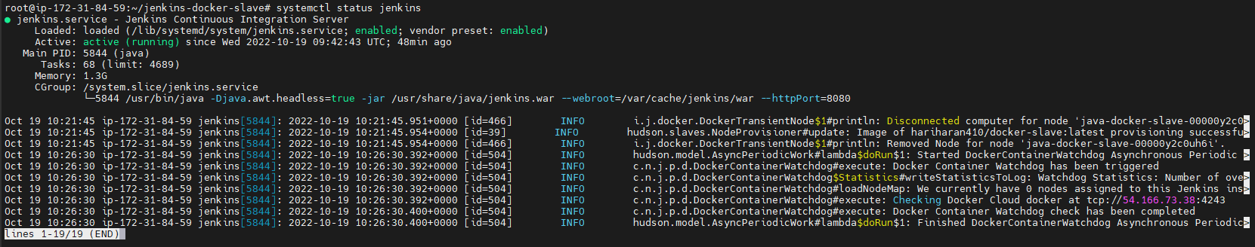

Step 1.3 :: Install Docker in both Master and Slave machines
$ sudo apt install docker.io -qy
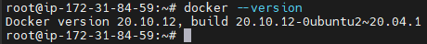

Step 1.4 :: Configure Docker in Slave Machine
$ sudo vi /lib/systemd/system/docker.service
Search for “ExecStart” and replace that line with the following.
ExecStart=/usr/bin/dockerd -H tcp://0.0.0.0:4243 -H unix:///var/run/docker.sock
$ sudo systemctl daemon-reload
$ sudo service docker restart
Validate API by executing the following curl command
curl http://<Slave.ip.address>:4243/version

Step 2 :: Configure Jenkins Server with Docker Plugin

Step 2.1 :: Head over to Jenkins Dashboard –> Manage Jenkins –> Manage Plugins
Step 2.2 :: Under the Available tab, search for “Docker” and install the docker cloud plugin
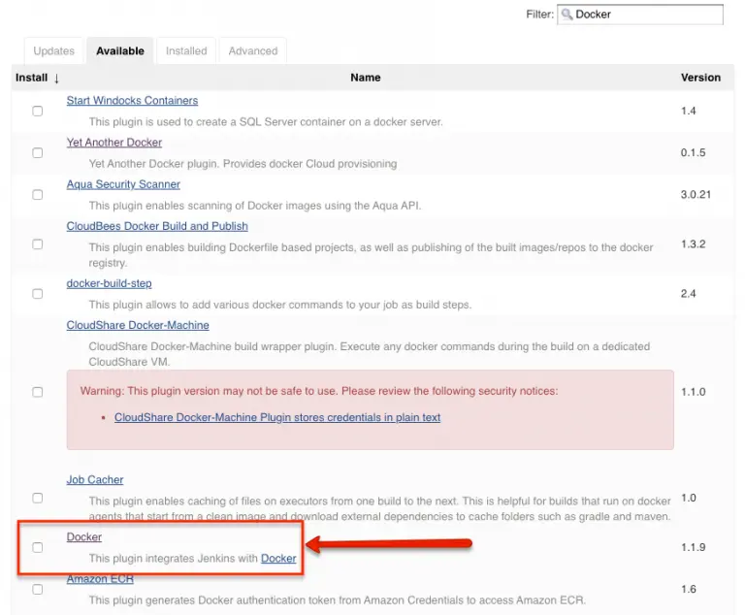
Step 2.3 :: Once installed head over to Dashboard -> Manage Jenkins -> Manage Nodes and Clouds -> Configure Clouds -> Add a new cloud -> Docker
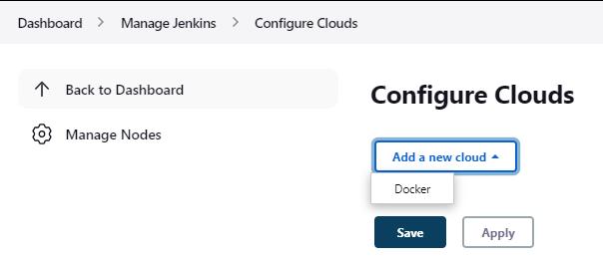
Step 2.4 :: Configure Cloud as below
Name : docker
Docker Host URI : tcp://<client.server.ip>:4243
Ensure to check Enabled and Expose DOCKER_HOST check boxes
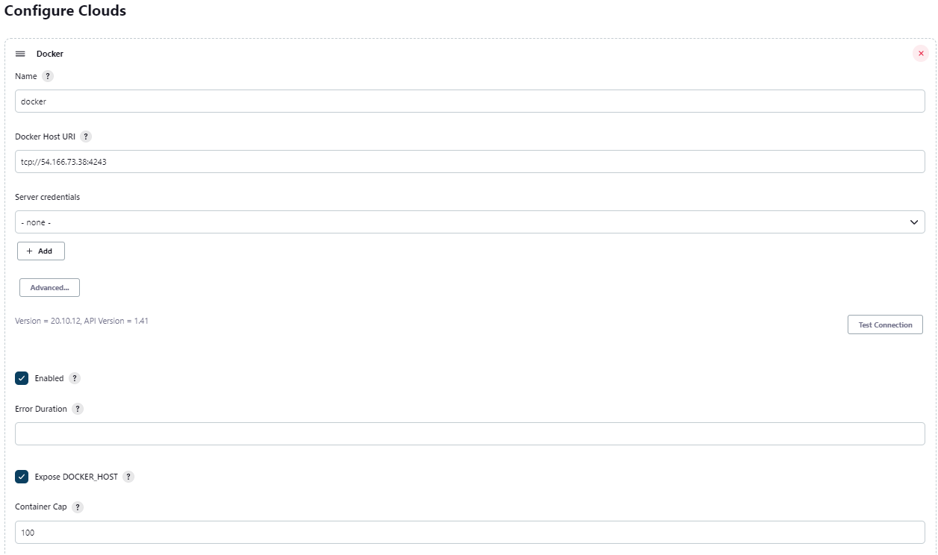
Step 2.5 :: Configure Docker Agent Template
Label : java-docker-slave
Ensure to tick the Enabled check box
Docker Image : hariharan410/docker-slave:latest
Remote File System : /home/jenkins
Connect method : Connect with SSH
SSH credentials : Create a new one with user name and password as “jenkins”
Host Key Verification Strategy : Non verifying Verification Strategy
Click on Advanced and update JavaPath : /usr/bin/java
Click on Save
Note : Other values can be left as default

Step 3 :: Run a job
Step 3.1 :: Goto Dashboard -> New Item
Step 3.2 :: Create a freestyle project
Step 3.3 :: Enable “Restrict where this project can be run” and enter value as “java-docker-slave”
Step 3.4 : Select Execute Shell under Build Steps and the below
echo "Hello World"
Save and Build the job (Wait for few mins... Initially we will get as below)

Step 4 :: Result

