Create a pipeline (build, test, deploy)using GitLab

Table of Contents
Create a pipeline (build, test, deploy)using GitLab 1
Step 1 :: Creating an Instance (AWS Linux) 2
Step 2 :: Installing Docker and Git 2
Step 3 :: Installing the GitLab Runner 2
Step 4 :: Letting GitLab know that we want to use a dedicated runner 2
Step 5 :: Configuring the GitLab CI Runner 4
Step 6 :: Enabling the privileged mode 5
Step 7 :: Testing the installation 6

Step 1 :: Creating an Instance (AWS Linux)
Create an Instance using AWS Linux.
Note: Allow “All Traffic” in Inbound rules
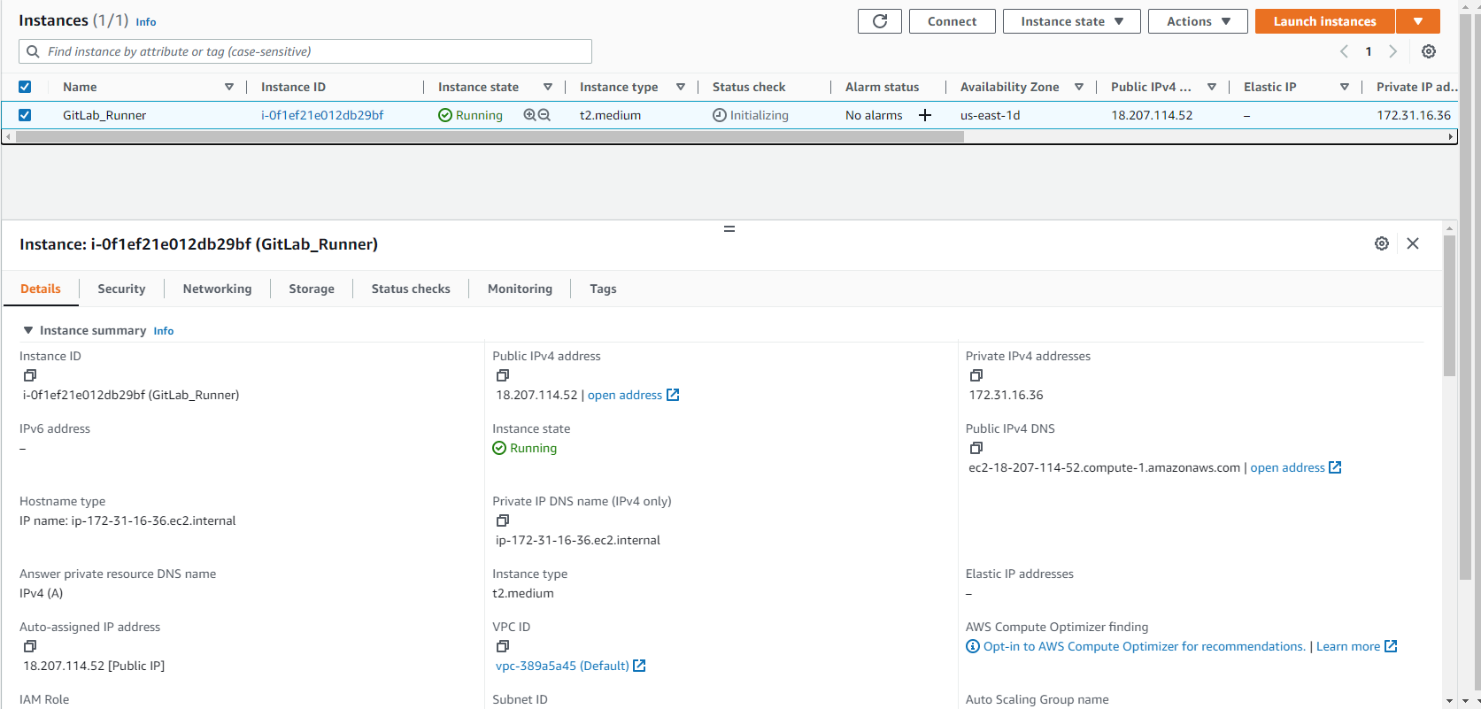

Step 2 :: Installing Docker and Git
Install and configure docker and Git using below steps
$ sudo yum -y update
$ sudo yum install -y git
$ sudo amazon-linux-extras install -y docker
$ sudo usermod -aG docker ec2-user
$ sudo systemctl enable docker
$ sudo reboot

Step 3 :: Installing the GitLab Runner

$ curl -LJO "https://gitlab-runner-downloads.s3.amazonaws.com/latest/rpm/gitlab-runner_amd64.rpm"
$ sudo rpm -i gitlab-runner_amd64.rpm

Step 4 :: Letting GitLab know that we want to use a dedicated runner
Lets create a private group just for this runner
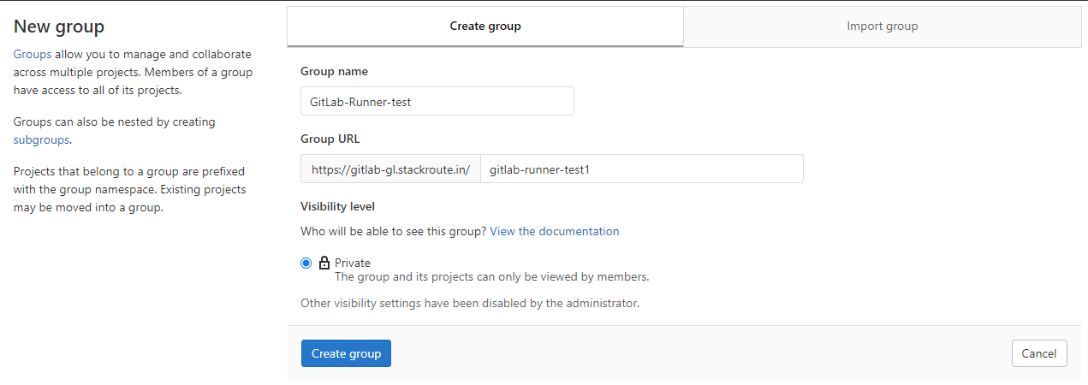
From the group (gitlab-runner-test) select Settings -> CI/CD -> Runners -> Disable “Set up shared runner availability”
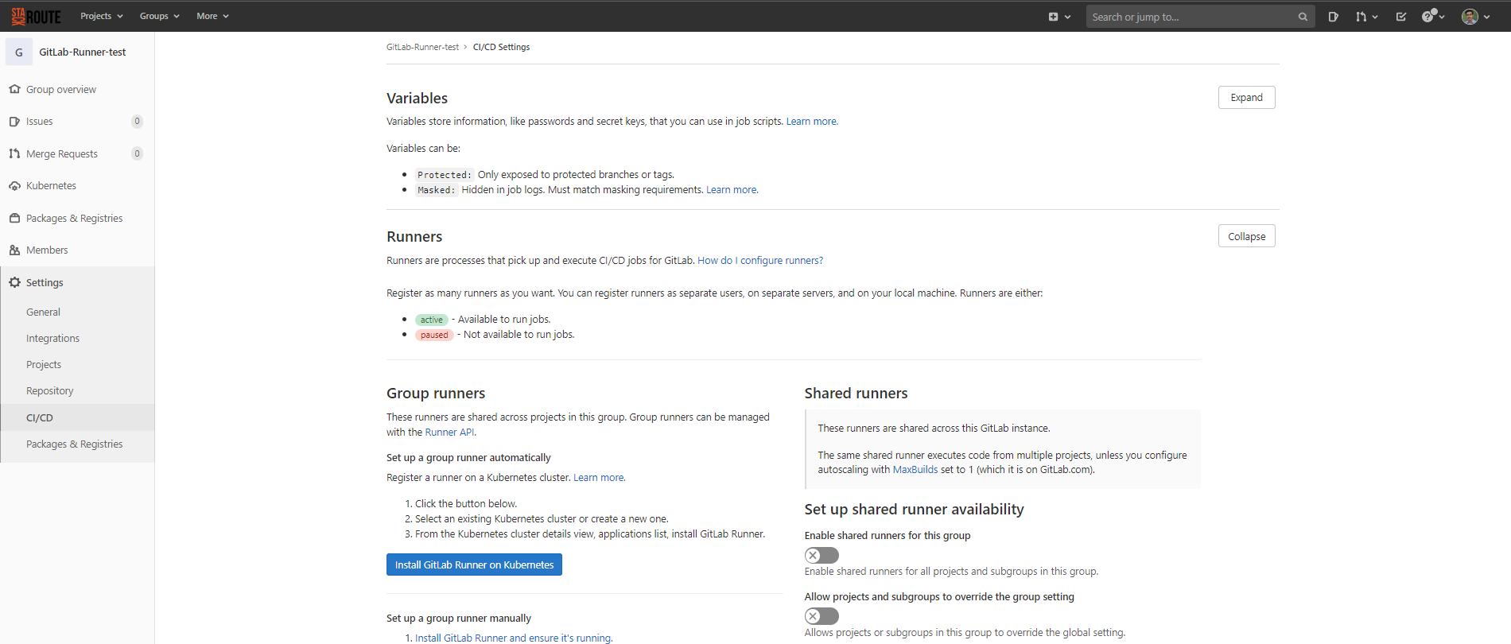

Step 5 :: Configuring the GitLab CI Runner
Note : Make a note of URL and Registration Token provided by GitLab
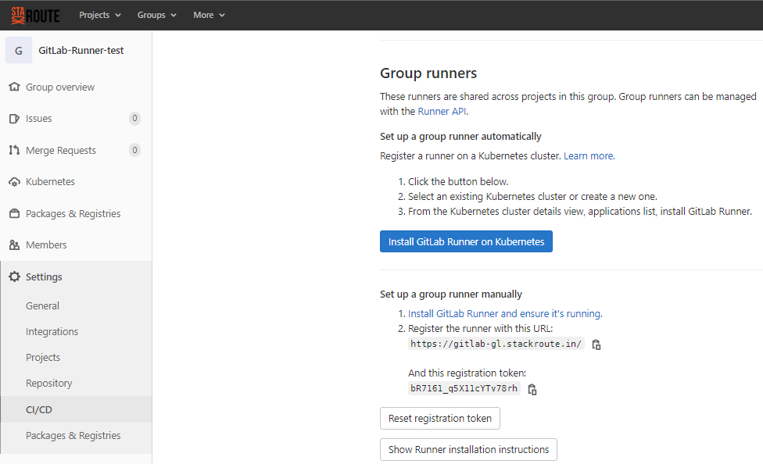
$ sudo gitlab-runner register
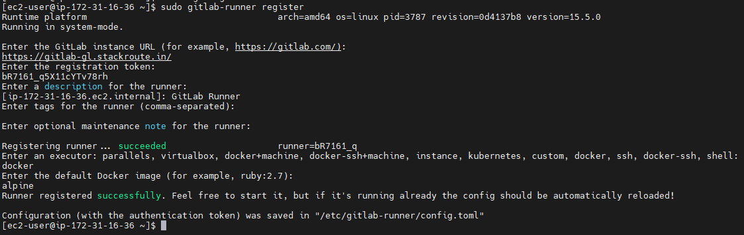
$ sudo gitlab-runner status

Now we should be able to see the runners details in CI/CD settings page
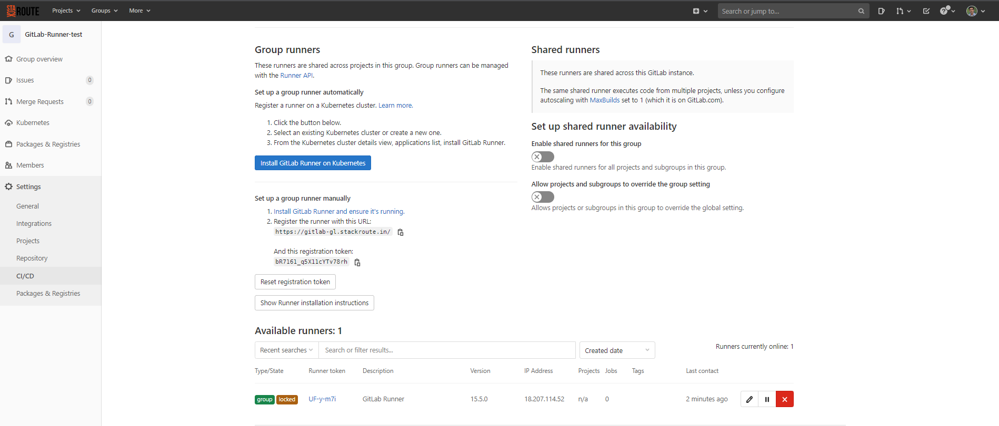

Step 6 :: Enabling the privileged mode

Change privileged = true in below file
$ sudo vi /etc/gitlab-runner/config.toml
Then restart the gitlab-runner
$ sudo gitlab-runner restart

Step 7 :: Testing the installation

Create a blank project under the created group and import the necessary codes
Test job Log
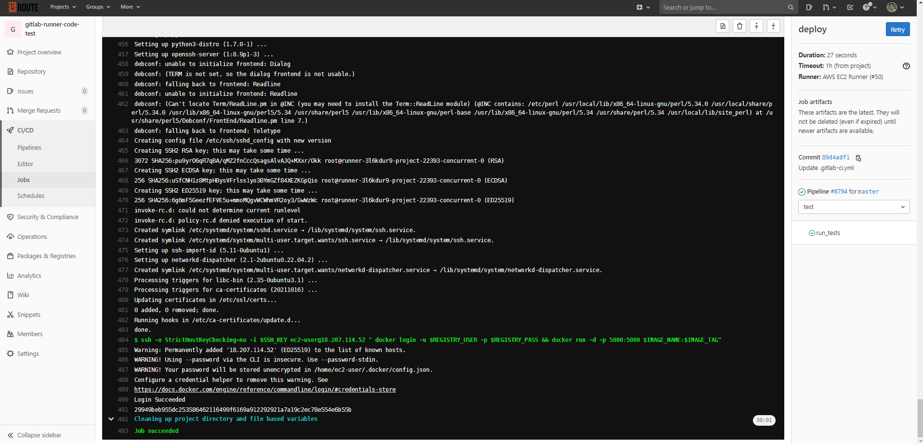
Build job Log
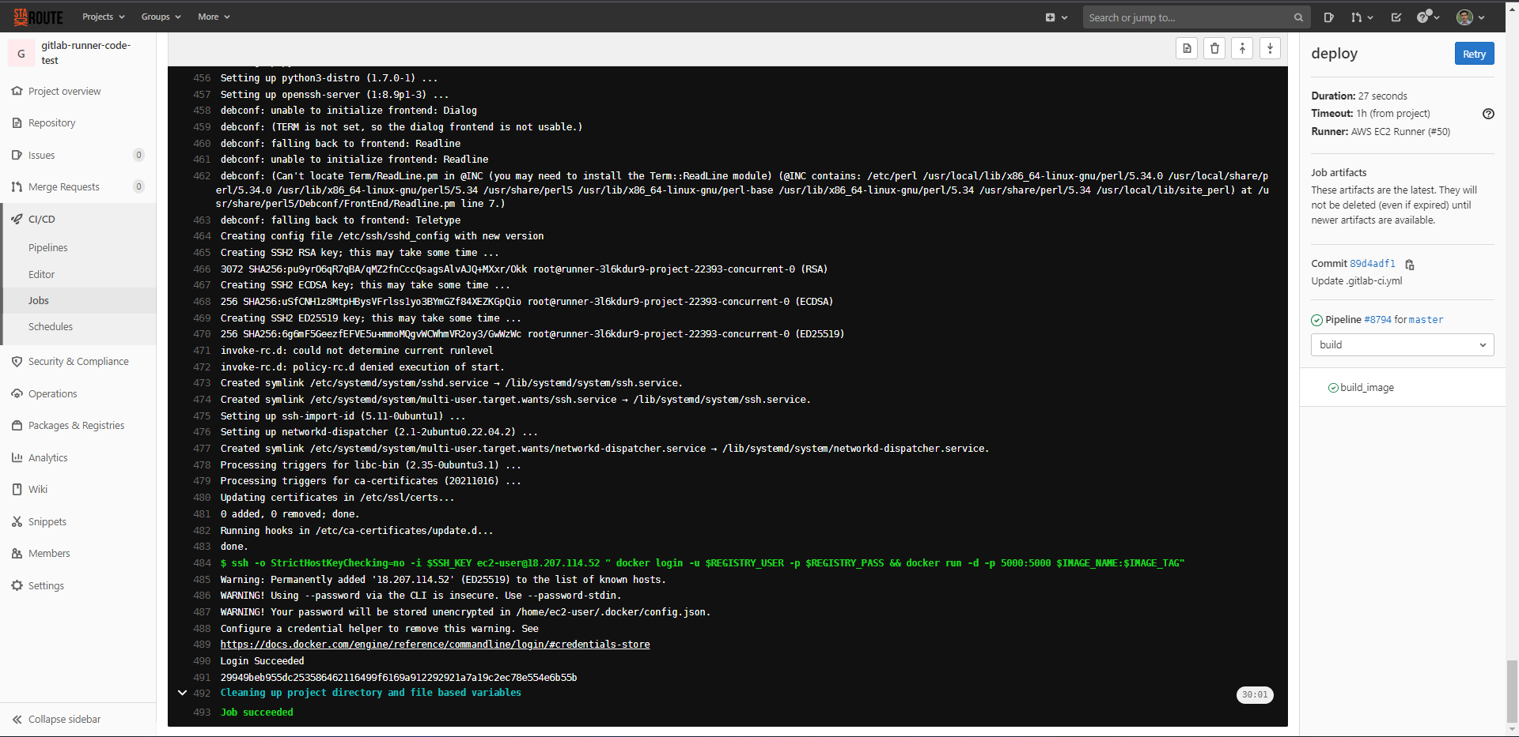

Deploy job Log
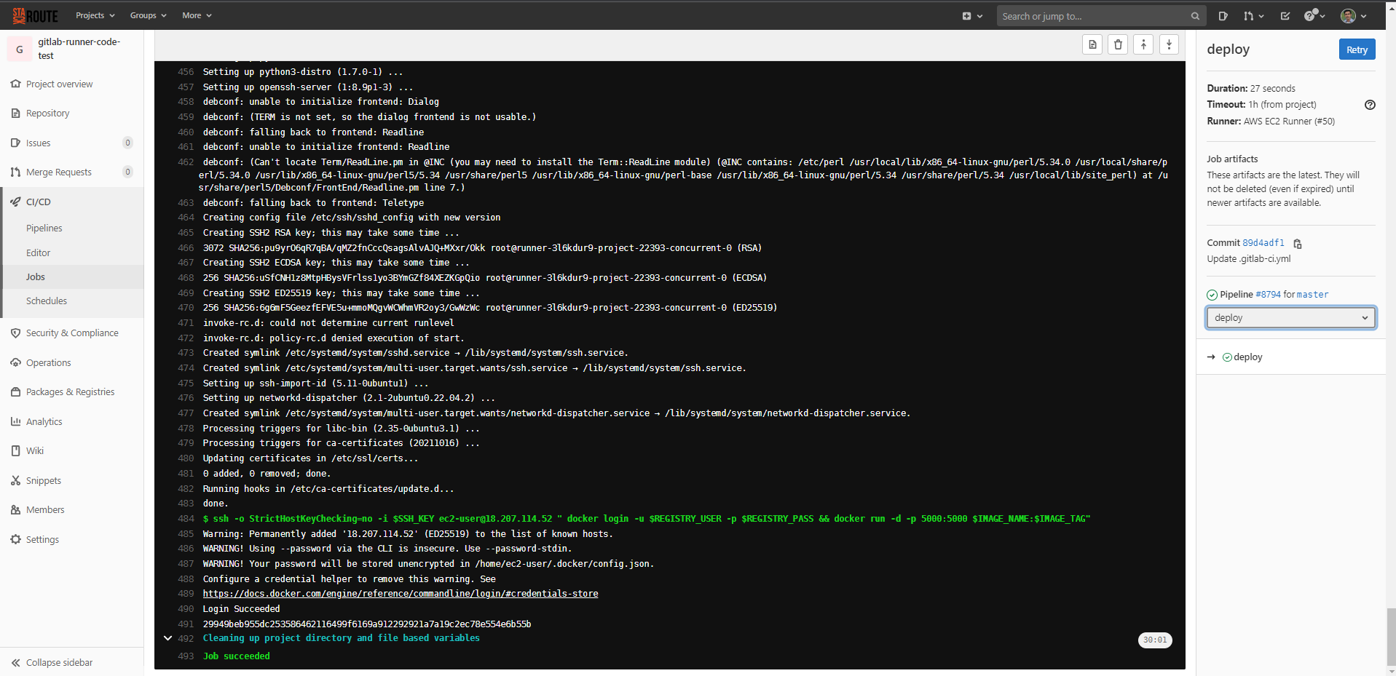
Container running in GitLab-runner (EC2 Instance)
Final Output
