|  |
| --- |
| **MACHINE LEARNING MODEL DEPLOYMENT WITH IBM CLOUD WATSON STUDIO (NAAN MUDHALVAN PHASE-2 CAD)** |

We have decided to deploy a Disease Prediction Algorithm using IBM Cloud Watson Studio. Our goal is to design, develop, and deploy an intelligent disease prediction algorithm that leverages the capabilities of IBM Cloud Watson Studio, a robust and versatile platform at the forefront of data-driven innovation. This document outlines our approach, strategy, and roadmap to realize this vision.

**INTRODUCTION:**

This approach revolutionizes the deployment of disease prediction machine learning models using IBM Cloud Watson Studio. By infusing innovation at every step, from model training and integration to seamless deployment and user-friendly application integration, we have created a transformative pathway. We've found a new and really smart way to use computers to guess if someone might get sick. Our goal is to make this technology as accurate as possible, so it can really help doctors and people. It's like having a super assistant that aims in helping the people to recognize their disease and to stay healthy. It will be easy to use so that any type of people can use it without any difficulties.

**STEPS INVOLVED IN DEPLOYING A DISEASE PREDICTION MACHINE LEARNING MODEL IN IBM CLOUD WATSON:**

Deploying a disease prediction machine learning model on IBM Cloud Watson Studio involves several steps, including training the model, saving it in a format compatible with Watson Studio, creating a Watson Machine Learning instance, and finally deploying the model.

**STEP 1:** **Train and Save the Machine Learning Model**

TRAIN THE MACHINE LEARNING MODEL:

* Download the disease prediction dataset and load the dataset for training the model (<https://www.kaggle.com/datasets/kaushil268/disease-prediction-using-machine-learning> - Link for the dataset).
* Choose a machine learning algorithm suitable for disease prediction (e.g., logistic regression, decision trees, and random forests).
* Train the model using a dataset with features relevant to disease prediction.

SAVE THE MODEL:

* Save the trained machine learning model in a format compatible with Watson Machine Learning. For example, we can save it as a pickle file (.pkl).

**STEP 2:** **Prepare the Model for Deployment**

INSTALL NECESSARY LIBRARIES:

* Ensure whether the required libraries installed to work with the model and prepare it for deployment (e.g., scikit-learn, pandas).

LOAD THE TRAINED MODEL:

* Load the trained machine learning model using the appropriate library.

PREPARE DATA PRE-PROCESSING STEPS:

* If there were any preprocessing steps (e.g., scaling, encoding) applied during training, make sure to replicate these steps for new data during deployment.



**STEP 3: Set Up IBM Cloud Watson Studio**

CREATE AN IBM WATSON STUDIO PROJECT:

* Log in to IBM Cloud and access Watson Studio.
* Create a new project, defining the necessary resources (such as storage and compute) for the project.

**STEP 4: Deploy the Model on Watson Machine Learning**

SET UP WATSON MACHINE LEARNING:

* Navigate to the IBM Cloud Dashboard and create a Watson Machine Learning service instance.

SAVE THE MODEL TO WATSON MACHINE LEARNING:

* Save the trained model to Watson Machine Learning using the Watson Machine Learning Python client or APIs.

DEPLOY THE MODEL:

* Deploy the model from Watson Machine Learning to create an API endpoint for making predictions.

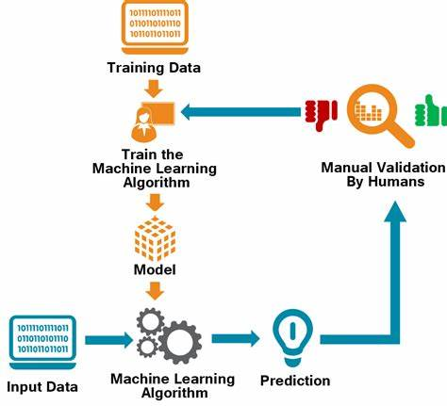**STEP 5: Test the Deployed Model**

ACCESS THE MODEL ENDPOINT:

* Obtain the endpoint for the deployed model from Watson Machine Learning.

TEST THE MODEL:

* Send sample input data to the model's endpoint and observe the predictions.

**STEP 6: INTEGRATE WITH THE APPLICATION**

* Integrate the model endpoint into a application, allowing it to make predictions based on the disease prediction model.

**CONCLUSION:**

These are the detailed steps that are involved in the deploying the disease prediction machine learning algorithm with IBM cloud watson studio.