High-5 CPU Manual

Introduction:
This is a non-pipelined RISCV processor implementing RV32IM instruction set. It follows Harvard architecture with separate memories for instruction and data. The memory interface is currently primitive, with a direct one to one connection. It has three stages, namely – Fetch, Decode and Execute. The Write back stage is combined within the Execute stage but if needed, could be separated as the fourth stage. Currently the execute stage takes two and the others take one cycle each, making the instruction cycle to be four cycles long. Each stage is registered and hence can be scaled to a 4-stage pipelined processor. It has a 64-bit counter to count the number of cycles that has passed since starting it. It also has an UART Tx block which can be used to print a section of the data memory onto a PC terminal. A total of 7 Control Status Registers are implemented.
It is synthesized and implemented on an Artix-7 FPGA ( Arty-a7 35T development board).
It runs at a maximum frequency of 100Mhz utilizing 1160 LUTs. A program to calculate the first 10 numbers of fibonacci series and print the results through UART to PC terminal, incorporating Branches, Loads, stores, addition, Multiplication and CSR instructions was written and tested successfully. The screen grab of the terminal is shown below.

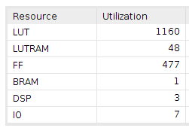

Fig 1: Resource Utilization on Artix-7 FPGA
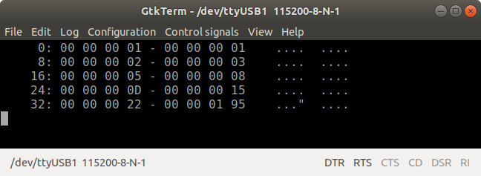
Fig 2: Terminal output of the fiboannci series program, printing the first ten numbers in hexadecimal.

The cycle counter value is printed at the end – (0x195) or 405 . This depicts the number of cycles taken to complete the program.

Block Diagram:

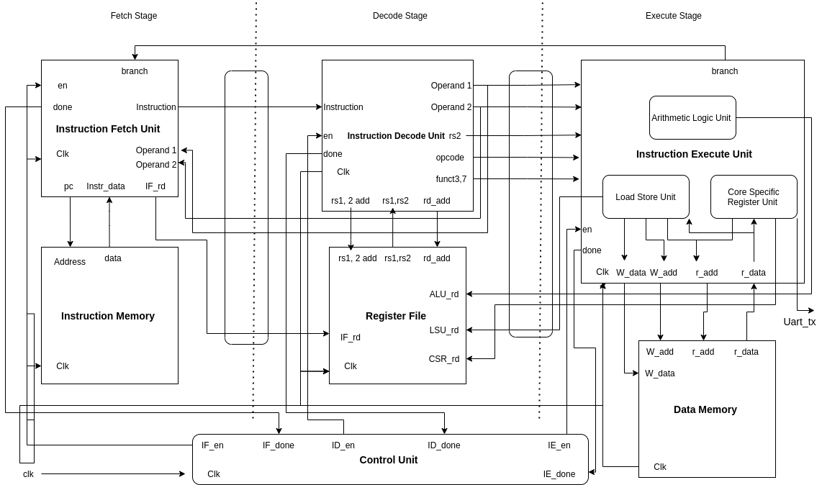

Control Status Registers
Cycle_L :
Address : 0xC00
Lower word of the 64-bit cycle counter

Cycle_H :
Address : 0xC80
Higher word of the 64-bit cycle counter

Timer_CON :
Address : 0xC01
Configuration register for cycle counter .
Bit 0 : 1 – starts the counter
0 – stops the counter
Bit 4 : 1 – resets the counter

SYS_CON :
Address : 0xCC0
System Control register
Bit 0 : 1 – halts the cpu
0 – releases the halt

EXT_CTL_CON :
Address : 0xCE0
Configuration register for the UART block
Bit 0 : 1 – starts the transmission
0 – stops the transmission
Bit 4 : 1 – transmission complete – set by hardware. Read only bit

Transfer_Start_Address:
Address: 0xCE1
Starting address of the Data memory region to be transmitted

Transfer_End_Address:
Adress : 0xCE2:
End address of the Data memory region to be trasmitted.

