*&---------------------------------------------------------------------*  
*& Report ZHARI_ALV_MERGE_FIELD  
*&---------------------------------------------------------------------*  
*&  
*&---------------------------------------------------------------------*  
REPORT ZHARI_ALV_MERGE_FIELD NO STANDARD PAGE HEADING LINE-COUNT 20(3) LINE-SIZE 360 MESSAGE-ID zhari_errmsg.  
  
load-of-program.  
include zhari_alv_mrgfld_inc_top.  
  
select-options s_aufnr for lv_aufnr obligatory.  
initialization.  
  clear : it_aufk.  
  s_aufnr-low = 1.  
  s_aufnr-high = 69.  
  append s_aufnr.  
  
  
at selection-screen on s_aufnr.   " 1 to 100  
  
  select single aufnr  
    into lv_aufnr  
     from ZHARI_EX_AUFK  
     where aufnr in s_aufnr.  
  
  if sy-subrc eq 0.  
    message s000.  " se91 - tcode.  
  else.  
    message e001.  " se91 - tcode.  
  endif.  
  
  
  
start-of-selection.  
  perform alv_vbak_fieldcat.  
  
  perform getData_vbak.  
  
end-of-selection.  
  
  perform dispData_vbak.  
  
  
  
  
*&---------------------------------------------------------------------*  
*& Form getData_vbak  
*&---------------------------------------------------------------------*  
*& text  
*&---------------------------------------------------------------------*  
*& -->  p1        text  
*& <--  p2        text  
*&---------------------------------------------------------------------*  
FORM getData_vbak .  
  
  select aufnr auart autyp werks  
    from ZHARI_EX_AUFK  
    into table it_aufk  
    where aufnr in s_aufnr.  
  
  if sy-subrc = 0.  
    MESSAGE s000.  
  else.  
    message e001.  
  endif.  
  
ENDFORM.  
*&---------------------------------------------------------------------*  
*& Form dispData_vbak  
*&---------------------------------------------------------------------*  
*& text  
*&---------------------------------------------------------------------*  
*& -->  p1        text  
*& <--  p2        text  
*&---------------------------------------------------------------------*  
FORM dispData_vbak .  
  
  CALL FUNCTION 'REUSE_ALV_GRID_DISPLAY'  
   EXPORTING  
*     I_INTERFACE_CHECK                 = ' '  
*     I_BYPASSING_BUFFER                = ' '  
*     I_BUFFER_ACTIVE                   = ' '  
      I_CALLBACK_PROGRAM                = SY-REPID  
*     I_CALLBACK_PF_STATUS_SET          = ' '  
*     I_CALLBACK_USER_COMMAND           = ' '  
*     I_CALLBACK_TOP_OF_PAGE            = ' '  
*     I_CALLBACK_HTML_TOP_OF_PAGE       = ' '  
*     I_CALLBACK_HTML_END_OF_LIST       = ' '  
*     I_STRUCTURE_NAME                  =  
*     I_BACKGROUND_ID                   = ' '  
*     I_GRID_TITLE                      =  
*     I_GRID_SETTINGS                   =  
*     IS_LAYOUT                         =  
     IT_FIELDCAT                       = LT_FIELDCAT  
*     IT_EXCLUDING                      =  
*     IT_SPECIAL_GROUPS                 =  
*     IT_SORT                           =  
*     IT_FILTER                         =  
*     IS_SEL_HIDE                       =  
*     I_DEFAULT                         = 'X'  
*     I_SAVE                            = ' '  
*     IS_VARIANT                        =  
*     IT_EVENTS                         =  
*     IT_EVENT_EXIT                     =  
*     IS_PRINT                          =  
*     IS_REPREP_ID                      =  
*     I_SCREEN_START_COLUMN             = 0  
*     I_SCREEN_START_LINE               = 0  
*     I_SCREEN_END_COLUMN               = 0  
*     I_SCREEN_END_LINE                 = 0  
*     I_HTML_HEIGHT_TOP                 = 0  
*     I_HTML_HEIGHT_END                 = 0  
*     IT_ALV_GRAPHICS                   =  
*     IT_HYPERLINK                      =  
*     IT_ADD_FIELDCAT                   =  
*     IT_EXCEPT_QINFO                   =  
*     IR_SALV_FULLSCREEN_ADAPTER        =  
*     O_PREVIOUS_SRAL_HANDLER           =  
*     O_COMMON_HUB                      =  
*   IMPORTING  
*     E_EXIT_CAUSED_BY_CALLER           =  
*     ES_EXIT_CAUSED_BY_USER            =  
    TABLES  
      t_outtab                          = IT_AUFK  
*   EXCEPTIONS  
*     PROGRAM_ERROR                     = 1  
*     OTHERS                            = 2  
            .  
  IF sy-subrc <> 0.  
* Implement suitable error handling here  
  ENDIF.  
  
  
  
  
ENDFORM.  
*&---------------------------------------------------------------------*  
*& Form alv_vbak_fieldcat  
*&---------------------------------------------------------------------*  
*& text  
*&---------------------------------------------------------------------*  
*& -->  p1        text  
*& <--  p2        text  
*&---------------------------------------------------------------------*  
FORM alv_vbak_fieldcat .  
  
  CALL FUNCTION 'REUSE_ALV_FIELDCATALOG_MERGE'  
   EXPORTING  
     I_PROGRAM_NAME               = sy-repid  
     I_INTERNAL_TABNAME           = 'IT_AUFK'  
     I_STRUCTURE_NAME             = 'ZHARI_EX_AUFK_STR'  
*     I_CLIENT_NEVER_DISPLAY       = 'X'  
*     I_INCLNAME                   =  
*     I_BYPASSING_BUFFER           =  
*     I_BUFFER_ACTIVE              =  
    CHANGING  
      ct_fieldcat                  = LT_FIELDCAT  
   EXCEPTIONS  
     INCONSISTENT_INTERFACE       = 1  
     PROGRAM_ERROR                = 2  
     OTHERS                       = 3  
            .  
  IF sy-subrc <> 0.  
* Implement suitable error handling here  
  ENDIF.  
  
  
ENDFORM.

Global Structure:

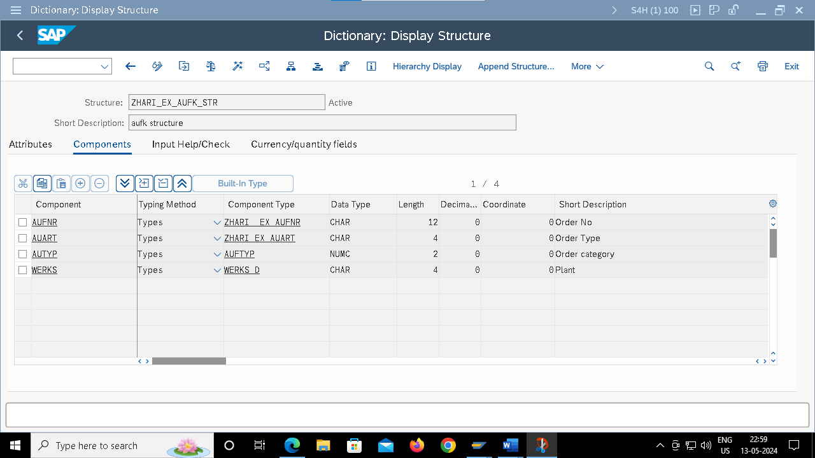

Output:

