# **2015:**

# **1. Fractional Hedonic Games: Individual and Group Stability:**

Fractional hedonic games (FHGs) is a subclass of hedonic games in which every agent is assumed to have cardinal utilities or valuations for the other agents. These induce preferences over coalitions by considering the average valuation for the members of every coalition. In this paper, existence and complexity of various stability concepts such as core stability, nash stability and individual stability of fractional hedonic games is dealt.

Definitions:

* Mathematical Definition of Fractional Hedonic Games: A hedonic game (N, >~) is said to be a fractional hedonic game (FHG) if, for every agent i in N, there is a valuation function vi such that for all coalitions S, T ∈ Ni, S >~i T if and only if vi(S) ≥ vi(T).
  + An FHG is symmetric if vi(j) = vj(i) for all i, j ∈ N.
  + An FHG is simple if vi(j) ∈ {0, 1} for all i, j ∈ N.
* We say that a coalition S ⊆ N blocks a partition π, if every agent i ∈ S strictly prefers S to his current coalition π(i), i.e., if S ­>~i π(i) for all i ∈ S. A partition that is not blocked by any coalition is core stable (CS).
* A partition π is Nash stable (NS) if no agent can beneﬁt from joining another (possibly empty) coalition, i.e., if π(i) >~i S ∪{i} for all S ∈ π∪{∅} and i ∈ N.
* A partition π is individually stable (IS) if no agent can beneﬁt from joining another (possibly empty) coalition without making some member of the coalition he joins worse oﬀ, i.e., if π(i) >~i S ∪{i} or S ­>j S ∪{i} for some j ∈ S for all S ∈ π∪{∅} and i ∈ N.
* For a stability notion **E** ∈ {CS, NS,IS}, the decision problem (SYMM)FHG-**E** is given by a (symmetric) FHG (N, >~). The answer to (SYMM)FHG-**E** is “Yes” if there is an **E** -stable partition in (N, >~) and “No” otherwise.

Results:

* In unrestricted FHGs, core stable, Nash stable, or individually stable partitions may not exist.
* In symmetric FHGs, core stable or Nash stable partitions may not exist.
* In simple symmetric FHGs, core stable partitions may not exist.
* It is coNP-complete to decide whether a given proﬁle of valuation functions induces strict preferences over coalitions.
* The following hardness results hold:

1. SYMMFHG-CS is NP-hard,
2. SYMMFHG-NS is NP-complete, and
3. FHG-IS is NP-complete.

Open Problems:

* Check if connection between the existence of stable partitions and the hardness of ﬁnding stable partitions can be made more precise and extended to more general class of hedonic games.
* Find more natural classes for which the existence of stable partitions is guaranteed.
* Existence of individually stable partitions in symmetric FHGs remains an open problem.
* 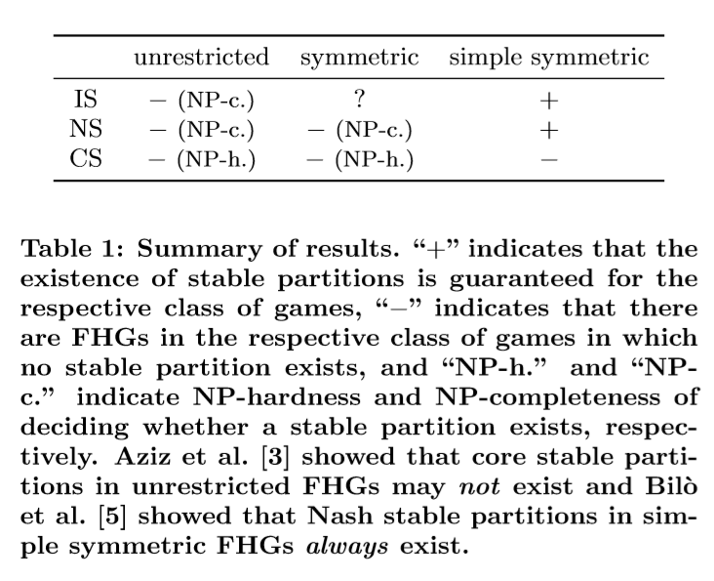

# **2. On the Price of Stability of Fractional Hedonic Games:**

We consider fractional hedonic games, where self-organized groups (or clusters) are created as a result of the strategic interactions of independent and selﬁsh players and the happiness of each player in a group is the average value she ascribes to its members. We adopt Nash stable outcomes, that is states where no player can improve her utility by unilaterally changing her own group, as the target solution concept. We study the quality of the best Nash stable outcome and refer to the ratio of its social welfare to the one of an optimal clustering as to the price of stability. We remark that a best Nash stable outcome has a natural meaning of stability since it is the optimal solution among the ones which can be accepted by selﬁsh users.

Acronyms and Definitions:

* Price of Stability (PoS): ratio of value of best Nash equilibrium to value of optimal solution
* Price of Anarchy (PoA): ratio of value of worst Nash equilibrium to the value of optimal solution
* G (G): Fractional Hedonic Game represented by Graph G
* SW(C) = Σu∈V Pu(C) where SW(C) is social welfare functional value of cluster C and Pu(C) is payoff of player u in cluster C.
* k-Strong Nash Stable Clustering: a clustering C is k-Strong Nash stable (or is a k-Strong Nash equilibrium) if, for each C’ obtained from C when at most k players jointly change their strategies, it holds that Pu(C) ≥ Pu(C’) for some u belonging to the set of deviating players, that is, there always exists a player not improving her utility after the joint collective deviation.
* NSCk(G (G)): set of k-Strong Nash stable clusterings of G (G).
* Star clustering: A star clustering C = (C1, ..., Cn) for G (G) is a clustering such that Ci is a star for each i ∈ [n].
* Optimal Star Clustering: An optimal star clustering for G (G) is a star clustering for G (G) of maximum social welfare.
* A fractional assignment of leaves (to stars centered at V ∗) is a function f : C* \ V* ×[p] → R≥0 such that

1. Σi ∈ [p] f(u, i) = 1 for each u ∈ C* \ V*,
2. Σu ∈ C*\V* f(u, i) > 0 for each i ∈ [p].

Results:

* For any graph G and index k ≥ 1, PoS(G (G)) ≤ PoAk(G (G)).
* For any E > 0, there exists a graph GE such that PoS(G (GE)) > 2−E.
* For any fractional hedonic game G (G) such that NSC2(G (G)) != ∅, PoS(G (G)) ≤ 4.
* There exists a graph G such that NSC2(G (G)) = ∅.
* Let C be a star clustering for G (G). For any node u ∈ V and k ∈ [n] such that |C(u)| > |Ck| + 1 and (C, u, k) is a star clustering for G, it holds that SW(C, u, k) > SW(C).
* Let G be a triangle-free graph, then any optimal star clustering for G (G) is Nash stable.
* For any triangle-free graph G, PoS(G (G)) ≤ 4.
* For any bipartite graph G, PoS(G (G)) ≤ 6(3 −2√2) ≈ 1.0294.
* There exists a bipartite graph G such that PoS(G (G)) > 1.003.

Open Problems:

* Reduce the subtle gap between the lower and the upper bound on the price of stability in bipartite graphs, thus getting its exact value.
* Providing suitable bounds for more general classes of graphs and better understanding the structure of equilibria for unrestricted topologies.

# **3. Representing and Solving Hedonic Games with Ordinal Preferences and Thresholds:**

We propose a new representation setting for hedonic games, where each agent partitions the set of other agents into friends, enemies, and neutral agents, with friends and enemies being ranked. Under the assumption that preferences are monotonic (respectively, anti-monotonic) with respect to the addition of friends (respectively, enemies), we propose a bipolar extension of the Bossong–Schweigert extension principle and use this principle to derive the (partial) preferences of agents over coalitions. Then, for a number of solution concepts, we characterize partitions that necessarily (respectively, possibly) satisfy them, and identify the computational complexity of the associated decision problems. Alternatively, we suggest cardinal comparability functions in order to extend to complete preference orders consistent with the generalized Bossong– Schweigert order.

Definitions:

* The individually rational encoding: Each agent ranks only the coalitions she prefers to herself being alone.
* The additive encoding: Each agent gives a valuation (positive or negative) of each other agent; preferences are additively separable, and the extension principle is that the valuation of a set of agents, for agent i, is the sum of the valuations i gives to the agents in the set (and then the preference relation is derived from this valuation function).
* The “friends and enemies” encoding: Each agent partitions the set of other agents into two sets (her friends and her enemies); under the friend-oriented preference extension, coalition X is preferred to coalition Y if X contains more friends than Y, or as many friends as Y and fewer enemies than Y; under the enemy-oriented preference extension, X is preferred to Y if X contains fewer enemies than Y, or as many enemies as Y and more friends than Y.
* The singleton encoding: Each agent ranks only single agents; under the optimistic (respectively, pessimistic) extension, X is preferred to Y if the best (respectively, worst) agent in X is preferred to the best (respectively, worst) agent in Y.
* The anonymous encoding: Each agent speciﬁes only a preference relation over the number of agents in her coalition (and does not care about the identities of these agents).
* Hedonic coalition nets: Each agent speciﬁes her utility function over the set of all coalitions via (more or less) a set of weighted logical formulas.
* Fractional hedonic games: Each agent assigns a value to each other agent (and 0 to herself); an agent’s utility of a coalition is the average value she assigns to the members of the coalition. A coalition X is preferred to Y if the utility of X is greater than that of Y.
* A coalition structure Γ is called
  + Perfect: if each player i weakly prefers Γ(i) to every other coalition containing i,
  + Individually rational: if each player i ∈ A weakly prefers Γ(i) to being alone in{i},
  + Nash stable: if for each player i ∈ A, Γ(i) >~i A’∪{i} holds for each coalition A’ ∈ Γ∪Φ,
  + Individually stable: if for each player i ∈ A and for each coalition A’ ∈ Γ∪Φ, it holds that Γ(i) >­~i A’∪{i} or there exists a player j ∈ A’ such that A’ >­j A’∪{i},
  + Contractually individually stable: if for each player i ∈ A and for each coalition A’ ∈ Γ∪Φ, it holds that Γ(i) >~i A’∪{i}, or there exists a player j∈A’ such that A0’ >j A’∪{i}, or there exists a player j’ ∈ Γ(i) such that Γ(i)­ >j’ Γ(i)\{i}.
* Let A = {1, 2, ..., n} be a set of agents. For each i ∈ A, a weak ranking with double threshold for agent i, denoted by Δi+0−, consists of a partition of A\{i}into three sets:
  + A­i+ (i’s friends), together with a weak order Δi+0− over Ai+,
  + Ai- (i’s enemies), together with a weak order Δi+0− over Ai-, and
  + Ai0 (the neutral agents, i.e., the agents i does not care about).
* Let Δi+0− be a weak ranking with double threshold for agent i. The extended order Δi+0− is deﬁned as follows: For every X,Y ⊆A, X >~i+0− Y if and only if the following two conditions hold:

1. There is an injective function σ from Y ∩ Ai+ to X ∩ Ai+ such that for every y ∈ Y ∩ Aii , we have σ(y) Δi y.
2. There is an injective function θ from X ∩ Ai- to Y ∩ Ai- such that for every x ∈ X ∩ Ai- , we have x Δi θ(x).

Finally, X ­>~i+0− i Y if and only if X >~i+0− Y and not (Y >~i+0− X).

* A complete preference relation >~i over all coalitions containing i extends >~i+0− if and only if it contains it; that is, if C >~i+0− D implies C >~i D for all coalitions C, D. Let Ext(>~i+0−) be the set of all complete preference relations extending >~i+0−.
* An FEN-hedonic game is a tuple H = <A, Δ1+0−, ..., Δn+0−>, where A ={1, 2, ..., n} is a set of players, and Δi+0− gives the ordinal preferences with thresholds of player i ∈ A as defined in above definitions.
* Let α be a stability concept for hedonic games, <A, Δ1+0−, ..., Δn+0−> be a FEN-hedonic game and Γ be a coalition structure. Γ satisﬁes possible α if and only if there exists a proﬁle <>~1, …., >~n> in Ext(Δi+0−) such that <A, >~1, …., >~n> satisﬁes α. Γ satisﬁes necessary α if and only if for each <>~1, …., >~n> in Ext(Δi+0−), <A, >~1, …., >~n> satisﬁes α.
* Let A be a set of players and Δi+0− be player i’s preference relation. Let wi : A → Z, compatible with Δi+0−, assign n points to each agent in Ai, 1+, n−1 points to each agent in Ai, 2+, ..., and n-l+1 points to each agent in Ai, l+. Moreover, let each agent in Ai, m- get −n points, each agent in Ai, m−1- get −n+1 points, ..., and each agent in Ai, 1- get −(n−m+1) points. Then, we call wi strongly friend-optimistic and strongly enemy-pessimistic.
* For each ﬁxed agent i ∈ A and for every ﬁxed choice of scoring vectors wi, the Borda-like CF

fBordai : { C ⊆ A | i ∈ C} → Z maps every coalition C containing i to the sum of the scores the agents in C obtain from wi. The value of a coalition C ⊆ A is deﬁned as FBorda(C) =∑i∈C fBordai(C).

Results:

* Consider a FEN-hedonic game <A, Δ1+0−, ..., Δn+0−>

1. A coalition structure Γ is (necessarily and possibly) perfect if and only if for each player i, Ai+⊆Γ(i) and Ai-∩Γ(i) = Φ2.
2. A coalition structure Γ is possibly individually rational if and only if for each i ∈ A, Γ(i) contains at least a friend of i’s or only neutral agents.
3. A coalition structure Γ is necessarily individually rational if and only if for each i ∈ A, Γ(i) does not contain any enemies of i’s.
4. A coalition structure Γ is necessarily individually stable if and only if it is necessarily individually rational and no player i can join a coalition that she would possibly prefer and the members of which do not see her as an enemy.

* All problems regarding perfection are in P.
* The veriﬁcation problem for possible Nash stability is in P.
* The problem of whether there exists a possibly Nash stable coalition structure in a given FEN-hedonic game is NP-complete.
* For each player i ∈ A, the comparability function fBordai preserves those rankings that are induced by the Bossong–Schweigert extension. Furthermore, a game that is induced by comparability function FBorda (as an extension) is additively separable.

Open Problems:

* Introducing the notion of partition correspondences with the purpose to actually identify “good” coalition structures as an output. In contrast to the original idea of hedonic games where coalitions form in a decentralized manner, here a central correspondence is used, in order to decide which coalitions will work together. This might, for example, be the case in a setting where the head of a department has to divide a group of employees into teams. The teams should be stable, in the sense that the team members are as happy as possible with their group to create a good working atmosphere.

# **4. Simple Causes of Complexity in Hedonic Games:**

In this paper, we identify simple conditions on expressivity of hedonic games that are sufﬁcient for the problem of checking whether a given game admits a stable outcome to be computationally hard.

Acronyms and Definitions:

* C: polynomially representable class of hedonic games
* CR: core stability
* NS: nash stability
* SCR: strict core stability
* SNS: strict nash stability
* IS: individual stability
* α-EXISTENCE FOR C
  + Instance: Game <N, (>~i)i∈N> from C in its binary encoding.
  + Question: Is there anα-stable partition π of N?
* Individually Rational Coalition Lists (IRCL): Represent a hedonic game by listing the agent preferences >~i explicitly from best to worst, but cutting the list off after the entry {i}. This representation is complete, but not always succinct.
* Hedonic Coalition Nets: Rule-Based representation for hedonic games in which agents’ preferences are described by weighted boolean formulas.
* W-preferences: Hedonic games where each agent ﬁrst ranks all other agents and then compares coalitions based on their worst member under this ranking.
* WB-preferences: Hedonic games where agents rank coalitions according to their worst member, but break ties in favor of the coalition with better best member.
* W- and B-hedonic games: In these two classes of games, agents rank coalitions according to their worst or best member, but coalitions containing an enemy are not individually rational.

Results:

* CR-EXISTENCE FOR C is NP-hard if for all N and every mutual collection of orderings (>~i)i∈N in which each agent has at most 3 friends, there is a game <N,( >~i)i∈N> ∈ C that is consistent on pairs, {0-1}-toxic and weakly {1-1,2-2} - toxic with respect to (>~i)i∈N.
* NS- and IS-EXISTENCE FOR C are NP-complete if for all N and every strict and mutual collection of orderings (>~i)i∈N in which each agent has at most 3 friends, there is a game <N, (>~i)i∈N> ∈ C that is consistent on pairs and strictly {0-1,1-1,2-5}-toxic with respect to (>~i)i∈N.
* CR- and SCR-EXISTENCE FOR C are NP-hard if for all N and every collection of strict and mutual orderings (>~i)i∈N in which each agent has at most 4 friends, there is a game <N, (>~i)i∈N> ∈ C that is consistent on pairs, triangle appreciating, monotone on triangles, {0-1}-toxic, weakly {1-1,2-2,3-3}-toxic, and intolerant in triangles with respect to (>~i)i∈N.
* Additively Separable Games(ASGs): In these games, preferences are given by S >~i T iff ∑j∈S vi(j) > ∑j∈T vi(j).
* Fractional Hedonic Games (FHGs). In these games, preferences are given by S >~i T iff 1/|S|∑j∈Svi(j) > 1/|T|∑j∈T vi(j).
* Social FHGs. An FHG is social if agents’ utilities for each other are non-negative.
* Median Games: Agents evaluate coalitions according to their median value, which in odd-size coalitions is the middle element, and in even-size coalitions is the mean of the middle two elements.
* Geometric Mean Games: In these games agents evaluate coalitions according to the geometric mean (∏vi(j))1/|S| of member utilities.
* Nash Product Games: This is the class of games that are ‘multiplicatively separable’; agents evaluate coalitions according to ∏j∈Svi(j).
* Midrange (1/2B+ 1/2W): In this case, agents evaluate a coalition by averaging the maximum and minimum utility in it.
* r-Approval: Starting with cardinal utilities, sum the (up to) r highest elements of a coalition.
* 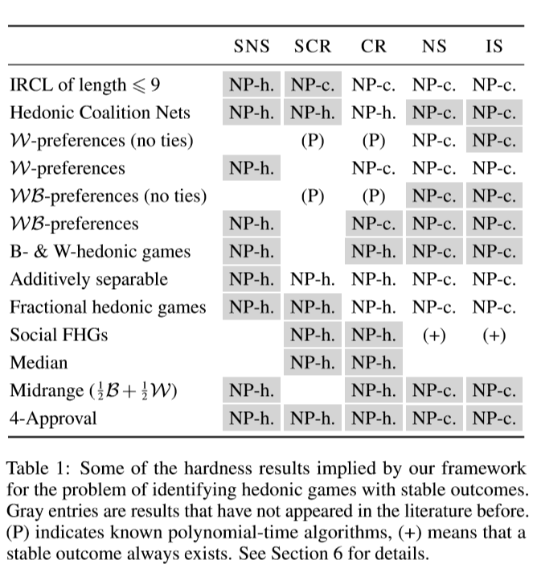

Open Problems:

* Extend the above framework to deal with notions of stability that are based on group deviations which is often coNP-complete.
* Check whether our framework can be extended from NP-hardness proofs to Σ2p-hardness proofs.

# **5. Welfare Maximization in Fractional Hedonic Games:**

We consider the computational complexity of computing welfare maximizing partitions for fractional hedonic games- a natural class of coalition formation games that can be succinctly represented by a graph. For such games, welfare maximizing partitions constitute desirable ways to cluster the vertices of the graph. We present both intractability results and approximation algorithms for computing welfare maximizing partitions.

Acronyms and Definitions:

* Utilitarian maximization: maximizing sum of utility of players
* Egalitarian Maximization: maximizing utility of worst off agent
* Nash Welfare Maximization: maximizing product of utility of players

Results:

* For simple symmetric FHGs, UTILITARIAN WELFARE and EGALITARIAN WELFARE are both NP-hard.
* For simple symmetric FHGs, NASH WELFARE is NP-hard.
* For simple symmetric FHGs, UTILITARIAN WELFARE has a linear-time 4-approximation algorithm.
* For simple symmetric FHGs, UTILITARIAN WELFARE has an O(|N0.5|E|)-time 2-approximation algorithm.
* For symmetric FHGs, UTILITARIAN WELFARE has a polynomial-time 4-approximation algorithm.
* For simple symmetric FHGs, EGALITARIAN WELFARE has a polynomial-time 3-approximation algorithm.
* 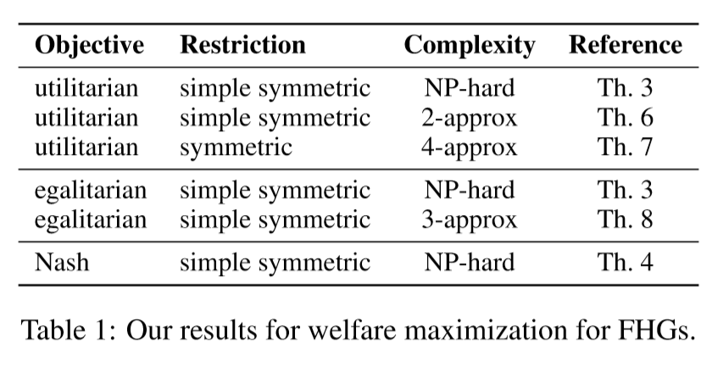

Open Problems:

* Check whether one can obtain ﬁxed parametrized tractable results for parameter treewidth.
* Check whether there are similar approximation bounds (as we did for utilitarian and egalitarian welfare) for maximum Nash welfare and better bounds for utilitarian and egalitarian welfare