# **2016:**

### **1. Complexity of Hedonic Games with Dichotomous Preferences:**

Dichotomous Hedonic Games are hedonic games in which each agent either approves or disapproves of a given coalition. In this work, we study the computational complexity of questions related to ﬁnding optimal and stable partitions in dichotomous hedonic games under various ways of restricting and representing the collection of approved coalitions.

Definitions:

* Lists: In a context in which it is sensible to presume that agents will only approve at most polynomially many coalitions, we can represent their preferences by merely listing all approved coalitions. The complexity of stability problems for lists in the non-dichotomous case is studied by Ballester (2004). We consider here an even more restricted variant: in the k-list representation, every agent submits a list of at most k approved coalitions.
* Anonymous Preferences:

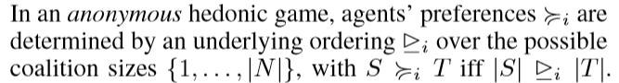

* Roommates: Consider the restriction of dichotomous hedonic games where agents only approve coalitions of size at most 2. This case could also be referred to as a (stable) roommate problem with dichotomous preferences.
* Majority Games: Consider agents that approve those coalitions in which the agent is friends with majority of members.

Results:

* Every dichotomous hedonic game admits a partition that is both core-stable and individually stable.
* For every dichotomous hedonic game, we can ﬁnd an individually stable partition in O(n3) calls to an oracle that decides whether a given coalition S ⊆ N is approved by a given agent i ∈ N.

Algorithm 1 finds an individually stable partition in O(n3). Note that the while loop executes at most n times, since each agent is assigned only once.

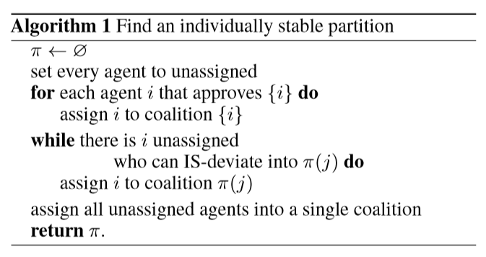

* It is FNP-hard to ﬁnd a core-stable partition in a boolean hedonic game.
* It is coNP-complete to decide whether a given partition π is core-stable in a boolean hedonic game.
* Maximizing social welfare is NP-complete even for 1-lists.
* Deciding existence of a strict-core-stable partition is NP-complete even for 1-lists.
* Finding a perfect partition or a Nash-stable partition is easy for 2-lists.
* Deciding existence of a perfect partition or a strict-core-stable partition is NP-complete for 3-lists.
* The problems of deciding existence of a perfect, a strict-core-stable, or a Nash-stable partition are NP-complete for anonymous preferences, even if at most 4 sizes are approved.
* If every agent only approves intervals, we can ﬁnd a welfare-maximizing partition in polynomial time.
* Deciding the existence of a Nash stable partition for dichotomous roommates is NP-complete, even in the bipartite (marriage) case, and even if each agent approves at most 4 coalitions.
* In a majority game, a partition that is both Nash-stable and core-stable is guaranteed to exist and can be found in polynomial time.
* Let δ(G) be minimum degree of G where G is graph representing majority game with n agents. Then if δ(G) >= n/2 then G is Hamiltonian.
* Let Δ(G) be maximum degree of G where G is graph representing majority game with n agents. If Δ(G) <= k−1 then G has an equitable k-colouring.
* If G is a graph with δ(G) >= n/2 then the vertices of G can be partitioned into edges and triangles.
* In majority games, perfect and strict-core stable partitions coincide. If a perfect partition exists, then a perfect partition consisting of edges and triangles exists. Hence there is a polynomial time algorithm which will produce a perfect and strict-core-stable partition if it exists.

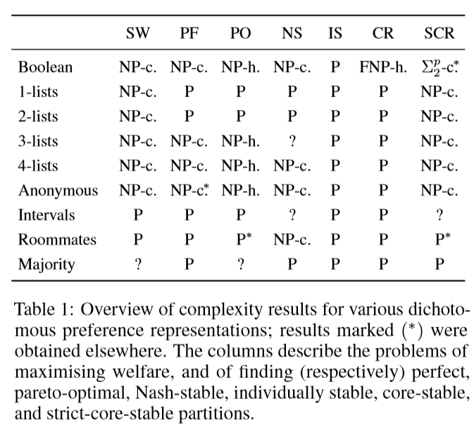

Open Problems:

* Settle the ‘frontier of tractability’ for Nash-stability in k-lists.
* Decide the existence of Nash and strict-core-stable partitions in the interval case.
* Empirical evaluation of the power of boolean hedonic games when solved by modern SAT solvers.

# **2. Graphical Hedonic Games of Bounded Tree width:**

Hedonic games are a well-studied model of coalition formation, in which selﬁsh agents are partitioned into disjoint sets and agents care about the make-up of the coalition they end up in. The computational problems of ﬁnding stable, optimal, or fair outcomes tend to be computationally intractable in even severely restricted instances of hedonic games. We introduce the notion of a graphical hedonic game and show that, in contrast, on classes of graphical hedonic games whose underlying graphs are of bounded treewidth and degree, such problems become easy.

Acronyms and Definitions:

* Graphical Hedonic Games:

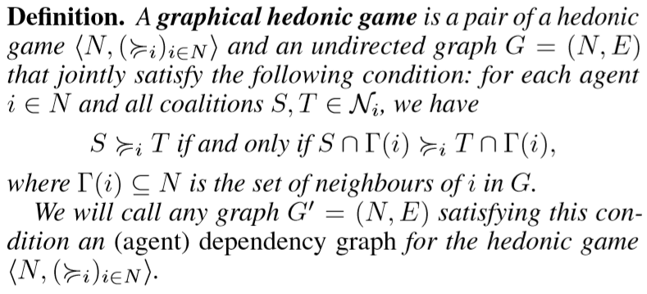

* Let (<N, (≥ i) i∈N>, G) be a graphical hedonic game. Its treewidth is the treewidth of G, and its degree is the maximum degree of G.
* In a graphical hedonic game with dependency graph G, a coalition S ⊆ N is connected if G[S] is connected, that is if S induces a connected subgraph in G. A partition π of N is connected if each S ∈ π is connected.
* The formulas of hedonic game logic (HG-logic) are deﬁned recursively as:

1. atomic formulas: i = j, i ∈ S, S = π(i), S ≥ i T
2. boolean combinations of formulas: ¬φ, (φ ∨ ψ), (φ ∧ ψ)
3. quantiﬁcation over agents: ∀i φ, ∃i φ
4. quantiﬁcation over coalitions: ∀S φ, ∃S φ
5. quantiﬁcation over partitions: ∀π φ, ∃π φ

* φ-HEDONIC GAMES Instance: a graphical hedonic game (<N, (≥ i) i∈N>, G) and a formula φ of HG-logic.
* MSO[σ]: Given a signature σ, the language MSO[σ] of monadic second order logic is given by the grammar

φ ::= x=y | Rix1 ......xar(Ri)| Xx| (φ ∨ φ) | (φ ∧ φ) | ¬φ |∃x φ|∀x φ|∃x φ|∀x φ, where x,y,x1,x2,... are ﬁrst-order variables, and X denotes set variables.

* Hedonic Coalition Nets(or HC-nets): Each agent speciﬁes a set of weighted propositional formulas, called rules, with propositional atoms given by the agents.

Results:

* For each hedonic game, there exists a unique edge-minimal agent dependency graph.
* The problem φ-HEDONIC GAMES is ﬁxed parameter tractable with respect to the length |φ| of the formula φ, and the treewidth k and degree d of the graph G. That is, the problem can be solved in time O(f(|φ|, k, d)·n) where f is a computable function, and n is the number of agents. Here we assume that the relation “S ≥ i T” can be decided in time only depending on d, but not on n.
* For every class of graphical hedonic games of bounded treewidth and degree, there exist linear-time algorithms that can decide whether a given such game admits a partition that is (i) core-stable, (ii) strict-core-stable, (iii) Pareto-optimal, (iv) perfect (v) Nash-stable, (vi) individually stable, (vii) envy-free, or that satisﬁes any combination of these properties.
* Given a formula φ of MSO[σ] and a σ-structure A, we can in time g(|φ|, tw(A))·|A|+O(||A||) decide whether A |= φ, where g is a computable function.
* There is an O(2kd*dn) algorithm that, given a graphical hedonic game and a tree decomposition, decides whether there exists a connected partition π of the agent set that satisﬁes (a combination of) (i) individual rationality, (ii) Nash stability, (iii) individual stability, (iv) envy-freeness. Subject to any combination (or none) of the preceding conditions, we can also maximize utilitarian, egalitarian, or Nash social welfare under π.
* There is an O(2kd*dn) algorithm that given a hedonic game, an associated dependency graph, a tree decomposition, and a partition π of N, decides whether π is (i) Pareto optimal, (ii) core-stable, (iii) strict-core-stable.
* CORE-EXISTENCE is NP-hard even for graphical hedonic games of tree width 2 that are given by an HC-net.
* NASH-STABLE-EXISTENCE is NP-hard even for graphical hedonic games of treewidth 1 that are given by an HC-net.

Open Problems:

* Are there alternative conditions on graph topology that yield tractability?
* Can we say anything about the structure of stable outcomes in dependence on the structure of the graphical hedonic game?
* Find faster algorithms than those provided through HG-logic for Σp 2-type questions like the existence of a core-stable partition or of ﬁnding a Pareto-optimal partition.

# **3. Price of Pareto Optimality in Hedonic Games:**

Price of Anarchy measures the welfare loss caused by selfish behavior: it is deﬁned as the ratio of the social welfare in a socially optimal outcome and in a worst Nash equilibrium. A similar measure can be derived for other classes of stable outcomes. In this paper, we argue that Pareto optimality can be seen as a notion of stability, and introduce the concept of Price of Pareto Optimality: this is an analogue of the Price of Anarchy, where the maximum is computed over the class of Pareto optimal outcomes, i.e., outcomes that do not permit a deviation by the grand coalition that makes all players weakly better off and some players strictly better off.

Acronyms and Definitions:

* Social Welfare (SW): Social Welfare of partition P is defined as follows 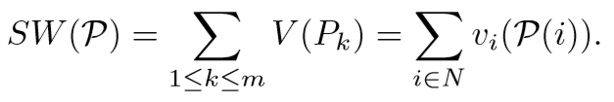 where vi is the utility function of player i
* Given a hedonic game (N, (vi)i∈N), the Price of Pareto Optimality (PPO) is deﬁned as

PPO = maxp∈PSW(P*)/SW(P) if SW(P) > 0 for all p∈P and

PPO = +∞ otherwise.

* ΔG: maximum degree of a node in Graph G.

Results:

* For any M > 0 there is a symmetric fractional hedonic game F(G) where G =(N, E, w) is a tree and all weights are positive such that PPO(F(G)) >M.
* Let G =(N, E) be asymmetric unweighted graph with |N| ≥ 2, and let P be a Pareto optimal partition for F(G). Then

1. every coalition in P is connected,
2. if E != ∅, then P contains at least one non-singleton coalition.

* Let G = (N, E) be a symmetric unweighted graph with |N| ≥ 2. Then PPO(F(G)) ≤ 2ΔG(ΔG + 1).
* Let G = (N, E) be an unweighted tree with |N| ≥ 2 and let P* be an optimal partition for the fractional hedonic game F(G). Then every Pk* ∈P* is a dk-star for some dk ≥ 1.
* Let G = (N, E) be an unweighted tree with |N| ≥ 2 and let C be a minimum vertex cover of G. The social welfare of any optimal partition for the fractional hedonic game F(G) is at most (2ΔG/(ΔG+1))|C|.
* Let G = (N, E) be an unweighted tree with |N|≥2, and let P be a Pareto optimal partition for the fractional hedonic game F(G). Then every coalition in P is either a star or a superstar.
* Let G =(N,E) be an unweighted tree with |N|≥2. Let P be a Pareto optimal partition for the fractional hedonic game F(G). If P contains a singleton P = {i} then every j such that (i, j) ∈ E satisﬁes the following conditions:

1. j is not in a singleton,
2. j is not the center of a superstar,
3. j is not the leaf of a superstar.

* Let G = (N, E) be an unweighted tree with |N| ≥ 2. Then PPO(F(G)) ≤ ΔG +2.
* There exists a fractional hedonic game on an unweighted tree G = (N, E) for which the Price of Pareto Optimality is strictly greater than ΔG −1/3.
* Let G = (N, E) be a symmetric unweighted graph with |N| ≥ 2. Let C be a minimum vertex cover of G. The social welfare of any optimal partition for the modiﬁed fractional hedonic game MF(G) is at most 2|C|.
* Let G = (N, E) be a symmetric unweighted graph with |N| ≥ 2. Let P be a Pareto optimal partition for the modiﬁed fractional hedonic game MF(G). Then every coalition in P is either a star or a clique.
* Let G = (N, E) be a symmetric unweighted graph with |N| ≥ 2. Let P be a Pareto optimal partition for the modiﬁed fractional hedonic game MF(G). For every edge (i, j) ∈ E with P(i) != P(j), it holds that if i in P forms a singleton, is a leaf of a multi-degree star or a node in a triangle, then j in P is either the center of a multi-degree star or a node in a 1-star.
* Let G = (N, E) be a symmetric unweighted graph with |N|≥2, and let P be a Pareto optimal partition for MF(G). Then

1. every coalition in P is connected,
2. if E != ∅, then P contains at least one non-singleton coalition.

* Let G = (N, E) be a symmetric unweighted graph with |N| ≥ 2. Then PPO(MF(G)) ≤ 2.
* Let G = (N, E) be a symmetric unweighted bipartite graph with |N| ≥ 2. Then PPO(MF(G)) ≤ 1.

Open Problems:

* It is not clear if the upper bound of PPO(F(G), where G is symmetric unweighted graph with |N|>2, is tight; in fact, we do not have examples of fractional hedonic games on symmetric unweighted graphs whose PPO exceeds ΔG.
* It would be interesting to compute or bound PPO measure for other classes of (cooperative and non-cooperative) games.

# **4. Towards Structural Tractability in Hedonic Games:**