# **2017:**

# **1. Core Stability in Hedonic Games among Friends and Enemies: Impact of Neutrals:**

In this paper, we investigate hedonic games under enemies aversion and friends appreciation, where every agent considers other agents as either a friend or an enemy. We extend these simple preferences by allowing each agent to also consider other agents to be neutral. Neutrals have no impact on her preference, as in a graphical hedonic game.

Acronyms:

* HG/E: Hedonic Game with Enemies Aversion i.e. each agent ﬁrst compares the number of enemies. Hence, without loss of generality, any coalition that contains an enemy is unacceptable. Within acceptable coalitions, she prefers coalitions with more friends.
* HG/F: Hedonic Games with Friends Appreciation i.e. each agent prefers coalitions with more friends, and in case of a tie, she prefers the one with fewer enemies.
* HG/E/SC/VERIF: verification problem of strict core under HG/E
* HG/E/SC/EXIST: existence problem of strict core under HG/E
* HG/E/C/VERIF: verification problem of core under HG/E
* HG/E/C/EXIST: existence problem of core under HG/E
* HG/F /SC/VERIF: verification problem of strict core under HG/F
* HG/F/SC/EXIST: existence problem of strict core under HG/F
* HG/F/C/VERIF: verification problem of core under HG/F
* HG/F/C/EXIST: existence problem of core under HG/F

Results:

* In an HG/E, the core can be empty.
* In an HG/F, the strict core can be empty.
* Problem HG/E/SC/VERIF is coNP-complete.
* Problem HG/E/SC/EXIST is NPNP-complete.
* Problem HG/E/C/VERIF is coNP-complete.
* Problem HG/E/C/EXIST is NPNP-complete.
* Problem HG/F/SC/EXIST is NPNP-complete.
* Given an HG/F,
  + the existence of a core-stable coalition structure is guaranteed, and
  + it can be computed in polynomial-time as the strongly connected components of graph GF = (N,AF).

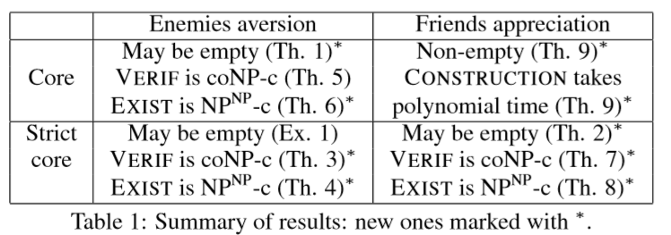

Open Problems:

* Explore assumptions that make veriﬁcation tractable, in order to bring the existence problem to class NP.
* Extend the above results to if friend/enemy relations are symmetric

# **2. Learning Hedonic Games:**

Coalitional stability in hedonic games has usually been considered in the setting where agent preferences are fully known. We consider the setting where agent preferences are unknown; we lay the theoretical foundations for studying the interplay between coalitional stability and (PAC) learning in hedonic games. We introduce the notion of PAC stability — the equivalent of core stability under uncertainty — and examine the PAC stabilizability and learnability of several popular classes of hedonic games.

Acronyms and Definitions:

* H : family of functions from subsets of players to R.
* Hn : restriction of H to functions over n players.
* PAC Stabilizability: We say that an algorithm A can PAC stabilize a class of hedonic games, if after seeing some examples, it is able to propose a partition that is unlikely to be core blocked by a coalition sampled from D.
* Additively separable hedonic games (ASHGs) are hedonic games where an agent’s utility from a coalition is the sum of utilities she assigns to other members of that coalition.
* In hedonic games with W-preferences (W-hedonic games), each player i has a preference over other players and coalition’s value is determined by the worst player in that coalition.
* B-games are the counterpart of W-games, where the value of a coalition depends on the favorite agent in that coalition. However, if two coalitions of different size share their most preferred agent, the smaller one is preferred.
* In Top Responsive games, each agents appreciation of a coalition depends on the most preferred subset within the coalition. More formally, let the choice sets of agent i in coalition S ∈Ni be deﬁned by Ch(i, S) := {X ⊆ S : ∀Y ⊆ S, i ∈ Y : X is preferred over Y}.

If |Ch(i, S)| = 1, we denote the only element of Ch(i, S) by ch(i, S). A game satisﬁes top-responsiveness if:

1. For all i ∈ N and S ∈ Ni, |Ch(i, S)| = 1
2. For all i ∈ N and S, T ∈Ni:
   1. If ch(i, S) is preferred to ch(i, T) then S ­is preferred to T
   2. If ch(i, S) = ch(i, T) and S ⊂ T, then S ­is preferred to T.

Results:

* hypothesis class H is (ε, δ) PAC learnable using m samples, where m is polynomial in Pdim(H), 1/ε and log(1/δ) by giving a hypothesis v* consistent with the sample, i.e. v*(Si) = v(Si) for all i. Furthermore, if Pdim(H) is super polynomial in n, H is not PAC learnable.
* The class of additively separable hedonic games is PAC learnable.
* The class of additively separable hedonic games is not PAC stabilizable.
* The class of Fractional Hedonic Games is PAC learnable, but not PAC stabilizable.
* The class of all representation functions of W-hedonic games is efﬁciently PAC learnable.
* B-hedonic games with arbitrary representation functions are efﬁciently PAC learnable.
* The class of B-games with arbitrary representation functions is not PAC stabilizable.
* Top Responsive hedonic games with informative representation functions are not PAC learnable.
* Top Responsive hedonic games with informative representation are efﬁciently PAC stabilizable.

Algorithm 1 PAC stabilized Top Responsive Games:

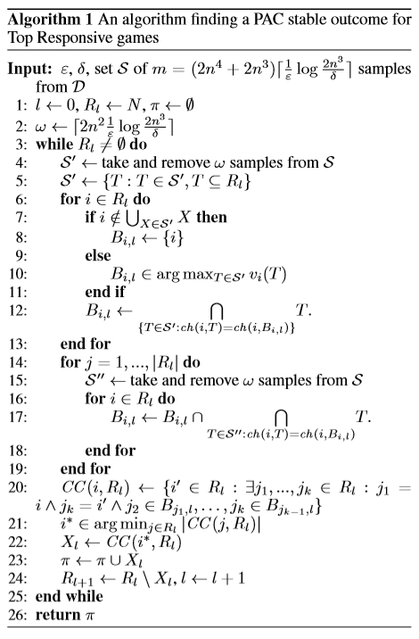

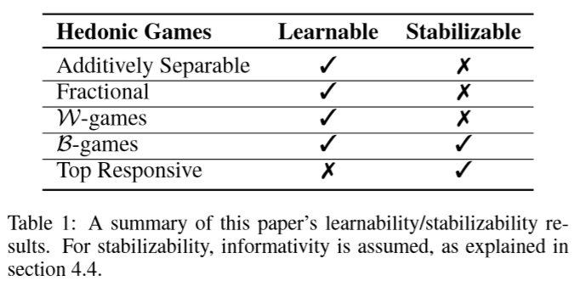

Open Problems:

* One interesting direction for future work would be using structural restrictions: recent works study hedonic games where agent preferences follow a graph structure [Igarashi and Elkind, 2016]. It would be useful to see whether certain graphical assumptions imply PAC stabilizability. Furthermore, while our work studies the core, one can focus on other hedonic solution concepts.
* Empirical evaluation of hedonic games, a further step towards their implementation in real-world systems.