# **2019:**

### **1. Hedonic Diversity Games:**

Here we only study the classic Red-Blue agents diversity game. Each agent is either red or blue and has single peaked preferences. For this game, we present an algorithm to find Individually Stable outcome that runs in polynomial time.

Results:

* Core Stability: may be empty
* Individual Stability: always exists and can be computed in O(|N|4) time where N is the set of agents

Algorithm to find Individual Stable Outcome is divided into three parts:

1. For agents with peaks greater than half, make mixed coalitions with red majority. For agents with peaks smaller than half, make mixed coalitions with blue majority. (HALF(R, B, (>i)**i∈RUB)**)
2. Make pairs from the remaining red agents and blue agents who are not in the mixed coalitions.
3. Put all the remaining agents into singletons.

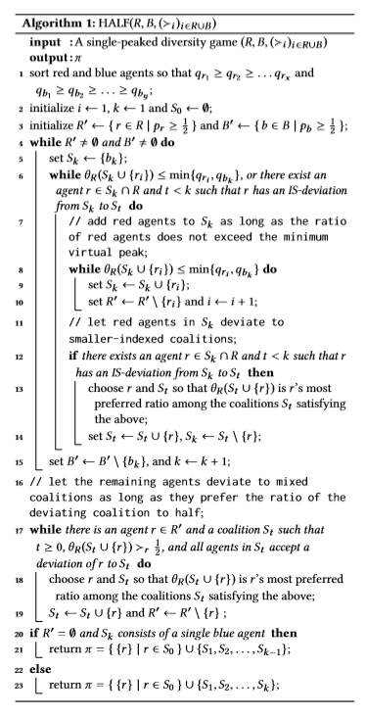 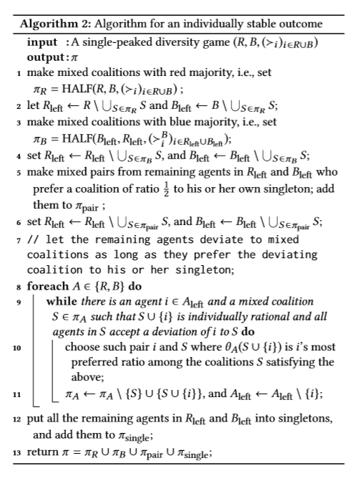

First, while we have argued that Nash stable outcomes may fail to exist, the complexity of deciding whether a given diversity game admits a Nash stable outcome remains unknown. Also, we have obtained an existence result for individual stability under the assumption that agent’s preferences are single-peaked, but it is not clear if the single-peakedness assumption is necessary; in fact, we do not have an example of a diversity game with no individually stable outcome. In a similar vein, it would be desirable to identify further special classes of diversity games that admit core stable outcomes. More broadly, it would be interesting to extend our model to more than two agent types. Another possible extension is to consider the setting where agents are located on a social network, and each agent’s preference over coalitions is determined by the fraction of her acquaintances in these coalitions; this model would capture both the setting considered in our work and fractional hedonic games

### **2. Unknown Agents in Friends Oriented Hedonic Games: Stability and Complexity:**

Here we study existence of individual and core stabilities under the presence of unknown agents, friends and enemies. let N denote set of agents. For each individual i ∈ N, we have three sets which are subsets of N\{i}. Set of friends, set of enemies and set of unknown agents.

We consider three types of games.

1. HG/F: hedonic game in which unknown agents have no effect on preference of an agent.
2. HG/F+: hedonic game in which unknown agents have positive effect i.e. in case of tie between two coalitions having same number of friends and enemies, the agent prefers the coalition that has higher unknown agents.
3. HG/F-: hedonic game in which unknown agents have negative effect i.e. in case of tie between two coalitions having same number of friends and enemies, the agent prefers the coalition that has lower unknown agents.

In these three games, we find the time-complexity of finding the existence of individual stability and core stability denoted by HG/F(+, -)/IS(C)/EXIST and time-complexity of verifying the solution denoted by HG/F(+, -)/IS(C)/VERIF.

Results:

* HG/F/IS/EXIST: individual stability may not exist
* HG/F/IS/VERIF: polynomial time
* HG/F/C/EXIST: always exists and can be found in polynomial time
* HG/F/C/VERIF: polynomial time
* HG/F+/IS/EXIST: may not exist and NP-complete
* HG/F+/IS/VERIF: NP-complete
* HG/F+/C/EXIST: core may be empty. NP^NP-complete
* HG/F+/C/VERIF: Co-NP-complete
* HG/F-/IS/EXIST: always exists
* HG/F-/IS/VERIF:
* HG/F-/C/EXIST: always exists and polynomial times
* HG/F-/C/VERIF: polynomial time

We proved that three distinct extensions of the existing preference lead to a diverse stability and complexity landscape. With extraverted agents, we provided counterexamples showing that both core and individually stable coalition structures may not exist, whereas the strict core is guaranteed in the presence of introverted agents. Then we proved that deciding the existence of such outcomes is NPNP-complete for core stability and NP-complete for individual stability. We also proved that an individually stable coalition structure may not exist under friends appreciation with neutrality. An open question is to prove the complexity of deciding the existence of individual stable outcomes under friends appreciation with neutrality.

### **3. Local Core Stability in Simple Symmetric Fractional Hedonic:**

Here we study local core stability in simple symmetric fractional hedonic games. The input is an unweighted undirected graph G where vertices are the agents and edges model social connection (i.e., acquaintance) among agents. We assume that if there is an edge between two agents then they value 1 each other otherwise they value 0 each other, i.e., we consider the simple setting where an agent values 1 all and only her acquaintances. A coalition structure is a partition of the agents into coalitions where the utility of an agent is equal to the number of agents inside her coalition that are valued 1 divided by the size of the coalition.

It is shown that simple symmetric fractional hedonic games may not admit core stable outcome. Hence, we are looking for local core stable outcome. A coalition structure is said to be local core if following conditions are met:

1. if there is no subset of agents which induces a clique in the graph G
2. if there is no subset of agents such that all agents can improve their utility by forming a new coalition together

We showed that local core dynamics converge. Therefore, **local stable core exists for all simple symmetric fractional hedonics**.

Local core price of anarchy = (optimal social welfare)/ (social welfare of worst local core)

Local core price of stability = (optimal social welfare)/ (social welfare of best local core)

Acronyms:

* SW: social welfare
* SS-FHG: simple symmetric fractional hedonic game
* CPoA: core price of anarchy
* LCPoA: local core price of anarchy
* CPoS: core price of stability
* LCPoS: local core price of stability

Results:

* Given an instance of SS-FHG, a local core stable coalition is always 2-core stable.
* Given any fractional hedonic graph G, 2−CPoA(G(G)) ≤ 4.
* For any ϵ > 0, there exists a graph G for some instance of a SS-FHG such that it’s LCPoS(G) ≥ 2- ϵ.
* Given any graph G, LCPoS(G) ≤ 8/3.

The following Algorithm takes a coalition structure as input and returns local core stable coalition structure:

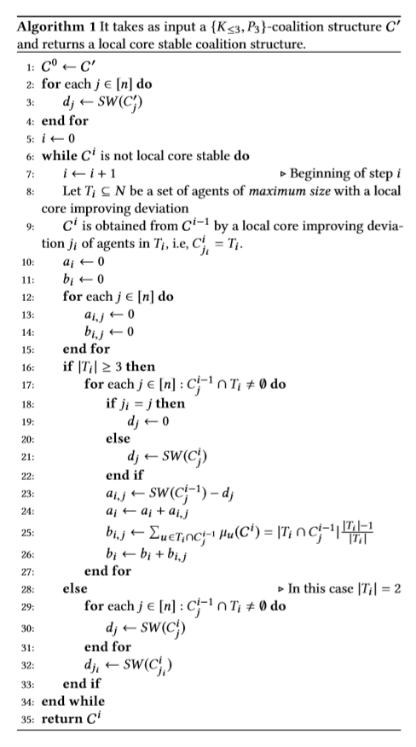

Open Problems:

* Closing the gap between the lower and upper bound of the local core price of stability.
* Next, it could be interesting to study whether any optimal coalition structure is also 2-core stable. Infact, while we proved that an optimal coalition structure may not be resilient to cliques of at least three nodes, we were not able to prove if this holds also for deviations performed by coalitions which are matchings.
* It would also be interesting to address the complexity of computing a local core in SS-FHG. Furthermore, it is worth considering complexity issues that have not been addressed in this work; for instance, even checking whether a coalition structure is in the local core or not is an open problem.
* Another interesting research direction could be that of considering the x-local core. More specifically, a coalition structure is in the x-local core if there is no subset of agents which induces a sub graph of G of diameter at most x that can all improve their utility by forming a new coalition together.

### **4. On the Performance of Stable Outcomes in Modified Fractional Hedonic Games with Egalitarian Social Welfare:**

In this paper we consider modified fractional hedonic games, that are coalition formation games defined over an undirected edge weighted graph G = (N, E, w),where N is the set of agents and for any edge {u, v} ∈ E, wu, v = wv, u reflects how much agents u and v benefit from belonging to the same coalition. More specifically, given a coalition structure, i.e., a partition of the agents into coalitions, the utility of an agent u is given by the sum of wu, v over all other agents v belonging to the same coalition of u averaged over all other members of that coalition, i.e., excluding herself.

We focus on common stability notions: we are interested in strong Nash stable, Nash stable and core stable outcomes. The existence of these natural outcomes for modified fractional hedonic games is completely characterized; moreover, many tight or asymptotically tight results on their performance are shown for the classical utilitarian social welfare function, that is defined as the sum of all agents’ utilities.

It is known that there exists a graph G containing edges with negative weights such that its MFHG admits not Nash stable outcome. Therefore we focus only on graphs with positive weights

Acronyms and Definitions:

* MFHG: Modified Fractional Hedonic Game
* PoA: Price of Anarchy
* PoS: Price of Stability
* SW: Social Welfare
* CPoA: Core Price of Anarchy
* CPoS: Core Price of Stability
* SPoS: Strong Price of Stability
* Star-Coalition: Given a graph G, a star-coalition structure is a coalition structure C = {C1,. . .,Cn} in which, for i ∈ [n], every non-empty Ci is such that G(Ci) is isomorphic to a star graph, i.e., G(Ci) = (Ci, Ei) such that there exist (i) a node u ∈ Ci, called center, with degree |Ci|−1 and (ii) |Ci|−1 nodes with degree 1 and connected to node u, called leaves.

Results:

* There exists an unweighted path G such that PoA(G) ≥ n−1
* For any weighted graph G, PoA(G) ≤ n−1
* For any even number n ≥ 4,there exists a weighted tree G with n nodes such that PoS(G) ≥ n−1
* There exists an unweighted path G such that CPoA(G) is unbounded
* There exists a weighted path G such that CPoS(G)is unbounded
* For any k > 0, there exists an unweighted graph G with n ≥ k nodes such that n−SPoA(G) ≥ (n+1)/4
* For any unweighted bipartite graph G, n−SPoS(G) = 1
* For any unweighted graph G with maximum degree at most 2, n−SPoS(G(G)) = 1.

Algorithm1 takes a star coalition structure as input and returns a strong Nash equilibrium

Algorithm2 takes as input a bipartite graph G = (A∪B,E) and returns a star-coalition structure

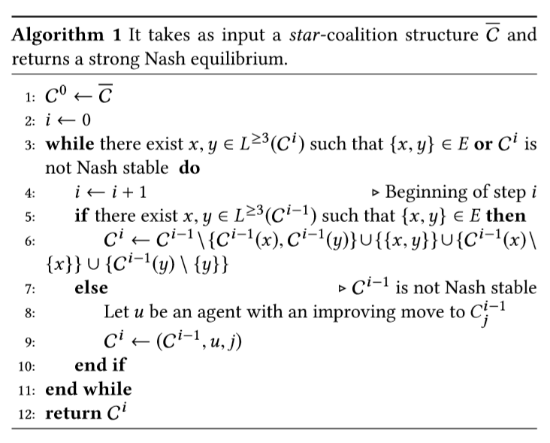 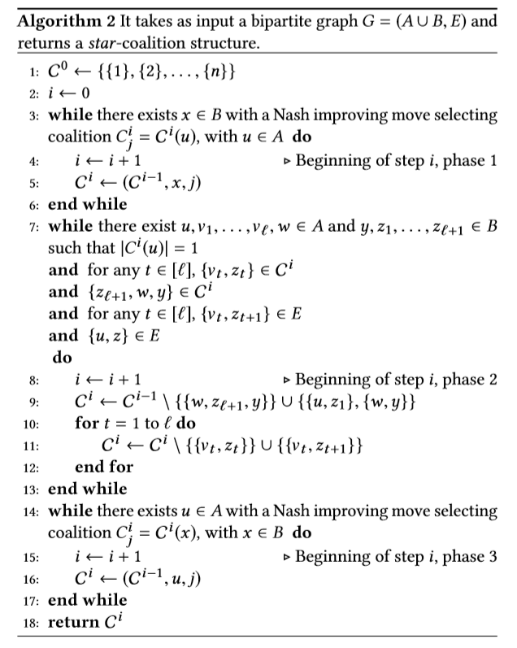

Open Problems:

* Determining the strong price of stability, and also the price of stability and the core price of stability, for unweighted graphs which are neither bipartite nor of maximum degree at most two.
* Designing truthful mechanisms for MFHG that perform well under the egalitarian social welfare function.

# **5. Stability in FEN-Hedonic Games for Single-Player Deviations:**

Here we consider hedonic games in which each agent considers other agents as either friends, enemies or neutral agents. We settle several open cases in complexity analysis of stability concepts based on single-player deviations.

Acronyms and Definitions:

* FEN-HG: A FEN-hedonic game is a pair consisting of a set of agents A = {1,...,n} and a profile of preferences. Again, a coalition structure for a FEN-hedonic game is a partition of A into disjoint coalitions and we denote the set of all possible coalition structures by C(A).
* Perfect Coalition Structure: perfect if each player weakly prefers her assigned coalition to every other coalition containing her.
* Individually Rational Coalition Structure: if every player weakly prefers her assigned coalition to being alone.
* Nash stable: if no player prefers another coalition in Γ.
* Individually stable: if no player prefers another coalition in Γ and could deviate to it without harming any player in that new coalition.
* Contractually individually stable: if no player prefers another coalition in Γ and could deviate to it without harming a player in the new or her assigned coalition.

Results:

* Possible-Nash-Stability-Verification is in P.
* Possible-Individual-Stability-Verification is in P.
* Possible-Contractually-Individual-Stability Verification is in P.
* Possible-Contractually-Individual-Stability Existence is in P.
* Necessary-Individual-Stability-Existence is NP-complete.

Algorithm 1 is polynomial verifier for Possible-Nash-Stability

Algorithm 2 is polynomial verifier for Individual-Stability

Algorithm 3 is a polynomial verifier for Possible-Contractually-Individual-Stability

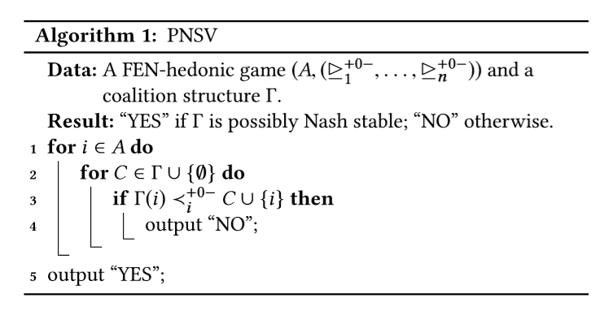

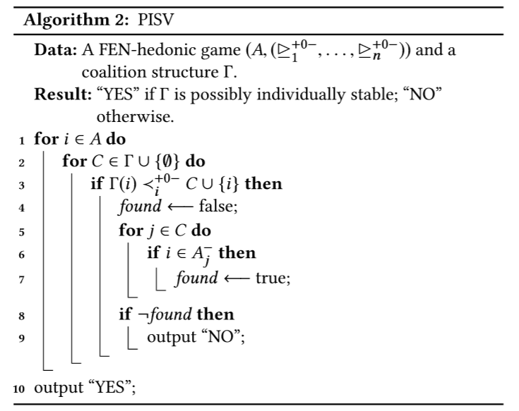

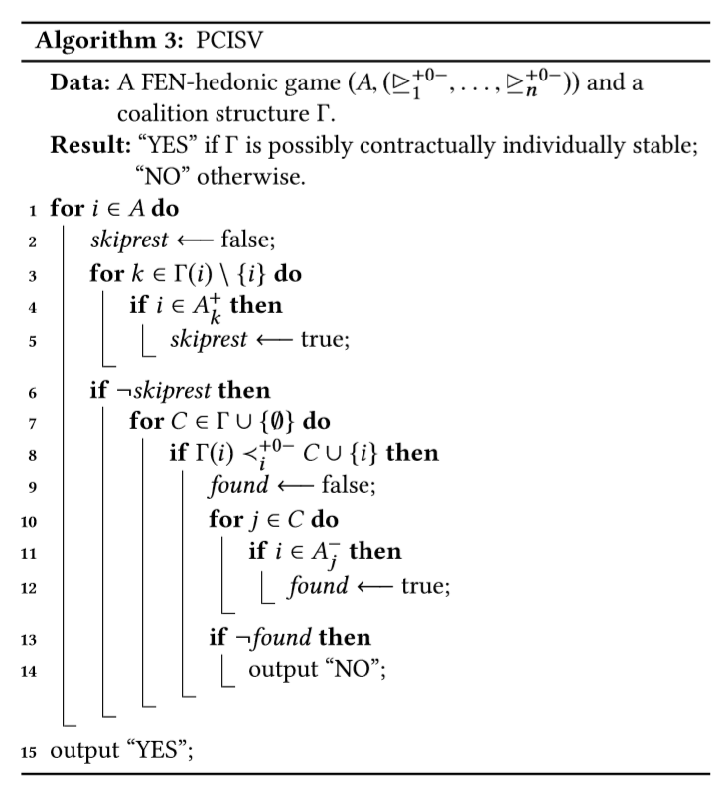

Open Problems:

* Out of the five stability concepts given above, three we are discussed in this paper. The complexity of two remaining concepts is yet to explore.
* Computational Complexity of stability problems that are based on group of players deviating from their coalitions. Core Stability and Strict Core Stability.
* Comparison of given coalition structure with another possible coalition structure. Pareto Optimality, Popularity, Strict Popularity.

# **6. Testing Individual-Based Stability Properties in Graphical Hedonic Games:**

In this paper, we initiate the study of sublinear time property testing algorithms for existence and verification problems under several notions of coalition stability in a model of hedonic games represented by graphs with bounded degree. In graph property testing, one shall decide whether a given input has a property (e.g., a­­ game admits a stable coalition structure) or is far from it, i.e., one has to modify at least an ϵ-fraction of the input (e.g., the game’s preferences) to make it have the property. We consider verification of perfection, individual rationality, Nash stability, and (contractual) individual stability.

Definitions:

* One-sided error and two-sided error: In the setting of graph properties, a graph G = (V,E) with bounded vertex degreed is ϵ-far from satisfying some property P (e.g., bipartiteness) if one has to modify at least ϵ*d*n edges to make G have property P. If the property tester always accepts graphs in P, it has one-sided error; otherwise, it has two-sided error.
* Stability Existence Property: The set of stable graphs with respect to some stability concept (e.g., Nash stability) is these to fall graphs G that admit a stable coalition structure.
* Γ-stability verification property: Let n ∈ N, and let Γ be a partition of [n].The set of Γ-stable graphs with respect to some stability concept (e.g., Nash stability) is the set of n-vertex graphs G such that Γ is a stable coalition structure of G.

Results:

* Given a FEN-hedonic game G with bounded degree d, it can be tested whether G admits a perfect coalition structure with bounded coalition size c with one-sided error and query complexity poly(ϵ, c, d).
* Given a FEN-hedonic game G with bounded degree d and a coalition structure Γ, it can be tested whether G is stable under Γ with respect to perfection, individual rationality, Nash stability, individual stability and contractual individual stability with one-sided error and query complexity poly(ϵ, d).
* Let G = (N, F∪E) be a graph that represents a FEN-hedonic game and Γ a coalition structure of N. Let, furthermore, γ be a stability concept, for which there exists a feasible player property ϕ. If there are at most k witnesses, k*d edge modifications are sufficient to make the game stable with respect to γ.
* Let γ be a stability concept for which there exists a feasible player property ϕ. It holds that Algorithm 1 is a one-sided error property tester for Γ-stability verification with respect to γ.
* For the FEN-hedonic game model, the Γ-stability verification property can be tested with respect to
  1. perfection and individual rationality with query complexity in O(d/ϵ),
  2. Nash stability, individual and contractual individual stability with query complexity in O(d/ϵ).
* Each symmetric FEN-hedonic game (all considered preference extensions) allows a Nash-stable, and consequently individually stable and contractually individually stable coalition structure.
* There is a one-sided error tester with constant query complexity for the existence of a perfect coalition structure in the FEN-hedonic game model with a constant coalition size bound.

Algorithm1 provides a property tester for the verification problem of each stability concept with a feasible player property:

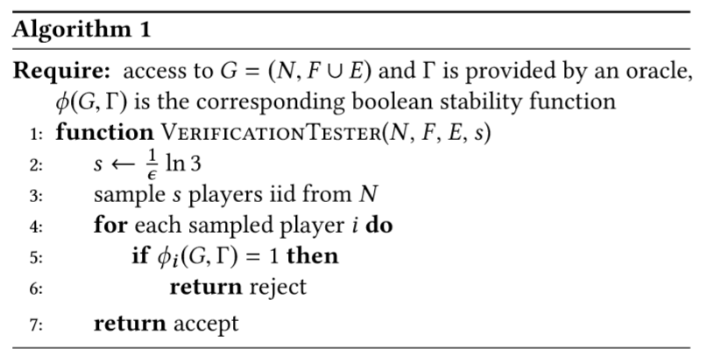

Open Problems:

* Obtain sublinear algorithms for games with unbounded coalition size.
* Obtain sublinear algorithms with different graph model like dense model, etc.,
* Obtain algorithms for property testers with two-side error.
* Studying of other stability concepts like core-stability, Pareto-optimality and popularity