# **2015:**

# **1. Fractional Hedonic Games: Individual and Group Stability:**

Fractional hedonic games (FHGs) is a subclass of hedonic games in which every agent is assumed to have cardinal utilities or valuations for the other agents. These induce preferences over coalitions by considering the average valuation for the members of every coalition. In this paper, existence and complexity of various stability concepts such as core stability, nash stability and individual stability of fractional hedonic games is dealt.

Definitions:

* Mathematical Definition of Fractional Hedonic Games: A hedonic game (N, >~) is said to be a fractional hedonic game (FHG) if, for every agent i in N, there is a valuation function vi such that for all coalitions S, T ∈ Ni, S >~i T if and only if vi(S) ≥ vi(T).
  + An FHG is symmetric if vi(j) = vj(i) for all i, j ∈ N.
  + An FHG is simple if vi(j) ∈ {0, 1} for all i, j ∈ N.
* We say that a coalition S ⊆ N blocks a partition π, if every agent i ∈ S strictly prefers S to his current coalition π(i), i.e., if S ­>~i π(i) for all i ∈ S. A partition that is not blocked by any coalition is core stable (CS).
* A partition π is Nash stable (NS) if no agent can beneﬁt from joining another (possibly empty) coalition, i.e., if π(i) >~i S ∪{i} for all S ∈ π∪{∅} and i ∈ N.
* A partition π is individually stable (IS) if no agent can beneﬁt from joining another (possibly empty) coalition without making some member of the coalition he joins worse oﬀ, i.e., if π(i) >~i S ∪{i} or S ­>j S ∪{i} for some j ∈ S for all S ∈ π∪{∅} and i ∈ N.
* For a stability notion **E** ∈ {CS, NS,IS}, the decision problem (SYMM)FHG-**E** is given by a (symmetric) FHG (N, >~). The answer to (SYMM)FHG-**E** is “Yes” if there is an **E** -stable partition in (N, >~) and “No” otherwise.

Results:

* In unrestricted FHGs, core stable, Nash stable, or individually stable partitions may not exist.
* In symmetric FHGs, core stable or Nash stable partitions may not exist.
* In simple symmetric FHGs, core stable partitions may not exist.
* It is coNP-complete to decide whether a given proﬁle of valuation functions induces strict preferences over coalitions.
* The following hardness results hold:

1. SYMMFHG-CS is NP-hard,
2. SYMMFHG-NS is NP-complete, and
3. FHG-IS is NP-complete.

* 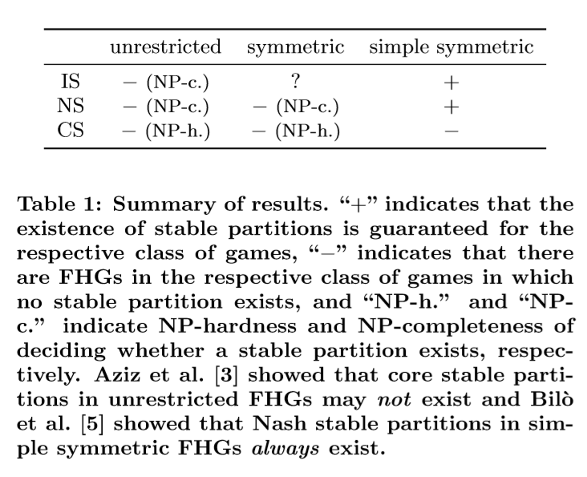

Open Problems:

* Check if connection between the existence of stable partitions and the hardness of ﬁnding stable partitions can be made more precise and extended to more general class of hedonic games.
* Find more natural classes for which the existence of stable partitions is guaranteed.
* Existence of individually stable partitions in symmetric FHGs remains an open problem.

# **2. On the Price of Stability of Fractional Hedonic Games:**

We consider fractional hedonic games, where self-organized groups (or clusters) are created as a result of the strategic interactions of independent and selﬁsh players and the happiness of each player in a group is the average value she ascribes to its members. We adopt Nash stable outcomes, that is states where no player can improve her utility by unilaterally changing her own group, as the target solution concept. We study the quality of the best Nash stable outcome and refer to the ratio of its social welfare to the one of an optimal clustering as to the price of stability. We remark that a best Nash stable outcome has a natural meaning of stability since it is the optimal solution among the ones which can be accepted by selﬁsh users.

Acronyms and Definitions:

* Price of Stability (PoS): ratio of value of best Nash equilibrium to value of optimal solution
* Price of Anarchy (PoA): ratio of value of worst Nash equilibrium to the value of optimal solution
* G (G): Fractional Hedonic Game represented by Graph G
* SW(C) = Σu∈V Pu(C) where SW(C) is social welfare functional value of cluster C and Pu(C) is payoff of player u in cluster C.
* k-Strong Nash Stable Clustering: a clustering C is k-Strong Nash stable (or is a k-Strong Nash equilibrium) if, for each C’ obtained from C when at most k players jointly change their strategies, it holds that Pu(C) ≥ Pu(C’) for some u belonging to the set of deviating players, that is, there always exists a player not improving her utility after the joint collective deviation.
* NSCk(G (G)): set of k-Strong Nash stable clusterings of G (G).
* Star clustering: A star clustering C = (C1, ..., Cn) for G (G) is a clustering such that Ci is a star for each i ∈ [n].
* Optimal Star Clustering: An optimal star clustering for G (G) is a star clustering for G (G) of maximum social welfare.
* A fractional assignment of leaves (to stars centered at V ∗) is a function f : C* \ V* ×[p] → R≥0 such that

1. Σi ∈ [p] f(u, i) = 1 for each u ∈ C* \ V*,
2. Σu ∈ C*\V* f(u, i) > 0 for each i ∈ [p].

Results:

* For any graph G and index k ≥ 1, PoS(G (G)) ≤ PoAk(G (G)).
* For any E > 0, there exists a graph GE such that PoS(G (GE)) > 2−E.
* For any fractional hedonic game G (G) such that NSC2(G (G)) != ∅, PoS(G (G)) ≤ 4.
* There exists a graph G such that NSC2(G (G)) = ∅.
* Let C be a star clustering for G (G). For any node u ∈ V and k ∈ [n] such that |C(u)| > |Ck| + 1 and (C, u, k) is a star clustering for G, it holds that SW(C, u, k) > SW(C).
* Let G be a triangle-free graph, then any optimal star clustering for G (G) is Nash stable.
* For any triangle-free graph G, PoS(G (G)) ≤ 4.
* For any bipartite graph G, PoS(G (G)) ≤ 6(3 −2√2) ≈ 1.0294.
* There exists a bipartite graph G such that PoS(G (G)) > 1.003.

Open Problems:

* Reduce the subtle gap between the lower and the upper bound on the price of stability in bipartite graphs, thus getting its exact value.
* Providing suitable bounds for more general classes of graphs and better understanding the structure of equilibria for unrestricted topologies.

# **3. Representing and Solving Hedonic Games with Ordinal Preferences and Thresholds:**

We propose a new representation setting for hedonic games, where each agent partitions the set of other agents into friends, enemies, and neutral agents, with friends and enemies being ranked. Under the assumption that preferences are monotonic (respectively, anti-monotonic) with respect to the addition of friends (respectively, enemies), we propose a bipolar extension of the Bossong–Schweigert extension principle and use this principle to derive the (partial) preferences of agents over coalitions. Then, for a number of solution concepts, we characterize partitions that necessarily (respectively, possibly) satisfy them, and identify the computational complexity of the associated decision problems. Alternatively, we suggest cardinal comparability functions in order to extend to complete preference orders consistent with the generalized Bossong– Schweigert order.

Definitions:

* The individually rational encoding: Each agent ranks only the coalitions she prefers to herself being alone.
* The additive encoding: Each agent gives a valuation (positive or negative) of each other agent; preferences are additively separable, and the extension principle is that the valuation of a set of agents, for agent i, is the sum of the valuations i gives to the agents in the set (and then the preference relation is derived from this valuation function).
* The “friends and enemies” encoding: Each agent partitions the set of other agents into two sets (her friends and her enemies); under the friend-oriented preference extension, coalition X is preferred to coalition Y if X contains more friends than Y, or as many friends as Y and fewer enemies than Y; under the enemy-oriented preference extension, X is preferred to Y if X contains fewer enemies than Y, or as many enemies as Y and more friends than Y.
* The singleton encoding: Each agent ranks only single agents; under the optimistic (respectively, pessimistic) extension, X is preferred to Y if the best (respectively, worst) agent in X is preferred to the best (respectively, worst) agent in Y.
* The anonymous encoding: Each agent speciﬁes only a preference relation over the number of agents in her coalition (and does not care about the identities of these agents).
* Hedonic coalition nets: Each agent speciﬁes her utility function over the set of all coalitions via (more or less) a set of weighted logical formulas.
* Fractional hedonic games: Each agent assigns a value to each other agent (and 0 to herself); an agent’s utility of a coalition is the average value she assigns to the members of the coalition. A coalition X is preferred to Y if the utility of X is greater than that of Y.
* A coalition structure Γ is called
  + Perfect: if each player i weakly prefers Γ(i) to every other coalition containing i,
  + Individually rational: if each player i ∈ A weakly prefers Γ(i) to being alone in{i},
  + Nash stable: if for each player i ∈ A, Γ(i) >~i A’∪{i} holds for each coalition A’ ∈ Γ∪Φ,
  + Individually stable: if for each player i ∈ A and for each coalition A’ ∈ Γ∪Φ, it holds that Γ(i) >­~i A’∪{i} or there exists a player j ∈ A’ such that A’ >­j A’∪{i},
  + Contractually individually stable: if for each player i ∈ A and for each coalition A’ ∈ Γ∪Φ, it holds that Γ(i) >~i A’∪{i}, or there exists a player j∈A’ such that A0’ >j A’∪{i}, or there exists a player j’ ∈ Γ(i) such that Γ(i)­ >j’ Γ(i)\{i}.
* Let A = {1, 2, ..., n} be a set of agents. For each i ∈ A, a weak ranking with double threshold for agent i, denoted by Δi+0−, consists of a partition of A\{i}into three sets:
  + A­i+ (i’s friends), together with a weak order Δi+0− over Ai+,
  + Ai- (i’s enemies), together with a weak order Δi+0− over Ai-, and
  + Ai0 (the neutral agents, i.e., the agents i does not care about).
* Let Δi+0− be a weak ranking with double threshold for agent i. The extended order Δi+0− is deﬁned as follows: For every X,Y ⊆A, X >~i+0− Y if and only if the following two conditions hold:

1. There is an injective function σ from Y ∩ Ai+ to X ∩ Ai+ such that for every y ∈ Y ∩ Aii , we have σ(y) Δi y.
2. There is an injective function θ from X ∩ Ai- to Y ∩ Ai- such that for every x ∈ X ∩ Ai- , we have x Δi θ(x).

Finally, X ­>~i+0− i Y if and only if X >~i+0− Y and not (Y >~i+0− X).

* A complete preference relation >~i over all coalitions containing i extends >~i+0− if and only if it contains it; that is, if C >~i+0− D implies C >~i D for all coalitions C, D. Let Ext(>~i+0−) be the set of all complete preference relations extending >~i+0−.
* An FEN-hedonic game is a tuple H = <A, Δ1+0−, ..., Δn+0−>, where A ={1, 2, ..., n} is a set of players, and Δi+0− gives the ordinal preferences with thresholds of player i ∈ A as defined in above definitions.
* Let α be a stability concept for hedonic games, <A, Δ1+0−, ..., Δn+0−> be a FEN-hedonic game and Γ be a coalition structure. Γ satisﬁes possible α if and only if there exists a proﬁle <>~1, …., >~n> in Ext(Δi+0−) such that <A, >~1, …., >~n> satisﬁes α. Γ satisﬁes necessary α if and only if for each <>~1, …., >~n> in Ext(Δi+0−), <A, >~1, …., >~n> satisﬁes α.
* Let A be a set of players and Δi+0− be player i’s preference relation. Let wi : A → Z, compatible with Δi+0−, assign n points to each agent in Ai, 1+, n−1 points to each agent in Ai, 2+, ..., and n-l+1 points to each agent in Ai, l+. Moreover, let each agent in Ai, m- get −n points, each agent in Ai, m−1- get −n+1 points, ..., and each agent in Ai, 1- get −(n−m+1) points. Then, we call wi strongly friend-optimistic and strongly enemy-pessimistic.
* For each ﬁxed agent i ∈ A and for every ﬁxed choice of scoring vectors wi, the Borda-like CF

fBordai : { C ⊆ A | i ∈ C} → Z maps every coalition C containing i to the sum of the scores the agents in C obtain from wi. The value of a coalition C ⊆ A is deﬁned as FBorda(C) =∑i∈C fBordai(C).

Results:

* Consider a FEN-hedonic game <A, Δ1+0−, ..., Δn+0−>

1. A coalition structure Γ is (necessarily and possibly) perfect if and only if for each player i, Ai+⊆Γ(i) and Ai-∩Γ(i) = Φ2.
2. A coalition structure Γ is possibly individually rational if and only if for each i ∈ A, Γ(i) contains at least a friend of i’s or only neutral agents.
3. A coalition structure Γ is necessarily individually rational if and only if for each i ∈ A, Γ(i) does not contain any enemies of i’s.
4. A coalition structure Γ is necessarily individually stable if and only if it is necessarily individually rational and no player i can join a coalition that she would possibly prefer and the members of which do not see her as an enemy.

* All problems regarding perfection are in P.
* The veriﬁcation problem for possible Nash stability is in P.
* The problem of whether there exists a possibly Nash stable coalition structure in a given FEN-hedonic game is NP-complete.
* For each player i ∈ A, the comparability function fBordai preserves those rankings that are induced by the Bossong–Schweigert extension. Furthermore, a game that is induced by comparability function FBorda (as an extension) is additively separable.

Open Problems:

* Introducing the notion of partition correspondences with the purpose to actually identify “good” coalition structures as an output. In contrast to the original idea of hedonic games where coalitions form in a decentralized manner, here a central correspondence is used, in order to decide which coalitions will work together. This might, for example, be the case in a setting where the head of a department has to divide a group of employees into teams. The teams should be stable, in the sense that the team members are as happy as possible with their group to create a good working atmosphere.

# **4. Simple Causes of Complexity in Hedonic Games:**

In this paper, we identify simple conditions on expressivity of hedonic games that are sufﬁcient for the problem of checking whether a given game admits a stable outcome to be computationally hard.

Acronyms and Definitions:

* C: polynomially representable class of hedonic games
* CR: core stability
* NS: nash stability
* SCR: strict core stability
* SNS: strict nash stability
* IS: individual stability
* α-EXISTENCE FOR C
  + Instance: Game <N, (>~i)i∈N> from C in its binary encoding.
  + Question: Is there anα-stable partition π of N?
* Individually Rational Coalition Lists (IRCL): Represent a hedonic game by listing the agent preferences >~i explicitly from best to worst, but cutting the list off after the entry {i}. This representation is complete, but not always succinct.
* Hedonic Coalition Nets: Rule-Based representation for hedonic games in which agents’ preferences are described by weighted boolean formulas.
* W-preferences: Hedonic games where each agent ﬁrst ranks all other agents and then compares coalitions based on their worst member under this ranking.
* WB-preferences: Hedonic games where agents rank coalitions according to their worst member, but break ties in favor of the coalition with better best member.
* W- and B-hedonic games: In these two classes of games, agents rank coalitions according to their worst or best member, but coalitions containing an enemy are not individually rational.

Results:

* CR-EXISTENCE FOR C is NP-hard if for all N and every mutual collection of orderings (>~i)i∈N in which each agent has at most 3 friends, there is a game <N,( >~i)i∈N> ∈ C that is consistent on pairs, {0-1}-toxic and weakly {1-1,2-2} - toxic with respect to (>~i)i∈N.
* NS- and IS-EXISTENCE FOR C are NP-complete if for all N and every strict and mutual collection of orderings (>~i)i∈N in which each agent has at most 3 friends, there is a game <N, (>~i)i∈N> ∈ C that is consistent on pairs and strictly {0-1,1-1,2-5}-toxic with respect to (>~i)i∈N.
* CR- and SCR-EXISTENCE FOR C are NP-hard if for all N and every collection of strict and mutual orderings (>~i)i∈N in which each agent has at most 4 friends, there is a game <N, (>~i)i∈N> ∈ C that is consistent on pairs, triangle appreciating, monotone on triangles, {0-1}-toxic, weakly {1-1,2-2,3-3}-toxic, and intolerant in triangles with respect to (>~i)i∈N.
* Additively Separable Games(ASGs): In these games, preferences are given by S >~i T iff ∑j∈S vi(j) > ∑j∈T vi(j).
* Fractional Hedonic Games (FHGs). In these games, preferences are given by S >~i T iff 1/|S|∑j∈Svi(j) > 1/|T|∑j∈T vi(j).
* Social FHGs. An FHG is social if agents’ utilities for each other are non-negative.
* Median Games: Agents evaluate coalitions according to their median value, which in odd-size coalitions is the middle element, and in even-size coalitions is the mean of the middle two elements.
* Geometric Mean Games: In these games agents evaluate coalitions according to the geometric mean (∏vi(j))1/|S| of member utilities.
* Nash Product Games: This is the class of games that are ‘multiplicatively separable’; agents evaluate coalitions according to ∏j∈Svi(j).
* Midrange (1/2B+ 1/2W): In this case, agents evaluate a coalition by averaging the maximum and minimum utility in it.
* r-Approval: Starting with cardinal utilities, sum the (up to) r highest elements of a coalition.
* 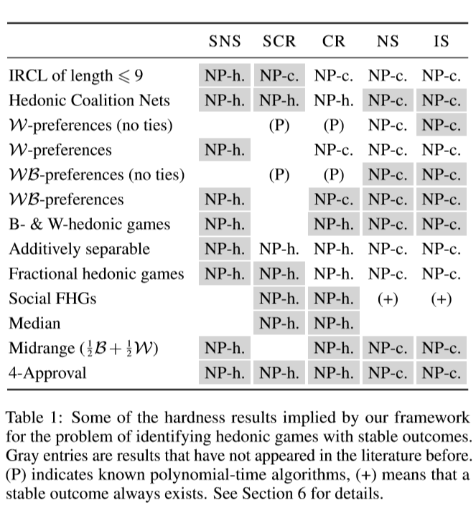

Open Problems:

* Extend the above framework to deal with notions of stability that are based on group deviations which is often coNP-complete.
* Check whether our framework can be extended from NP-hardness proofs to Σ2p-hardness proofs.

# **5. Welfare Maximization in Fractional Hedonic Games:**

We consider the computational complexity of computing welfare maximizing partitions for fractional hedonic games- a natural class of coalition formation games that can be succinctly represented by a graph. For such games, welfare maximizing partitions constitute desirable ways to cluster the vertices of the graph. We present both intractability results and approximation algorithms for computing welfare maximizing partitions.

Acronyms and Definitions:

* Utilitarian maximization: maximizing sum of utility of players
* Egalitarian Maximization: maximizing utility of worst off agent
* Nash Welfare Maximization: maximizing product of utility of players

Results:

* For simple symmetric FHGs, UTILITARIAN WELFARE and EGALITARIAN WELFARE are both NP-hard.
* For simple symmetric FHGs, NASH WELFARE is NP-hard.
* For simple symmetric FHGs, UTILITARIAN WELFARE has a linear-time 4-approximation algorithm.
* For simple symmetric FHGs, UTILITARIAN WELFARE has an O(|N0.5|E|)-time 2-approximation algorithm.
* For symmetric FHGs, UTILITARIAN WELFARE has a polynomial-time 4-approximation algorithm.
* For simple symmetric FHGs, EGALITARIAN WELFARE has a polynomial-time 3-approximation algorithm.
* 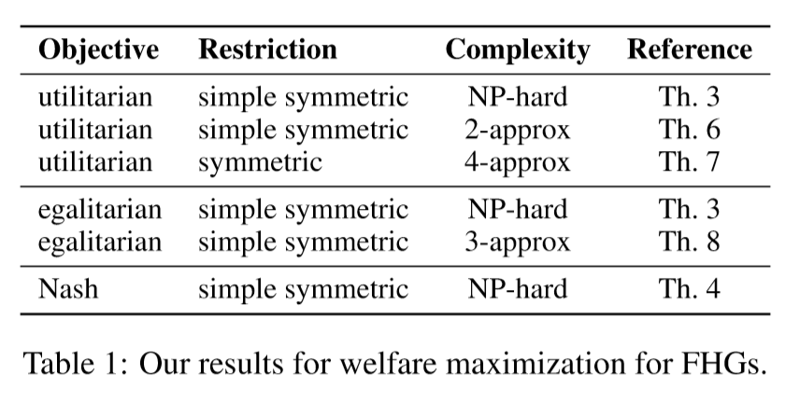

Open Problems:

* Check whether one can obtain ﬁxed parametrized tractable results for parameter treewidth.
* Check whether there are similar approximation bounds (as we did for utilitarian and egalitarian welfare) for maximum Nash welfare and better bounds for utilitarian and egalitarian welfare

# **2016:**

# **1. Complexity of Hedonic Games with Dichotomous Preferences:**

Dichotomous Hedonic Games are hedonic games in which each agent either approves or disapproves of a given coalition. In this work, we study the computational complexity of questions related to ﬁnding optimal and stable partitions in dichotomous hedonic games under various ways of restricting and representing the collection of approved coalitions.

Definitions:

* Lists: In a context in which it is sensible to presume that agents will only approve at most polynomially many coalitions, we can represent their preferences by merely listing all approved coalitions. The complexity of stability problems for lists in the non-dichotomous case is studied by Ballester (2004). We consider here an even more restricted variant: in the k-list representation, every agent submits a list of at most k approved coalitions.
* Anonymous Preferences:

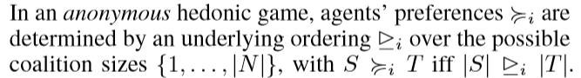

* Roommates: Consider the restriction of dichotomous hedonic games where agents only approve coalitions of size at most 2. This case could also be referred to as a (stable) roommate problem with dichotomous preferences.
* Majority Games: Consider agents that approve those coalitions in which the agent is friends with majority of members.

Results:

* Every dichotomous hedonic game admits a partition that is both core-stable and individually stable.
* For every dichotomous hedonic game, we can ﬁnd an individually stable partition in O(n3) calls to an oracle that decides whether a given coalition S ⊆ N is approved by a given agent i ∈ N.

Algorithm 1 finds an individually stable partition in O(n3). Note that the while loop executes at most n times, since each agent is assigned only once.

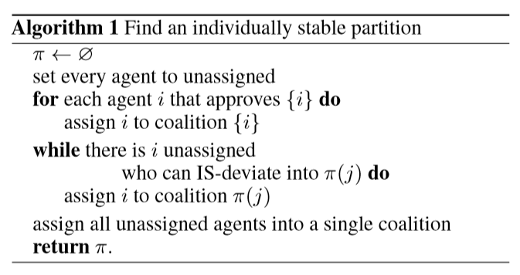

* It is FNP-hard to ﬁnd a core-stable partition in a boolean hedonic game.
* It is coNP-complete to decide whether a given partition π is core-stable in a boolean hedonic game.
* Maximizing social welfare is NP-complete even for 1-lists.
* Deciding existence of a strict-core-stable partition is NP-complete even for 1-lists.
* Finding a perfect partition or a Nash-stable partition is easy for 2-lists.
* Deciding existence of a perfect partition or a strict-core-stable partition is NP-complete for 3-lists.
* The problems of deciding existence of a perfect, a strict-core-stable, or a Nash-stable partition are NP-complete for anonymous preferences, even if at most 4 sizes are approved.
* If every agent only approves intervals, we can ﬁnd a welfare-maximizing partition in polynomial time.
* Deciding the existence of a Nash stable partition for dichotomous roommates is NP-complete, even in the bipartite (marriage) case, and even if each agent approves at most 4 coalitions.
* In a majority game, a partition that is both Nash-stable and core-stable is guaranteed to exist and can be found in polynomial time.
* Let δ(G) be minimum degree of G where G is graph representing majority game with n agents. Then if δ(G) >= n/2 then G is Hamiltonian.
* Let Δ(G) be maximum degree of G where G is graph representing majority game with n agents. If Δ(G) <= k−1 then G has an equitable k-colouring.
* If G is a graph with δ(G) >= n/2 then the vertices of G can be partitioned into edges and triangles.
* In majority games, perfect and strict-core stable partitions coincide. If a perfect partition exists, then a perfect partition consisting of edges and triangles exists. Hence there is a polynomial time algorithm which will produce a perfect and strict-core-stable partition if it exists.
* 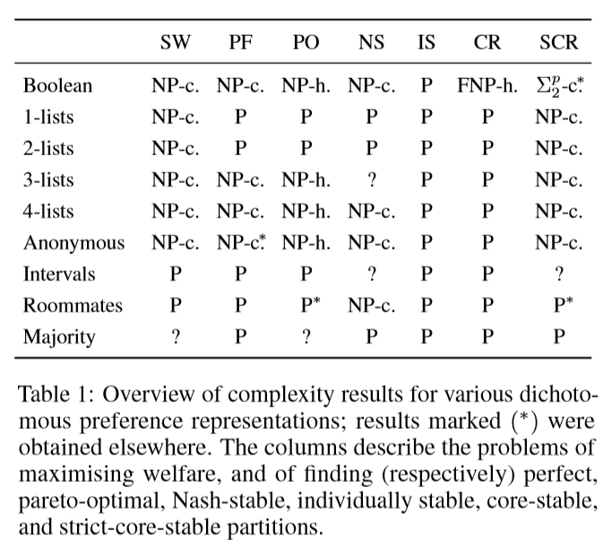

Open Problems:

* Settle the ‘frontier of tractability’ for Nash-stability in k-lists.
* Decide the existence of Nash and strict-core-stable partitions in the interval case.
* Empirical evaluation of the power of boolean hedonic games when solved by modern SAT solvers.

# **2. Graphical Hedonic Games of Bounded Tree width:**

Hedonic games are a well-studied model of coalition formation, in which selﬁsh agents are partitioned into disjoint sets and agents care about the make-up of the coalition they end up in. The computational problems of ﬁnding stable, optimal, or fair outcomes tend to be computationally intractable in even severely restricted instances of hedonic games. We introduce the notion of a graphical hedonic game and show that, in contrast, on classes of graphical hedonic games whose underlying graphs are of bounded treewidth and degree, such problems become easy.

Acronyms and Definitions:

* Graphical Hedonic Games:

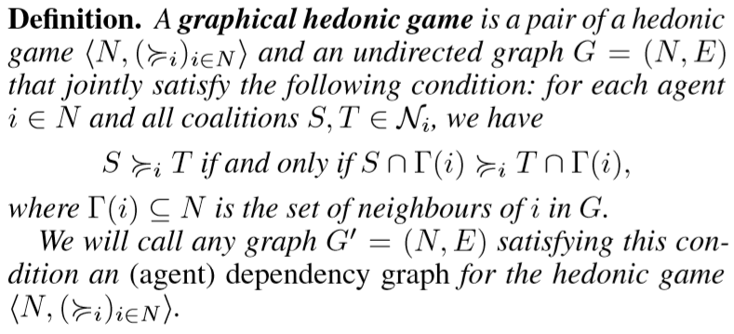

* Let (<N, (≥ i) i∈N>, G) be a graphical hedonic game. Its treewidth is the treewidth of G, and its degree is the maximum degree of G.
* In a graphical hedonic game with dependency graph G, a coalition S ⊆ N is connected if G[S] is connected, that is if S induces a connected subgraph in G. A partition π of N is connected if each S ∈ π is connected.
* The formulas of hedonic game logic (HG-logic) are deﬁned recursively as:

1. atomic formulas: i = j, i ∈ S, S = π(i), S ≥ i T
2. boolean combinations of formulas: ¬φ, (φ ∨ ψ), (φ ∧ ψ)
3. quantiﬁcation over agents: ∀i φ, ∃i φ
4. quantiﬁcation over coalitions: ∀S φ, ∃S φ
5. quantiﬁcation over partitions: ∀π φ, ∃π φ

* φ-HEDONIC GAMES Instance: a graphical hedonic game (<N, (≥ i) i∈N>, G) and a formula φ of HG-logic.
* MSO[σ]: Given a signature σ, the language MSO[σ] of monadic second order logic is given by the grammar

φ ::= x=y | Rix1 ......xar(Ri)| Xx| (φ ∨ φ) | (φ ∧ φ) | ¬φ |∃x φ|∀x φ|∃x φ|∀x φ, where x,y,x1,x2,... are ﬁrst-order variables, and X denotes set variables.

* Hedonic Coalition Nets(or HC-nets): Each agent speciﬁes a set of weighted propositional formulas, called rules, with propositional atoms given by the agents.

Results:

* For each hedonic game, there exists a unique edge-minimal agent dependency graph.
* The problem φ-HEDONIC GAMES is ﬁxed parameter tractable with respect to the length |φ| of the formula φ, and the treewidth k and degree d of the graph G. That is, the problem can be solved in time O(f(|φ|, k, d)·n) where f is a computable function, and n is the number of agents. Here we assume that the relation “S ≥ i T” can be decided in time only depending on d, but not on n.
* For every class of graphical hedonic games of bounded treewidth and degree, there exist linear-time algorithms that can decide whether a given such game admits a partition that is (i) core-stable, (ii) strict-core-stable, (iii) Pareto-optimal, (iv) perfect (v) Nash-stable, (vi) individually stable, (vii) envy-free, or that satisﬁes any combination of these properties.
* Given a formula φ of MSO[σ] and a σ-structure A, we can in time g(|φ|, tw(A))·|A|+O(||A||) decide whether A |= φ, where g is a computable function.
* There is an O(2kd*dn) algorithm that, given a graphical hedonic game and a tree decomposition, decides whether there exists a connected partition π of the agent set that satisﬁes (a combination of) (i) individual rationality, (ii) Nash stability, (iii) individual stability, (iv) envy-freeness. Subject to any combination (or none) of the preceding conditions, we can also maximize utilitarian, egalitarian, or Nash social welfare under π.
* There is an O(2kd*dn) algorithm that given a hedonic game, an associated dependency graph, a tree decomposition, and a partition π of N, decides whether π is (i) Pareto optimal, (ii) core-stable, (iii) strict-core-stable.
* CORE-EXISTENCE is NP-hard even for graphical hedonic games of tree width 2 that are given by an HC-net.
* NASH-STABLE-EXISTENCE is NP-hard even for graphical hedonic games of treewidth 1 that are given by an HC-net.

Open Problems:

* Are there alternative conditions on graph topology that yield tractability?
* Can we say anything about the structure of stable outcomes in dependence on the structure of the graphical hedonic game?
* Find faster algorithms than those provided through HG-logic for Σp 2-type questions like the existence of a core-stable partition or of ﬁnding a Pareto-optimal partition.

# **3. Price of Pareto Optimality in Hedonic Games:**

Price of Anarchy measures the welfare loss caused by selfish behavior: it is deﬁned as the ratio of the social welfare in a socially optimal outcome and in a worst Nash equilibrium. A similar measure can be derived for other classes of stable outcomes. In this paper, we argue that Pareto optimality can be seen as a notion of stability, and introduce the concept of Price of Pareto Optimality: this is an analogue of the Price of Anarchy, where the maximum is computed over the class of Pareto optimal outcomes, i.e., outcomes that do not permit a deviation by the grand coalition that makes all players weakly better off and some players strictly better off.

Acronyms and Definitions:

* Social Welfare (SW): Social Welfare of partition P is defined as follows 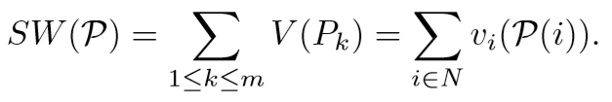 where vi is the utility function of player i
* Given a hedonic game (N, (vi)i∈N), the Price of Pareto Optimality (PPO) is deﬁned as

PPO = maxp∈PSW(P*)/SW(P) if SW(P) > 0 for all p∈P and

PPO = +∞ otherwise.

* ΔG: maximum degree of a node in Graph G.

Results:

* For any M > 0 there is a symmetric fractional hedonic game F(G) where G =(N, E, w) is a tree and all weights are positive such that PPO(F(G)) >M.
* Let G =(N, E) be asymmetric unweighted graph with |N| ≥ 2, and let P be a Pareto optimal partition for F(G). Then

1. every coalition in P is connected,
2. if E != ∅, then P contains at least one non-singleton coalition.

* Let G = (N, E) be a symmetric unweighted graph with |N| ≥ 2. Then PPO(F(G)) ≤ 2ΔG(ΔG + 1).
* Let G = (N, E) be an unweighted tree with |N| ≥ 2 and let P* be an optimal partition for the fractional hedonic game F(G). Then every Pk* ∈P* is a dk-star for some dk ≥ 1.
* Let G = (N, E) be an unweighted tree with |N| ≥ 2 and let C be a minimum vertex cover of G. The social welfare of any optimal partition for the fractional hedonic game F(G) is at most (2ΔG/(ΔG+1))|C|.
* Let G = (N, E) be an unweighted tree with |N|≥2, and let P be a Pareto optimal partition for the fractional hedonic game F(G). Then every coalition in P is either a star or a superstar.
* Let G =(N,E) be an unweighted tree with |N|≥2. Let P be a Pareto optimal partition for the fractional hedonic game F(G). If P contains a singleton P = {i} then every j such that (i, j) ∈ E satisﬁes the following conditions:

1. j is not in a singleton,
2. j is not the center of a superstar,
3. j is not the leaf of a superstar.

* Let G = (N, E) be an unweighted tree with |N| ≥ 2. Then PPO(F(G)) ≤ ΔG +2.
* There exists a fractional hedonic game on an unweighted tree G = (N, E) for which the Price of Pareto Optimality is strictly greater than ΔG −1/3.
* Let G = (N, E) be a symmetric unweighted graph with |N| ≥ 2. Let C be a minimum vertex cover of G. The social welfare of any optimal partition for the modiﬁed fractional hedonic game MF(G) is at most 2|C|.
* Let G = (N, E) be a symmetric unweighted graph with |N| ≥ 2. Let P be a Pareto optimal partition for the modiﬁed fractional hedonic game MF(G). Then every coalition in P is either a star or a clique.
* Let G = (N, E) be a symmetric unweighted graph with |N| ≥ 2. Let P be a Pareto optimal partition for the modiﬁed fractional hedonic game MF(G). For every edge (i, j) ∈ E with P(i) != P(j), it holds that if i in P forms a singleton, is a leaf of a multi-degree star or a node in a triangle, then j in P is either the center of a multi-degree star or a node in a 1-star.
* Let G = (N, E) be a symmetric unweighted graph with |N|≥2, and let P be a Pareto optimal partition for MF(G). Then

1. every coalition in P is connected,
2. if E != ∅, then P contains at least one non-singleton coalition.

* Let G = (N, E) be a symmetric unweighted graph with |N| ≥ 2. Then PPO(MF(G)) ≤ 2.
* Let G = (N, E) be a symmetric unweighted bipartite graph with |N| ≥ 2. Then PPO(MF(G)) ≤ 1.

Open Problems:

* It is not clear if the upper bound of PPO(F(G), where G is symmetric unweighted graph with |N|>2, is tight; in fact, we do not have examples of fractional hedonic games on symmetric unweighted graphs whose PPO exceeds ΔG.
* It would be interesting to compute or bound PPO measure for other classes of (cooperative and non-cooperative) games.

# **4. Towards Structural Tractability in Hedonic Games:**

Hedonic games are a well-studied model of coalition formation, in which selﬁsh agents are partitioned into disjoint sets, and agents care about the make-up of the coalition they end up in. The computational problem of ﬁnding a stable outcome tends to be computationally intractable, even after severely restricting the types of preferences that agents are allowed to report. We investigate a structural way of achieving tractability, by requiring that agents’ preferences interact in a well-behaved manner.

Results:

* The problems of deciding whether a given additively separable hedonic game admits a core or a strict-core-stable partition are Σp2-complete, even if valuations are symmetric and sparse: no agent has non-zero valuations for more than 10 agents.
* For any logical sentence φ of HG-logic that may quantify over(connected) partitions, coalitions, and agents, the problem of deciding whether a hedonic game given by an HC-net satisﬁes φ is ﬁxed-parameter tractable with parameters the treewidth and degree of the dependency graph of the game.
* 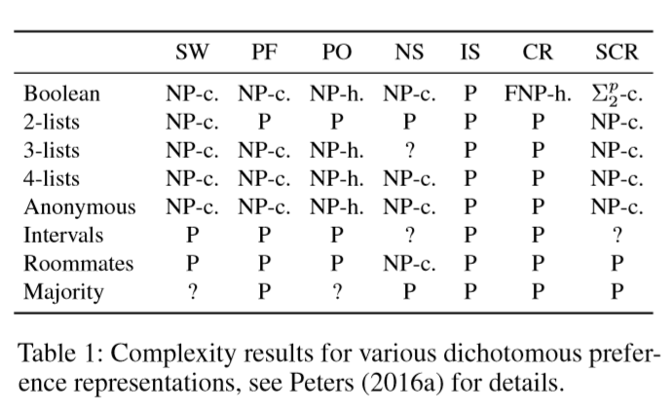

Open Problems:

* Suppose agents are ordered along a line and have additively separable preferences that are single-peaked on that line: agents prefer those agents closer to them on the line. Does every such game admit a core-stable outcome?
* If so, can we ﬁnd it in polynomial time?
* What happens if all individually rational coalitions are intervals with respect to this line?
* Can we dispense with the bound on G’s maximum degree when only considering additively separable games?

# **5. Altruistic Hedonic Games:**

All models of representing hedonic games studied so far are based upon selfish players only. Among the known ways of representing hedonic games compactly, we focus on friend-oriented hedonic games and propose a novel model for them that considers not only a player’s own preferences but also her friends’ preferences under three degrees of altruism.

Definitions:

* Weak Friend-Orientedness: If coalition A is acceptable for i, then A∪{f} is also acceptable for i, where f ∈ Fi\A.
* Favoring Friends: If x ∈ Fi and y ∈ Ei then {x, i}­ >i {y, i}.
* In difference between Friends: If x, y ∈ Fi then {x, i} ∼i {y, i}.
* In difference between Enemies: If x, y ∈ Ei then{ x, i} ∼i {y, i}.
* Sovereignty of Players: For a ﬁxed player i and each C ∈ Ni, there exists a network of friends such that C ends up as i’s most preferred coalition.
* Monotonicity: Let j != i be a player with j ∈ Ei and A, B ∈ Ni, and >=i be the preference relation resulting from >=i when j turns from being i’s enemy to being i’s friend (all else being equal).
* Symmetry: Let j and k be two distinct players with j != i !=k. We say that >=i is symmetric if it holds that if swapping the positions of j and k in G is an automorphism then

(∀C ∈Ni \ (Ni ∪ Nk))[C ∪ {j} ∼i C ∪ {k}].

* Local Friend Dependence: The preference order >=i can depend on the sets of friends F1,...,Fn. Let A, B ∈ Ni. We say that comparison (A,B) is
  + friend-dependent in >=i if (1) A >=i i B is true (false) and (2)can be made false(true) by changing the set of friends of some players (except for i);
  + locally friend-dependent in >=i if (1) A >=i B is true(false), (2) can be made false(true) by changing the set of friends of some players that are in A or B and are i’s friends, and (3) changing the set of friends of all other players in N\({i}∪(Fi∩(A∪B)) does not affect the status of the comparison.
* Friend-Oriented Unanimity: Let A, B ∈ Ni with A ∩ Fi = B ∩ Fi. We say that >=i is friend-orientedly unanimous if A­ >jF B for each j ∈ (Fi ∪ {i})∩A implies that A­ >i B.
* Let(N, >=) be a hedonic game and Γ be a coalition structure. A coalition C ⊆ N blocks Γ if for each i ∈ C it holds that C­ >=i Γ(i). If there is at least one I ∈ C with C­ >i Γ(i) while C >=j Γ(j) holds for the other players j != i in C, we call C weakly blocking. A coalition structure Γ is said to be

1. Individually rational if for all i∈N, Γ(i) is acceptable;
2. Nash-stable if for all i ∈ N and for each C ∈ Γ∪{∅} with Γ(i) != C, it holds that Γ(i) >=i C∪{i};
3. Individually stable if for all i ∈ N and for each C ∈ Γ∪{∅}, it either holds that Γ(i) >=i C∪{i} or there is a player j ∈ C with C ­>j C∪{i};
4. Contractually individually stable if for all i ∈ N and for each C ∈ Γ∪{∅}, it either holds that Γ(i) >=i C∪{i}, or there is a player j ∈C with C­ >j C∪{i}, or there is a player k ∈ Γ(i)with i != k and Γ(i)­ >k Γ(i)\{i};
5. Strictly popular if it beats every other coalition structure Γ’ != Γ in pairwise comparison, that is, if |{ i∈N | Γ(i)­ >i Γ’(i)}| > |{ i∈N | Γ’(i)­ >i Γ(i)}|;
6. (Strictly) core-stable if there is no (weakly) blocking coalition;
7. Perfect if for all i ∈ N and for all C ∈ Ni, it holds that Γ(i) >=i C.

Results:

* Under all three degrees of altruism, weak friend-orientedness, favoring friends, indifference between friends, indifference between enemies, sovereignty of players, symmetry, and friend-oriented unanimity are satisﬁed.
* Equal-treatment preferences and altruistic treatment preferences are not type-II-monotonic.
* For all three degrees of altruism, it can be tested in polynomial time whether a given coalition structure in a given game is Nash-stable, individually stable, or contractually individually stable.
* For all three degrees of altruism, there always exist Nash-stable, individually stable, and contractually individually stable coalition structures.
* Under selﬁsh-ﬁrst preferences, the problem of whether a given coalition structure in a given game is strictly popular is coNP-complete and the problem of whether there exists a strictly popular coalition structure in a given game is coNP-hard.
* In games with selﬁsh-ﬁrst preferences, there always exists a (strictly) core-stable coalition structure.

Open Problems:

* Completely characterize when certain properties hold or stable coalition structures exist.
* Extend the model and normalize by the size of the coalition to consider only relative contributions of friend-of-a friend relationships.

# **6. Hedonic Games with Graph-restricted Communication:**

We study hedonic coalition formation games in which cooperation among the players is restricted by a graph structure: a subset of players can form a coalition if and only if they are connected in the given graph. We investigate the complexity of ﬁnding stable outcomes in such games, for several notions of stability.

Definitions:

* A hedonic game with graph structure, or a hedonic graph game, is a triple (N,(>i)i∈N, L) where (N,(>i)i∈N) is a hedonic game and L ⊆ { {i, j}| i != j, i, j ∈ N } is the set of communication links between players. A coalition X ⊆ N is said to be feasible if it is connected in (N, L).
* Given a hedonic graph game(N, (>i)i∈N, L), we say that j is a neighbor of i if {i, j} ∈ L. A feasible deviation of a player i to X 6∈Ni is called
  + in-neighbor feasible if it is NS feasible and accepted by all of i’s neighbors in X.
  + IR-in-neighbor feasible if it is in-neighbor feasible and for all j ∈ X it holds that X ∪{i} >j {j}.

Results:

* Suppose that we are given oracle access to the preference relations >i of all players in a hedonic graph game G = (N, (>i)i∈N, L), where (N, L) is a forest. Then we can ﬁnd an individually stable feasible outcome of G in time polynomial in |N|.
* Algorithm 1 finds IS partitions

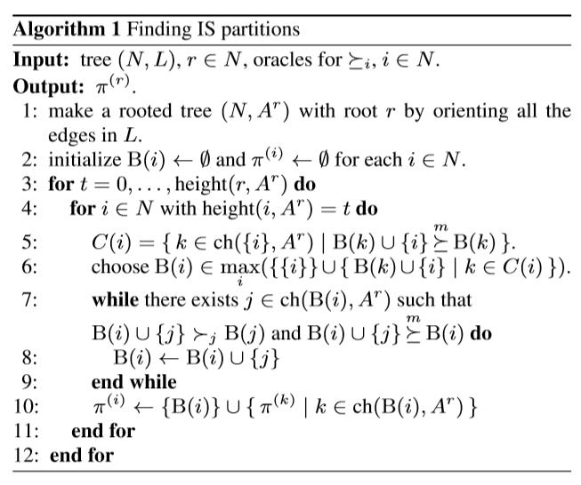

* For each i ∈ N, j ∈ succ(i, Ar) and all X ∈ π(i)∪{∅} there is no IS feasible deviation of j from π(i)(j) to X.
* Suppose that the graph(N, L) contains a cycle C = {i1,i2,...,ik} with k ≥ 3, {ih, ih+1} ∈ L for h = 1,2,...,k, where ik+1 := i1. Then, we can choose preference relations (>i)i∈N so that the set of IS feasible partitions of the game (N, (>i)i∈N, L) is empty.
* For the class of hedonic graph games, the following statements are equivalent.

1. (N, L) is a forest.
2. For every hedonic graph game (N, (>i)i∈N, L) there exists an individually stable feasible partition of N.

* For the class of hedonic games with graph structure, the following statements are equivalent.

1. (N, L) is a forest.
2. For every hedonic graph game (N, (>i)i∈N, L) there exists a core stable feasible partition of N.

* For the class of hedonic games with graph structure, the following statements are equivalent.

1. (N,L) is a forest.
2. For every hedonic graph game (N, (>i)i∈N, L), there exists a feasible partition of N that belongs to the core and is individually stable.

* Suppose that we are given oracle access to the preference relations >i of all players in a hedonic graph game G = (N, (>i)i∈N, L),where (N, L) is a forest. Then we can ﬁnd a core stable feasible outcome of G in time polynomial in the number of connected subsets of (N, L).
* Suppose that we are given oracle access to the preference relations >i of all players in a hedonic graph game G = (N, (>i)i∈N, L), where (N, L) is a forest. Then we can ﬁnd a feasible outcome of G that belongs to the core and is individually stable in time polynomial in the number of connected subsets of (N, L).
* If one can ﬁnd a core stable feasible partition in a symmetric enemy-oriented graph game whose underlying graph is a star in time polynomial in the number of players then P=NP.
* If there exists a polynomial-time algorithm that, given a symmetric enemy-oriented graph game whose underlying graph is a star, decides whether this game has a strictly core stable feasible partition then P=NP.
* Given a symmetric additively separable hedonic graph game whose underlying graph is a star, it is NP-hard to determine whether it has a strictly core stable feasible partition.
* Suppose that we are given oracle access to the preference relations >i of all players in a hedonic graph game G = (N, (>i)i∈N, L), where (N, L) is a forest. Then we can decide whether G admits a Nash stable, in-neighbor stable or IR in-neighbor stable feasible outcome (and ﬁnd one if it exists) in time polynomial in the number of connected subsets of (N, L).
* 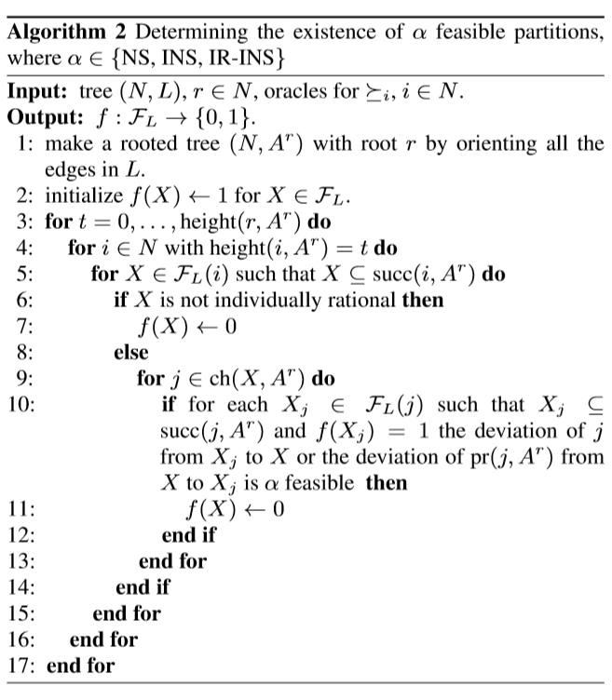
* Given an additively separable hedonic graph game whose underlying graph is a star, it is NP-complete to determine whether it has an in-neighbor stable feasible partition.
* Given an additively separable hedonic graph game whose underlying graph is a star, it is NP-complete to determine whether it has a Nash stable feasible partition.
* Every hedonic graph game (N, (>i)i∈N, L) where (N, L) is a star has an IR-in-neighbor stable partition, and givenoracleaccesstotheplayers’preferencerelations,suchapartition can be found using O(|N|3) oracle calls.
* Given a symmetric additively separable hedonic graph game whose under lying graph is a star, it is PLS-complete to ﬁnd an in-neighbor stable feasible partition.
* Given a symmetric additively separable hedonic graph game whose underlying graph is a star, it is PLS-complete to ﬁnd a Nash stable feasible partition.
* A Nash stable feasible outcome of a symmetric enemy-oriented game on a star can be computed in polynomial time
* 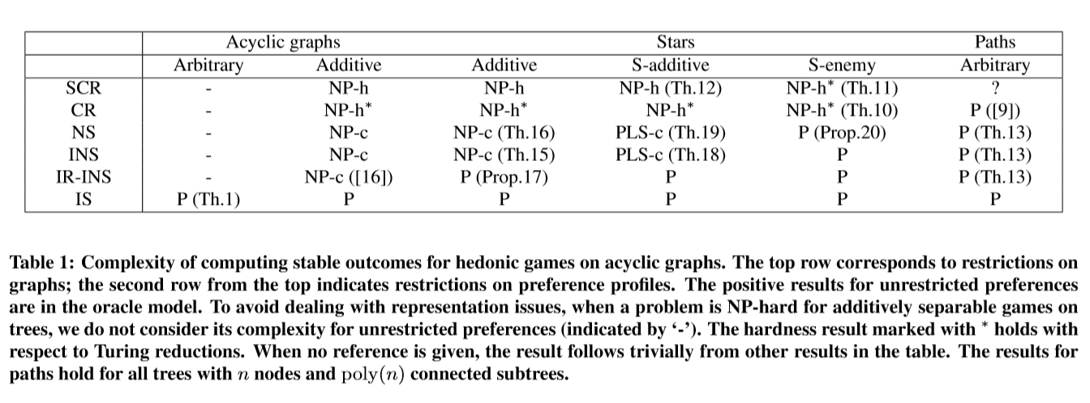

Open Problems:

* It remains unknown whether a strictly core stable partition for a hedonic game on a tree can be computed in time polynomial in the number of connected coalitions.
* Checking if our algorithms can be extended to graphs that are “almost” acyclic.
* if there are constraints on the communication structure other than acyclicity that lead to existence/tractability results for common hedonic games stability concepts.

# **7. Local Fairness in Hedonic Games via Individual Threshold Coalitions:**

We introduce and systematically study local fairness notions in hedonic games by suitably adapting fairness notions from fair division. In particular, we introduce three notions that assign to each player a threshold coalition that only depends on the player’s individual preferences. A coalition structure (i.e., a partition of the players into coalitions) is considered locally fair if all players’ coalitions in this structure are each at least as good as their threshold coalitions. We relate our notions to previously studied concepts and show that our fairness notions form a proper hierarchy. We also study the computational aspects of ﬁnding threshold coalitions and of deciding whether fair coalition structures exist in additively separable hedonic games. At last, we investigate the price of fairness.

Definitions:

* The grand-coalition threshold of i ∈ N is deﬁned as

GCi = max{{i}, N}, where we maximize with respect to >=i. A coalition structure satisﬁes grand-coalition fairness (GC) if π(i) >=i GCi for every i ∈ N.

* The max-min threshold of i ∈ N is deﬁned as
* MaxMini = maxπ∈Π(N\{i}) max{{i}, minC∈πC∪{i}}, where maximization and minimization are with respect to >=i. A coalition structure π satisﬁes max-min fairness (MAX-MIN) if π(i) >=i MaxMini for every i ∈ N.
* Let G = (N, v) be an additively separable hedonic game and let π* denote a coalition structure maximizing utilitarian social welfare. Deﬁne the maximum price of min-max fairness by

Max-PoMMF(G) = max π∈Π(N), π is min-max fairSW(π∗)/SW(π)

Results:

* An individually rational or core-stable coalition structure does not necessarily satisfy min-max fairness.
* Every Nash-stable coalition structure satisﬁes min-max fairness.
* Every grand-coalition fair coalition structure satisﬁes min-max fairness, yet a min-max fair coalition structure does not necessarily satisfy grand-coalition fairness.
* A strictly strong Nash-stable coalition structure does not necessarily satisfy grand-coalition fairness.
* An individually rational, Nash-stable, core stable, or strictly core-stable coalition structure does not necessarily satisfy grand-coalition fairness.
* Every max-min fair coalition structure satisﬁes grand-coalition fairness, yet a grand-coalition fair coalition structure does not necessarily satisfy max-min fairness.
* A max-min fair coalition structure does not necessarily satisfy contractually individual stability or core stability.
* A grand-coalition fair or min-max fair coalition structure does not necessarily satisfy contractually individual stability or core stability.
* A max-min fair, grand-coalition fair, or min-max fair coalition structure does not necessarily satisfy Nash stability, Pareto optimality, strictly strong Nash stability, strict core stability, utilitarian social welfare, or perfectness.
* A max-min fair coalition structure does not necessarily satisfy envy-freeness by replacement or egalitarian social welfare.
* A grand-coalition fair or min-max fair coalition structure does not necessarily satisfy envy-freeness by replacement or egalitarian social welfare.
* An individually rational, Nash-stable, core stable, strictly strong Nash-stable, or strictly core-stable coalition structure does not necessarily satisfy max-min fairness.
* MIN-MAX-THRESHOLD is coNP-complete.
* MIN-MAX-EXIST is NP-hard and in Σp2.
* In additively separable hedonic games, for every i ∈ N we have MaxMini = GCi.
* MAX-MIN-THRESHOLD and GRAND-COALITION-THRESHOLD are in P.
* The problems GRAND-COALITION-EXIST and MAX-MIN-EXIST are NP-complete.
* Let G=(N, v) be a symmetric ASHG of n players with vi(j) ≥ 0 for every i, j ∈ N. Then Max-PoMMF(G) ≤ n−1. In addition, this bound is tight.
* Let G = (N, v) be a symmetric ASHG. Then every coalition structure π that maximizes utilitarian social welfare satisﬁes min-max fairness.

Open Problems:

* Finding suitable restrictions to players’ valuation functions such that the maximum price of min-max fairness is bounded by a nontrivial constant.
* Identify sufﬁcient conditions that imply the existence of a fair coalition structure, determining the complexity of searching for a min-max fair coalition structure in symmetric additively separable hedonic games, and showing Σp2-hardness of MIN-MAX-EXIST.

# **2017:**

# **1. Core Stability in Hedonic Games among Friends and Enemies: Impact of Neutrals:**

In this paper, we investigate hedonic games under enemies aversion and friends appreciation, where every agent considers other agents as either a friend or an enemy. We extend these simple preferences by allowing each agent to also consider other agents to be neutral. Neutrals have no impact on her preference, as in a graphical hedonic game.

Acronyms:

* HG/E: Hedonic Game with Enemies Aversion i.e. each agent ﬁrst compares the number of enemies. Hence, without loss of generality, any coalition that contains an enemy is unacceptable. Within acceptable coalitions, she prefers coalitions with more friends.
* HG/F: Hedonic Games with Friends Appreciation i.e. each agent prefers coalitions with more friends, and in case of a tie, she prefers the one with fewer enemies.
* HG/E/SC/VERIF: verification problem of strict core under HG/E
* HG/E/SC/EXIST: existence problem of strict core under HG/E
* HG/E/C/VERIF: verification problem of core under HG/E
* HG/E/C/EXIST: existence problem of core under HG/E
* HG/F /SC/VERIF: verification problem of strict core under HG/F
* HG/F/SC/EXIST: existence problem of strict core under HG/F
* HG/F/C/VERIF: verification problem of core under HG/F
* HG/F/C/EXIST: existence problem of core under HG/F

Results:

* In an HG/E, the core can be empty.
* In an HG/F, the strict core can be empty.
* Problem HG/E/SC/VERIF is coNP-complete.
* Problem HG/E/SC/EXIST is NPNP-complete.
* Problem HG/E/C/VERIF is coNP-complete.
* Problem HG/E/C/EXIST is NPNP-complete.
* Problem HG/F/SC/EXIST is NPNP-complete.
* Given an HG/F,
  + the existence of a core-stable coalition structure is guaranteed, and
  + it can be computed in polynomial-time as the strongly connected components of graph GF = (N,AF).
* 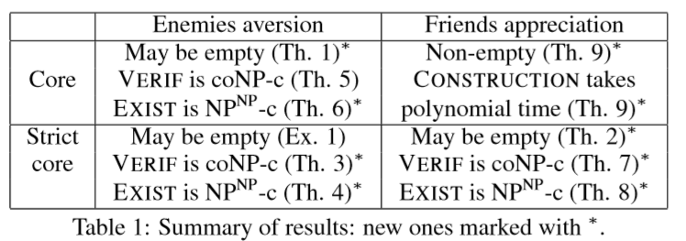

Open Problems:

* Explore assumptions that make veriﬁcation tractable, in order to bring the existence problem to class NP.
* Extend the above results to if friend/enemy relations are symmetric

# **2. Learning Hedonic Games:**

Coalitional stability in hedonic games has usually been considered in the setting where agent preferences are fully known. We consider the setting where agent preferences are unknown; we lay the theoretical foundations for studying the interplay between coalitional stability and (PAC) learning in hedonic games. We introduce the notion of PAC stability — the equivalent of core stability under uncertainty — and examine the PAC stabilizability and learnability of several popular classes of hedonic games.

Acronyms and Definitions:

* H : family of functions from subsets of players to R.
* Hn : restriction of H to functions over n players.
* PAC Stabilizability: We say that an algorithm A can PAC stabilize a class of hedonic games, if after seeing some examples, it is able to propose a partition that is unlikely to be core blocked by a coalition sampled from D.
* Additively separable hedonic games (ASHGs) are hedonic games where an agent’s utility from a coalition is the sum of utilities she assigns to other members of that coalition.
* In hedonic games with W-preferences (W-hedonic games), each player i has a preference over other players and coalition’s value is determined by the worst player in that coalition.
* B-games are the counterpart of W-games, where the value of a coalition depends on the favorite agent in that coalition. However, if two coalitions of different size share their most preferred agent, the smaller one is preferred.
* In Top Responsive games, each agents appreciation of a coalition depends on the most preferred subset within the coalition. More formally, let the choice sets of agent i in coalition S ∈Ni be deﬁned by Ch(i, S) := {X ⊆ S : ∀Y ⊆ S, i ∈ Y : X is preferred over Y}.

If |Ch(i, S)| = 1, we denote the only element of Ch(i, S) by ch(i, S). A game satisﬁes top-responsiveness if:

1. For all i ∈ N and S ∈ Ni, |Ch(i, S)| = 1
2. For all i ∈ N and S, T ∈Ni:
   1. If ch(i, S) is preferred to ch(i, T) then S ­is preferred to T
   2. If ch(i, S) = ch(i, T) and S ⊂ T, then S ­is preferred to T.

Results:

* hypothesis class H is (ε, δ) PAC learnable using m samples, where m is polynomial in Pdim(H), 1/ε and log(1/δ) by giving a hypothesis v* consistent with the sample, i.e. v*(Si) = v(Si) for all i. Furthermore, if Pdim(H) is super polynomial in n, H is not PAC learnable.
* The class of additively separable hedonic games is PAC learnable.
* The class of additively separable hedonic games is not PAC stabilizable.
* The class of Fractional Hedonic Games is PAC learnable, but not PAC stabilizable.
* The class of all representation functions of W-hedonic games is efﬁciently PAC learnable.
* B-hedonic games with arbitrary representation functions are efﬁciently PAC learnable.
* The class of B-games with arbitrary representation functions is not PAC stabilizable.
* Top Responsive hedonic games with informative representation functions are not PAC learnable.
* Top Responsive hedonic games with informative representation are efﬁciently PAC stabilizable.

Algorithm 1 PAC stabilized Top Responsive Games:

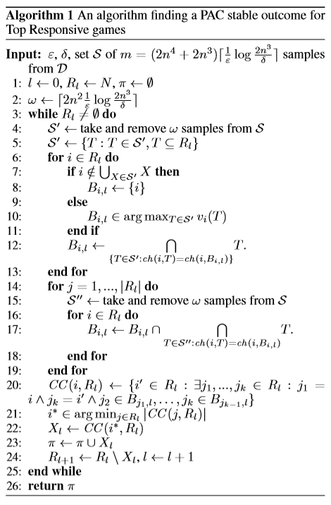

* 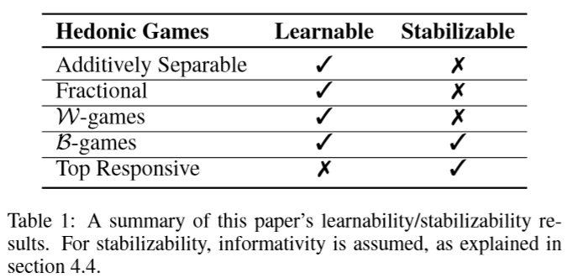

Open Problems:

* One interesting direction for future work would be using structural restrictions: recent works study hedonic games where agent preferences follow a graph structure [Igarashi and Elkind, 2016]. It would be useful to see whether certain graphical assumptions imply PAC stabilizability. Furthermore, while our work studies the core, one can focus on other hedonic solution concepts.
* Empirical evaluation of hedonic games, a further step towards their implementation in real-world systems.

# **2018:**

# **1. Stable Outcomes in Modified Fractional Hedonic Games:**

In coalition formation games self-organized coalitions are created as a result of the strategic interactions of independent agents. For each couple of agents(i, j), weight wi, j = wj, i reflects how much agents i and j benefit from belonging to the same coalition. We consider the modified fractional hedonic game, that is a coalition formation game in which agents’ utilities are such that the total benefit of agent i belonging to a coalition (given by the sum of wi,j overall other agents j belonging to the same coalition) is averaged overall the other members of that coalition, i.e., excluding herself.

We consider common stability notions, leading to strong Nash stable outcomes, Nash stable outcomes or core stable outcomes: we study their existence, complexity and performance, both in the case of general weight sand in the case of 0-1 weights. In particular, we completely characterize the existence of the considered stable outcomes and show many tight or asymptotically tight results on the performance of these natural stable outcomes for modified fractional hedonic games, also highlighting the differences with respect to the model of fractional hedonic games, in which the total benefit of an agent in a coalition is averaged over all members of that coalition, i.e., including herself.

Acronyms and Definitions:

* MFHG: Modified Fractional Hedonic Games
* SW: Social Welfare
* SN: Strong Nash
* PoA: Price of Anarchy
* PoS: Price of Stability
* SPoA: Strong Price of Anarchy
* SPoS: Strong Price of Stability
* CPoA: Core Price of Anarchy
* CPoS: Core Price of Stability

Results:

* There exists a star graph G containing only nonnegative edge-weights such that MFHG admits no 2-strong Nash stable outcome.
* For any coalition structure C, there exists a coalition structure C′ containing only basic coalitions and such that SW(C′) ≥ SW(C).
* Given an unweighted graph G, there exists a polynomial time algorithm for computing a coalition structure C*­ maximizing the social welfare.
* Given an unweighted graph G, it is possible to compute in polynomial time an outcome C ∈ n−SN and such that SW(C) = SW(C∗).
* The strong price of anarchy for unweighted graphs is 2.
* There exists a graph G containing edges with negative weights such that its MFHG admits no Nash stable outcome.
* For any weighted graph with non-negative edge weights G, PoA(MFHG(G)) ≤ n−1.
* There exists a weighted star G with non-negative edge weights such that PoS(MFHG(G)) = Ω(n).
* Given any graph G = (N, E, w), there exists a polynomial time algorithm for computing a core stable coalition structure C such that SW(C) ≥ ½*SW(C*(MFHG(G))) and all coalitions in C are of cardinality at most 2.
* For any graph G, CPoS(MFHG(G)) ≤ 2.
* For any ϵ > 0,there exists a weighted graph G such that CPoS(MFHG(G)) ≥ 2−ϵ.
* For any unweighted graph G, CPoS(MFHG(G)) = 1.
* For any graph G, CPoA(G(G)) ≤ 4.
* For any unweighted graph G, CPoA(MFHG(G)) = 2.

Open Problems:

* Reduce the gap between the lower bound of 2 for the core price of stability and the upper bound of 4 for the core price of anarchy.
* Complexity of computing an optimal outcome when the graph is weighted.
* Designing truthful mechanisms for MFHGs that perform well with respect to the sum of the agents’ utility.
* Adopting different social welfare functions like maximizing the minimum utility among the agents.

# **2019:**

# **1. Hedonic Diversity Games:**

Here we only study the classic Red-Blue agents diversity game. Each agent is either red or blue and has single peaked preferences. For this game, we present an algorithm to find Individually Stable outcome that runs in polynomial time.

Results:

* Core Stability: may be empty
* Individual Stability: always exists and can be computed in O(|N|4) time where N is the set of agents

Algorithm to find Individual Stable Outcome is divided into three parts:

1. For agents with peaks greater than half, make mixed coalitions with red majority. For agents with peaks smaller than half, make mixed coalitions with blue majority. (HALF(R, B, (>i)**i∈RUB)**)
2. Make pairs from the remaining red agents and blue agents who are not in the mixed coalitions.
3. Put all the remaining agents into singletons.

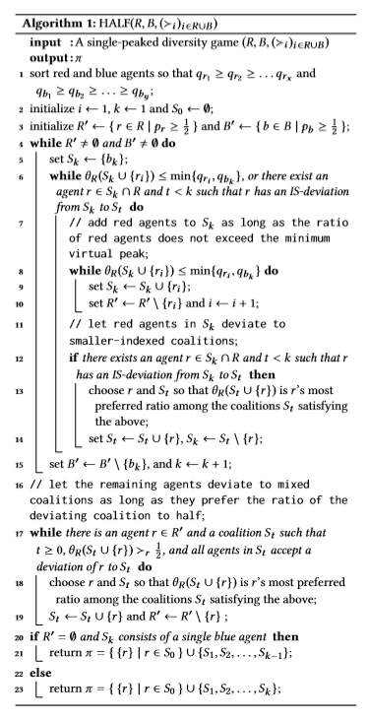 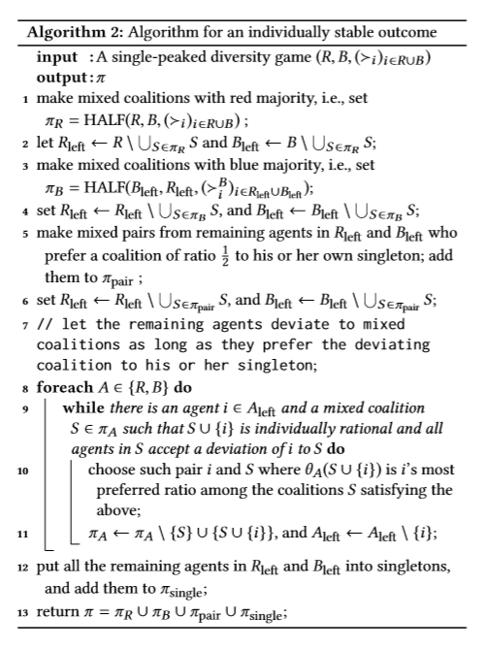

First, while we have argued that Nash stable outcomes may fail to exist, the complexity of deciding whether a given diversity game admits a Nash stable outcome remains unknown. Also, we have obtained an existence result for individual stability under the assumption that agent’s preferences are single-peaked, but it is not clear if the single-peakedness assumption is necessary; in fact, we do not have an example of a diversity game with no individually stable outcome. In a similar vein, it would be desirable to identify further special classes of diversity games that admit core stable outcomes. More broadly, it would be interesting to extend our model to more than two agent types. Another possible extension is to consider the setting where agents are located on a social network, and each agent’s preference over coalitions is determined by the fraction of her acquaintances in these coalitions; this model would capture both the setting considered in our work and fractional hedonic games

# **2. Unknown Agents in Friends Oriented Hedonic Games: Stability and Complexity:**

Here we study existence of individual and core stabilities under the presence of unknown agents, friends and enemies. let N denote set of agents. For each individual i ∈ N, we have three sets which are subsets of N\{i}. Set of friends, set of enemies and set of unknown agents.

We consider three types of games.

1. HG/F: hedonic game in which unknown agents have no effect on preference of an agent.
2. HG/F+: hedonic game in which unknown agents have positive effect i.e. in case of tie between two coalitions having same number of friends and enemies, the agent prefers the coalition that has higher unknown agents.
3. HG/F-: hedonic game in which unknown agents have negative effect i.e. in case of tie between two coalitions having same number of friends and enemies, the agent prefers the coalition that has lower unknown agents.

In these three games, we find the time-complexity of finding the existence of individual stability and core stability denoted by HG/F(+, -)/IS(C)/EXIST and time-complexity of verifying the solution denoted by HG/F(+, -)/IS(C)/VERIF.

Results:

* HG/F/IS/EXIST: individual stability may not exist
* HG/F/IS/VERIF: polynomial time
* HG/F/C/EXIST: always exists and can be found in polynomial time
* HG/F/C/VERIF: polynomial time
* HG/F+/IS/EXIST: may not exist and NP-complete
* HG/F+/IS/VERIF: NP-complete
* HG/F+/C/EXIST: core may be empty. NP^NP-complete
* HG/F+/C/VERIF: Co-NP-complete
* HG/F-/IS/EXIST: always exists
* HG/F-/IS/VERIF:
* HG/F-/C/EXIST: always exists and polynomial times
* HG/F-/C/VERIF: polynomial time

We proved that three distinct extensions of the existing preference lead to a diverse stability and complexity landscape. With extraverted agents, we provided counterexamples showing that both core and individually stable coalition structures may not exist, whereas the strict core is guaranteed in the presence of introverted agents. Then we proved that deciding the existence of such outcomes is NPNP-complete for core stability and NP-complete for individual stability. We also proved that an individually stable coalition structure may not exist under friends appreciation with neutrality. An open question is to prove the complexity of deciding the existence of individual stable outcomes under friends appreciation with neutrality.

# **3. Local Core Stability in Simple Symmetric Fractional Hedonic:**

Here we study local core stability in simple symmetric fractional hedonic games. The input is an unweighted undirected graph G where vertices are the agents and edges model social connection (i.e., acquaintance) among agents. We assume that if there is an edge between two agents then they value 1 each other otherwise they value 0 each other, i.e., we consider the simple setting where an agent values 1 all and only her acquaintances. A coalition structure is a partition of the agents into coalitions where the utility of an agent is equal to the number of agents inside her coalition that are valued 1 divided by the size of the coalition.

It is shown that simple symmetric fractional hedonic games may not admit core stable outcome. Hence, we are looking for local core stable outcome. A coalition structure is said to be local core if following conditions are met:

1. if there is no subset of agents which induces a clique in the graph G
2. if there is no subset of agents such that all agents can improve their utility by forming a new coalition together

We showed that local core dynamics converge. Therefore, **local stable core exists for all simple symmetric fractional hedonics**.

Local core price of anarchy = (optimal social welfare)/ (social welfare of worst local core)

Local core price of stability = (optimal social welfare)/ (social welfare of best local core)

Acronyms:

* SW: social welfare
* SS-FHG: simple symmetric fractional hedonic game
* CPoA: core price of anarchy
* LCPoA: local core price of anarchy
* CPoS: core price of stability
* LCPoS: local core price of stability

Results:

* Given an instance of SS-FHG, a local core stable coalition is always 2-core stable.
* Given any fractional hedonic graph G, 2−CPoA(G(G)) ≤ 4.
* For any ϵ > 0, there exists a graph G for some instance of a SS-FHG such that it’s LCPoS(G) ≥ 2- ϵ.
* Given any graph G, LCPoS(G) ≤ 8/3.
* The following Algorithm takes a coalition structure as input and returns local core stable coalition structure:

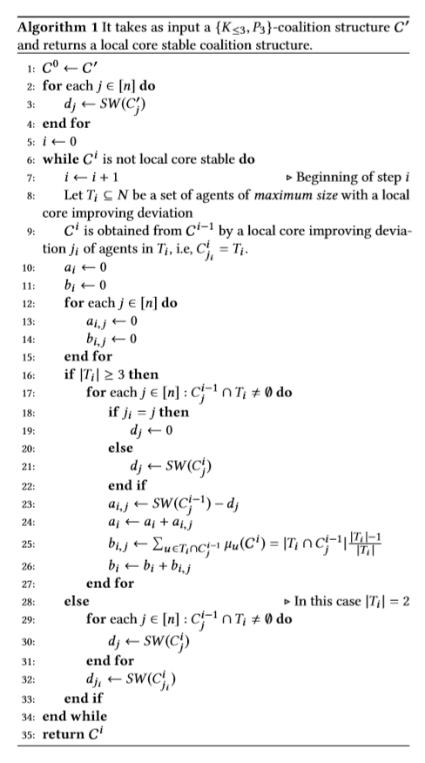

Open Problems:

* Closing the gap between the lower and upper bound of the local core price of stability.
* Next, it could be interesting to study whether any optimal coalition structure is also 2-core stable. Infact, while we proved that an optimal coalition structure may not be resilient to cliques of at least three nodes, we were not able to prove if this holds also for deviations performed by coalitions which are matchings.
* It would also be interesting to address the complexity of computing a local core in SS-FHG. Furthermore, it is worth considering complexity issues that have not been addressed in this work; for instance, even checking whether a coalition structure is in the local core or not is an open problem.
* Another interesting research direction could be that of considering the x-local core. More specifically, a coalition structure is in the x-local core if there is no subset of agents which induces a sub graph of G of diameter at most x that can all improve their utility by forming a new coalition together.

# **4. On the Performance of Stable Outcomes in Modified Fractional Hedonic Games with Egalitarian Social Welfare:**

In this paper we consider modified fractional hedonic games, that are coalition formation games defined over an undirected edge weighted graph G = (N, E, w),where N is the set of agents and for any edge {u, v} ∈ E, wu, v = wv, u reflects how much agents u and v benefit from belonging to the same coalition. More specifically, given a coalition structure, i.e., a partition of the agents into coalitions, the utility of an agent u is given by the sum of wu, v over all other agents v belonging to the same coalition of u averaged over all other members of that coalition, i.e., excluding herself.

We focus on common stability notions: we are interested in strong Nash stable, Nash stable and core stable outcomes. The existence of these natural outcomes for modified fractional hedonic games is completely characterized; moreover, many tight or asymptotically tight results on their performance are shown for the classical utilitarian social welfare function, that is defined as the sum of all agents’ utilities.

It is known that there exists a graph G containing edges with negative weights such that its MFHG admits not Nash stable outcome. Therefore, we focus only on graphs with positive weights

Acronyms and Definitions:

* MFHG: Modified Fractional Hedonic Game
* PoA: Price of Anarchy
* PoS: Price of Stability
* SW: Social Welfare
* CPoA: Core Price of Anarchy
* CPoS: Core Price of Stability
* SPoS: Strong Price of Stability
* Star-Coalition: Given a graph G, a star-coalition structure is a coalition structure C = {C1,. . .,Cn} in which, for i ∈ [n], every non-empty Ci is such that G(Ci) is isomorphic to a star graph, i.e., G(Ci) = (Ci, Ei) such that there exist (i) a node u ∈ Ci, called center, with degree |Ci|−1 and (ii) |Ci|−1 nodes with degree 1 and connected to node u, called leaves.

Results:

* There exists an unweighted path G such that PoA(G) ≥ n−1
* For any weighted graph G, PoA(G) ≤ n−1
* For any even number n ≥ 4,there exists a weighted tree G with n nodes such that PoS(G) ≥ n−1
* There exists an unweighted path G such that CPoA(G) is unbounded
* There exists a weighted path G such that CPoS(G)is unbounded
* For any k > 0, there exists an unweighted graph G with n ≥ k nodes such that n−SPoA(G) ≥ (n+1)/4
* For any unweighted bipartite graph G, n−SPoS(G) = 1
* For any unweighted graph G with maximum degree at most 2, n−SPoS(G(G)) = 1.

Algorithm1 takes a star coalition structure as input and returns a strong Nash equilibrium

Algorithm2 takes as input a bipartite graph G = (A∪B,E) and returns a star-coalition structure

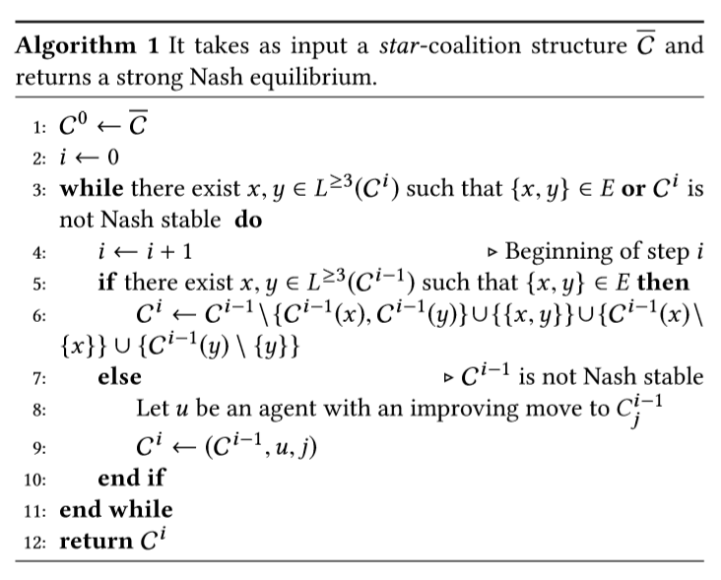 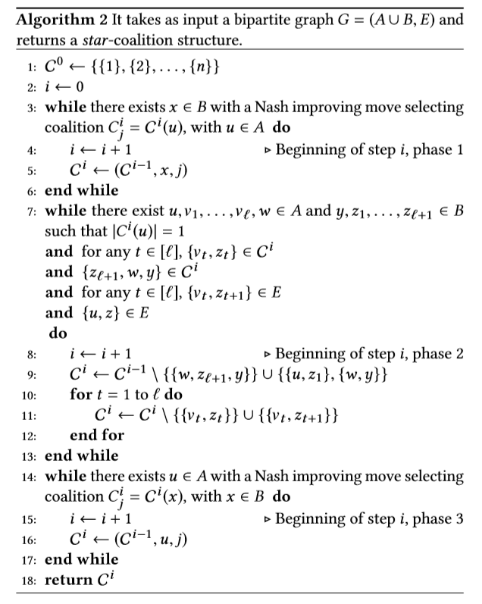

Open Problems:

* Determining the strong price of stability, and also the price of stability and the core price of stability, for unweighted graphs which are neither bipartite nor of maximum degree at most two.
* Designing truthful mechanisms for MFHG that perform well under the egalitarian social welfare function.

# **5. Stability in FEN-Hedonic Games for Single-Player Deviations:**

Here we consider hedonic games in which each agent considers other agents as either friends, enemies or neutral agents. We settle several open cases in complexity analysis of stability concepts based on single-player deviations.

Acronyms and Definitions:

* FEN-HG: A FEN-hedonic game is a pair consisting of a set of agents A = {1,...,n} and a profile of preferences. Again, a coalition structure for a FEN-hedonic game is a partition of A into disjoint coalitions and we denote the set of all possible coalition structures by C(A).
* Perfect Coalition Structure: perfect if each player weakly prefers her assigned coalition to every other coalition containing her.
* Individually Rational Coalition Structure: if every player weakly prefers her assigned coalition to being alone.
* Nash stable: if no player prefers another coalition in Γ.
* Individually stable: if no player prefers another coalition in Γ and could deviate to it without harming any player in that new coalition.
* Contractually individually stable: if no player prefers another coalition in Γ and could deviate to it without harming a player in the new or her assigned coalition.

Results:

* Possible-Nash-Stability-Verification is in P.
* Possible-Individual-Stability-Verification is in P.
* Possible-Contractually-Individual-Stability Verification is in P.
* Possible-Contractually-Individual-Stability Existence is in P.
* Necessary-Individual-Stability-Existence is NP-complete.

Algorithm 1 is polynomial verifier for Possible-Nash-Stability

Algorithm 2 is polynomial verifier for Individual-Stability

Algorithm 3 is a polynomial verifier for Possible-Contractually-Individual-Stability

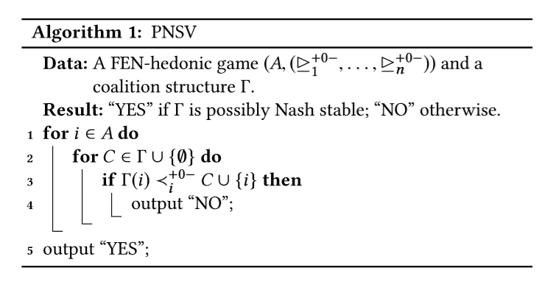

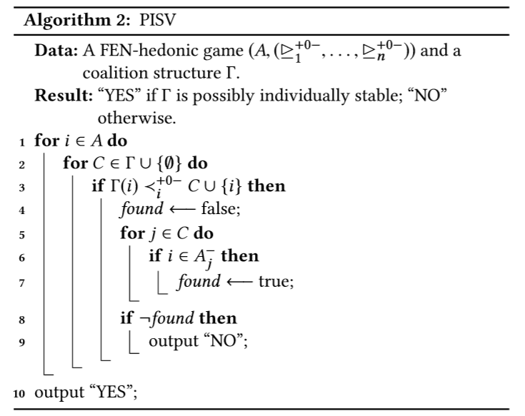

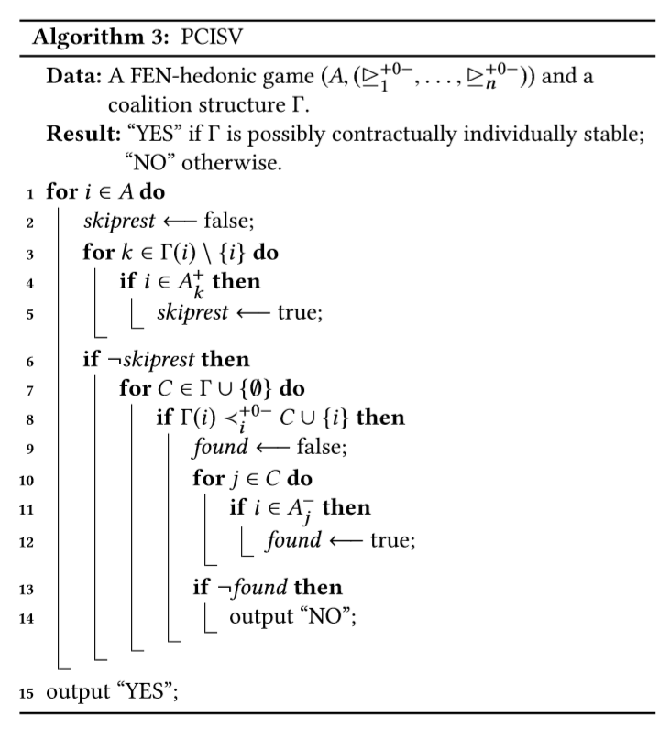

Open Problems:

* Out of the five stability concepts given above, three we are discussed in this paper. The complexity of two remaining concepts is yet to explore.
* Computational Complexity of stability problems that are based on group of players deviating from their coalitions. Core Stability and Strict Core Stability.
* Comparison of given coalition structure with another possible coalition structure. Pareto Optimality, Popularity, Strict Popularity.

# **6. Testing Individual-Based Stability Properties in Graphical Hedonic Games:**

In this paper, we initiate the study of sublinear time property testing algorithms for existence and verification problems under several notions of coalition stability in a model of hedonic games represented by graphs with bounded degree. In graph property testing, one shall decide whether a given input has a property (e.g., a­­ game admits a stable coalition structure) or is far from it, i.e., one has to modify at least an ϵ-fraction of the input (e.g., the game’s preferences) to make it have the property. We consider verification of perfection, individual rationality, Nash stability, and (contractual) individual stability.

Definitions:

* One-sided error and two-sided error: In the setting of graph properties, a graph G = (V,E) with bounded vertex degreed is ϵ-far from satisfying some property P (e.g., bipartiteness) if one has to modify at least ϵ*d*n edges to make G have property P. If the property tester always accepts graphs in P, it has one-sided error; otherwise, it has two-sided error.
* Stability Existence Property: The set of stable graphs with respect to some stability concept (e.g., Nash stability) is these to fall graphs G that admit a stable coalition structure.
* Γ-stability verification property: Let n ∈ N, and let Γ be a partition of [n].The set of Γ-stable graphs with respect to some stability concept (e.g., Nash stability) is the set of n-vertex graphs G such that Γ is a stable coalition structure of G.

Results:

* Given a FEN-hedonic game G with bounded degree d, it can be tested whether G admits a perfect coalition structure with bounded coalition size c with one-sided error and query complexity poly(ϵ, c, d).
* Given a FEN-hedonic game G with bounded degree d and a coalition structure Γ, it can be tested whether G is stable under Γ with respect to perfection, individual rationality, Nash stability, individual stability and contractual individual stability with one-sided error and query complexity poly(ϵ, d).
* Let G = (N, F∪E) be a graph that represents a FEN-hedonic game and Γ a coalition structure of N. Let, furthermore, γ be a stability concept, for which there exists a feasible player property ϕ. If there are at most k witnesses, k*d edge modifications are sufficient to make the game stable with respect to γ.
* Let γ be a stability concept for which there exists a feasible player property ϕ. It holds that Algorithm 1 is a one-sided error property tester for Γ-stability verification with respect to γ.
* For the FEN-hedonic game model, the Γ-stability verification property can be tested with respect to
  1. perfection and individual rationality with query complexity in O(d/ϵ),
  2. Nash stability, individual and contractual individual stability with query complexity in O(d/ϵ).
* Each symmetric FEN-hedonic game (all considered preference extensions) allows a Nash-stable, and consequently individually stable and contractually individually stable coalition structure.
* There is a one-sided error tester with constant query complexity for the existence of a perfect coalition structure in the FEN-hedonic game model with a constant coalition size bound.
* Algorithm1 provides a property tester for the verification problem of each stability concept with a feasible player property:

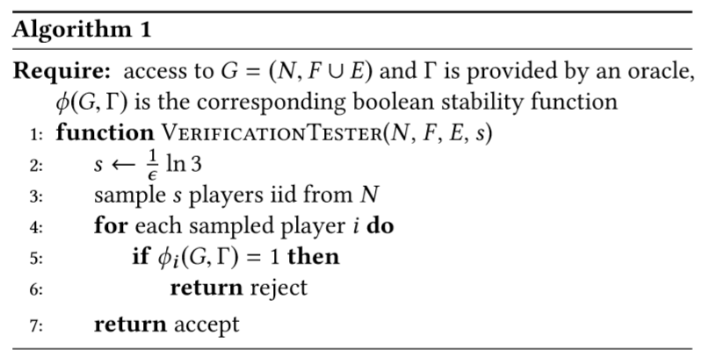

Open Problems:

* Obtain sublinear algorithms for games with unbounded coalition size.
* Obtain sublinear algorithms with different graph model like dense model, etc.,
* Obtain algorithms for property testers with two-side error.
* Studying of other stability concepts like core-stability, Pareto-optimality and popularity