Fractional Knapsack
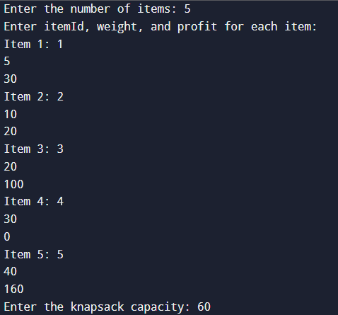
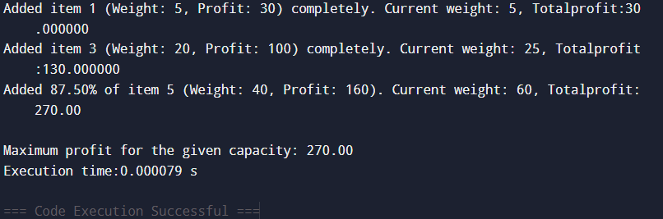

0/1 Knapsack
