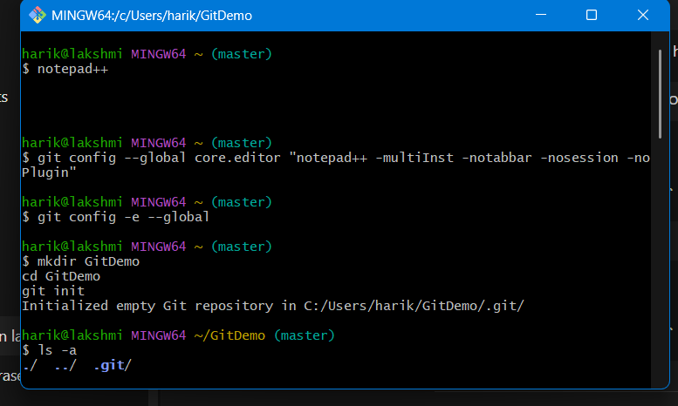

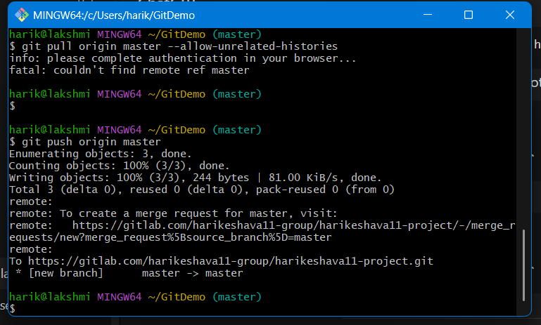

**Git Ignore**

.gitignore is a **special file in Git** where you list file names or patterns that Git should **ignore**.

Ignored files will:

* Not appear in git status.
* Not be staged or committed to the repository.

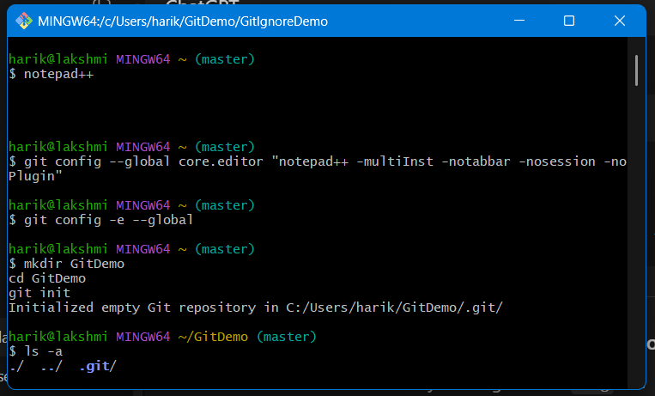

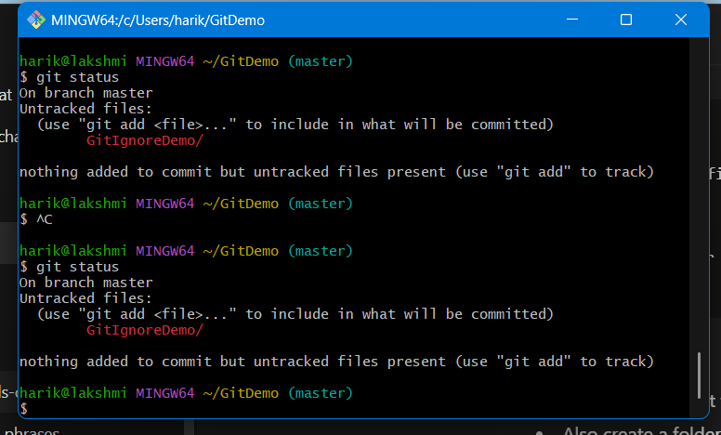

**GitNewBranch**

**Branching in Git**

* **Branching** is a way to create a separate line of development from the main code (usually master or main).
* It allows you to work on new features, bug fixes, or experiments **without disturbing the main project**.
* Example:
* git branch feature-1 # creates a new branch

git checkout feature-1 # switches to the branch

**Merging in Git**

* **Merging** is the process of combining the changes from one branch into another (commonly from a feature branch back into master).
* Git tries to automatically merge changes, but if two people edited the same part of a file, it may cause **merge conflicts** that must be resolved manually.
* Example:
* git checkout master

git merge feature-1

**Creating a Branch Request in GitLab (Merge Request initiation)**

In **GitLab**, you don’t directly request a branch. Instead, you create a **branch** in the repository and then raise a **Merge Request (MR)**. Steps:

1. Go to your project in GitLab.
2. Navigate to **Repository > Branches**.
3. Click on **New Branch**.
4. Provide a branch name (e.g., feature-login) and select the branch source (usually master).
5. Click **Create Branch**.

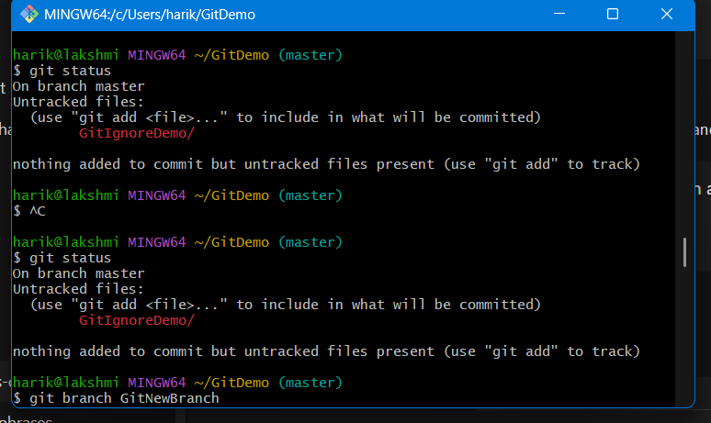

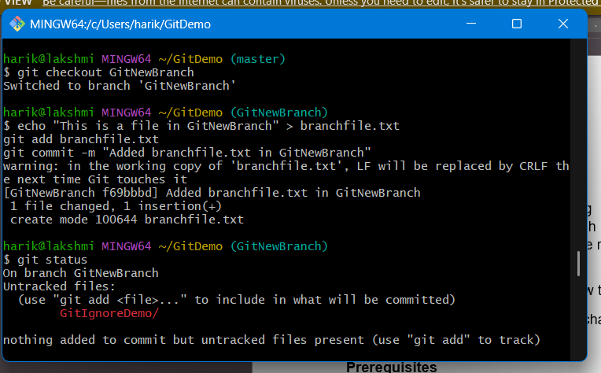

**Basic Git Workflow Demo**

* Clone repo
* Create branch
* Do changes
* Push branch
* Merge into main