Nighthawk IDS: A Python-Based Real-Time Network Intrusion Detection and Prevention System
Abhinaya M, Harikrishnan B, Preethi S, Yanamandala Yogesh
Department of Computer Science and Engineering
Kangeyam Institute of Technology, Tamil Nadu, India
Email: harikrishnan.cs23@builderscollege.edu.in
Guided by: Sasikala V, Assistant Professor
Abstract—This paper presents Nighthawk IDS, a Python-based real-time network intrusion detection and prevention system. With the rapid growth of network applications, the risk of cybercrimes and unauthorized access has increased significantly. Attackers exploit the internet to gain access without proper authorization, leading to data theft, manipulation, and leakage. The proposed system monitors network traffic using Scapy for packet sniffing and detects five attack types: SYN Scan, FIN Scan, NULL Scan, ICMP Flood, and UDP Flood. Upon detecting an attack, the system automatically blocks the attacker's IP address via the Windows Firewall using netsh commands, broadcasts a UDP alert to all subnet hosts, and displays a tkinter desktop popup notification. A Flask-based web dashboard provides real-time threat visualization, traffic anomaly logging, ARP-based device discovery, and manual block/unblock controls. The system is simple, efficient, and well suited for small-scale network environments.
Keywords—Intrusion Detection System, SYN Scan, ICMP Flood, Network Security, Packet Sniffing, Scapy, Flask, ARP Scan, Firewall Automation, Real-Time Monitoring

I. INTRODUCTION
Intrusion detection mechanisms have advanced rapidly in recent years due to the growing threat of cybercrimes. Network security has become a major concern for both individuals and organizations. Traditional security tools such as firewalls and antivirus software provide a baseline of protection, but they often require complex configurations and may not suit small-scale or individual users. Intrusion Detection Systems (IDS) and Intrusion Prevention Systems (IPS) are designed to monitor network traffic, detect suspicious activities, and take corrective action automatically.
This paper proposes a user-friendly and effective Network Intrusion Detection and Prevention System implemented entirely in Python. The system focuses on real-time monitoring of network traffic, detects potential attackers based on IP addresses and packet behavior, and responds by blocking attacker IPs through the Windows Firewall. The main goal is to develop a lightweight solution that can be deployed in small-scale environments without relying on complex traditional security infrastructure.
Beyond detection, the system also takes preventive action by blocking attacker IPs through the Windows Firewall and alerting all connected devices on the subnet via UDP broadcast. A browser-accessible dashboard built with Flask and Chart.js allows the operator to view detected threats, monitor network nodes, and manually block or unblock IP addresses. ARP scanning provides device discovery, giving administrators visibility into all active devices on the subnet. Together, these features make Nighthawk IDS a comprehensive yet lightweight solution for small-scale network security.
II. RELATED WORK
Many researchers have studied packet analysis techniques for network intrusion detection systems (NIDS), particularly using machine learning approaches. One of the earliest open-source NIDS is Snort [1], a signature-based system that identifies attack patterns in real time. While highly effective, Snort requires considerable configuration and maintenance, making it less practical for small environments.
Suricata improved upon Snort by adding multi-processor support and increased throughput [2]. Both systems operate primarily as detection engines and do not include built-in automated firewall response mechanisms.
Liao et al. [3] conducted a comprehensive review of machine learning techniques for anomaly-based intrusion detection. Their work highlights that signature-based detection systems tend to be more reliable in controlled environments such as small businesses and educational institutions, although they are limited to detecting previously defined attack patterns.
Vinayakumar et al. [4] proposed deep learning-based NIDS architectures that achieve very high accuracy on the NSL-KDD dataset. However, these approaches require substantial training data and computational resources, which limits their applicability in resource-constrained environments.
In contrast to prior work, the proposed system combines Scapy-based packet analysis with automated firewall response and subnet-wide broadcast alerting. This combination provides an efficient and practical approach to network intrusion detection without the overhead of machine learning models.
III. PROPOSED SYSTEM
A. System Overview
Nighthawk IDS is a Python-based real-time network intrusion detection and prevention system that runs on a Windows host. It monitors all incoming and outgoing packets on the local subnet and is designed around three core objectives: detect attacks quickly, respond automatically without human intervention, and provide a clear interface for network monitoring and manual control.
Detection is based on packet-level signatures for five attack types: SYN Scan (abnormal TCP SYN flag patterns), FIN Scan (TCP FIN-only packets), NULL Scan (packets with no TCP flags), ICMP Flood (high-volume ICMP Echo Requests from a single source), and UDP Flood (high-rate UDP packets from a single source). Each attack type has specific threshold-based rules defined in the detection engine.
The architecture follows a pipeline model with six primary components. Scapy handles raw packet capture, feeding each packet into the Detection Engine. When an attack is confirmed, the Alert System sends a UDP broadcast to all subnet hosts and displays a GUI popup notification. The Firewall Blocking module calls the netsh command to create a Windows Firewall rule blocking the attacker IP. The ARP Scanner module periodically discovers active devices and maps IP addresses to MAC addresses. All data flows to the Flask Dashboard, where the operator can monitor activity and manage blocked IPs.
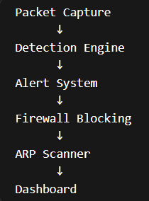
Fig. 1. System Architecture Diagram
B. Methodology
Packets are captured using Scapy's sniff() method in a separate thread, allowing the Flask server to run without interruption. Each captured packet is inspected for TCP flag anomalies or whether ICMP/UDP traffic volume from a single source exceeds a predefined threshold. Once an attack is detected, the attacker's IP is added to a global hostile IP list, a Windows Firewall rule is created via netsh, a UDP broadcast alert is sent to port 9999 on the subnet, and a tkinter popup notification appears on the host desktop.
In our implementation, we observed that the detection engine consistently responds within one to two seconds of an attack beginning, which is fast enough for practical use in small network environments. The ARP scanner runs in a separate thread and continuously monitors the subnet (192.168.1.0/24) using Scapy's ARP request method. Each discovered host is recorded with both its IP and MAC address. Block and unblock operations are performed by executing Windows Firewall commands through Python's subprocess module.
C. Modules
The system consists of seven modules. The Packet Sniffing Module captures raw network traffic using Scapy as a background thread. The Detection Engine analyzes packets against a signature rule set and maintains per-IP threshold counters. The Alert Module broadcasts alerts via UDP and creates popup notifications using the tkinter library. The Firewall Module uses netsh commands to block or unblock TCP/UDP connections from specific IPs. The ARP Scanner Module scans the local network to discover devices and retrieve their MAC addresses. The Flask Web Server renders the dashboard and exposes REST endpoints for frontend communication. Finally, the Dashboard Frontend displays a donut chart of threats, a traffic anomaly log, a list of local network devices, and hostile IP block/unblock controls.
IV. RESULTS AND DISCUSSION
The system was tested using four authorized devices and two simulated attacker virtual machines. Scapy scripts running on the test VMs generated controlled attack traffic. During testing, we observed that the system reliably detected all five attack types and responded within approximately two seconds in each case. The following subsections describe the behavior of the system across each test scenario.
A. Normal State
When no attacks are present, the Threat Distribution Chart on the dashboard appears completely cyan, indicating that all monitored traffic is safe. The Hostile IP Tracking panel displays "SECURE — NO THREATS" in green. No anomalies appear in the Traffic Anomalies log, and the ARP Scanner and Packet Sniffer continue running silently in the background.
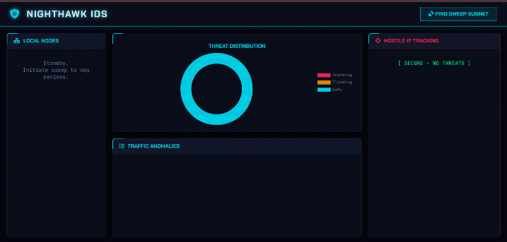
Fig. 2. Dashboard in Normal (No Threat) State
B. Intrusion Detection
A SYN scan was launched from 192.168.1.101. After approximately two seconds, the detection engine flagged it, turning the donut chart red to indicate scanning activity. The Hostile IP Tracking panel recorded 192.168.1.101 with the label "SYN Scan" and displayed a BLOCK button. The Traffic Anomalies log recorded the event with a timestamp, source IP, and detection type. An ICMP Flood from 192.168.1.102 was subsequently detected as well, causing the chart to display both scanning and flood traffic simultaneously.
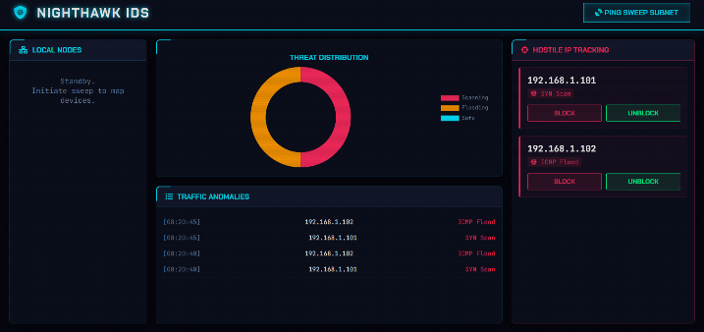
Fig. 3. Dashboard During Active Intrusion Detection
C. Alert Log System
The traffic anomaly log records all detected events in chronological order. Each entry includes the timestamp, source IP address, and the type of attack detected. During testing with simultaneous attacks from two sources, the log showed alternating entries for ICMP Flood from 192.168.1.102 and SYN Scan from 192.168.1.101, updating every five seconds as new detections occurred. The log remains active and scrollable throughout the session.

Fig. 4. Traffic Anomaly Log with Multiple Entries
D. Popup Notification
Whenever a new attacker IP is identified, a tkinter popup dialog appears on the host desktop displaying "ATTACKER DETECTED!" along with the attacker's IP address. This ensures the operator is immediately notified even if they are not watching the dashboard. During testing, popup notifications appeared one to two seconds after an attack was launched, which we found to be a responsive and practical alert mechanism.
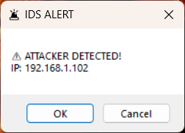
Fig. 5. Popup Alert Notification
E. Network Device Monitoring
After running the Ping Sweep Subnet function, the Local Nodes panel populated with all discovered devices, showing their IP and MAC addresses. The ARP-based discovery successfully identified all four legitimate devices on the test network along with the two attacker VMs. The panel updates dynamically as the ARP scanner completes each sweep cycle.
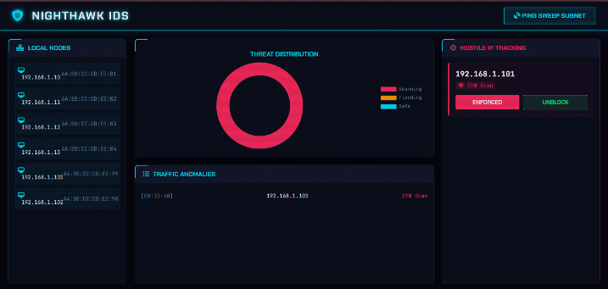
Fig. 6. Local Nodes Panel After Network Scan
F. Threat Visualization
The donut chart provides a real-time visual summary of the network threat status using three colors: red for scanning attacks (SYN/FIN/NULL), orange for flood attacks, and cyan for safe traffic. During combined attacks, the chart showed roughly equal portions of red and orange, indicating simultaneous scanning and flooding activity. The chart updates continuously via the dashboard's polling system at approximately 500-millisecond intervals.
V. ADVANTAGES
Nighthawk IDS offers several practical advantages over existing tools in its category. The system is entirely Python-based and requires no proprietary software or expensive licenses, making it accessible for academic and small business environments. Automated firewall blocking reduces the response window by eliminating the need for manual intervention during the initial stages of an attack.
The UDP broadcast alert system notifies all nodes on the subnet simultaneously, which is especially useful in environments without a centralized logging server. Real-time detection via Scapy packet sniffing means threats are identified as they occur, enabling faster response. The web-based Flask dashboard allows users to monitor network state and manage responses without any prior cybersecurity expertise.
The system combines both detection and prevention in a single platform. Once an intrusion is detected, the user can immediately block the attacker through the dashboard interface, providing a seamless transition from detection to prevention. The multi-threaded design ensures that detection, alerting, and the web server operate independently without blocking one another. The ARP scanner further complements threat data with real-time network topology awareness.
VI. LIMITATIONS
The current implementation has several limitations. The detection rules are entirely signature and threshold-based, which means novel or low-and-slow attacks may go undetected. The system is designed specifically for Windows environments due to its reliance on netsh for firewall management, limiting cross-platform usability without significant modifications.
Encrypted traffic analysis is beyond the scope of the current version, so attacks tunneled through HTTPS or VPN connections will not be detected. The threshold values used for flood detection are static and may require manual tuning for different network conditions. False positives can also occur in networks with legitimate high-volume traffic patterns that resemble flood attacks.
VII. FUTURE WORK
Several directions exist for extending the capabilities of Nighthawk IDS. A machine learning component could be integrated alongside the existing signature rules to enable anomaly-based detection, allowing the system to identify previously unseen attack patterns. Cross-platform support could be achieved by replacing the netsh-based blocking with platform-agnostic firewall libraries such as iptables wrappers on Linux.
Distributed monitoring, where multiple Nighthawk agents report to a central dashboard, would make the system suitable for larger network deployments. Dynamic threshold tuning based on baseline traffic profiling would help reduce false positives. Deep packet inspection techniques could be added to examine packet contents rather than relying solely on connection-level analysis, enabling detection of advanced threats such as malware communication and protocol-level attacks.
Persistent logging to a database such as SQLite or PostgreSQL would enable long-term threat analysis and reporting. Integration with email or SMS notification services could supplement the existing popup and broadcast alerts. Automated decision-making, where suspicious IP addresses are blocked instantly without user confirmation, is another promising area for future development. These enhancements would significantly improve the system's capabilities and make it suitable for more complex network environments.
VIII. CONCLUSION
This paper presented Nighthawk IDS, a real-time network intrusion detection and prevention system that combines Scapy-based packet sniffing, signature-based attack detection, automated Windows Firewall blocking, and a live Flask web dashboard. The system successfully detected SYN Scan, FIN Scan, NULL Scan, ICMP Flood, and UDP Flood attacks in a controlled test environment, responding within seconds and automatically blocking attacker IPs. The UDP broadcast alert mechanism and tkinter desktop popup notifications ensure that attacks are noticed promptly, even when the operator is not actively monitoring the dashboard.
The ARP-based network scanning provides useful device visibility, and the real-time threat distribution chart gives an intuitive summary of the network security posture. While the current version has limitations regarding encrypted traffic and cross-platform support, it demonstrates that a lightweight and practical IDS can be built using open-source Python libraries without sacrificing responsiveness or usability. Future work will focus on anomaly-based detection, distributed monitoring, and cross-platform compatibility to extend the system's applicability.
REFERENCES
[1] M. Roesch, "Snort - Lightweight Intrusion Detection for Networks," in Proc. USENIX LISA Conf., 1999, pp. 229–238.
[2] O. Kiraly, "Suricata: The Open Source IDS/IPS Engine," OISF, 2009. [Online]. Available: https://suricata.io
[3] H.-J. Liao, C.-H. R. Lin, Y.-C. Lin, and K.-Y. Tung, "Intrusion detection system: A comprehensive review," J. Netw. Comput. Appl., vol. 36, no. 1, pp. 16–24, Jan. 2013.
[4] R. Vinayakumar, M. Alazab, K. P. Soman, P. Poornachandran, A. Al-Nemrat, and S. Venkatraman, "Deep Learning Approach for Intelligent Intrusion Detection System," IEEE Access, vol. 7, pp. 41525–41550, 2019.
[5] B. Caswell and J. Beale, Snort Intrusion Detection and Prevention Toolkit. Syngress Publishing, 2007.
[6] A. Koziol, Intrusion Detection with Snort. Sams Publishing, 2003.
[7] P. Biondi, "Scapy: A Python Network Packet Manipulation Library," [Online]. Available: https://scapy.net
[8] M. Grinberg, Flask Web Development. O'Reilly Media, 2018.
[9] F. Schneider, "TCP Port Scanning Techniques," SANS Institute InfoSec Reading Room, 2001.
[10] S. Axelsson, "Intrusion Detection Systems: A Survey and T
axonomy," Tech. Rep. 99-15, Chalmers Univ. Technology, 2000.

