# **Day 1 - 16 May 2025**

**Document Name:**Day 1 - hmuvvala@ - Hari Gopal Muvvala

### **Task 1: What is SDLC?**

SDLC means **Software Development Life Cycle**. It is a process that is followed to build software step by step.

It starts from planning the software, designing how it should look, then developing (coding), testing it, and finally releasing it.

I feel it is like a structured way that helps to build software in an organized way without missing any steps.

### **Task 2: Why is SDLC Important?**

SDLC is important because it helps software teams work in a proper flow.

Instead of jumping directly to coding, it gives a proper plan — what to do first, what to do next, etc.

It also helps in avoiding mistakes, saving time, and making sure the final product is useful and working well.

### **Task 3: What are the stages of SDLC? Write 2 lines about each.**

1. **Requirement Gathering** – This is where we understand what exactly is needed in the software.
2. **Design** – We plan how the software will look and work.
3. **Development** – Actual coding happens here.
4. **Testing** – We check if the software is working properly and fix the bugs.
5. **Deployment** – The software is made available to users.
6. **Maintenance** – After launch, we fix any issues or add new features if needed.

### **Task 4: SDLC Models**

There are different SDLC models like:

* **Waterfall Model**: In this, each step is completed fully before moving to the next one.
* **Agile Model**: Work is done in small parts (called sprints), and changes can be made anytime.
* **V-Model**: Every development step has a testing step connected to it.
* **Spiral Model**: It mixes design and prototyping in small loops.

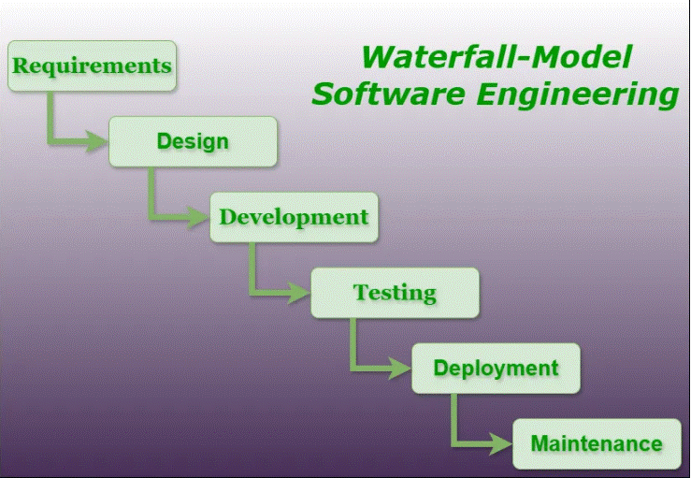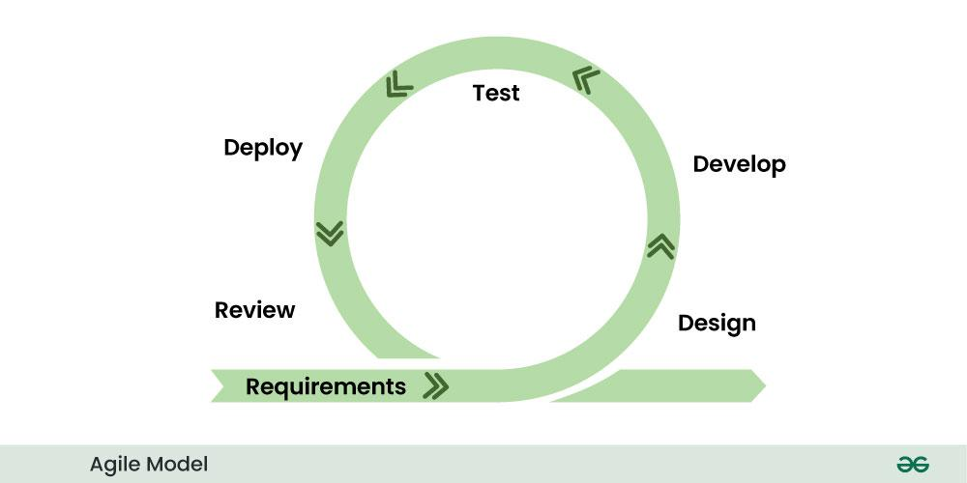

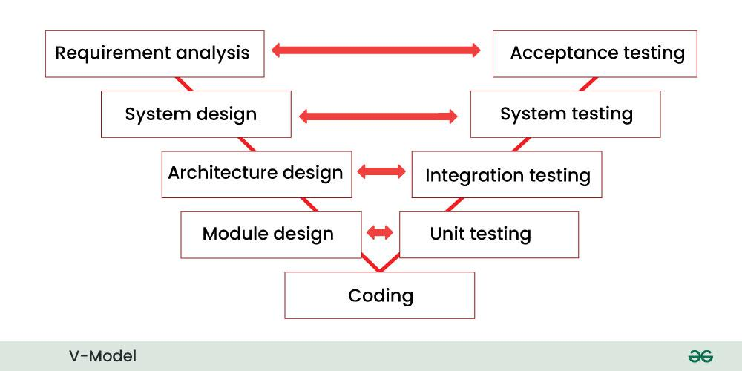

* 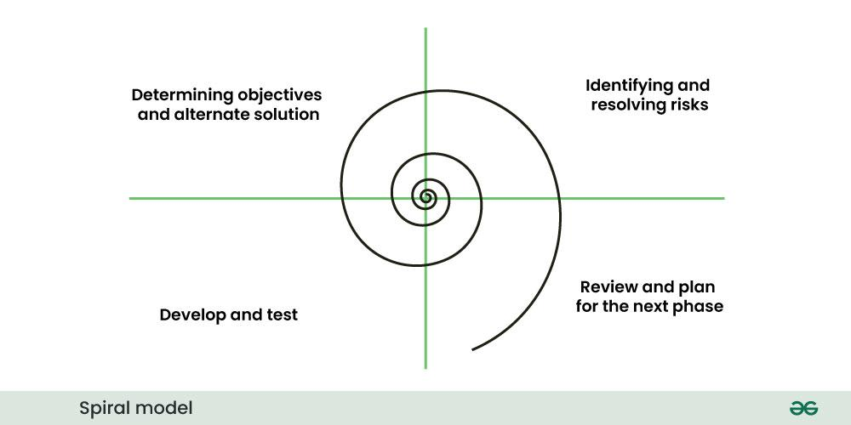

### **Task 5: Applications of SDLC**

SDLC is not only for apps and websites, but also used in creating other digital systems like:

* Banking software
* Hospital management tools
* E-commerce websites
* Mobile apps
* Government portals

It is used wherever software is involved.

### **Task 6: Advantages and Disadvantages of SDLC Models**

**Advantages**:

* Gives a clear step-by-step path
* Helps to find errors early
* Easy to manage and divide work among team members

**Disadvantages**:

* Not flexible in some models like Waterfall
* Changes are hard to include once a step is completed
* Can take more time if not followed properly

### **Task 7: What is Scrum in Agile?**

Scrum is a way of doing work in Agile where the team works in small time periods called **Sprints** (like mini-projects).

In Scrum, the team has clear roles, daily short meetings (called stand-ups), and focus on continuous improvement.

I liked Scrum because it feels more flexible and team-based.

### **Task 8: What is Sprint?**

Sprint is a small fixed time (usually 1 or 2 weeks) where the team works on a set of tasks.

The goal is to finish those tasks by the end of the sprint.

It helps in completing the work in parts and showing results faster.

### **Task 9: What are the Do’s and Don’ts of Sprint? (Write 3 points each)**

**Do’s**:

* Keep goals of the sprint clear.
* Attend daily stand-up meetings.
* Deliver the tasks by the deadline.

**Don’ts**:

* Don’t add new tasks in the middle of the sprint.
* Don’t skip communication with the team.
* Don’t miss deadlines without informing.

### **Task 10: What are Stories and Backlogs in Scrum?**

**Stories** are small descriptions of features or tasks from a user’s point of view (like “As a user, I want to reset my password”).

**Backlog** is a list of all the work to be done — like pending stories, tasks, bugs, etc.

Backlogs help the team stay on track and know what’s coming next.

### **Task 11: Scrum Artifacts – Can you brief the below?**

* **Product Backlog**: The complete list of features, bugs, and improvements for the product.
* **Sprint Backlog**: Only the tasks selected for the current sprint.
* **Burn-Down Chart**: A graph that shows how much work is left in a sprint.
* **Increment**: The working product after each sprint (small completed version).

### **Task 12: What are Ports and Protocols?**

Ports are like gates through which data enters or leaves a computer.

Protocols are rules that decide how data is shared between devices (like HTTP, FTP, etc.).

Example: Port 80 is used for websites (HTTP).

### **Task 13: What are the Different Network Types?**

There are 4 main types:

* **LAN (Local Area Network)** – like WiFi at home.
* **MAN (Metropolitan Area Network)** – used in cities.
* **WAN (Wide Area Network)** – like the internet.
* **PAN (Personal Area Network)** – like Bluetooth.

### **Task 14: What are the Types of Servers? (Write 2–3 lines)**

* **Web Server**: Delivers websites to your browser.
* **Database Server**: Stores and manages data.
* **File Server**: Stores and shares files.
* **Mail Server**: Sends and receives emails.

### **Task 15: What Do You Know About DNS (Domain Name System)?**

DNS is like a phonebook of the internet.

When I type a website name like www.amazon.com, DNS converts it into an IP address so that the computer knows where to connect.

Without DNS, we would have to remember numbers instead of names.

### **Task 16: What are the Different Network Topologies?**

Topology means how computers are connected in a network.

Some types:

* **Bus**: All devices use a single cable.

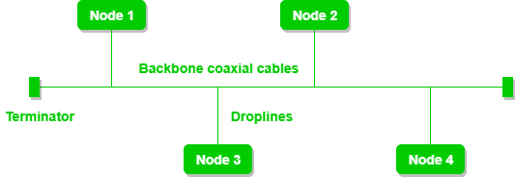

* **Star**: All devices connect to one central device.

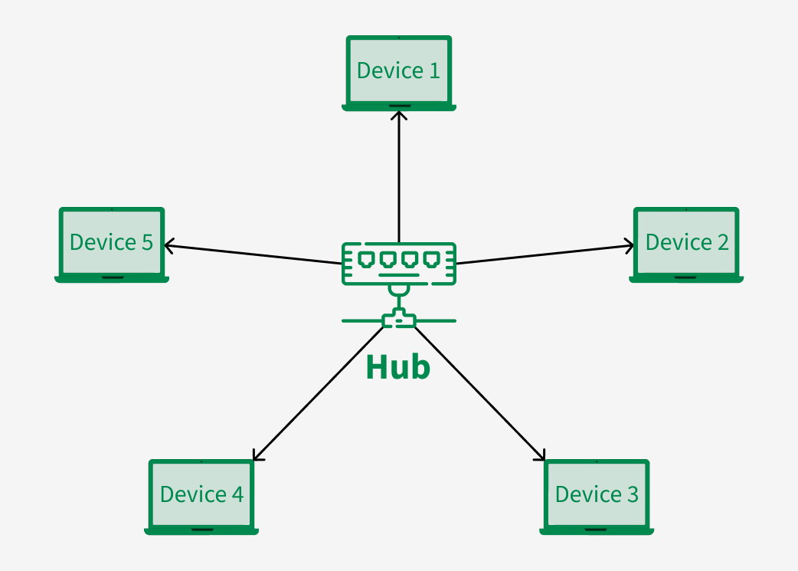

* **Ring**: Devices are connected in a circle.

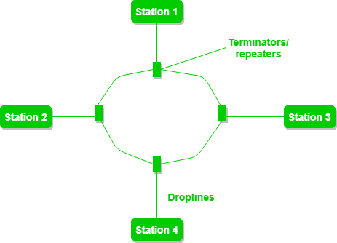

* **Mesh**: Every device is connected to every other device.

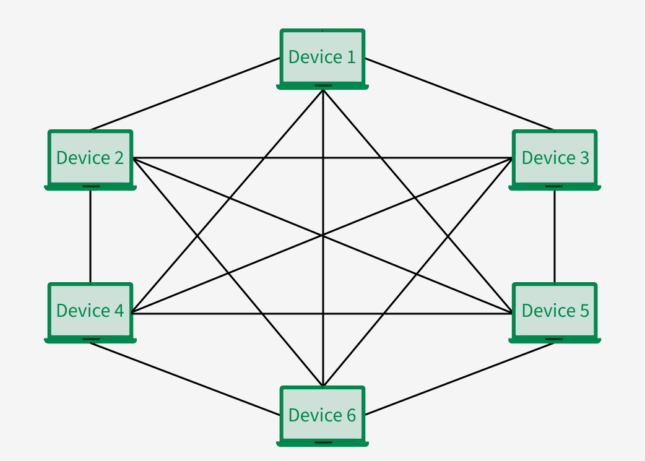

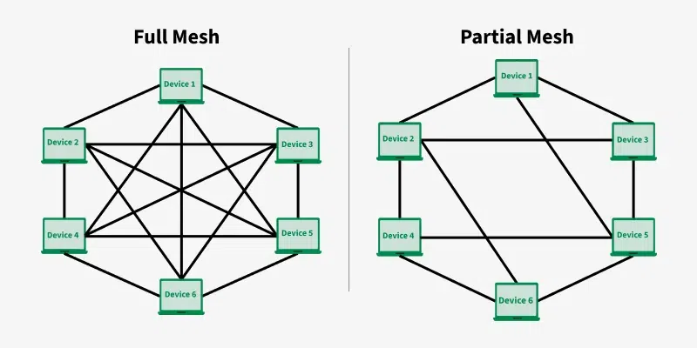

### **Task 17: What is the OSI Model? Describe 7 layers.**

OSI model shows how data moves from one computer to another. It has 7 layers:

1. **Physical** – Deals with cables and signals.
2. **Data Link** – Handles direct connections between devices.
3. **Network** – Finds the best path (IP address).
4. **Transport** – Makes sure data is complete (TCP/UDP).
5. **Session** – Starts and manages the connection.
6. **Presentation** – Converts data into readable format.
7. **Application** – Interacts with apps like browsers or email.