**DESIGN AND FABRICATION OF AUTONOMOUS ROBOT**

**FOR CROP YIELD PREDICTION AND ANALYSIS USING MACHINE LEARNING ALGORITHMS**

**18MT801- INDUSTRIAL PROJECT**

|  |  |
| --- | --- |
| ***Submitted by*** |  |
| **SUBBIAH S** | **(18EUMT102)** |
| **RISHIKESH SS** | **(18EUMT076)** |
| **VIKASHINI R** | **(18EUMT116)** |
| **SARAN C** | **(18EUMT088)** |

***In partial*** ***fulfilment of the requirements***

***For the award of degree***

***of***

**BACHELOR OF ENGINEERING**

***In***

**MECHATRONICS ENGINEERING**

**SRI KRISHNA COLLEGE OF**



**ENGINEERING AND TECHNOLOGY**

(An Autonomous Institution)

(Approved by AICTE and Affiliated to Anna University, Chennai)

ACCREDITED BY NAAC WITH ‘A’ GRADE

**MAY 2022**

**SRI KRISHA COLLEGE OF ENGINEERING AND TECHNOLOGY**

(An Autonomous Institution)

(Approved by AICTE and Affiliated to Anna University, Chennai)

ACCREDITED BY NAAC WITH “A” GRADE

**BONAFIDE CERTIFICATE**

Certified that this Industrial Project report **“DESIGN** **AND FABRICATION OF AUTONOMOUS ROBOT FOR CROP YIELD PREDICTION AND ANALYSIS USING MACHINE LEARNING ALGORITHMS”** is the bonafide work of **“RISHIKESH SS (18EUMT076), SUBBIAH S(18EUMT102), SARAN C (18EUMT102), VIKASHINI R (18EUMT116)”** who carried outthe project work under my supervision.

|  |  |
| --- | --- |
|  |  |
| **SIGNATURE**  **Dr.M.LYDIA**  Professor and Head of the Department,  Mechatronics Engineering,  Sri Krishna College of Engineering and Technology, Coimbatore – 641008. | **SIGNATURE**  **Prof. INDIRAPRIYADHARSHINI J**  Project Supervisor,  Mechatronics Engineering,  Sri Krishna College of Engineering and Technology, Coimbatore – 641008. |

This Industrial project work report is submitted for the Autonomous Project Viva-voce examination held on __________

**INTERNAL EXAMINER** **EXTERNAL EXAMINER**

**ABSTRACT**

At the current time, one of the most important sources of near-necessary progress, as well as a fundamental aspect of the growth of the Indian financial system, is agriculture. More than 70% of the Indian populace is involved in agricultural activities. Fruit spawn accounts are some of the most desirable but difficult tasks for every nation. To feed the increasing population of India, there is a need to incorporate today's technological know-how and tools within the predial sector. India is heavily dependent on agriculture. Organic, economic, and seasonal elements influence praedial yield. Estimating arable manufacturing is a tough mission for our country, in particular given the contemporary population situation , vital decision to put one's cards on the table for matters like storing and marketing

**ACKNOWLEDGEMENT**

At this juncture, we take the opportunity to convey our sincere thanks and gratitude to the management of the college for providing all the facilities to us.

We wish to convey our gratitude to our college Principal, Dr. J Janet, for forwarding us to do our project and offering adequate duration to complete our project.

We would like to express our grateful thanks to Dr. T. A Selvan, Head of the Depatment, Department of mechatronics engineering for his encouragement and valuable guidance to this project.

We express our sincere thanks to Dr. T A Selvan, project coordinator for motivating the students and for his valuable guidance towards the successful completin of the project.

We extend our gratitude to our beloved Prof. Indirapriyadharshini J, Assistant professor, Department of Mechatronics engineering for his constant support and immense help at all stages of the project.

**PROJECT CERTIFICATE**

**TABLE OF CONTENTS**

|  |  |  |
| --- | --- | --- |
| **CHAPTER NO** | **TITLE** | **PAGENO** |
|  | **ABSTRACT** | **3** |
|  | **ACKNOWLEDGEMENT** | **4** |
|  | **PROJECT CERTIFICATE** | **5** |
|  | **LIST OF FIGURES** | **8** |
|  | **LIST OF TABLES** | **10** |
| **1** | **INTRODUCTION** | **11** |
| 1.1 | INTRODUCTION | 11 |
| 1.2 | OBJECTIVE OF THE PROJECT WORK | 11 |
| 1.2 | CONCLUSION | 12 |
| **2** | **LITERATURE REVIEW** | **13** |
| 2.1 | INTRODUCTION | 13 |
| 2.2 | LITERATURE REVIEW | 13 |
| 2.3 | CONCLUSION | 17 |
| **3** | **SYSTEM DESIGN** | **18** |
| 3.1 | INTRODUCTION | 18 |
| 3.2 | FEATURES | 18 |
| 3.3 | PRE-EXISTING MODEL | 18 |
| 3.4 | BLOCK DIAGRAM | 20 |
| 3.5 | PROPOSED METHODOLOGY | 20 |
| 3.6 | PH TO NPK RELATION | 21 |
| 3.7 | CONCLUSION | 25 |
| **4** | **MACHINE LEARNING ALGORITHMS** | **26** |
| 4.1 | INTRODUCTION | 26 |
| 4.2 | PYTHON | 26 |
| 4.3 | LIBRARY USED | 27 |
| 4.4 | APPLICATION | 30 |
| 4.5 | PRE PROCESSING | 30 |
| 4.6 | TRAIN AND TESTING | 31 |
| 4.7 | ALGORITHM TESTED WITH FLOWCHART | 31 |
| 4.8 | PREDICTION USING CLASSIFICATION ALGORITHMS | 34 |
| 4.9 | PREDICT PROPAGATE | 35 |
| 4.1 | ACCURACY | 35 |
| 4.11 | CONCLUSION | 37 |
| **5** | **HARDWARE DESCRIPTION** | **39** |
| 5.1 | INTRODUCTION | 39 |
| 5.2 | 3D MODEL OF THE SETUP | 39 |
| 5.3 | TOP VIEW OF MODEL | 39 |
| 5.4 | SIDE VIEW OF MODEL | 39 |
| 5.5 | BOTTOM VIEW OF MODEL | 40 |
| 5.6 | DESIGN CALCULATION FOR CHOOSING DIMENSIONS | 41 |
| 5.7 | BENDING MOMENT CALCULATION | 42 |
| 5.8 | MOTOR TORQUE CALCULATION | 43 |
| 5.9 | THICKNESS CALCULATION | 44 |
| 5.1 | COMPONENTS USED | 45 |
| 5.11 | COMPONENTS DETAILS | 45 |
| **6** | **RESULTS AND DISCUSSION** | **55** |
| 6.1 | INTRODUCTION | 65 |
| 6.2 | WORKING PRINCIPLE | 65 |
| 6.3 | OUTPUT IMAGE | 68 |
| 6.4 | CONCLUSION | 69 |
| **7** | **CONCLUSION** | **70** |
| 7.1 | INTRODUCTION | 70 |
| 7.2 | FUTURE SCOPE | 70 |
| 7.3 | CONCLUSION | 71 |
| **8** | **REFERENCE** | **72** |
|  |  |  |

**LIST OF FIGURES**

|  |  |  |
| --- | --- | --- |
| **FIGURE NO** | **TITLE** | **PAGE NO** |
| 1.1 | ORGANIZATION OF CHAPTERS | 12 |
| 3.1 | BLOCK DIAGRAM | 20 |
| 4.1 | LINEAR REGRESSION FLOW CHART | 32 |
| 4.2 | DECISION TREE FLOWCHART | 32 |
| 4.3 | RANDOM FOREST FLOWCHART | 34 |
| 5.1 | 3D MODEL | 39 |
| 5.2 | TOP VIEW | 40 |
| 5.3 | SIDE VIEW | 40 |
| 5.4 | BOTTOM VIEW | 41 |
| 5.5 | ARDUINO UNO | 46 |
| 5.6 | PIN DIAGRAM | 47 |
| 5.6 | LAYOUT DIAGRAM OF ARDUINO | 47 |
| 5.7 | ARDUINO IDE SOFTWARE | 50 |
| 5.8 | CIRCUIT DIAGRAM | 51 |
| 5.9 | SOIL MOISTURE SENSOR | 52 |
| 5.1 | VOLTAGE SENSOR | 54 |
| 5.11 | MOTOR DRIVER | 54 |
| 5.12 | L293D PIN DIAGRAM | 56 |
|  | CIRCUIT DIAGRAM FOR L293D MOTOR DRIVER IC CONTROLLER | 57 |
| 5.13 | DC MOTOR | 58 |
| 5.14 | LCD DISPLAY | 60 |
| 5.15 | FLOW CHART OF INTERFACING LCD DISPLAY | 61 |
| 5.16 | WIFI MODULE | 62 |
| 6.1 | HANDLING MISSING VARIABLE | 65 |
| 6.2 | MSNO GRAPH | 66 |
| 6.3 | SEASONAL GRAPH | 66 |
| 6.4 | CROP YIELD GRAPH | 67 |
| 6.5 | HEATMAP OF AREA AND PRODUCTION | 67 |
| 6.6 | OUTPUT IMAGE | 68 |

**LIST OF TABLE**

|  |  |  |
| --- | --- | --- |
| **TABLE NO** | **TITLE** | **PAGE NO** |
| 3.1 | NPK TO PH RELATION | 22 |
| 3.2 | PLANT GROWTH WITH PH LEVEL | 24 |
| 3.3 | SOLUBILITY OF FERTILIZERS IN WATER | 24 |

**CHAPTER 1**

**INTRODUCTION**

**1.1INTRODUCTION:**

Growing crops in vast open fields poses unique challenges

Farmers have to analyse soil samples to determine the amount of nutrients that are needed in specific parts of the field. Using the optimum amount of nutrients can increase yields, reduce costs, and prevent surface and groundwater pollution.

Farmers usually take soil samples by hand, which is an inefficient method with a high rate of sampling errors.

Current method Consumes a Lot of Time and Money Due to Transportation, and the soil will lose its origin qualities such as NPK , pH , EC , temperature , humidity in Mean time.

This project is Deliberately Focuses on Implenting Automation in Field of Agriculture Mainly in Improving the Yield of Crops

The Moving Robot attached with Sensors will detect the pH , Moisture and N,P,K values , temperature and Rainfall.

The data is Stored in a Cloud Platform , and with the help of Obtained Data , the bot will predict the Yield and Ways to Improve the Yield using Efficient machine learning Algorithm.

Based on the Outcome , the results will be displayed and also the data can be retrieved in Android device

### 1.2OBJECTIVE OF THE PROJECT WORK

To Design and Fabricate the Autonomous Robot For Crop Yield Prediction And

Analysis Using Machine Learning Algorithm in Order to Reduce Time and Effort and To Predict the Crop Prediction

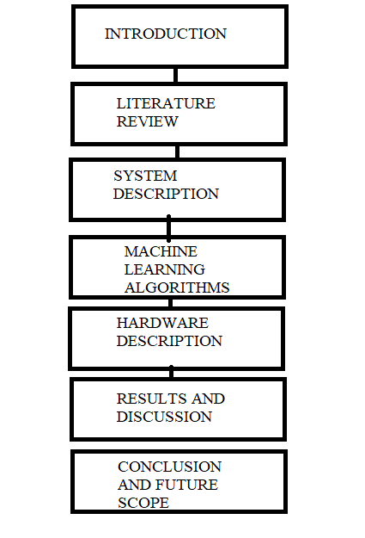

Fig 1.1 Organization of chapters

**1.3 CONCLUSION**

The objective of this project work has been framed into chapters for the development of A DESIGN AND FABRICATION OF AUTONOMOUS ROBOT FOR CROP YEILD PREDICTION AND ANALYSIS USING MACHINE LEARNING ALGORITHMS The Design calculations, Arduino programming, electronic circuits, along the photocopy of working progress have been included in the following chapters.

### CHAPTER 2

### LITERATURE REVIEW

### 2.1 INTRODUCTION:

In this project, we have designed and fabricated a Roller Bot.Before starting the project,it is important to research existing machines and the technologies used in them. This will help us understand any existing problems in such a way that they can be implemented in our project. Going through the literature also helps us to understand the practical outcomes and how to attain the required outcomes. It has been processed with the reference of the journals explained below.

**2.2 LITERATURE REVIEW**

### In GSM based Automated Irrigation Control using Raingun Irrigation System by R.Suresh, S.Gopinath, K.Govindaraju, T.Devika, N.Suthanthira Vanitha [1], system is automated microcontroller based rain gun irrigation system. Irrigation is done only when it becomes necessary to water the fields thus saving large quantity of water. Android based mobile device is used. Applications are developed on android platform using tools from android SDK in java programming language. The GPRS feature of mobile phone is used for proving solution to irrigation control problem.

### Sufficient amount of water can be given to the fields. The system sends messages using GSM. The android application is designed to overcome irrigation problems such as under irrigation and over irrigation which causes leaching and other losses in soil quality. Rain gun technique is more efficient as compared with drip system. It leads to less soil erosion and less wind erosion. Yields are increased with decrease in water and labor requirements.

### The conventional power supply is used to run the whole automated system which is less efficient and more costly compared to the solar power based system in long run. If lower land area is to be covered then the proposed system is not economical.

### In Automated Wireless Watering System (AWWS) by Chetana A.Kestikar, Rutuja M.Bhavsar [2], the system is facilitated by providing PC control and mobile control for monitoring and controlling watering activity. Also the wiring mess is reduced. The system is divided into two parts, one is PC side and the other is the hardware components on the site/field. The GUI interface is developed on .NET programming language.

### Programming is used to send message to GSM modem on site through PC and vice versa. Two modes of operation are there manual and automatic. In manual mode system will work as traditional watering system. The user decides when to start and stop watering. In automatic mode, once the system is started, the user need not pay attention to stopping of the system. The watering will be decided according to moisture levels. . The user can initiate the system by sending message to the microcontroller via the GSM modem through the program. This message being received by the microcontroller will initiate moisture sensors, water level indicator. Again the power supply used to run the whole system is conventional and thus less economical.

### In Solar Powered Smart Irrigation System by S.Harishankar, R.Satish Kumar, Sudharsan K.P, U.Vignesh, T.Viveknath [3], the solar energy from solar panels is utilized to pump water automatically from bore well directly into a ground level storage tank. Apart from the conventional techniques, the system makes efficient use of renewable energy or the irrigation module to be automatic, the water outlet valve of the tank is controlled by soil moisture sensing circuit.

### The soil moisture sensor placed in field converts moisture content of soil into equivalent voltage. The obtained equivalent voltage is given to microcontroller circuit which has a reference voltage that can be adjusted by farmer as per different moisture levels corresponding to different crops. The amount of water requisite of soil is proportional to the difference of equivalent voltage and reference voltage.

### A control signal is given to stepper motor having angle of rotation proportional to the difference in voltage. The cross section area of the valve controlling flow of water is controlled by stepper motor and hence the amount of water flow is proportional to moisture difference.

### Solar energy is harnessed using solar panel PVL-68 that generates 53W at nominal

### operating cell temperature.

### In Smart Irrigation System Autonomous Monitoring and Controlling of Water Pump by Using Photovoltaic Energy by Dhana Lakshmi.N, Gomathi K.S [4], the power supply for whole system is taken from renewable photovoltaic cells energy; it reduces the cost of power. The water supply, temperature and pH value of the soil are monitored autonomously. The water level in fields is sensed by using floating ball sensor and the pH value by using pH sensor. The low level analog signals from sensors are converted to digital signal by using IC ADC0808. This digital signal is fed to AMTEL microcontroller 89s52.

### The microcontroller will monitor the sensed values and sends the status to user’s cell phone via GSM module. For low water level in field, the temperature level goes high and temperature level on achieving certain threshold will switch the pumping motor ON.

### The hydrogen content in field is monitored by using pH sensor since every crop has a predefined pH value. The fertilizer sprinkling motor is switched ON after the pH value goes below the required pH value. Both pumping and sprinkler motor goes OFF automatically after soil has achieved required water level and pH value. The motors are operated and controlled by using GSM module through user’s mobile or manually.

### In Modern Solar Powered Irrigation System by Using ARMproposed by Basava Sidramappa Dhanne, Sachin Kedare, Shiva Sidramappa Dhanne [5], the design methodology of automated irrigation system in this paper includes the components, solar panel, arm processor, sensors, dc motors, relay, and battery. The main stress is laid on generating power supply by harnessing solar energy and reducing power consumption for irrigation purpose.

### The dc current is generated by using solar panel. This dc power is stored in a battery so as to operate the pump even during the night time. The farmer sends a text message via mobile phone so as to check the level of water storage tank and condition of moisture in filed.

### If task is complete then GSM module sends the message, “watering is complete” to the user. If the task is not complete then GSM module sends the message, ”watering not completed, lagging resources” also the state of charge of battery is sensed by charge sensor and send to ARM processor. The good thing about this work is that it also gives information about watering resources i.e. whether resources are lagging or not.

### In Solar Panel Based Automatic Plant Irrigation Systemproposed by Prof. Rupali S.Sawant, Shreejit Gubre, Swathi Pillai, Monica Jain [6], the moisture sensor unit along with the processor, GSM modem and solar panel is almost same as the previous proposed works for field irrigation. The newly added feature in this work is humidity sensor module. The humidity sensor HIH4000/HSY220 manufactured by Honeywell is used to check the temperature of surrounding.

### Temperature range going above or below the set value needed for good growth of a crop, the microcontroller directs the shedding so as to shed the field thereby maintaining the temperature need of the crop. Thus the controlled temperature as well as controlled irrigation can be provided to the crop for healthy growth. The use of solar panel makes the whole system less costly in long run.

### 2.3 CONCLUSION

### Thus, research was done regarding this project on various sources of literature. Many methodologies were studied and this information has helped to complete the project successfully.

# CHAPTER-3

# SYSTEM DESIGN

**3.1 INTRODUCTION**

In This Chapter we will Discuss about the features and the Working Principle of System in Detail

**3.2 FEATURES :**

IOT-based system embedded with Prediction Bot aiming to help Predict the crop to be yield under given circumstances which consists of

* + - * Cost Efficient
      * Mobile usability
    - Reduction of Travelling Time
    - Moving Facility
    - Weather reporting
    - Ability to display predicted values

**3.3 PRE-EXISTING MODEL**

A PRE-EXISTING SYSTEM Machine learning is an important selection support tool because of crop yield prediction and aiding choices such as crops in imitation of developing yet to be harvested according to work at some point in the thriving epoch over the crops. Several computing device education algorithms have been utilized to aid in corn yield calculation research. In this study, we conducted a Systematic Literature Review (SLR) in order to expel and synthesize the algorithms and capabilities that, to our expectation, have been chronic in fruit produce enumeration studies. Based on our enquire criteria, we retrieved more than 500 applicable studies beyond six electronic databases, as we chose 50 for further evaluation based on the use of inclusion or ban criteria. We Researched the choice studies carefully, analyzed the methods and purposes used, and supplied tips based on additional research. According to our Research, the most ancient identifiers are temperature, rainfall, and soil type, and the most widely applied algorithm is artificial neural networks in these models. After that commentary, primarily based on the analysis of more than 100 computer learning-based papers, we did an additional search in electronic databases to discover extreme learning-based studies, reaching 80 sound learningbased papers, yet extracting the applied extreme learning algorithms. According to extra analysis, Convolutional Neural Networks (CNN) is the nearly extensively ancient and awful instruction algorithm of these studies, or the extensively used deep discipline algorithms are Long-Short Term Memory (LSTM) and Deep Neural Networks (DNN). Disadvantages • It takes a very long epoch in conformity to train a CNN, especially with large datasets. • While CNN is translation-invariant, it is typically ineffective at dealing with circle and strip invariance, with the exception of record augmentation.

**3.4 BLOCK DIAGRAM**

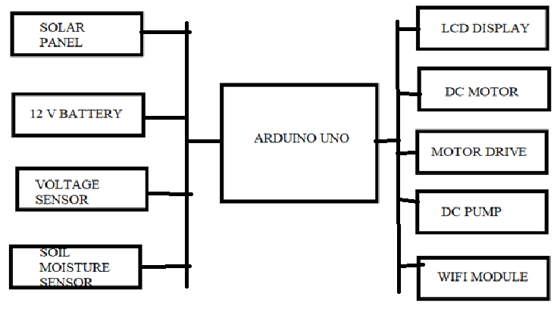

Fig 3.1 Block Diagram

**3.4 PROPOSED METHODOLOGY**

At the present time, one of the nearly necessary sources of development as well as the nearly critical component of the increase in the Indian financial system is agriculture. The corn propagation calculation is unquestionably one of the most suitable but difficult tasks for each nation.Nowadays, according to the climatic changes, farmers are struggling to obtain a good volume of yield from their crops. To feed the increasing population of India, there is a need to use brand new science and equipment into the praedial sector. This discipline focuses on the account of predominant crops among TamilNadu.As rainfall is the most important component of figuring out the amount of Crop albumen production, with the aid of this education, we predict the amount of predominant seasonal plants that will stand yielded with the aid of the rainfall information and region devoted to that particular grain by the usage of laptop lesson algorithms. By using the methodology of strong agricultural strategies, they may be performed in order to increase the yield of their crops. Because of seasonal crop production, this proposed methodology outperforms in predicting cases, as suggested.The proposed algorithms are: random forest, decision tree, kNN, logistic regression, SVM.

**3.5 PH to NPK Relation:**

The aim of this proposed system is to develop an on- the-go soil nutrient identification and automated fertigation system. To achieve this purpose, the development was divided into four stages when combined together they form a whole measuring electrical system. These stages are as follows

* Testing of soil
* Designing using Arduino controller and interfacing with the sensors
* Implementation in the field
* Prompting to farmer

This proposed system consists of temperature sensor, humidity sensor, and a pH sensor. This is correlated with the NPK measurement. Mainly pH level in the soil determines the NPK status of the soil. The relationship with the pH and NPK is as follows

|  |  |  |  |
| --- | --- | --- | --- |
| pH Value | Nitrogen  Content | Phosphorous  Content | Potassium  Content |
| 4.5(extremely  acidic) | 30% | 23% | 33% |
| 5(very strong  acid) | 53% | 34% | 52% |
| 5.5(Strong  acid) | 77% | 48% | 77% |
| 6(Medium  acid) | 89% | 52% | 100% |
| 7(Neutral) | 100% | 100% | 100% |

Table 3.1 NPK to PH Relation

### Testing of soil

Soil pH is an indicator of soil acidity and basicity. Most soils have a pH in the range of 4 to 10. The pH of a particular soil, such as 5 or 8, reflects a certain chemical and mineralogical environment in that soil, and thus the pH is of great importance to plant roots and microbial activity. Within the pH range of 4 to 10, the primary effect of soil pH on plant growth does notdepends on hydroxyl ions and hydrogen ions but associated with chemical environments. In general, the major influence of pH is on ion activities that affect the toxicity of elements like Al and Mn or on nutrient. Nitrogen availability is maximum between pH 6 and 8 because the mineralization of N is maximum in this range. The availability of P in acid soil is reduced by precipitation and adsorption by Fe and Al. For these reasons soil pH is one of the most important factors affecting soil fertility and so is commonly managed to increase crop yields. Based on pH status the plant type which must be grown on the particular soil is decided. This serves as an awareness to farmer. The above details are further listed in the table

|  |  |
| --- | --- |
| Soil Ph | Plant growth |
| >8.3 | Too alkaline for most plants |
| 7.5 | Iron availability becomes problem |
| 7.2 | Acceptable for most plants |
| 7.0 | Near neutral |
| 6.8 |
| 6.0 |
| 5.5 | Reduced microbial activity |
| <4.6 | Too acid for most plants |

Table 3.2 Plant growth with pH level

|  |  |
| --- | --- |
| Type of fertilizer | Solubility  (kg/100 litres) |
| Ammonium sulphate | 71 |
| Ammonium nitrate | 119 |
| Urea | 110 |
| Monoammonium phosphate | 23 |
| Potassium sulphate | 7 |
| Potassium nitrate | 32 |

Table 3.3 Solubility of fertilizers in water

When choosing the P fertilizer for fertigation, besides solubility, care must be taken to avoid P-Ca and P-Mg precipitation in the tubes and emitters. From this standpoint, acid P fertilizers (e.g., phosphoric acid, urea phosphate or monoammonium phosphate) are recommended. Different sources of fertilizers, including P fertilizers, have different effects on irrigation water and soil pH. High pH values (>7.5) in the irrigation water are undesirable. Calcium and Mg carbonate and orthophosphate precipitations may occur in the tubes and the drippers. In addition, high pH may reduce Zn, Fe and P availability to plants. The desired pH is below 7 and the range favoured by mostcultivated crops is 5.5-6.5. The pH of the irrigation water could be reduced or controlled by using P acid or acid based fertilizers like urea phosphate and monoammonium phosphate.

The use of acid fertilizers in drip systems may be beneficial in many ways other than the direct benefit from the added P, such as increased solubility of soil native P minerals, increased availability of other nutrients and micronutrients and prevention of chemical clogging of the fertigation system.

3.6 CONCLUSION

Thus in this chapter, we have discussed the features of the Prediction Robot. It shows the efficacy and Its capability to ensure the expectations of users are filled upto the mark.

**CHAPTER 4**

**MACHINE LEARNING ALGORITHMS:**

**4.1 INTRODUCTION:**

Agricultural dataset created on the kaggle website

Agricultural dataset Most of the research papers examined viewed climatic variables such as area, temperature, precipitation, or humidity. Some ground agronomical parameters, such as chalky, clay, loamy, sandy, and so on, so properly namely, special seasons, are included. The facts regarding these variables have been attached as input. Initially, a dataset is collected that consists of the parameters such as state name, district name, humidity, temperature, cause, etc. Take note of some vegetation that is desired to be planted in the area. This amassed dataset is in csv format

**4.2 PYTHON**

Python is a widely used general-purpose, high level programming language. It was initially designed by Guido van Rossum in 1991 and developed by Python Software Foundation. It was mainly developed for emphasis on code readability, and its syntax allows programmers to express concepts in fewer lines of code. Python is a programming language that lets you work quickly and integrate systems more efficiently. Python is a popular programming language. It was created by Guido van Rossum, and released in 1991. It is used for:

* Python can be used on a server to create web applications.
* Python can be used alongside software to create workflows.
* Python can connect to database systems. It can also read and modify files.
* Python can be used to handle big data and perform complex mathematics.
* Python can be used for rapid prototyping, or for production-ready software development.
* Python works on different platforms (Windows, Mac, Linux, Raspberry Pi, etc).
* Python has a simple syntax similar to the English language.
* Python has syntax that allows developers to write programs with fewer lines than some other programming languages.
* Python runs on an interpreter system, meaning that code can be executed as soon as it is written. This means that prototyping can be very quick.
* Python can be treated in a procedural way, an object-orientated way or a functional way.
* Python was designed for readability, and has some similarities to the English language with influence from mathematics. Python uses new lines to complete a command, as opposed to other programming languages which often use semicolons or parentheses. Python relies on indentation, using whitespace, to define scope; such as the scope of loops, functions and classes. Other programming languages often use curly-brackets for this purpose.

**4.3 LIBRARY USED**

**Matplotlib**

Matplotlib is a Python 2D plotting library which produces publication quality figures in a variety of hardcopy formats and interactive environments across platforms. Matplotlib can be used in Python scripts, the Python and IPython shells, the Jupyter notebook, web application servers, and four graphical user interface toolkits. Matplotlib tries to make easy things easy and hard things possible. You can generate plots, histograms, power spectra, bar charts, error charts, scatterplots, etc., with just a few lines of code. For examples, see the sample plots and thumbnail gallery. For simple plotting the pyplot module provides a MATLAB-like interface, particularly when combined with IPython. For the power user, you have full control of line styles, font properties, axes properties, etc, via an object oriented interface or via a set of functions familiar to MATLAB users. matplotlib.

Pyplot is a collection of command style functions that make matplotlib work like MATLAB. Each pyplot function makes some change to a figure: e.g., creates a figure, creates a plotting area in a figure, plots some lines in a plotting area, decorates the plot with labels, etc.

In matplotlib.pyplot various states are preserved across function calls, so that it keeps track of things like the current figure and plotting area, and the plotting functions are directed to the current axes (please note that “axes” here and in most places in the documentation refers to the *axes* part of a figure and not the strict mathematical term for more than one axis).

**Numpy**

Numpy library for the (Python programming language, adding support for large, multi-dimensional arrays and (matrices, along with a large collection of high-level mathematical (functions to operate on these arrays. The ancestor of NumPy, Numeric, was originally created by Jim Hugunin with contributions from several other developers. In 2005, Travis Oliphant created NumPy by incorporating features of the competing Numarray into Numeric, with extensive modifications. NumPy is open-source software and has many contributors. It provides:

* a powerful N-dimensional array object
* sophisticated (broadcasting) functions
* tools for integrating C/C++ and Fortran code
* useful linear algebra, Fourier transform, and random number capabilities and much more

Besides its obvious scientific uses, NumPy can also be used as an efficient multi-dimensional container of generic data. Arbitrary data-types can be defined. This allows NumPy to seamlessly and speedily integrate with a wide variety of databases.

All NumPy wheels distributed on PyPI are BSD licensed. ndarray.shape is the array attribute that returns a tuple consisting of array dimensions. It can also be used to resize the array.

**Pandas**

Pandas is an open-source Python Library providing high-performance data manipulation and analysis tools using its powerful data structures. The name Pandas is derived from the word Panel Data – an Econometrics from Multidimensional data.

In 2008, developer Wes McKinney started developing pandas when in need of high performance, flexible tools for analysis of data. Prior to Pandas, Python was majorly used for data munging and preparation. It had very little contribution towards data analysis. Pandas solved this problem. Using Pandas, we can accomplish five typical steps in the processing and analysis of data, regardless of the origin of data — load, prepare, manipulate, model, and analyze. Python with Pandas is used in a wide range of fields including academic and commercial domains including finance, economics, Statistics, analytics, etc. The key features of pandas are,

* Fast and efficient DataFrame object with default and customized indexing.
* Tools for loading data into in-memory data objects from different file formats.
* Data alignment and integrated handling of missing data.
* Reshaping and pivoting of date sets.
* Label-based slicing, indexing and subsetting of large data sets.
* Columns from a data structure can be deleted or inserted.
* Group by data for aggregation and transformations.
* High performance merging and joining of data.
* Time Series functionality

**4.4 APPLICATIONS**

* + - IOT Projects
    - Access Point Portals
    - Wireless Data logging
    - Smart Home Automation
    - Learn basics of networking
    - Portable Electronics
    - Smart bulbs and Sockets

**4.5 PREPROCESSING**

A huge dataset is wanted for the relevant information excavation application. The statistics gathered from extraordinary sources are hourly in their raw form. It ought to include information up to the expectation that it is incomplete, obsolete, and inconsistent. As a result, certain uneconomical records should be filtered out of that process. The facts ought to be kept normalized. The supplied statistics series has deep "NA" values, which are filtered between Python and Normalization is associated with powerful scaling, which was once additionally chronic, but using the interquartile extent rather than normalizing the records because the data set incorporates numeric data. Normalization reduces the greatness of the facts by a component of 0 after 1.

**4.6 TRAIN AND TESTING**

In the preprocessing step, the dataset wishes to remain furcate in the training dataset, then check out the dataset. This is the necessary foot while growing the model. The training dataset is ancient after training a model, and the dataset that is tested out is aged in accordance with the model. So, we match the mannequin together with training facts and take a look at it along with the testing data.

**4.7 ALGORITHM TESTED WITH FLOWCHART**:

The Data Set we are using for our project is Supervised We decided to test 3 most sort off Algorithms of Supervised learning , They are

* RandomForest,
* LinearRegression and
* Decision Tree.

**LINEAR REGRESSION**:

Linear Regression is a machine learning algorithm based on supervised learning. It performs a regression task. Regression models a target prediction value based on independent variables. It is mostly used for finding out the relationship between variables and forecasting. Different regression models differ based on – the kind of relationship between dependent and independent variables they are considering, and the number of independent variables getting used.

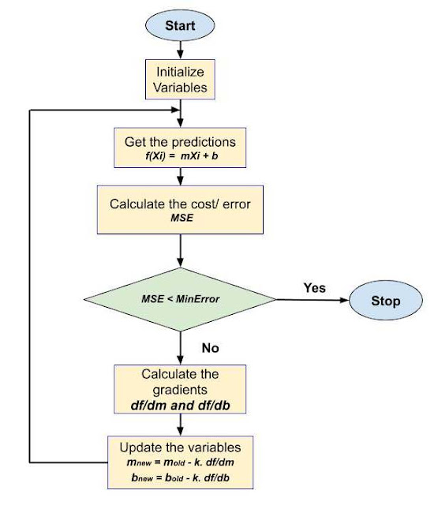

Fig 4.1 Linear Regression Flow chart

Linear Regression FlowChart The Model is Given by Equation: Y = θ1+ θ2 .X x: input training data (univariate – one input variable(parameter)) y: labels to data (supervised learning) When training the model – it fits the best line to predict the value of y for a given value of x. The model gets the best regression fit line by finding the best θ1 and θ2 values. θ1: intercept θ2: coefficient of x Once we find the best θ1 and θ2 values, we get the best fit line. So when we are finally using our model for prediction, it will predict the value of y for the input value of x. We Tried this Model in our DataSet and We obtained an Accuracy of 37.8%, which is very Low , So we decided to Skip this Algorithm

**DECISION TREE:**

Decision Tree algorithm belongs to the family of supervised learning algorithms. Unlike other supervised learning algorithms, the decision tree algorithm can be used for solving regression and classification problems too.

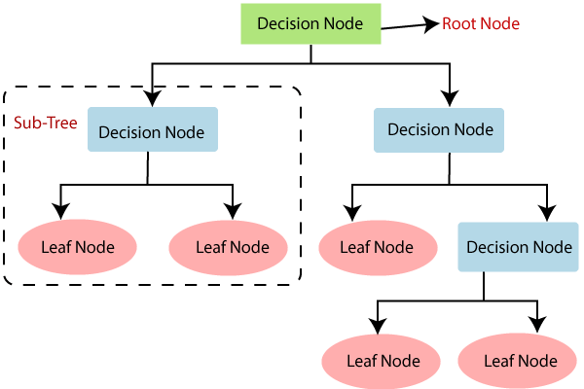

Fig 4.2 Decision Tree Flowchart

Decision Tree Flow Chart The goal of using a Decision Tree is to create a training model that can use to predict the class or value of the target variable by learning simple decision rules inferred from prior data(training data). In Decision Trees, for predicting a class label for a record we start from the root of the tree. We compare the values of the root attribute with the record’s attribute. On the basis of comparison, we follow the branch corresponding to that value and jump to the next node. Decision Tree Process Decision Trees follow Sum of Product (SOP) representation. The Sum of product (SOP) is also known as Disjunctive Normal Form. For a class, every branch from the root of the tree to a leaf node having the same class is conjunction (product) of values, different branches ending in that class form a disjunction (sum). The primary challenge in the decision tree implementation is to identify which attributes do we need to consider as the root node and each level. Handling this is to know as the attributes selection. We have different attributes selection measures to identify the attribute which can be considered as the root note at each level. So, We Tried Using this algorithm , and Obtained Accuracy of 6-%, so this Algorithm is Taken into Consideration and Also we Decided to Check Random Forest Algorithm as Well.

**Random Forest:**

Random Forest is a popular machine learning algorithm that belongs to the supervised learning technique. It can be used for both Classification and Regression problems in ML.

It is based on the concept of ensemble learning, which is a process of combining multiple classifiers to solve a complex problem and to improve the performance of the model. Instead of relying on one decision tree, the random forest takes the prediction from each tree and based on the majority votes of predictions, and it predicts the final output.

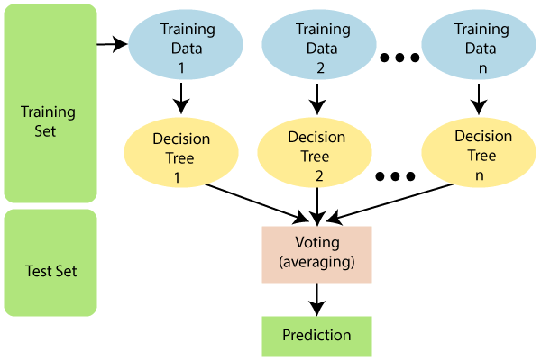

Fig 4.3 Random Forest FlowChart

Random Forest Algorithm As the name suggests, "Random Forest is a classifier that contains a number of decision trees on various subsets of the given dataset and takes the average to improve the predictive accuracy of that dataset." The below diagram explains the working of the Random Forest algorithm Random Forest Process

**ADVANTAGES OF RANDOM FOREST**

Random Forest is capable of performing both Classification and Regression tasks. o It is capable of handling large datasets with high dimensionality.

It enhances the accuracy of the model and prevents the overfitting issue.

**4.8 PREDICTION USING CLASSIFICATION ALGORITHMS**

Classification algorithm Once data splitting is completed, the next step is to create and train a model using scikit-learn. The work regarding the education machine learning mannequin requires a computing device study algorithm along with training information in order to hold the pattern.

Here we are using the Random Forest algorithm, which is properly regarded as a supervised lesson algorithm, so this event is about bagging technique. A Random Forest Algorithm is an aggregate of quantities about a decision tree. This algorithm is an alignment algorithm based on the ensemble classifier. It will partition the dataset into training information and testing data. Further, the coaching dataset is aged in imitation of building the selection tree. Model choice builds a selection arbor by way of thinking about training statistics and separates the weaker node beyond coaching data after reaching a higher model. Every education dataset selection either gives birth to a decision arbor or after giving birth to a pathetic forest.The overall thinking on the bagging approach is up to expectations. A total of learning yield wishes to make the normal result bigger. The random woodland algorithm builds multiple choice trees all through training. Predictions made alongside these decisions, timber pleasure remain accumulated, or the remaining output pleasure remain with the one who has the lowest number of votes. notebook is a tribune, as used to create the educated mannequin using the Random Forest Algorithm.

**4.9 PREDICT PROPAGATE**

The educated mannequin is aged in imitation of the output over the latter input. Here we store the educated model within a file, so the model's execution can be augured over the new input. In this dictation, we aged the pickle format created by Jupyter to look for the educated machine learning mannequin who stores the goal into a double stream but takes the mannequin into account when attempting out dataset.This prediction model consists of an indiscriminately woodland algorithm that learns properties out of coaching records through the usage of statistics that wish to edit the predictions.

**4.10 ACCURACY**

Accuracy is the only certainty regarding the metrics' usage for evaluating classification models. Accuracy is calculated by dividing a wide variety of unerring predictions with the aid of a large variety of predictions.

Accuracy = number of correct predictions / the total number of predictions………….………..(1)

**METRICES FOR PERFORMANCE EVALUATION**

Various assessment matrices have been ancient because of the necessity to check the performance of the classifier. For this purpose, the obsession form was once used. It is a 22 casting, appropriate in imitation of pair lessons from the dataset. The matrix form offers a couple of kinds of mathematical calculation on the classifier, yet two types of imperfect account concerning the classifier.

**CLASSIFICATION ACCURACY**

When evaluating an array model, accuracy is one of the metrics used. Accuracy is calculated with the aid of sharing quantity regarding accurate predictions by volume of predictions.

Classification accuracy suggests the mathematical dimension regarding reckoning results. It computes out of the matrix. Alignment exactness is observed by equation 2:



**ERROR IN CLASSIFICATION**

Classification oblivion indicates the bad dimensions of calculation results. It computes from the attack matrix. The alignment confusion is located by way of equation 3:



**PRECISION**

Precision is a vital mannequin performance contrast matrix. It is the fraction of over-related situations among the aggregation of retrieved instances. It is a wonderful expected value. The candidness is thought to be much like the following: equation 4:



**RECALL**

Recall is also an important aspect of the mannequin's overall performance contrast matrix.

It is the fraction of related situations among the wide variety of retrieved instances. The recall is deliberated as follows between equations 5 and 6:

 **MEASURE**

It is also regarded as an F Score. The F-measure is calculated then, as in accordance with the precision of the test. It is deliberated beyond candidness and recall by means of equation 6:



We have performed the 98% rigor test and found that the model is good for predicting yield.

**4.11 CONCLUSION**:

By considering the specific algorithm whilst predicting the yield, the Random Forest Algorithm achieved high accuracy. This is due to the random forest's desire to construct the choice plant due to its singular engagement over the education dataset, but because they mix the multiple decision arbor into the imitation of a single decision arbor, they intend to predict the yield by considering the tree's average cost. Analysis concerning one of an algorithm is viewed

**CHAPTER 5**

**HARDWARE DESCRIPTION**

# 5.1 INTRODUCTION

This chapter consists of the complete system architecture. The system architecture shows the layout of the unit and the communication cables used for the interconnection of various parts of the system. The prime motive of the “process sheet” chapter is to provide the fine details about the components being used, their material, and the quantity of each component involved in the project. It also illustrates the processing steps to complete the project.

**5.2 3D MODEL OF THE SETUP**

### Figure 5.1 shows the 3D Model

### 5.3 TOP VIEW OF MODEL

### Fig.5.2 Top View

### 5.4 SIDE VIEW OF MODEL

### Fig 5.3 Side View

### 5.5 BOTTOM VIEW OF MODEL

### Fig 5.4 Bottom View

### 5.6 DESIGN CALCULATION FOR CHOOSING DIMENSIONS:

### Using Golden Ratio:

### a+b/a = a/b=1.618=ø

### using trial and error method,

### Assuming, a=6cm ; b=4cm

### (6+4)/6 = 6/4

### 10/6 = 6/4

### (Ratio doesn't match)

### a=14cm ; b = 10cm

### (14+8)/14 = 14/10

### 24/14 = 14/10 ≠1.618 (Doesn't match)

### A=14cm ; b=8cm

### (14+8)/14 = 14/8

### 22/14 = 14/8 ≠1.618 (Doesn’t match)

### A=14cm;b=8.65cm

### (14+8.6) / 14 = 14/8.6

### 1.618 = 1.618 (Matches)

### Area = 317.13 cm2

### 5.7 Bending Moment Calculation

### Bending moment of UDL = WL2/8

### W = 1 kg

### = 1*(140)2/8

### Bending Moment = 2450 Nm

### Factor of Safety for Brittle material = 4

### Linear Velocity = 5 km/hr

### = 5 * 103 m/s

### Linear Velocity = 1.38 m/s

### Comparison between Yield Stress and Allowable Stress

### Ϭ = P/A

### Ϭ = M / I

### Ϭ = Ϭy/FOS

### Yield Stress of Hylem sheet = 89

### = 89/4

### = 22.25 Mpa

### Working stress for Brittle materials

### = Ultimate strength / FOS

### Ultimate strength of Hylem = 65 Mpa

### = 65 / 4

### Ϭ wor = 16.5 Mpa

### 5.8 Motor Torque Calculation

### T = P/W

### ω = 2πN / 60

### For DC motor

### T = V * I / (2πN / 60)

### = 12 * 2.6 / (2*3.14*1500/60)

### = 0.195 Nm

### V = 12

### W = 16

### I = 2.4 A

### N = 1500

### P = V*I

### = 12 * 2.4

### = 28.8

### Pout = τ * ω

### ω = RPM * 2 π/60

### = (1500*2*3.14)/60

### ω = 157 Rad/s

### Pout = 0.38 * 157

### = 59.66

### Pout = 60 W

### Fr = CW

### W = m.ag

### m = 1

### Ag = 9.8

### W = 9.8

### Cf = 0.5

### Fr = 0.5 * 9.8

### Fr = 4.905 N

### F air = Cv^2

### C = Force constant

### V = Object Velocity

### = 0.5 * (1.38)2

### = 0.952 N

### F grad = m . sinϴ

### = 1 . Sin 18

### = 0 . 309 N

### ƩF= Fr + F air + F grad

### = 4.905 + 0.952 N+0 . 309 N

### ƩF =6.1612N.

### P=F.V

### = ƩF * V

### 6.1612 * 0.277

### = 1.7066 W.

### 5.9 Thickness Calculation

### Ϭ / y = M / I

### 22.23 / (8.65 t3/12) = 1 / (t/2)

### 22.23 * 2 / t = 12 / 8.65 t3

### 22.05 * 2 * 8.65 t3= 12t

### 99.5 * 8.65 t3 = 12t

### 99.5 * 8.65 t2 = 12

### t2 = 12 / 49.5 * 8.65

### t = 0.173

### 5.10 COMPONENTS USED

* + - Arduino uno
    - Battery
    - Soil moisture sensor
    - Voltage sensor
    - Solar panel
    - Dc motor
    - Dc pump
    - Motor driver
    - Lcd display
    - Wifi module
    - Arduino IDE

### 

### 5.11 COMPONENTS DETAILS

### ARDUINO UNO

### Arduino is an open-source electronics platform based on easy-to-use hardware and software. Arduino boards are able to read inputs - light on a sensor, a finger on a button, or a Twitter message - and turn it into an output - activating a motor, turning on an LED, publishing something online. Message can be sent to the board what to do by sending a set of instructions to the microcontroller on the board. To do so the Arduino programming language and the Arduino Software (IDE) are used.

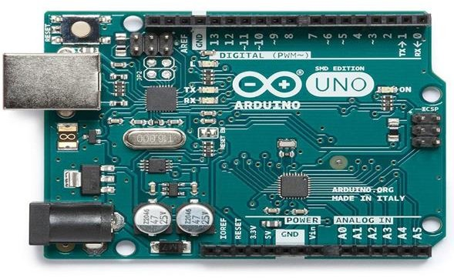

Fig.5.5 Arduino UNO

Over the years Arduino has been the brain of thousands of projects, from everyday objects to complex scientific instruments. Arduino was born at the Ivrea Interaction Design Institute as an easy tool for fast prototyping, aimed at students without a background in electronics and programming.

## 

Fig.5.6 Pin Diagram

### LAYOUT CONNECTION OF ARDUINO UNO

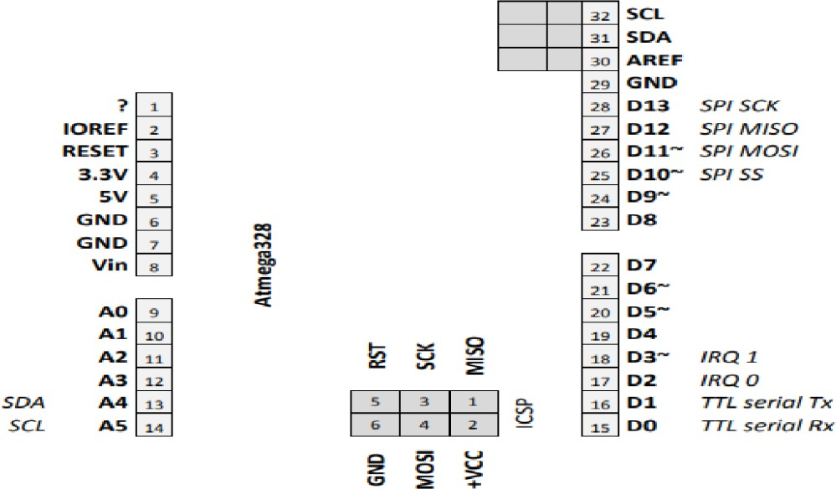Fig.6.6 Layout diagram of Arduino

### FEATURES OFARDUINO

* + Microcontroller ATmega328.
  + Operating Voltage 5V.
  + Input Voltage (recommended) 7-12V.
  + Input Voltage (limits) 6-20V.
  + Digital I/O Pins 14 (of which 6 provide PWM output)
  + Analog Input Pins 6.
  + DC Current per I/O Pin 40 mA.
  + DC Current for 3.3V Pin 50 mA.
  + Protocol : USART, SPI & I2C.
  + Low Power Consumption 0.3mA/MHz
  + Operating Frequency : 20 MHz

### BENEFITS OFARDUINO

* + Inexpensive - Arduino boards are relatively inexpensive compared to other microcontroller platforms
  + Cross-platform - The Arduino software runs on Windows, Macintosh OSX, and Linux operating systems. Most microcontroller systems are limited to Windows.
  + Simple, clear programming environment - The Arduino programming environment is easy-to-use for beginners, yet flexible enough for advanced users to take advantage of as well.
  + Open source and extensible software - The Arduino software is published as open source tools, available for extension by experienced programmers.
  + Open source and extensible hardware - The Arduino is based on Atmel's ATMEGA8 and ATMEGA168 microcontroller.

### ARDUINO IDE

The Integrated Development Environment (IDE)is a combination of editor, linker and a compiler which helps the developer to make their Firmware for their Innovative Projects.

Arduino IDE play a major role in open source platform for fast prototyping and easy to access of library.

It is user friendly tool for beginners and it supports programming language like embedded C, Luna etc. Over the years Arduino has been the brain of thousands of projects, from everyday objects to complex scientific instruments. Its supports all the variant of Arduino boards like Arduino Uno, Nano and Mega etc. As soon as it reaches a wider community, the Arduino board started changing to adapt to new needs and challenges, differentiating its offer from simple 8-bit boards to products for IoT applications, wearable, 3D printing, and embedded environments

**ARDUINO IDE SOFTWARE**

With this Arduino Integrated Development Environment you can edit, compile and upload Arduino sketches to the Arduino boards.

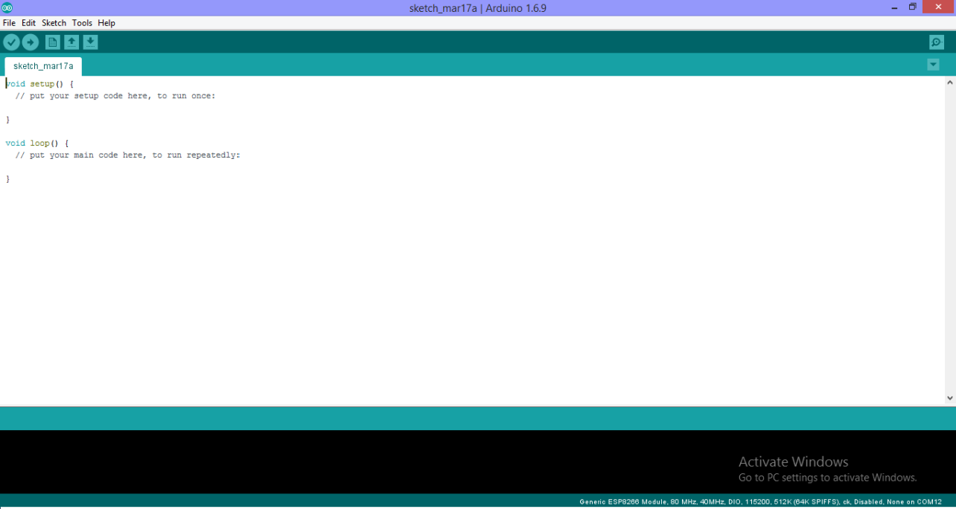

Fig.5.7 Arduino IDE software

**POWER SUPPLY:**

This is a simple approach to obtain a 12V and 5V DC power supply using a single circuit. The circuit uses two ICs 7812 and 7805 for obtaining the required voltages. The AC mains voltage will be stepped down by the transformer, rectified by bridge and filtered by capacitor to obtain a steady DC level .The 7812 regulates this voltage to obtain a steady 12V DC. The output of the IC1 will be regulated by the 7805 to obtain a steady 5V DC at its output. In this way both 12V and 5V DC are obtained.

**BLOCK DIAGRAM**

OUTPUT

REGULATOR

BRIDGE RECTIFIER (AC TO DC VOLTAGE)

STEP DOWN TRANSFORMER (230V TO 12V)

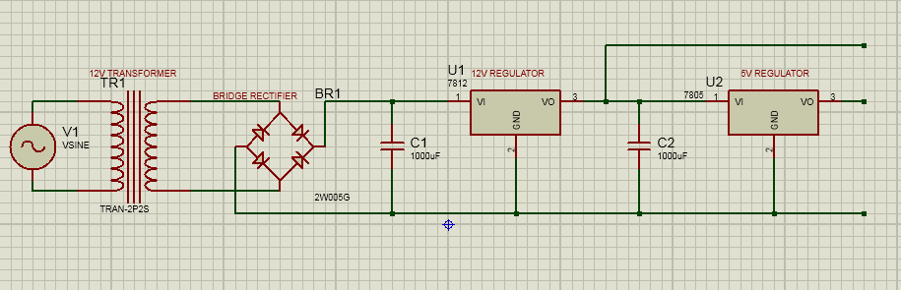

Fig 5.8 Circuit diagram

Initially small step down transformer is used to reduce the voltage level 230V AC into 12V AC. The output of the transformer is a pulsating sinusoidal AC voltage, which is converted to pulsating DC with the help of a rectifier.This output is given to a filter circuit which reduces the AC ripples, and passes the DC components. 7812 regulator is used to converts 12V DC study voltage. And 7805 regulator is converts constant 5V DC voltage.

### SOIL MOISTURE SENSOR:

The moisture of the soil plays an essential role in [the irrigation field](https://www.elprocus.com/microcontroller-based-automatic-irrigation-system/) as well as in gardens for plants. As nutrients in the soil provide the food to the plants for their growth. Supplying water to the plants is also essential to change the temperature of the plants.

The temperature of the plant can be changed with water using the method like transpiration. And plant root systems are also developed better when rising within moist soil. Extreme soil moisture levels can guide to anaerobic situations that can encourage the plant’s growth as well as soil pathogens. 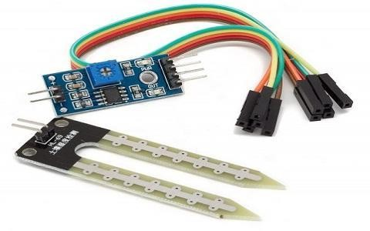This article discusses an overview of the soil moisture sensor, working and it’s applications.

Fig.5.9 Soil Moisture sensor

Interface Description (4-wire)

1. VCC: .3 V-5V
2. GND: GND
3. DO: digital output interface (0 and 1)
4. AO: Analog Output Interface

### WORKING OF SENSOR

The soil moisture sensor consists of two probes which are used to measure the volumetric content of water. The two probes allow the current to pass through the soil and then it gets the resistance value to measure the moisture value.

When there is more water, the soil will conduct more electricity which means that there will be less resistance. Therefore, the moisture level will be higher. Dry soil conducts electricity poorly, so when there will be less water, then the soil will conduct less electricity which means that there will be more resistance. Therefore, the moisture level will be lower.

This sensor can be connected in two modes; Analog mode and digital mode. First, we will connect it in Analog mode and then we will use it in Digital mode.

**Specifications**

The specification of this sensor includes the following.

* The required voltage for working is 5V
* The required current for working is <20mA
* Type of interface is analog
* The required working temperature of this sensor is 10°C~30°C

### Applications

The applications of moisture sensor include the following.

### VOLTAGE SENSOR

Electrical voltage sensors measure AC and/or DC voltage levels. They receive voltage inputs and provide outputs as analog voltage signals, analog current levels, switches, or audible signals. They can also provide frequency and modulated frequency outputs. For example, some electrical voltage sensors produce sine waves or pulse trains. Others provide amplitude modulation (AM), frequency modulation (FM), or pulse width modulation (PWM).

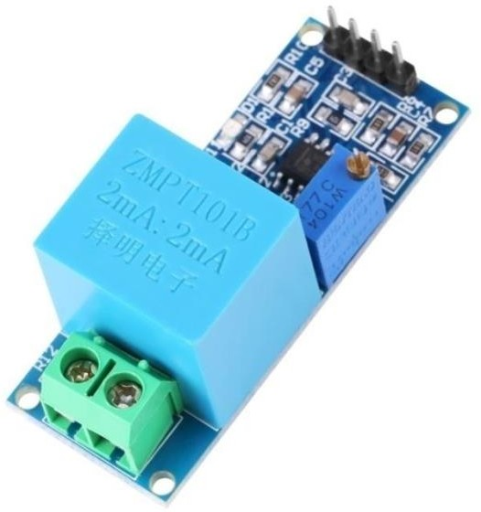

Fig.5.10 Voltage sensor

### SPECIFICATIONS:

* + - * Voltage input range : 0-25 V DC for 5V Microcontrollers
      * Voltage input range: 0-16.5V DC for 3.3V Microcontrollers
      * Voltage analog resolution : 0.00489 V
      * Operating voltage output : 3.3V – 5V MAX

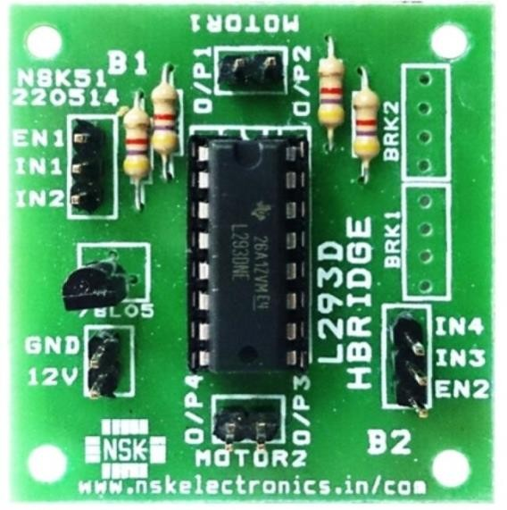 **MOTOR DRIVE**

Fig.5.11 Motor Driver

L293D is a typical Motor driver or Motor Driver IC which allows DC motor to drive on either direction. L293D is a 16-pin IC which can control a set of two DC motors simultaneously in any direction. It means that you can control two [DC motor](https://www.rakeshmondal.info/High-Torque-Motor-Low-RPM-Motor) with a single L293D IC.

It works on the concept of H-bridge. H-bridge is a circuit which allows the voltage to be flown in either direction. As you know voltage need to change its direction for being able to rotate the motor in clockwise or anticlockwise direction

Hence H-bridge IC are ideal for driving a DC motor. In a single L293D chip there are two h-Bridge circuit inside the IC which can rotate two dc motor independently.

Due its size it is very much used in robotic application for controlling DC motors.

Given below is the pin diagram of a L293D motor controller. There are two Enable pins on l293d. Pin 1 and pin 9, for being able to drive the motor, the pin 1 and 9 need to be high. For driving the motor with left H-bridge you need to enable pin 1 to high. And for right H-Bridge you need to make the pin 9 to high. If anyone of the either pin1 or pin9 goes low then the motor in the corresponding section will suspend working. It’s like a switch.

L293D Pin Diagram

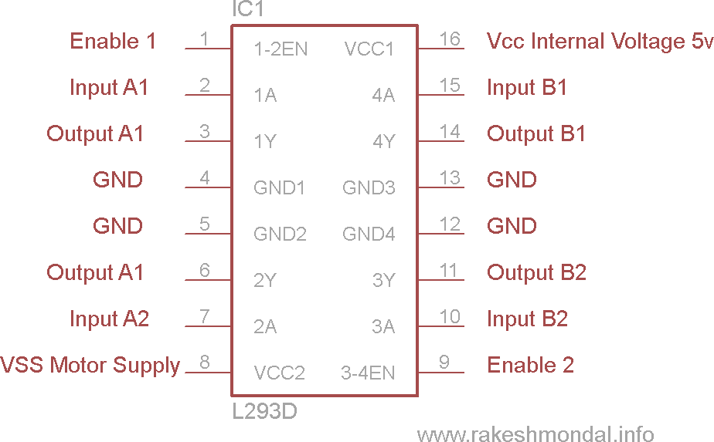

Fig 5.12 L293D Pin Diagram

Working of L293D

There are 4 input pins for l293d, pin 2,7 on the left and pin 15 ,10 on the right as shown on the pin diagram. Left input pins will regulate the rotation of motor connected across left side and right input for motor on the right hand side. The motors are rotated on the basis of the inputs provided across the input pins as LOGIC 0 or LOGIC 1..

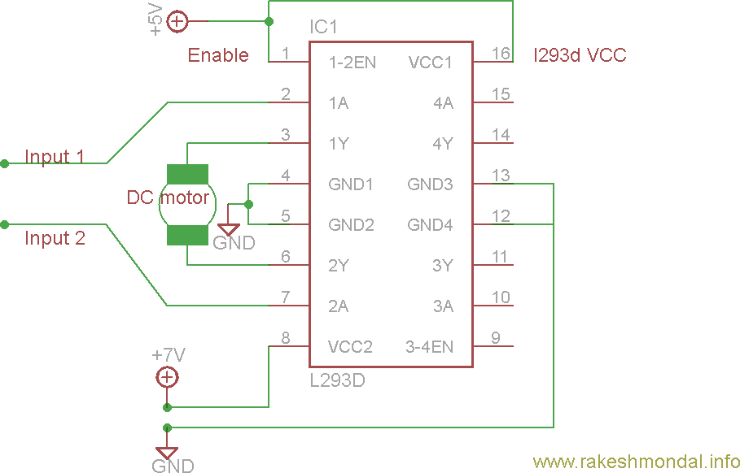

Fig 5.13 Circuit Diagram For l293d motor driver IC controller

**Voltage Specification**

VCC is the voltage that it needs for its own internal operation 5v; L293D will not use this voltage for driving the motor. For driving the motors it has a separate provision to provide motor supply VSS (V supply). L293d will use this to drive the motor. It means if you want to operate a motor at 9V then you need to provide a Supply of 9V across VSS Motor supply.

The maximum voltage for VSS motor supply is 36V. It can supply a max current of 600mA per channel.Since it can drive motors Up to 36v hence you can drive pretty big motors with this l293d VCC pin 16 is the voltage for its own internal Operation.

The maximum voltage ranges from 5v and upto 36v.\

**DC MOTOR**

A DC motor is any motor within a class of electrical machines whereby direct current electrical power is converted into mechanical power. Most often, this type of motor relies on forces that magnetic fields produce. Regardless of the type, DC motors have some kind of internal mechanism, which is electronic or electromechanical. In both cases, the direction of current flow in part of the motor is changed periodically.

The speed of a DC motor is controlled using a variable supply voltage or by changing the strength of the current within its field windrings. While smaller DC motors are commonly used in the making of appliances, tools, toys, and automobile mechanisms, such as electric car seats, larger DC motors are used in hoists, elevators, and electric vehicles.

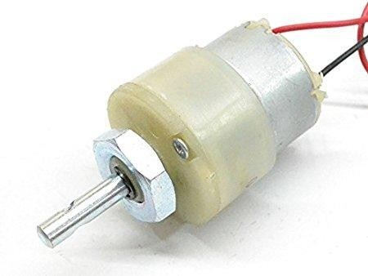

Fig.5.13 DC motor

Here we are using 12V DC 60 RPM motor.

60RPM Centre Shaft Economy Series DC Motor is high quality low cost DC geared motor. It has steel gears and pinions to ensure longer life and better wear and tear properties. The gears are fixed on hardened steel spindles polished to a mirror finish. The output shaft rotates in a plastic bushing. The whole assembly is covered with a plastic ring. Gearbox is sealed and lubricated with lithium grease and require no maintenance.

### SPECIFICATIONS AND FEATURES

* Operating Voltage: 12V DC
* Gearbox: Attached Plastic (spur)Gearbox
* Shaft diameter: 6mm with internal hole
* No-load current = 60 mA(Max)
* Load current = 300 mA(Max)

### LCD DISPLAY

There are many display devices used by the hobbyists. LCD displays are one of the most sophisticated display devices used by them. Once you learn how to interface it, it will be the easiest and very reliable output device used by you! More, for micro controller based project, not every time any debugger can be used. So LCD displays can be used to test the outputs.

PIN DIAGRAM

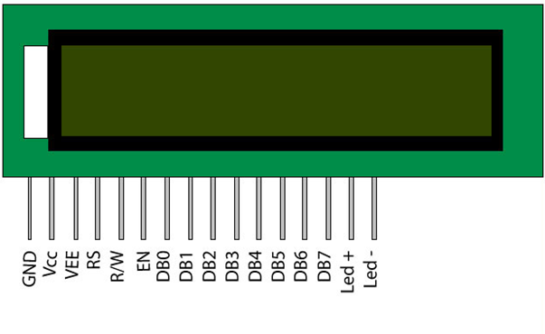

Fig.5.14LCDdisplay

LCD accepts two types of signals, one is data, and another is control. These signals are executes it, same for the case of transmission. LCD display takes a time of 39-43µS to place a character or execute a command. Except for clearing display and to seek cursor to home recognized by the LCD module from status of the RS pin. Now data can be read also from the LCD display, by pulling the R/W pin high. As soon as the E pin is pulsed, LCD display reads data at the falling edge of the pulse and position it takes 1.53ms to 1.64ms. Any attempt to send any data before this interval may lead to failure to read data or execution of the current data in some devices.

Some devices compensate the speed by storing the incoming data to some temporary registers.

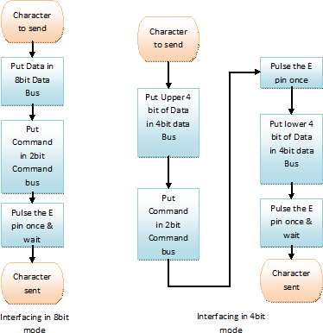

Fig 5.15 Flow chart of interfacing LCD display

LCD displays have two RAMs, naming DDRAM and CGRAM. DDRAM registers in which position which character in the ASCII chart would be displayed. Each byte of DDRAM represents each unique position on the LCD display. The LCD controller reads the information from the DDRAM and displays it on the LCD screen. CGRAM allows user to define their custom characters. For that purpose, address space for first 16 ASCII characters are reserved for users. After CGRAM has been setup to display characters, user can easily display their custom characters on the LCD screen.

**WIFI MODULE**

The ESP8266 is a very user friendly and low cost device to provide internet connectivity to your projects. The module can work both as a Access point (can create hotspot) and as a station (can connect to Wi-Fi), hence it can easily fetch data and upload it to the internet making Internet of Things as easy as possible. It can also fetch data from internet using API’s hence your project could access any information that is available in the internet, thus making it smarter. Another exciting feature of this module is that it can be programmed using the Arduino IDE which makes it a lot more user friendly. However this version of the module has only 2 GPIO pins (you can hack it to use upto 4) so you have to use it along with another microcontroller like [Arduino,](https://components101.com/microcontrollers/arduino-uno) else you can look onto the more standalone ESP-12 or ESP-32 versions. So if you are looking for a module to get started with IOT or to provide internet connectivity to your project then this module is the right choice for you

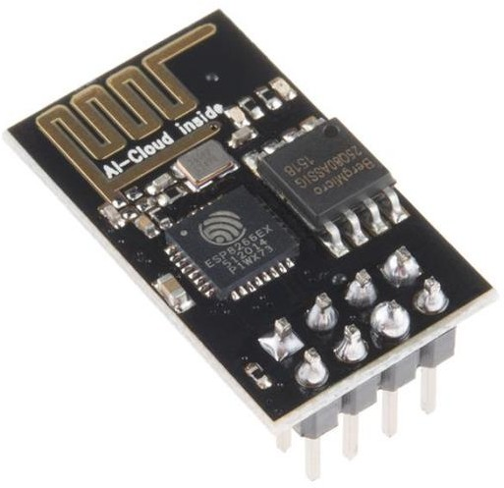

Fig.5.16 Wifi module

The ESP8266 WiFi Module is a self contained SOC with integrated TCP/IP protocol stack that can give any microcontroller access to your WiFi network. The ESP8266 is capable of either hosting an application or offloading all Wi-Fi networking functions from another application processor. Each ESP8266 module comes pre-programmed with an AT command set firmware, meaning, you can simply hook this up to your Arduino device and get about as much WiFi-ability as a WiFi Shield offers (and that’s just out of the box)! The ESP8266 module is an extremely cost effective board with a huge, and ever growing, community.

This module has a powerful enough on-board processing and storage capability that allows it to be integrated with the sensors and other application specific devices through its GPIOs with minimal development up-front and minimal loading during runtime. Its high degree of on-chip integration allows for minimal external circuitry, including the front-end module, is designed to occupy minimal PCB area.

The ESP8266 supports APSD for VoIP applications and Bluetooth co- existance interfaces; it contains a self-calibrated RF allowing it to work under all operating conditions, and requires no external RF parts.

**FEATURES**

* + - * Low cost, compact and powerful Wi-Fi Module
      * Power Supply: +3.3V only
      * Current Consumption: 100mA
      * I/O Voltage: 3.6V (max)
      * I/O source current: 12mA (max)
      * Built-in low power 32-bit MCU @ 80MHz
      * 512kB Flash Memory
      * Can be used as Station or Access Point or both combined
      * Supports Deep sleep (<10uA)
      * Supports serial communication hence compatible with many development platform like Arduino
      * Can be programmed using Arduino IDE or AT-commands or Lua Script

### CONCLUSION:

Thus the process sheet has been illustrated by tabulating all the components required for the design and fabrication of Bin Bot. It also contains material used along with its dimensions

**CHAPTER 6**

**RESULTS AND DISCUSSION**

**6.1 INTRODUCTION**

This chapter explains the stages of working of the design and fabrication of the bin bot. It will also depict the output which is received at each stage of experimentation.

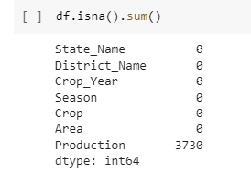

Fig 6.1 handling missing variables

**6.2 WORKING PRINCIPLE**

Solar cell will generate energy from solar panel and wind mill will generate energy from wind turbine. These solar panel and wind turbine convert energy into electricity. These energies will get combine and pass to charge controller. It will control the amount of charge generated by solar panel and wind turbine and the energy is then stored in battery which is of 12V . Battery Level, water pump and soilmoisture 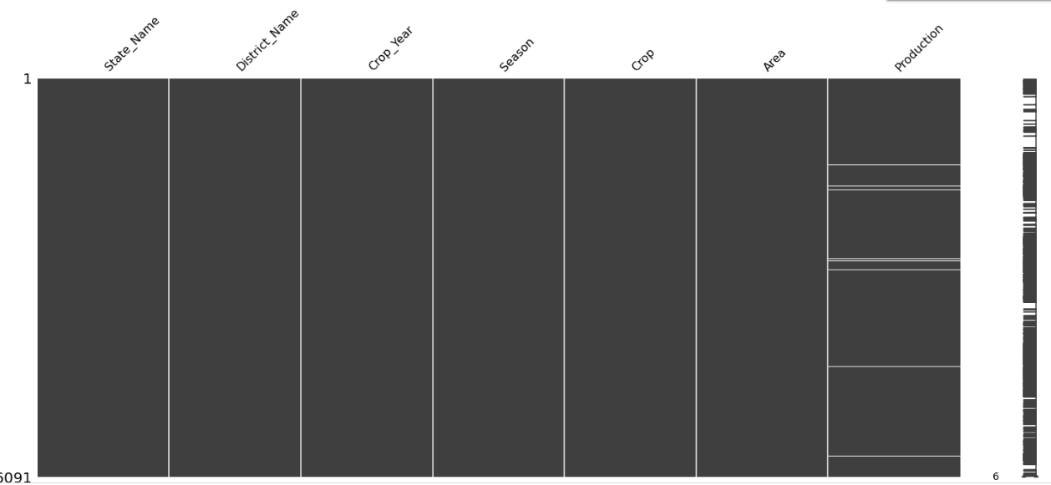.

Fig 6.2 MSNO graph

Wastage of water must be monitored in agricultural field by using automatic plant irrigation system. Photo voltaic cell generates power from solar energy. Hence alternative form of electricity is introduced in irrigation. Wind turbines capture kinetic energy from wind and generate electricity.

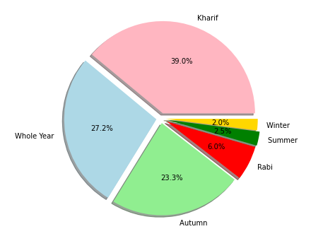

Fig 6.3 Seasonal Graph

The whole system is controlled by microcontroller which monitors the sensors. The soil state will be identified by the sensors which in return microcontroller passes the command to relay driver IC.

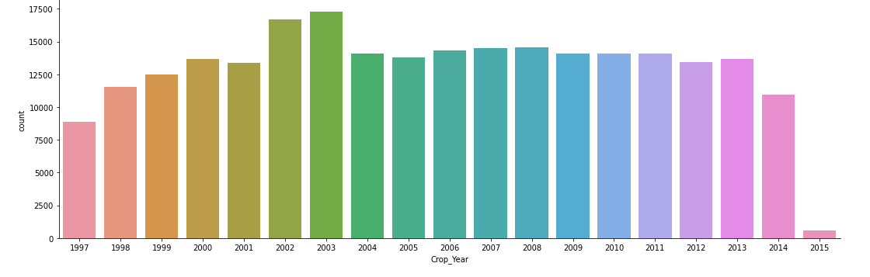

Figure 6.4. crop yield graph

If the soil is in wet state the motor is turned off and vice versa. The microcontroller receives the signal from the sensors through the output of the op-amp, the software controls the signal which is stored in ROM of the microcontroller. The condition of the pump i.e., ON/OFF is displayed on a 16X2 LCD which is connected with the microcontroller.

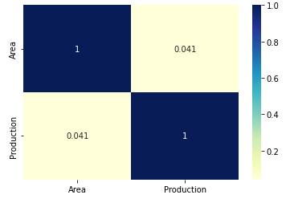

Figure 6.5 heatmap of area and production

**6.3 OUTPUT IMAGE**:

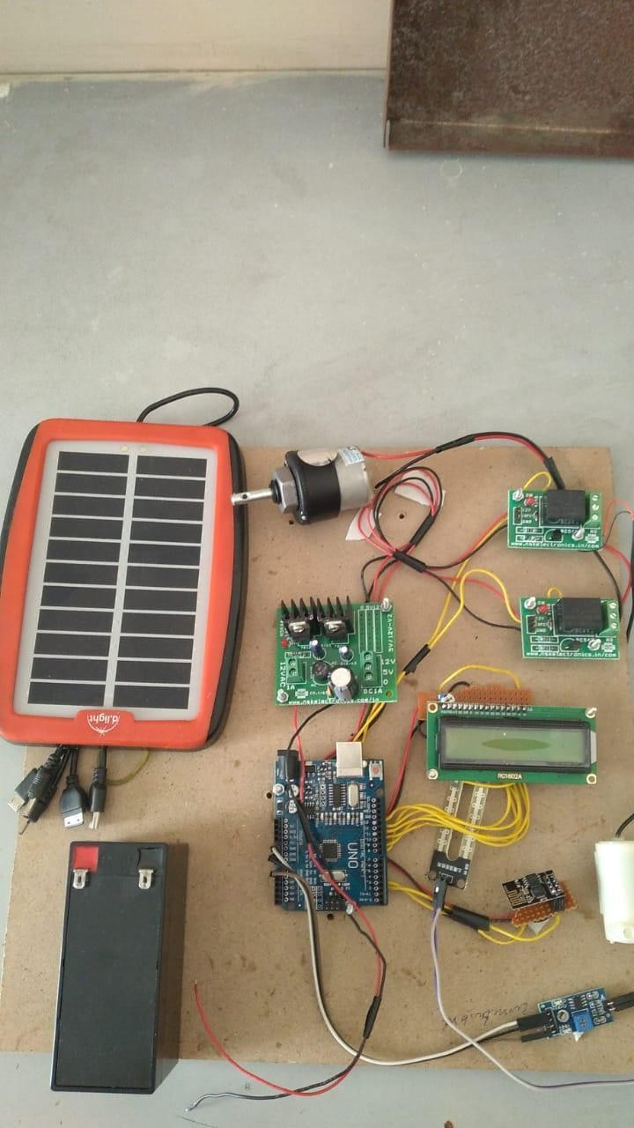

Fig 6.6 Output Image

This paper reinforces the crop production with the aid of machine learning techniques. Thetechnique which results in high accuracy predicted the right crop with its yield. The machinelearning algorithms are implemented on Python 3.8.5(Jupyter Notebook) having input librariessuch as ScikitLearn, Numpy, Keras, Pandas. Developed Android application queried the resultsof machine learning analysis. Flutter based Android app portrayed crop name and itscorresponding yield, in this project we implement automated soil testing method using a handheld device which willdetermine the pH of that soil. Then on basis of pH we will give values of nutrients i.e. NPKpresent in soil. On the basis of values we get from our device we predict list of suitable cropsand fertilizers The Obtained value is processed and compared With the data sets.The output will be displayed in the LED display.The output can also be linked and viewed in a mobile app

**6.4 CONCLUSION**:

Thus, the analysis of the performance of the Roller Bot was done. Methods of improvement were found and analyzed for further development.

**CHAPTER 7**

**CONCLUSION**

**7.1 INTRODUCTION:**

This proposed concept algorithm for predicting grain based on temperature, season, or location. A Yield reckoning for a specific shire is instituted by way of combining precipitation, temperature, and other parameters such as period and location. When all the factors are considered, Random Forest emerges as the best classifier. The dataset that is in use for greater purposes increases the truth rate. In contrast, there are multiple linear regression and decision trees after ignoble applied sciences. Our dataset contains a fascicle of greater variables, resulting in greater unerring predictions. The preface of that assignment is useful to the farmers according to reducing their losses, then expanding crop plant yields according to amplifying their assets in agriculture. This pleasure now not only assists farmers in selecting the best crop after smearing of the upcoming season, but it also intends to assist in bridging the pragmatic yet agricultural divide.

On our challenge is that yield is expected because of 100 acres or carried out because of 30 districts

**7.2 FUTURE SCOPE**

This proposed concept algorithm for predicting grain based on temperature, season, or location. A Yield reckoning for a specific shire is instituted by way of combining precipitation, temperature, and other parameters such as period and location. When all the factors are considered, Random Forest emerges as the best classifier. The dataset that is in use for greater purposes increases the truth rate. In contrast, there are multiple linear regression and decision trees after ignoble applied sciences. Our dataset contains a fascicle of greater variables, resulting in greater unerring predictions. The preface of that assignment is useful to the farmers according to reducing their losses, then expanding crop plant yields according to amplifying their assets in agriculture. This pleasure now not only assists farmers in selecting the best crop after smearing of the upcoming season, but it also intends to assist in bridging the pragmatic yet agricultural divide. On our challenge is that yield is expected because of 100 acres or carried out because of 30 districts..

**7.3 CONCLUSION**

The system will moniter the automation in agricultural field with better efficiency and controls the process of irrigation. In these days smartphone usage are very high. They worked as per the values sent by the sensors and it is also controlled via a developed website if there is any depletion of smartphone.

**CHAPTER 8**

**REFERENCE**

1. R.Suresh, S.Gopinath, K.Govindaraju, T.Devika, N.Suthanthira Vanitha, “GSM based Automated Irrigation Control using Raingun Irrigation System”, International Journal of Advanced Research in Computer and Communication Engineering, Volume 3, Issue 2, February 2014.
2. Chetana A.Kestikar, Rutuja M.Bhavsar, ”Automated Wireless Watering System”, International Journal of Applied Information Systems, Volume 2, Number 3, February 2012.
3. S.Harishankar, R.Satish Kumar, Sudharsan K.P, U.Vignesh, T.Viveknath, “Solar Powered Smart Irrigation System”, Advance in Electronic and Electrical Engineering, Volume 4, Number 4, 2014.
4. Dhana Lakshmi.N, Gomathi K.S, “Smart Irrigation System Autonomous Monitoring and Controlling of Water Pump by Using Photovoltaic Energy”, SSRG International Journal of Electronics and Communication Engineering,Volume 2, Issue 11, November 2015.
5. Basava Sidramappa Dhanne, Sachin Kedare, Shiva Sidramappa Dhanne, “Modern Solar Powered Irrigation System by Using ARM”, International Journal of Reseach in Engineering and Technology, Volume 3, Issue 3, May 2014.
6. Prof. Rupali S.Sawant, Shreejit Gubre, Swathi Pillai, Monica Jain, “ Solar Panel Based Automatic Plant Irrigation System”, ”, International Journal of Innovative Science, Engineering and Technology, Volume 2, Issue 3, March 2015.
7. Ananthara, M. G., Arunkumar, T., & Hemayathy, R. (2013, February). CRY- an improved crop yield prediction model using beehive clustering approach for agricultural data sets. In 2013 International Conference on Pattern Recognition, Informatics and Mobile Engineering.
8. Awan, A. M., & Sap, M. N. M. (2006, April). An intelligent system based on kernel methods for crop yield prediction. In Pacific- Asia Conference on Knowledge Discovery and Data Mining (pp. 841-846). Springer, Berlin, Heidelberg.
9. Bang, S., Bishnoi, R., Chauhan, A. S., Dixit, A. K., & Chawla, I. (2019, August). Fuzzy logic-based Crop Yield Prediction using Temperature and Rainfall parameters predicted through ARMA, SARIMA and ARMAX models. In 2019 Twelfth International Conference on Contemporary Computing (IC3) (pp. 1-6). IEEE
10. Bhosale, S. V., Thombare, R. A., Dhemey, P. G., & Chaudhari, A. N. (2018, August). Crop Yield Prediction using data analytics and hybrid approach. In 2018 Fourth International Conference on Computing Communication Control and Automation (ICCUBEA) (pp. 1-5). IEEE.
11. Gandge, Y. (2017, December). A study on various data mining techniques for crop yield prediction. In 2017 International Conference on Electrical, Electronics, Communication, Computer and Optimization Techniques (ICEECCOT) (pp. 420-423). IEEE
12. Gandhi, N., Petkar, O., & Armstrong, L. J. (2016, July). Rice crop yield prediction using artificial neural networks. In 2016 IEEE Technological Innovations in ICT for Agriculture and Rural Development (TIAR) (pp. 105-110). IEEE.
13. Islam, T., Chisty, T. A., & Chakrabarty, A. (2018, December). A Deep Neural Network Approach for Crop Selection and Yield Prediction in Bangladesh. In 2018 IEEE Region 10 Humanitarian Technology Conference (R10- HTC) (pp. 1-6). IEEE.
14. Jaikla, R., Auephanwiriyakul, S., & Jintrawet, A. (2008, May). Rice yield prediction using a support vector regression method. In 2008 5th International Conference on Electrical Engineering/ Electronics, Computer, Telecommunications, and Information Technology (Vol.1, pp. 29-32). IEEE.
15. Kadir, M. K. A., Ayob, M. Z., & Miniappam, N. (2014, August). Wheat yield prediction: Artificial Neural Network based approach. In 2014 4th International Conference on Engineering Technology and Technopreneuship (ICE2T) (pp. 161-165). IEEE.
16. Manjula, A., & Narisimha, G. (2015, January). XCYPF: A flexible and extensible framework for agricultural Crop Yield Prediction. In 2015 IEEE 9th International Conference on Intelligent Systems and Control (ISCO) (pp. 1-5). IEEE.
17. Mariappan, A. K., & Das, J. A. B. (2017, April). A paradigm for rice yield prediction in Tamilnadu. In 2017 IEEE Technological Innovations in ICT for Agricultural and Rural Development (TIAR) (pp. 18-21). IEEE.
18. Paul, M., Vishwakarma, S. K., & Verma, A. (2015, December). Analysis of soil behavior and prediction of crop yield data mining approach. In 2015 International Conference on Computational Intelligence and Communication Networks (CICN) (pp. 766-771). IEEE.
19. Shah, A., Dubey, A., Hemnani, V., Gala, D., & Kalbande, D. R. (2018). Smart Farming System: Crop Yield Prediction Using Regression Techniques. In Proceedings of International Conference on Wireless Communication (pp. 49-56). Springer, Singapore.
20. Ahamed, A. M. S., Mahmood, N. T., Hossain, N., Kabir, M. T., Das, K., Rahman, F., & Rahman, R. M. (2015, June). Applying data mining Techniques to predict annual yield of major crops and recommend planting different crops in different districts in Bangladesh. In 2015 IEEE/ACIS 16th International Conference on Software Engineering, Artificial Intelligence, Networking and Parallel/ Distributed Computing (SNPD) (pp. 1-6). IEEE.
21. Shastry, A., Sanjay, H. A., & Hegde, M. (2015, June). A parameter based ANFIS model for crop yield prediction. In 2015 IEEE International Advance Computing Conference (IACC) (pp. 253-257). IEEE.
22. Sujatha, R., & Isakki, P. (2016, January). A study on crop yield forecasting using classification techniques. In 2016 International Conference on Computing Technologies and Intelligent Data Engineering (ICCTIDE’16) (pp. 1-4). IEEE.
23. Suresh, A., Kumar, P. G., & Ramalatha, M. (2018, October). Prediction of major crop yields of Tamilnadu using K-means and Modified KNN. In 2018 3rd International Conference on Communication and Electronics Systems (ICCES) (pp. 88-93). IEEE.
24. Veenadhari, S., Misra, B., & Singh, C. C. (2014, January). Machine learning approach for forecasting crop yield based on climatic parameters. In 2014 International Conference on Computer Communication and Informatics (pp. 1-5). IEEE.
25. Gandhi, N., Armstrong, L. J., Petkar, O., & Tripathy, A. K. (2016, July). Rice crop yield prediction in India using support vector machines. In 2016 13th International Joint Conference on Computer Science and Software Engineering (JCSSE) (pp. 1-5). IEEE.
26. Gandhi, N., Armstrong, L. J., & Petkar, O. (2016, July). Proposed decision support system (DSS) for Indian rice crop yield prediction. In 2016 IEEE Technological Innovations in ICT for Agriculture and Rural Development (TIAR) (pp. 13-18). IEEE.
27. J.Indirapriyadharshini, G.Gokul, V.Swathi, M.Tamil Prakash Assistant Professor, Department of EIE, Karpagam College of Engineering UG Scholar, Department of EIE, Karpagam College of Engineering ON THE GO SOIL NUTRIENT IDENTIFICATION AND AUTOMATED FERTIGATION SYSTEM
28. Viscarra Rossel, R.A.V.; Gilbertson, M.; Thylen, L.; Hansen, O.; McVey, S.; McBratney, A.B. ―Field measurements of soil pH and lime requirement using an on-the-go soil pH and lime requirement measurement system”Quality of runoff from fescue plots treated with poultry litter and inorganic fertilizer. J. Env. . 23:579-584.
29. Bundy, L.G., T.W. Andraski and J.M. Powell.”ASAE. 2005. Manure Production and Characteristics “Publication D384.3
30. Raghavendra,R. M.UttaraKumar,S. A.Hariprasad, “Implementation of Simulated Water Level Controller”, International Journal of Advanced Research in Computer Science and Software engineering.
31. Edwards, D.R., and T.C. Daniel”Management practices effects on phosphorus losses in runoff in corn production systems” J. of Environ. Qual. 30: 1822- 1828.1994.
32. F J Veihmeyer, and A H Hendrickson, "Soil Moisture in Relation to Plant Growth," Annual Review of Plant Physiology, Vol. 1, 1950, pp. 285-304
33. Raghavendra,R.M.UttaraKumar,S.A.Hariprasa d, “Implementation of Simulated Water Level Controller”, International Journal of Advanced Research in Computer Science and Software engineering pp(328-329).
34. Santhi, R, S. Maragatham, K.M. Sellamuthu, R. Natesan, V.P.Duraisami, Pradip Dey and A.Subba Rao.2012. Soil Test and Yield target based Fertiliser prescriptions (Tamil), AICRPSTCR, TNAU, Coimbatorel International Journal of Pure and Applied Mathematics Special Issue 1528
35. F J Veihmeyer, and A H Hendrickson, "Soil Moisture in Relation to Plant Growth," Annual Review of Plant Physiology, Vol. 1, 1950, pp. 285-304,