Software Requirements Specification

for

Code Enigma

03 / 08 / 2019

Table of Contents

Table of Contents ii

1. Introduction 1

1.1 Purpose 1

1.2 Document Conventions 1

1.3 Intended Audience and Reading Suggestions 1

1.4 Product Scope 1

1.5 References 1

2. Overall Description 2

2.1 Product Perspective 2

2.2 Product Functions 2

2.3 User Classes and Characteristics 2

2.4 Operating Environment 2

2.5 Design and Implementation Constraints 2

3. External Interface Requirements 3

3.1 User Interfaces 3

3.2 Hardware Requirements 3

3.3 Software Requirements 3

# Introduction

## Purpose

To create a learning site for both frontend and backend for coding purposes, sharpening skills, to practice hands on and to show case your talents in various subjects.

## Document Conventions

<Describe any standards or typographical conventions that were followed when writing this SRS, such as fonts or highlighting that have special significance. For example, state whether priorities for higher-level requirements are assumed to be inherited by detailed requirements, or whether every requirement statement is to have its own priority.>

## Intended Audience

* To make the fresher’s industry ready by directly work in business projects.
* To learn various technologies from basic to expertise level.
* To do hand’s on practices in various subjects.

## Product Scope

* To learn new technologies like MongoDB, VueJs, SpringBoot.
* To understand concepts both in hand’s on from beginner level to expertise level.
* To compete with peers and colleagues

## References

* www.google.com
* [www.getbootstrap.com](http://www.getbootstrap.com)
* [www.w3schools.com](http://www.w3schools.com)
* [www.hackerrank.com](http://www.hackerrank.com)
* www.hackerearth.com

# Overall Description

## Product Perspective

Code Enigma is going to be a WebApp that will help the freshers and other people to practice and showcase their skills in various topics like MySql, HTML,CSS,BootStrap,javascript.etc. The system will be storing the user data and content of various subjects for practice in a relational database. The whole system is designed so as to get hands-on and practice in various subjects.

## Product Functions

The major function of this WebApp is to

* Gives us the choice to choose between various topics.
* To get the progress report of each topics.
* Ample of questions to do the hands-on.
* To complete challenges and to learn new concepts.

## User Classes and Characteristics

Actor

* User

User can practice hands-on session after successful login.

On the consumer side, when a programmer submits a solution to a programming challenge, their submission is scored on the accuracy of their output. Programmers are then ranked globally on the Code Enigma leaderboard and earn badges based on their accomplishments to drive competition among users. In addition to individual programming challenges, Code Enigma also hosts contests where users compete on the same programming challenges during a set period of time and are then ranked at the conclusion of the event. Code Enigma is part of the growing gamification trend within competitive computer programming and the consumer-side of their website is free for coders to use.

* Developer

Developer will directly be able to manipulate the databases, front-end and back-end.

## Operating Environment

* Browser supporting javascript, HTML, CSS.
* Windows or UNIX Operating Systems

## Design and Implementation Constraints

There are some of the constraints which can cause serious issues like

* Internet Connection to communicate with the WebApp.
* Mandatory Login Credentials is required.

# External Interface Requirements

## User Interfaces

There will be two basic pages to interact with the WebApp

* Course Dashboard

Designed using HTML, CSS, Bootstrap, Javascript.

HTML Contents

* + Header
  + Main Body
  + Footer

Bootstrap 4 Classes used are

* Jumbotron
* Primary btn
* Secondary btn
* Container
* Row
* Flex
* Col

Javascript Functions used

* move()

move() function will provide the progress status of the user.

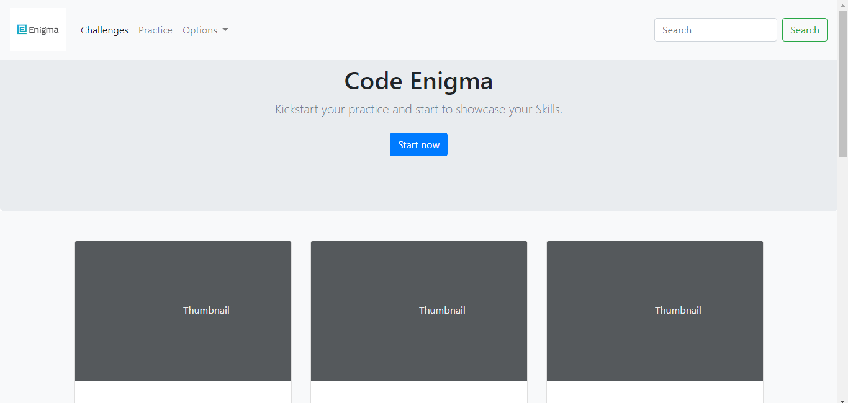

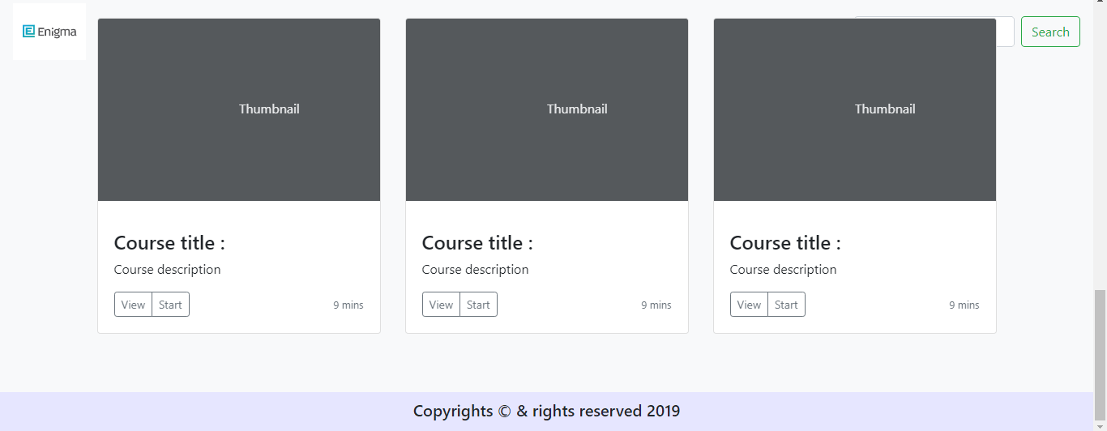‘

* Assessment Page

Designed using HTML, CSS, Bootstrap, Javascript, JQuery.

HTML Contents

* + Header
  + Main Body
  + Footer

Bootstrap 4 Classes used are

* Jumbotron
* Primary btn
* Secondary btn
* Container
* Row
* Flex
* Col

Javascript Functions used

* validate()

validate() function will validate the user’s answer and alert whether it is correct or not.

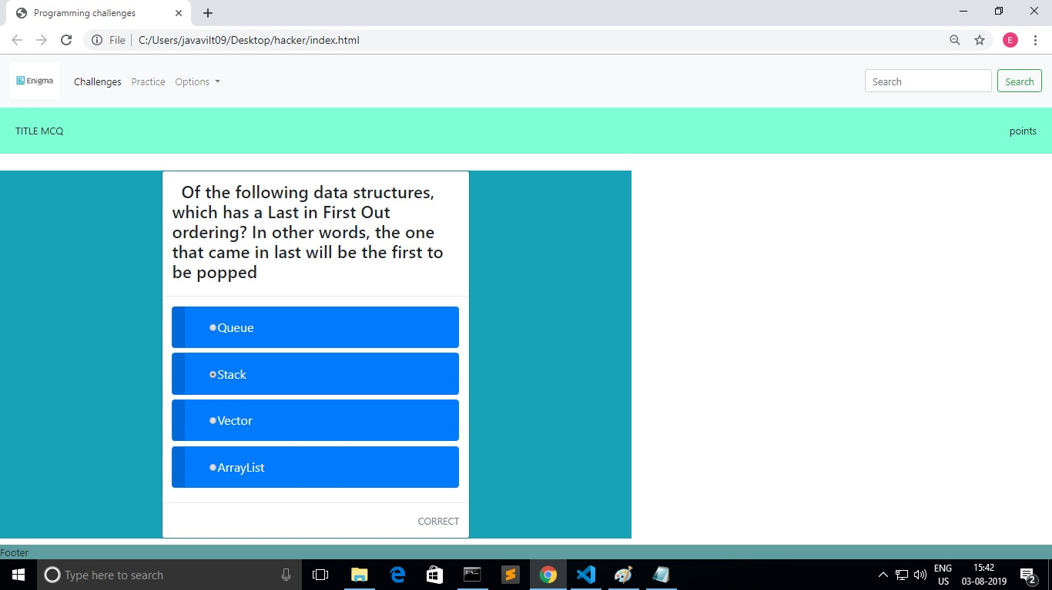

## Hardware Requirements

Minimum Requirements:

* 10Gb of Hard Disk space
* 512Mb of RAM
* Monitor and CPU processor (2GHZ)

## Software Requirements

*Minimum Requirements:*

* *Web Server (GlassFish and Apache Tomcat Server)*
* *Eclipse IDE*
* *Sublime Text Editor or Visual Code Studio*
* *JDBC jar files*
* *Relational Databases*