SHOW DATABASES
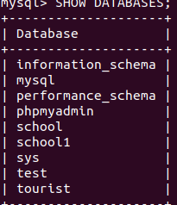

USE COMMAND:use tourist;
database changed;

CREATE TABLE person(person_id int primary key,person_name varchar(20),person_city varchar(15),person_package int,staff_id int);

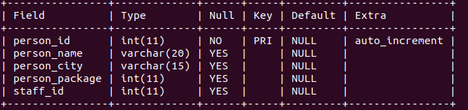
create table staff(staff_id int PRIMARY KEY ,staff_name varchar(20),staff_city varchar(10)
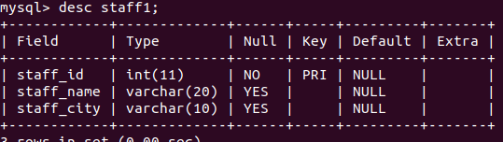

INSERT THE DATA INTO TABLES:
insert into persons (person_id,person_name,person_city,person_package,staff_id) values(1,’hari’,’chennai’,7000,901);
THEN ADD THE MULTIPLE VALUES USING THE SAME SYNTAX

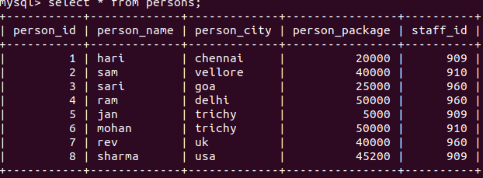
INSERT DATA INTI STAFF1 TABLE:

insert into staff1(staff_id,staff_name,staff_city) values(909,’suba’,’goa’);

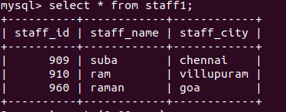

ADD THE STAFF_ID TO FOREIGN KEY;

alter table persons add column staff_id foreign key references staff1(staff_id);

USING THE BETWEEN IN SQL;

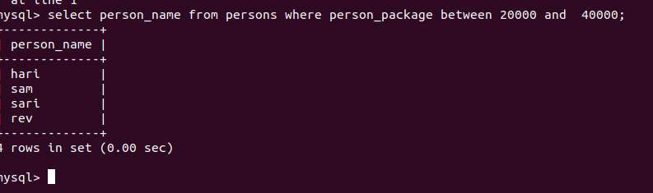
SELECT :

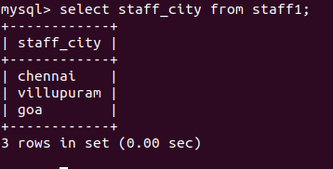

SELECT DISTINCT :
it reduces the duplicate values

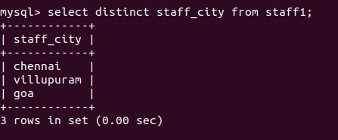

WHERE :

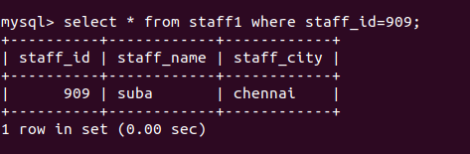

WHERE && AND :

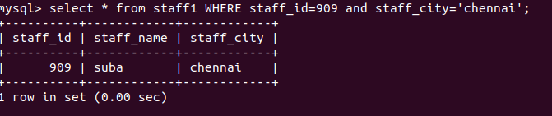

WHERE || OR:
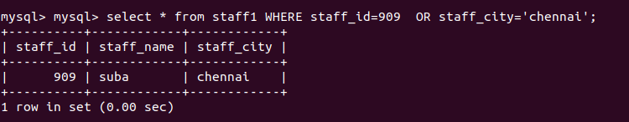

ORDER BY ASCENDING:

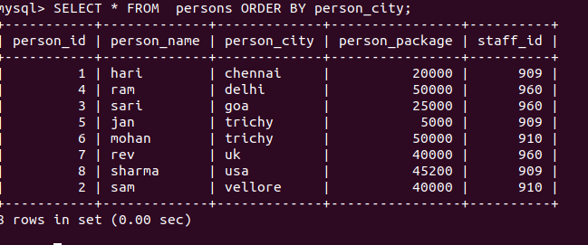

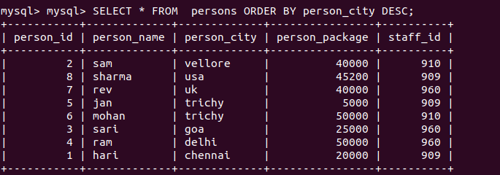
ORDER BY DESCENDING:

LIMIT:

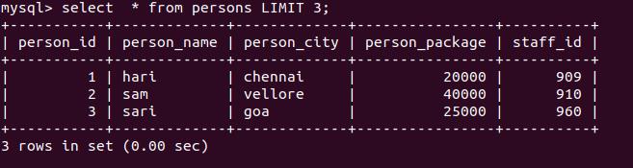

INNER JOIN:

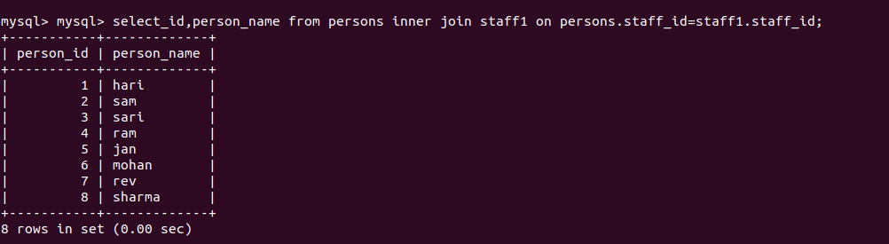
COUNT,AVG AND SUM:

