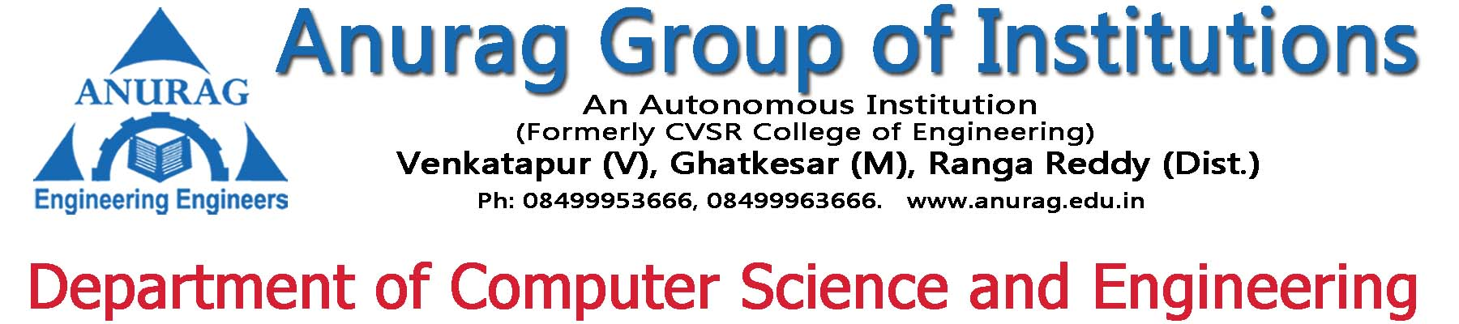

ANURAG WEB CLUB

List of Trainings Conducted During A.Y:2015-2016

Slno | Date | Topic | Resource person
1 | 30/9/2015 | Static web Page Design | Mr.Pallam ravi ,  Mr.V.Ramakrishna
2 | 19/12/2015 | Php mysql | Mr.Pallam ravi

ANURAG WEB CLUB

List of Trainings Conducted During A.Y:2016-2017

Slno | Date | Topic | Resource person
1 | 3/5/2016 to 7/5/2016 | A training program on web mini projects development | Mr. Pallam ravi

ANURAG WEB CLUB

Slno | Date | Topic | Resource person
2015-2016

1 | 30/9/2015 | Static web Page Design | Mr.Pallam ravi ,  Mr.V.Ramakrishna
2 | 19/12/2015 | Php mysql | Mr.Pallam ravi
2016-2017

1 | 3/5/2016 to 7/5/2016 | A training program on web mini projects development | Mr. Pallam ravi

