Microsoft Teams Android Devices Robot Automation Guide

Contents
Introduction to Robot Framework 2
Key Features of Robot 2
Framework 2
Test structure 3
High Level Architecture 3
Android Devices Automation [Robot & Appium] 3
Appium Inspector 4
Appium Capabilities 4
Test Code / Requirements / Invocation 5
Robot environment setup 5
Test code and common methods 7
Robot test invocation 7
Automation setup 8
Config files 8
Logs and reports 14

Introduction to Robot Framework
Robot Framework is a versatile and generic open-source automation framework that has garnered significant attention for its robustness and flexibility. It is used for test automation and robotic process automation, offering a range of features that make automation tasks simpler and more efficient.

Key Features of Robot
- Test Automation and Robotic Process Automation: Robot Framework serves dual purposes by supporting both test automation and robotic process automation, making it a versatile tool for a variety of automation needs.
- Easy Syntax: One of the standouts features of Robot Framework is its easy-to-understand syntax. It utilizes human-readable keywords and methods, which allows both technical and non-technical users to write and understand automation scripts with ease.
- Extensible Libraries: The capabilities of Robot Framework can be significantly extended using libraries written in Python, Java, and other languages. This extensibility allows for customization and the addition of new functionalities to meet specific requirements.
- Support for Various Applications: Robot Framework provides robust support for testing a wide range of applications. This includes web applications, REST APIs, mobile applications, and more, making it a comprehensive tool for different testing scenarios.
- Command Line Interface and XML Output: It offers a command line interface and generates XML-based output files. These features facilitate integration into existing build infrastructures, enabling seamless automation processes within development pipelines.
- Integration with Source Control: Test suites in Robot Framework are organized as files and directories. This structure allows for easy integration with source control systems, ensuring that test cases can be versioned and managed efficiently alongside the source code.

Complete Guide Link : Robot Framework User Guide [Robot official site]

Framework
When Robot Framework is started, it processes the data, executes test cases, and generates logs and reports. The core framework does not know anything about the target under test, and the interaction with it is managed by libraries.
Libraries can either use application interfaces directly or use lower-level test tools as drivers.
The modular design ensures that you can tailor the testing environment to precisely fit your needs, making Robot Framework a powerful choice for automation projects of any scale or complexity.

Test structure
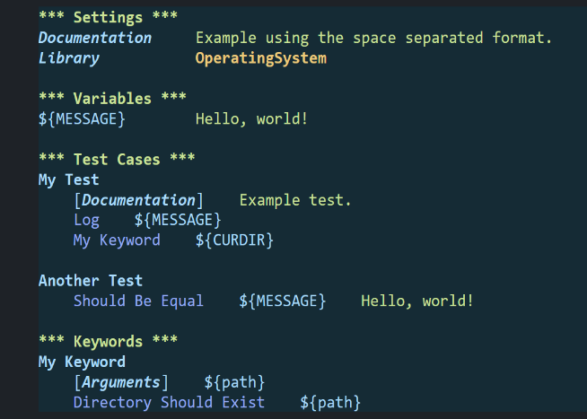

High Level Architecture
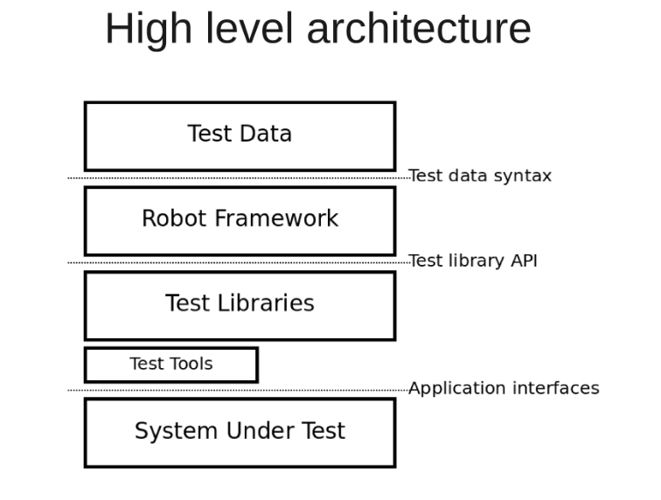

Android Devices Automation [Robot & Appium]
- Robot Test scripts send desired capabilities, specifying device information and test environment settings, to initiate a test session.
- Appium server, running as a standalone entity, listens for commands from the client over HTTP.
- Platform-specific drivers, such as UIAutomator2 for Android devices to interact with app elements based on locator strategies.
- Automation commands from the client, such as “click” or “send Keys,” are translated by the server into low-level device-specific actions.
- Automation scripts the process allows testers to write automation scripts once and run them across various devices and operating systems.
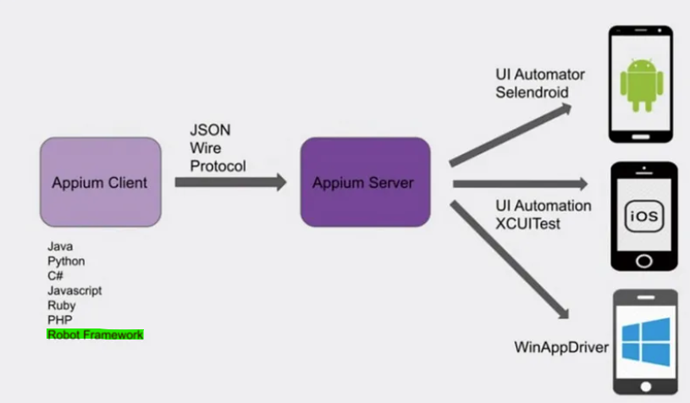

Appium Inspector
Appium Inspector is a tool used in mobile application testing and development. It is specifically designed for automating mobile apps on various platforms such as iOS, Android, and Windows using the Appium framework.
- It is primarily a graphical user interface (GUI) tool that helps streamline the process of creating and inspecting automation scripts for mobile apps.
- It provides a visual representation of the app’s user interface, allowing testers to interact with app elements and inspect their properties.
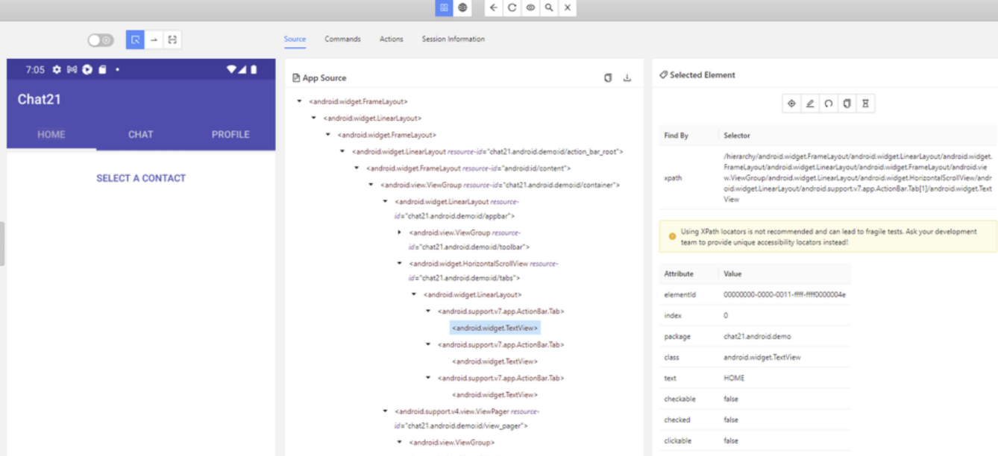

Appium Capabilities
"Capabilities" is the name given to the set of parameters used to start an Appium session. The information in the set is used to describe what sort of "capabilities" you want your session to have, for example, a certain mobile operating system or a certain version of a device. When you start your Appium session, your Appium client will include the set of capabilities you've defined as an object in the JSON-formatted body of the request.

Capabilities are represented as key-value pairs, with values allowed to be any valid JSON type, including other objects. Appium will then examine the capabilities and make sure that they can satisfy them before proceeding to start the session and return an ID representing the session to your client library.

If you use Appium: capabilities in your tests, it can get a little repetitive. You can combine all capabilities as an object value of a single appium:options capability instead, in which case you do not need to use prefixes on the capabilities inside the object.

For example:
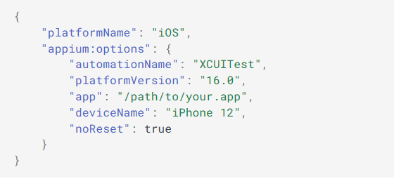

Complete Guide : Appium Documentation , Appium Inspector [Appium official git hub]

Test Code / Requirements / Invocation

Robot environment setup
- Install Java/JDK [Set system variable Path JAVA_HOME = C:\Program Files\Java\jdk-1.8, Path = JAVA_HOME%\bin, %JAVA_HOME%\lib] [For android studio, for emulators]
If asked to create an Oracle account. Kindly create and proceed for download
To check if installed correctly run > java -version

- Install Android studio [For ADB] from https://developer.android.com/studio
Installed studio at = C:\Program Files\Android\Android Studio and SDK at C:\AndroidSdk
[Set system variable Path ANDROID_HOME = C:\AndroidSDK, and add, %ANDROID_HOME%\platform-tools, %ANDROID_HOME%\build-tools to path]
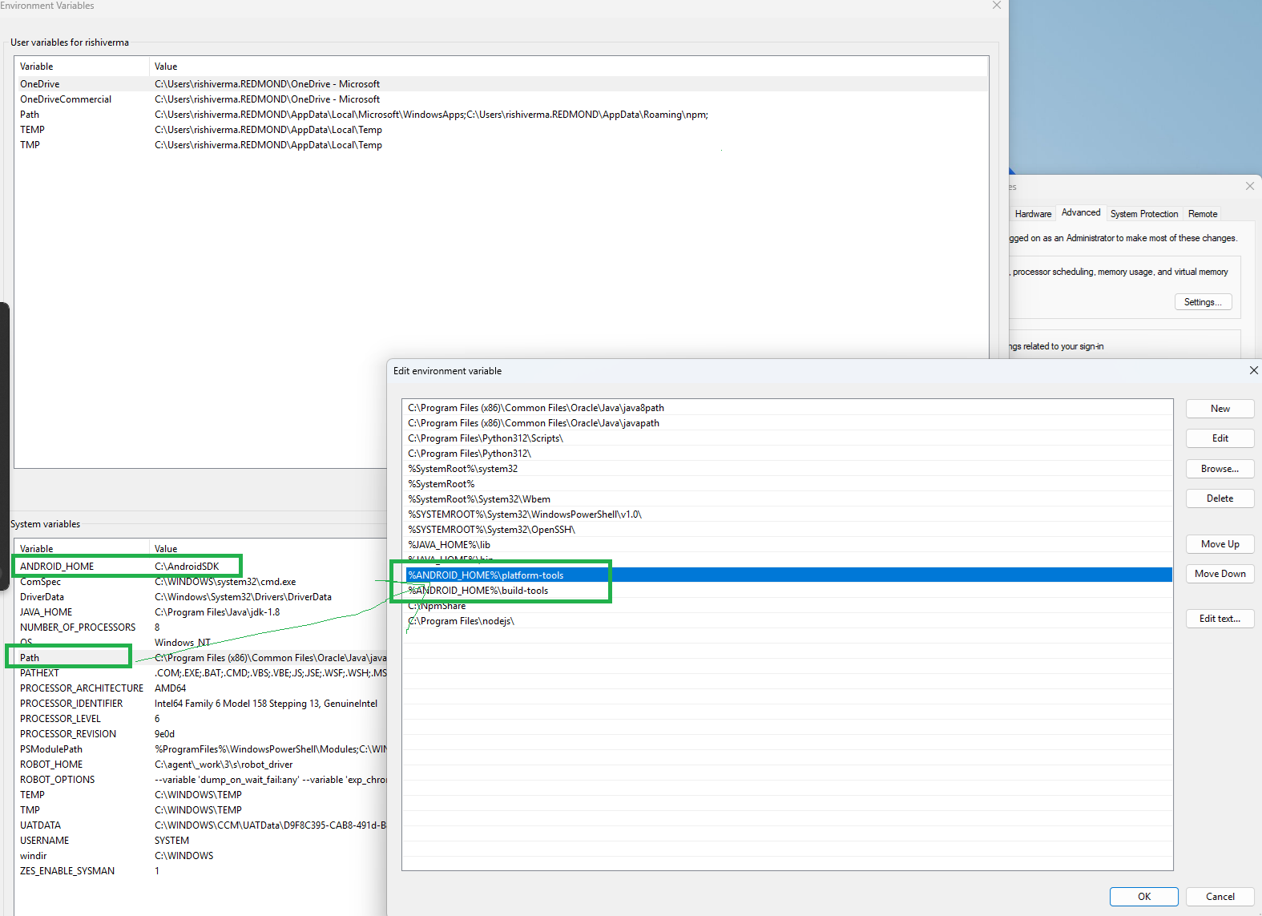

- Install Latest Python from google [> 3.10.11]
Install for everyone at : C:\Program Files\Python310 [Select add Python to Environment variables], Add Both C:\Program Files\Python310 and C:\Program Files\Python310\scripts to path

- Install Node JS and npm > 10.1.0 [Required for Appium]
Get latest at that time = 18.12.1 at C:\Program Files\nodejs\
(*)Create new file c:\NpmShare, and provide the above path in C:\Program Files\nodejs\node_modules\npm\npmrc file, and add c:\NpmShare to environment variables
To check if installed correctly run
> node –v [This should show the nodejs version you’ve installed.]
> npm –v [This should show the nodejs version you’ve installed.]

- Install Appium
npm install -g appium@1.22.1
To check if installed correctly run > appium -v

- Run Requirement.txt present at requirements.txt
pip install -r requirements.txt

- Install Test code
For just running copy from : robot_driver) in a temp folder ex: C:\Temp\robot_driver]
Or for running and development clone the test code : Git clone Link : Repo_Clone
- Add the following paths to PYTHONPATH in system variables [Based on where test code is present]
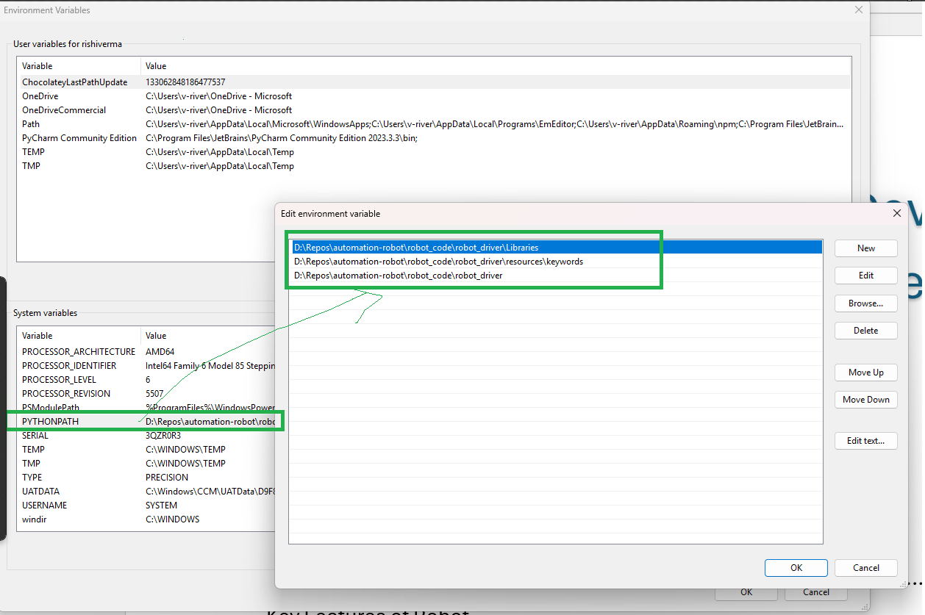

- Fill your config.
[for config details see below].

- To make sure your setup is ready, please run this command inside robot_driver folder
  - > robot --dryrun -d results\check [suite-dir]
[when PYTHONPATH is set] [Note: -d --outputdir dir ]

  - > robot -x outputxunit.xml -P . -P ./Libraries -P ./resources/keywords --dryrun -d results\check [suite-dir]
[when PYTHONPATH is NOT set]
[-P .\Libraries -P .\resources\keywords -P .’ this is all the local module directories the test code is using]

- Install IDE
PyCharm https://www.jetbrains.com/pycharm/ - Install the community version

Test code and common methods [New Repo – Open source]
- Repository: automation-robot
- Default Branch: main
- Organization: skypeforbusinesspartnerengineering
- Project: Teams Android Devices Automation
- Git clone Link : Repo_Clone
- Robot Automation overview and setup doc - checked-in new repo at : Docs - Repos
- Test Code
https://skypeforbusinesspartnerengineering.visualstudio.com/Teams%20Android%20Devices%20Automation/_git/automation-robot?path=/robot_code/robot_driver

- Config files at
https://skypeforbusinesspartnerengineering.visualstudio.com/Teams%20Android%20Devices%20Automation/_git/automation-robot?path=/robot_code/robot_driver/configs

- Common Keywords Defined at
https://skypeforbusinesspartnerengineering.visualstudio.com/Teams%20Android%20Devices%20Automation/_git/automation-robot?path=/robot_code/robot_driver/resources/keywords

- Page Objects defined at
https://skypeforbusinesspartnerengineering.visualstudio.com/Teams%20Android%20Devices%20Automation/_git/automation-robot?path=/robot_code/robot_driver/resources/Page_objects

Robot test invocation
cmd: robot [test selection] [-d outputDir] [python path additions] [suite-dir]
Specifier:
  - -i tag [Run all tests with tag ‘tag’ ],
  - -s suiteName [Run all tests in ‘suiteName’ ],
  - -e tag [Exclude all tests with tag ‘tag’ ],
  - -i tag1ANDtag2 [Run all tests with tags ‘tag1’ and ‘tag2’ ],
  - -d --outputdir dir
Ex:
robot -x outputxunit.xml -P . -P ./Libraries -P ./resources/keywords -d C:\agent/results/01010113/ -i 110022 tests_teams_room
Python Path Additions
Typically, we use relative -P .\Libraries -P .\resources\keywords -P .’ this is all the local module directories the test code is using.

For keywords, structure, variable and getting started check quick videos at : Robot Framework Tutorial - Basics [Youtube video]

Automation setup
- The device under test will always and only be “device_1” as mentioned in the config file.
- ADB setup - Connect each device to your computer using ADB, From command prompt.
If connecting via IP
  - adb connect <IP_ADDRESS>
  - adb –s <IP_ADDRESS> root (If you root the device for the first time, adb connection might be reset so you must connect again using following command. No harm connecting multiple times.)
  - adb connect <IP_ADDRESS>
  - adb devices - (This should list your devices’ IP address)
If connecting via USB
  - Plugin your device to your computer’s USB port.
  - adb devices (This should list your device’s MAC ID)
- Provide Device IP’s and User’s list in Config.json file.

Config files
By default, all "devices" defined in the config.json are connected and initialized – to speed things up, you can remove unused, for example, this test specifies "count=1" and only requires a single "device" definition:
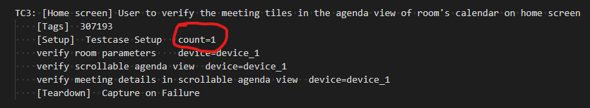

Phones- Config
- Depending on the tests, you may need Single or Multiple (maximum 4) devices.
- You can use mixed and match devices, i.e., different models of device.
- The Device under test will always and only be “device_1” as mentioned in the config.
- device_2, device_3 and device_4 are supporting devices to make P2P calls and conference calls, etc.
- Based on the number of devices present in config, the execution will take place
- Test Cases requiring a greater number of devices than connected will eventually fail.
- The port for the 3 devices must be unique the udid must be complete id, i.e. along with :5555 For example: “udid”: “10.50.100.70:5555”.

- device_1 will have multiple accounts, namely
    - user: User Sign-in Policy Account
    - cap_search_enabled: CAP Account with Search Enabled Policy
    - cap_search_disabled: CAP Account with Search Disabled Policy
    - meeting_user: Meeting Policy Account
    - cq_user: Call Queue User (Call Queue Agent)
    - hotdesk_disabled_user: User without Hot Desking Policy
    - mtra_basic_account: Account with ‘Microsoft Teams Rooms Basic’ license
    - minimum_os_account: Account with ‘Microsoft 365 E3’ license
    - maximum_os_account: Account with ‘Microsoft 365 E3’ license
    - cap_limit_reached_account: User Sign-in Policy Account with Intune license post CAP limit reached
    - enrollment_restrict_account: Account with ‘Microsoft 365 E3’ license
    - cap_mtra_pro_license_with_personal_policy_assigned_account: Account with ‘Microsoft Teams Room Pro’ and ‘Microsoft Teams Shared Devices’ licenses
    - cap_personal_license_with_personal_policy_assigned_account: Account with ‘Microsoft 365 E5’ and ‘Microsoft Teams Shared Devices’ licenses
    - 7-digit Extension policy needs to be assigned to “user” of device_1

- device_2 will have accounts, namely
    - user: User Sign-in Policy Account
    - pstn_user: PSTN (different domain user/account from different tenants)
    - delegate_user: Delegate of user assigned to “user” of device_1
    - gcp_user: User added to call group to “user” of device_1

- device_3 will have accounts, namely
    - user: User Sign-in Policy Account
    - pstn_user: PSTN (different domain user)
    - cq_user: Call Queue User (Call Queue Agent)
    - delegate user: Another user, which acts as delegate user for few tests cases

- device_4 will have accounts, namely
    - user: User Sign-in Policy Account

- Ensure to fill the user details correctly as they are case-sensitive.
- The user details are as follows:
    - username: Email-id of the account
    - password: Password to sign-in in the above-mentioned account
    - displayname: Display name configured while creating the account (alternatively you can check in the device by going to the navigation menu (where display picture is visible)
    - phonenumber: DID number assigned to the account
    - privatelinenumber: Private line number assigned to the account
    - pstndisplay: Complete DID number with ‘+’ and ‘-‘
    - extension number: Extension number (last 7 digits based on the phone number assigned)
    - admin_username: Admin username to enter into admin settings on device
    - admin_password: Password for admin account on the device
    - firmware: Firmware version installed on the device
    - teams_device_capabilities: The expected capabilities of the device ▪ Ex: Video, Better Together
    - ▪ This can also be obtained from device using the command: ‘adb -s <IP/MAC_address> shell settings get secure teams_device_capabilities’

For example:
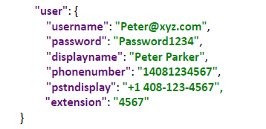

- The “oem” and “model” values for each different device will be shared separately in ‘Partner mapping’ file along with the Appium version to be installed.

MTRA- Config
- Depending on the tests, you may need Single or Multiple (maximum 4) devices.
- The complete Test Pass requires 3 to 4 devices.
    - For Sign-in tests – 1 Devices (To run only on MTRA)
    - For Sign-in tests on Teams Consoles – 2 devices (1MTRA + 1 Console)
    - For Transfer tests – 3 Devices (To run only on MTRA)
    - For Transfer tests – 4 Devices (1 MTRA + 1 Console)
- You can use mixed and match devices, i.e., different models of device.
- The primary device (“device_1”) must be Microsoft Teams Rooms on Android Device only. The supporting devices (“device_2”, “device_3”, and so on) can be Microsoft Teams Rooms on Android Device or Teams Phone. Support for both is available.
- The Device under test will always and only be “device_1” as mentioned in the config.
- device_2, device_3, and device_4 are supporting devices to make P2P calls and conference calls, etc.
- Call forwarding should be disabled in accounts used on device_1, device_2, device_3 and device_4 by logging into those accounts on Desktop Client.
- Based on the number of devices present in config, the execution will take place.
- Test Cases requiring a greater number of devices than connected will eventually fail
- The port for the 3 devices must be unique the udid must be complete id, i.e. along with :5555 For example: “udid”: “10.50.100.70:5555”.

- device_1 will have multiple users, namely
    - user: User Sign-in Policy Account
    - meeting_user: Meeting Policy Account
    - pstn_user: PSTN (different tenants)

- device_2 will have accounts, namely
    - user: User Sign-in Policy Account
    - pstn_user: PSTN (different tenants)
    - pstn_disabled: PSTN (different tenants)

- device_3 will have accounts, namely
    - user: User Sign-in Policy Account
    - pstn_user: PSTN (different tenants)

- device_4 will have accounts, namely
    - user: User Sign-in Policy Account

- While creating an account for “pstn_disabled” user account, assign only the 'Microsoft Teams Rooms Pro' policy; Do not assign any DID to this account.
- The user details are as follows
    - username: email-id of the account
    - password: password to sign-in in the above-mentioned account
    - displayname: display name configured while creating the account (alternatively you can check on the home-screen of the device)
    - phonenumber: the DID number assigned to the account
    - pstndisplay: the complete DID with ‘+’ and ‘-‘
    - extension number: extension number (last 4 or 7 digits based on the policy assigned)

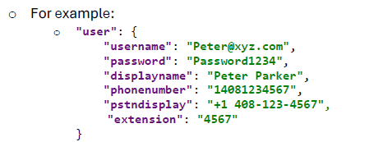

- The “oem” and “model” values for each different device will be shared separately in mapping file along with the Appium version to be installed.
- Only for MTRA execution, please remove the “consoles” section from the config if it is not used.
- In case of console, we need to mention the “user” and “meeting_user” w.r.t to “device_1” “user” and “meeting_user”.
- For console device: “console_1” the “admin_username” and “admin_password” value is same as the admin username and password mentioned in “admin_username” and “admin_password” of “device_1”, which is to be used for Meeting Policy accounts for additional checks like Sign-out.
- The “serial number” in “console_1” is the serial number of the “device_1” with which the “console_1” is paired with.
- The “firmware” in “console_1” is the firmware that is there on console_1 which is used for firmware check validation.

Panels-Config
- The device under test is device_1.
- device_2 and device_3 are supporting devices to test features like knock-knock, room equipment, Auto check-in feature etc.
- device_4 is also a supporting panel device to test Auto/Multi check-in feature.
- Based on the number of devices present in config, the execution will take place.
- You cannot use only two devices for the test pass. (Either one device or all three devices need to be connected for the test pass).
- The complete Test Pass requires a maximum of 4 devices 3.
    - For Sign-in tests – 1 Device
    - For meeting scenario tests – 3 Devices
    - For Auto check-in tests – 4 Devices
- The devices setup should be as mentioned below:
    - First Device: Teams Panel
    - Second Device: Teams Rooms on Android
    - Third Device: Teams Panel
    - Fourth Device: Teams Panel
- The time zone of all three devices should be the same and set time format as 12 hours.
- The “Power Saving Mode” should be disabled for all devices.
- The device under test is device_1.
- device_2 and device_3 are supporting devices to test features like knock-knock, room equipment, Auto check-in feature etc.
- device_4 is also a supporting panel device to test Auto/Multi check-in feature.
- Based on the number of devices present in config, the execution will take place based on the number of devices present in config, the execution will take place
- Test Cases requiring a greater number of devices than connected will eventually fail

- device_1
    - User: The account needs to be assigned with ‘Microsoft Teams Rooms Pro’ license
    - cap_user: The account needs to be assigned with ‘Teams Shared Devices License’
    - premium_user: The account needs to be assigned with ‘Premium license’
    - standard_user: The account needs to be assigned with ‘Standard license’
    - sku_user: The account needs to be assigned with ‘Basic license’
    - auto_checkin_user: The account needs to be assigned with ‘Teams Shared Devices License’ along with ECS enabled for auto check-in feature

- device_2
    - “serial_number”: The serial number of the Teams Rooms device (Required for device pairing with Teams Panel), For Ex: "serial_number": "503032C090000105"
    - user: The account needs to be assigned with ‘Microsoft Teams Rooms Pro’ license
    - cap_user: The account needs to be assigned with ‘Teams Shared Devices License’
    - auto_checkin_user: The account needs to be assigned with ‘Teams Shared Devices License’ along with ECS enabled for auto check-in feature the user credentials need to be exactly same as the user credentials for “device_1”.

- device_3
    - user: User sign-in policy account the user credentials should be unique from the device_1 and device_2 user credentials.

- device_4
    - User: The account needs to be assigned with ‘Microsoft Teams Rooms Pro’ license.
    - auto_checkin_user: The account needs to be assigned with ‘Teams Shared Devices License’ along with ECS enabled for auto check-in feature. The user credentials need to be exactly same as the user credentials for “device_1”.

- All primary accounts should be from the same tenants.
- Fill the user details correctly as they are case-sensitive.
- Based on the Test Cases (Suites), the devices will sign-out and sign-in with the required users mentioned in the config file for them.
- The display name must be the same as before the start of every suite (set of similar cases), the display name is verified to sign-in/sign-out for required user.
- The bottom section of the config needs to be filled with appropriate data as mentioned below:
    - “invalid_username” - Any invalid username with correct domain name
    - “invalid_domain” - Any valid username with invalid domain name
    - “invalid_password” - Invalid password for the account under “user” of “device_1”
- The “oem” and “model” values for each different device will be shared separately in mapping file along with the Appium version to be installed.

Logs and reports
Below is the sample screenshot of logs (log.html)

Multiple suits can be executed together, as shown below:

You can open the log in any browser (log.html) and can see the execution results. Green Coding is for Pass Scenario; Red for Fail, A log file will show you statistics by Suite Names also, as shown below

