MedOrchestrate: Evidence-Grounded Multimodal Clinical Decision Support with Human Review
Project report submitted in partial fulfilment of the requirements for the award of the degree of
BACHELOR OF TECHNOLOGY
in
COMPUTER SCIENCE AND ENGINEERING
Submitted by
[Student 1 name] [Student 1 registration number]
[Student 2 name] [Student 2 registration number]
[Student 3 name] [Student 3 registration number]
[Student 4 name] [Student 4 registration number]
Under the guidance of
[Guide name]
[Guide designation]

AMRITA SCHOOL OF COMPUTING
AMRITA VISHWA VIDYAPEETHAM
AMRITAPURI CAMPUS
KOLLAM 690525
NOVEMBER 2026

DEPARTMENT OF COMPUTER SCIENCE AND ENGINEERING
Amrita School of Computing, Amritapuri Campus
BONAFIDE CERTIFICATE
This is to certify that the project report entitled “MedOrchestrate: Evidence-Grounded Multimodal Clinical Decision Support with Human Review”, submitted by [Student 1 name] ([Student 1 registration number]), [Student 2 name] ([Student 2 registration number]), [Student 3 name] ([Student 3 registration number]) and [Student 4 name] ([Student 4 registration number]), in partial fulfilment of the requirements for the award of the degree of Bachelor of Technology in Computer Science and Engineering at Amrita Vishwa Vidyapeetham, is a bonafide record of the work carried out by them under my guidance and supervision at Amrita School of Computing, Amritapuri, during Semester 7 of the academic year 2026 - 2027.
[Guide name]  Project Guide  Signature ______________________ | [Coordinator name]  Project Coordinator  Signature ______________________
[Chairperson name]  Chairperson, CSE  Signature ______________________ | Reviewers  Signature ______________________

Place: Amritapuri
Date: [DD Month YYYY]

DEPARTMENT OF COMPUTER SCIENCE AND ENGINEERING
Amrita School of Computing, Amritapuri Campus
DECLARATION
We, [Student 1 name] ([Student 1 registration number]), [Student 2 name] ([Student 2 registration number]), [Student 3 name] ([Student 3 registration number]) and [Student 4 name] ([Student 4 registration number]), hereby declare that the project entitled “MedOrchestrate: Evidence-Grounded Multimodal Clinical Decision Support with Human Review” is a record of our original work carried out under the guidance of [Guide name and designation], Department of Computer Science and Engineering, Amrita Vishwa Vidyapeetham, Amritapuri. To the best of our knowledge, this work has not formed the basis for the award of any degree, diploma, fellowship or similar qualification to any candidate at any university. All sources and contributions of others have been appropriately acknowledged, including the use of an AI coding assistant described in the Acknowledgement.
Place: Amritapuri
Date: [DD Month YYYY]
Student details | Signature of the student
[Student 1 name]  [Student 1 registration number] | ______________________
[Student 2 name]  [Student 2 registration number] | ______________________
[Student 3 name]  [Student 3 registration number] | ______________________
[Student 4 name]  [Student 4 registration number] | ______________________

Project Guide: [Guide name]
Signature of the Project Guide: ______________________

ACKNOWLEDGEMENT
We express our sincere gratitude to [Guide name], [Guide designation], Amrita School of Computing, Amritapuri, for guiding this project through its milestones and for insisting that every claim in it be backed by evidence. We thank [Project Coordinator name] and the reviewers for their feedback at the Milestone II and mid-semester reviews, [Chairperson name] and the Department of Computer Science and Engineering, and Amrita Vishwa Vidyapeetham for the facilities and the opportunity. [Add any clinicians or other people who reviewed the system, with their permission.]
This work rests on openly available resources: the U.S. National Library of Medicine (MedlinePlus and PubMed), Europe PMC and ClinicalTrials.gov, whose public interfaces provide the evidence the system retrieves; the authors of BiomedCLIP, BioBERT and MedCPT, who released their models; and the photographers and authors of the openly licensed medical images listed in Appendix A.
Use of an AI assistant. Much of the code, the automated tests, the documentation and the drafting of this report were produced with an AI coding assistant (Anthropic’s Claude, through Claude Code) working under the team’s direction. The expected-diagnosis answer key used in the evaluation was also drafted by the assistant, and no clinician has verified it. We reviewed and ran the assistant’s output, and the limitations this implies are stated in the Results and Analysis chapter. [Confirm that this disclosure satisfies the department’s policy before submission.]

ABSTRACT
Language-model assistants can sound authoritative while being unsupported, and a clinician needs to know what a suggestion rests on and when not to trust it. This project builds MedOrchestrate, a clinician-facing prototype that accepts free text, a medical report, laboratory values, history and an optional CT, MRI or chest X-ray image, and returns a ranked differential in which every diagnosis cites its evidence. The system retrieves from a curated 67-passage knowledge base (BioBERT dense retrieval, MedCPT reranking), queries four public literature sources, reads images with BiomedCLIP zero-shot classification, and fuses everything in a multimodal language model. A deterministic confidence score, not the model’s own, decides whether the system refines its query (at most three rounds) and whether a clinician must review the case; clinician corrections are stored as retrievable precedent.
Achieved: a working end-to-end system with 611 backend and 115 frontend automated tests; a retrieval harness in which mean reciprocal rank on 14 real agent queries rose from 0.685 to 0.863 through fixes and then fell to 0.764 (hit@5 still 14/14) when the knowledge base grew from 42 to 67 passages to cover missing conditions; an 88-image real-image benchmark on which zero-shot top-1 finding accuracy was 42% on the first 62 (chance 10%), and 56% after a prompt change whose held-out gain (7/25 to 12/25 images) was not significant and was not reproduced on 26 fresh images (15/26 against 14/26); and a live 31-case run that exposed, and led to the fix of, a flaw letting empty inputs skip review. Not yet done: re-running the 31 cases on the final system, LLM-judged scoring, and clinician evaluation (3 real reviews of the 10 required). The project addresses UN Sustainable Development Goal 3, Good Health and Well-being (target 3.8); its contribution is expected, not demonstrated.
Keywords: clinical decision support; retrieval-augmented generation; multimodal fusion; confidence calibration; human-in-the-loop
TABLE OF CONTENTS
ACKNOWLEDGEMENT i
ABSTRACT ii
Chapter 1 Introduction 1
1.1 Background and motivation 1
1.2 Objectives 2
1.3 Scope and constraints 3
1.4 Project report organization 3
Chapter 2 Problem Definition 4
2.1 Problem statement 4
2.2 Existing system and limitations 4
Chapter 3 Literature Review 6
3.1 Review scope and selection 6
3.2 Descriptive review of literature works 6
3.3 Comparison of reviewed literature 12
Chapter 4 Requirements 13
4.1 Functional requirements 13
4.2 Non-functional requirements 14
4.3 Hardware requirements 14
4.4 Software and data requirements 14
Chapter 5 Proposed Methodology 16
5.1 Design (architecture) or conceptual framework 16
5.2 Proposed approach and procedure 17
Chapter 6 Results and Analysis 23
6.1 Evaluation setup 23
6.2 Evaluation criteria 23
6.3 Result 24
6.4 Comparative analysis 31
6.5 Discussion and Interpretation 32
6.6 Limitations 32
Chapter 7 Conclusion 34
7.1 Conclusion 34
7.2 Future work 34
References 36
Appendix A Source Code and Reproducibility 37
A.1 Setup and execution 37
A.2 Supporting material 37
Appendix B Supporting Results 38
B.1 Per-query retrieval results 38
B.2 Per-finding imaging results 38
Appendix C Worked Example 40
C.1 Input 40
C.2 Output 40
Appendix D Knowledge Base Inventory 42
Appendix E API and Configuration Reference 44
E.1 HTTP interface 44
E.2 Configuration 44
Appendix F Test Inventory and Live-Case Results 45
F.1 Automated tests by module 45
F.2 The 31 live cases 46

LIST OF FIGURES
Figure 5.1: System architecture 16
Figure 5.2: Pipeline workflow with the confidence-driven refinement loop and clinician review 17
Figure 5.3: Two-stage retrieval and calibrated scoring 18
Figure 5.4: Asynchronous diagnosis: submit, progress events and polling 21
Figure 5.5: The interface: (a) case form with history and lab fields; (b)–(d) screens populated by a mock API, so their contents are illustrative and not system output 22
Figure 6.1: Retrieval quality as the pipeline was corrected, and after the knowledge base grew 25
Figure 6.2: Top-1 finding accuracy before and after the caption change, with Wilson intervals 27
Figure 6.3: Prompt-wording experiment: development choice and the one-time held-out result 28
Figure 6.4: Reported confidence for the 31 live cases, before the input-sufficiency gate 30

LIST OF TABLES
Table 1.1: Objectives, evaluation methods, deliverables and status 2
Table 2.1: Existing approaches and the gap this project addresses 4
Table 3.1: Comparison of reviewed literature 12
Table 4.1: Functional requirements and acceptance criteria 13
Table 4.2: Non-functional requirements 14
Table 4.3: Software and data used 14
Table 5.1: Composition of the knowledge base 18
Table 5.2: Parameters of the confidence score 20
Table 6.1: Retrieval on 14 real agent queries (hit@5, hit@1 and MRR@5); 42-passage knowledge base unless stated 24
Table 6.2: Zero-shot finding accuracy on real images (true modality given; Wilson 95% interval) 26
Table 6.3: The 17 fresh images under the current captions and the bare labels 28
Table 6.4: Results against baselines and expectations 31
Table 7.1: Next steps, dependencies and proposed validation 34
Table B.1: Retrieval harness, final system: rank of the first relevant passage 38
Table B.2: Top-1 per finding on the original 62 images, before and after the caption change (counts of images) 38
Table C.1: Case CASE002 as submitted 40
Table C.2: Ranked differential for CASE002 40
Table D.1: Knowledge-base passages 42
Table E.1: Endpoints 44
Table E.2: Settings read from the environment (documented in .env.example) 44
Table F.1: Backend tests collected by pytest 45
Table F.2: Per-case results of the live run (version before the input-sufficiency gate) 46

Introduction

Background and motivation
Computerised clinical decision support systems help clinicians with complex decisions and have evolved from the 1980s to today’s record-integrated tools, but their effects on providers, patient outcomes and costs are not fully known and past setbacks show that they carry real risks [1]. A specific risk is automation bias, the tendency to over-rely on automated advice. A systematic review of 74 studies found that trust, confidence and workload influence it, and that design choices such as providing information rather than recommendations, and showing updated confidence levels, can mitigate it [2]. Any system that suggests diagnoses must therefore show what its suggestion rests on and how far to trust it.
Large language models now encode considerable clinical knowledge, yet human evaluation of a leading model still revealed gaps and answers that remained inferior to clinicians’ [5]. Retrieval-augmented generation conditions generation on retrieved text; its authors present this as a way to address the lack of provenance and the difficulty of updating knowledge in purely parametric models [3], and a large benchmark for medicine reports accuracy gains of up to 18% from retrieval over chain-of-thought prompting across six models [4]. Clinical reasoning is also multimodal. BiomedCLIP, a biomedical vision-language model pretrained on 15 million figure-caption pairs [6], scores images against text, so an image can be classified with text labels alone; how reliable that is on real films is an open question that this project measures rather than assumes.
MedOrchestrate is a prototype that combines these ideas under one rule: the language model may reason, but it may not set its own confidence, and a clinician stays in the loop. Evidence is retrieved from a curated knowledge base and from four public literature sources; every listed diagnosis must cite what supports it; a deterministic score, computed from the evidence and not from the model’s self-reported certainty, decides when the system should refine its search and when a human must review the case.

Sustainable Development Goal mapping
The project is relevant to United Nations Sustainable Development Goal 3: Good Health and Well-being (“Ensure healthy lives and promote well-being for all at all ages”) [16], specifically target 3.8, universal health coverage including access to quality essential health-care services. The mapping runs through the problem (reliable second-opinion support is unevenly available), the objectives (evidence that is traceable, a confidence that is honest about thin input, and mandatory review), the contribution (a locally runnable prototype that uses only public evidence sources and open models) and the intended beneficiaries (clinicians working with limited specialist access, and their patients). This is an expected contribution. Nothing in this report demonstrates a clinical outcome, and the system is not validated for clinical use.

Objectives
The objectives are stated so that each can be checked, and Table 1.1 links each to an evaluation method, a deliverable and its status.
Table 1.1: Objectives, evaluation methods, deliverables and status
ID | Objective | Evaluation method | Deliverable | Status
O1 | Accept any combination of text, report, labs, history and image, and return a ranked differential with cited evidence. | Automated tests (611 backend, 115 frontend); live runs | FastAPI backend, React interface | Met; see Section 6.3.1
O2 | Ground the differential in a curated knowledge base and four live sources; the relevant passage should reach the top five. | 14-query retrieval harness: hit@5, MRR@5 | 67-passage knowledge base; retrieval pipeline | Met on the harness; Section 6.3.2
O3 | Read CT, MRI and chest X-ray images with BiomedCLIP and characterise its reliability with uncertainty. | 88 real images; Wilson intervals; held-out test; fresh-image checks | Image benchmark and report | Met; Section 6.3.3
O4 | Make confidence deterministic, and route thin, empty or low-confidence cases to review. | Unit tests; 31-case live run; abstention check | Confidence module with sufficiency gate | Partly: gate verified by tests, not yet live; Section 6.3.6
O5 | Refine at most three times, then hand over to a clinician; keep corrections as retrievable precedent. | Tests; live runs; case-memory round trip | Optimizer, review screen, case memory | Met mechanically; clinical value not evaluated
O6 | Show sources, confidence and live progress in the interface. | Browser verification; real async run | Four-screen UI, async progress API | Met; Section 6.3.8
O7 | Report results honestly, separating achieved from planned work. | This report | Chapter 6 and Appendix B | Planned items listed in Section 6.6.1

Scope and constraints
Intended users are clinicians reviewing a case; the output is decision support for review, never an autonomous diagnosis. Included: text, report, laboratory value and history input; CT, MRI and chest X-ray images; offline and live evidence retrieval; multimodal fusion; deterministic confidence with an input-sufficiency gate; a bounded refinement loop; clinician accept, override and annotate; persistence; case memory; weight recalibration; and a web interface with live progress. Excluded: DICOM handling, integration with health records, regulatory validation, patient-identity management, and any clinical trial.
Assumptions and constraints. The prototype assumes that the four public evidence sources and a language-model provider are reachable. Live runs used a free-tier Gemini model (gemini-3.5-flash-lite), whose request quotas repeatedly limited the evaluation; the code supports Claude, but that path was unit-tested and not run end to end. The knowledge base is deliberately small (67 passages). The test cases are 24 synthetic and 7 real-image cases. The expected-diagnosis key is developer-drafted and not clinician-verified. The work was carried out in Semester 7.

Project report organization
Chapter 2 defines the problem and the limits of existing approaches. Chapter 3 reviews fourteen works. Chapter 4 states the requirements. Chapter 5 presents the design and methodology. Chapter 6 reports the evaluation, separating achieved results from planned ones. Chapter 7 concludes and lists future work. Appendix A gives the repository, setup and image credits, and Appendix B gives supporting results.

Problem Definition

Problem statement
Problem. Given a patient’s age and sex and any combination of free text, a medical report, laboratory values, past history and a CT, MRI or chest X-ray image, produce a ranked differential diagnosis, with the evidence behind each entry, and an honest indication of whether the result can be relied on. Stakeholders are the reviewing clinician, who needs traceable evidence; the patient, who is affected by an over-confident suggestion; and the institution, which needs the system to fail visibly rather than silently.
Consequences of getting it wrong. An unsupported but fluent answer invites over-reliance [2]; an empty or vague input that still yields a confident diagnosis is worse. The project therefore poses three questions. RQ1: can retrieval from a curated knowledge base and live sources make each diagnosis traceable to evidence? RQ2: can a deterministic confidence and an input-sufficiency check route unreliable cases to a human? RQ3: how reliable is zero-shot imaging as a pre-filter on real images? The inputs are the case fields above; the output is a report with a ranked differential, cited evidence, flagged conflicts, imaging findings, a confidence score and a review flag.

Existing system and limitations
Table 2.1 summarises the families of existing approaches, with their limitations as reported in the literature reviewed in Chapter 3.
Table 2.1: Existing approaches and the gap this project addresses
Approach | Strength | Limitation (source) | Gap
Clinical decision support in records [1] | Integrated into clinical workflow | Effects on outcomes and costs not fully known; documented risks and pitfalls [1] | Evidence behind each suggestion is rarely shown
General medical language models [5] | State-of-the-art accuracy on medical exam benchmarks | Gaps found by human evaluation; answers inferior to clinicians [5] | No provenance or deterministic reliability signal
Retrieval-augmented medicine [4] | Accuracy gains of up to 18% over chain-of-thought across six models | No agreed best settings for different medical purposes [4] | Text only; no confidence-driven escalation to a human
Biomedical vision-language models [6, 7] | Image-text retrieval, classification and question answering; a conversational image assistant | Reliability on real clinical films not reported in the abstracts | Image findings unvalidated; need a conflict check and cautious use

Among the works reviewed, none combines multimodal evidence, traceable citations, a reliability score that the language model cannot set, and a mandatory human review step in one pipeline; that combination is the gap this project addresses. The statement is limited to the fourteen works in Chapter 3 and is not a claim about the whole field.

Literature Review

Review scope and selection
The review covers the design questions this project had to answer: how decision support fails when advice is trusted without evidence [1, 2]; how language models and retrieval can be combined for medicine [3–5, 9]; which biomedical image-text and retrieval models to build on [6–8]; how to fuse rankings [11] and calibrate a score [10]; and how to evaluate generated answers [12]. Searches used these topics as keywords (clinical decision support, automation bias, retrieval-augmented generation, medical question answering, biomedical vision-language model, biomedical retrieval, rank fusion, calibration, LLM-as-a-judge) on arXiv, PubMed, Europe PMC and publisher pages. Works were selected if they were primary papers whose result bore directly on a design choice, and the publication period spans 2009 to 2025. Fourteen works were read; twelve are reviewed individually below, and two (BioBERT [13] and Ragas [14]) are cited where they are used.
Reading depth and honesty. Bibliographic details and findings were taken from each paper’s own abstract or primary page (for [11], the paper itself). We did not reproduce any result. Where an abstract is silent we write “Not reported”, as the template requires, and “Not applicable” only where a detail does not apply.

Descriptive review of literature works

Clinical decision support systems: benefits, risks and strategies
Sutton et al. (2020) in “An overview of clinical decision support systems: benefits, risks, and strategies for success” [1] investigate how computerised clinical decision support systems (CDSS) help clinicians with complex decisions, and what risks they carry, as such systems are increasingly delivered through electronic medical records. The work proposes an overview of the types of CDSS, use cases with proven efficacy, common pitfalls and potential harms, and closes with evidence-based recommendations for reducing risk in CDSS design, implementation, evaluation and maintenance. The study is situated in the literature on CDSS since the 1980s; datasets, tools and experiments are not applicable. The evaluation is a qualitative synthesis, and no quantitative criteria are reported in the abstract. The authors report that the effects of CDSS on providers, patient outcomes and costs are not fully known, and that past successes and setbacks show these systems carry risks. Comparisons with other approaches are not applicable. Limitations are not reported in the abstract. This work informs the present project through its warning that decision support is not automatically safe; it leaves open how to show the evidence behind each individual suggestion, which this project addresses.

Automation bias in clinical decision support
Goddard, Roudsari and Wyatt (2012) in “Automation bias: a systematic review of frequency, effect mediators, and mitigators” [2] investigate the tendency to over-rely on automated advice, with a focus on clinical decision support. The work is a systematic review: of 13,821 retrieved papers, 74 met the inclusion criteria. The databases and period searched are not reported in the abstract. The authors synthesise the included studies for the frequency of automation bias, the factors that mediate it and the ways to mitigate it. They report that user factors, trust and confidence, and environmental pressures such as workload, task complexity and time constraints influenced automation bias, and that mitigators included training, emphasising user accountability, and design choices such as where advice appears on screen, updated confidence levels, and providing information rather than recommendations. Comparisons with other approaches are not applicable and limitations are not reported in the abstract. This work informs the present project by motivating a display of evidence and confidence, and a mandatory review step, instead of a bare recommendation. It leaves open which confidence signal deserves trust, which is why this project computes confidence deterministically.

Retrieval-augmented generation
Lewis et al. (2020) in “Retrieval-augmented generation for knowledge-intensive NLP tasks” [3] investigate how to give generative language models access to external knowledge, since pretrained models store facts in their parameters but cannot readily access or precisely manipulate them, give provenance for their decisions, or update their knowledge. The work proposes retrieval-augmented generation (RAG) models that combine a pretrained sequence-to-sequence model as parametric memory with a dense vector index of Wikipedia, accessed through a pretrained neural retriever, as non-parametric memory, in two formulations: one conditions on the same retrieved passages for the whole output, the other can use different passages per token. The models were fine-tuned and evaluated on a range of knowledge-intensive tasks. The authors report state-of-the-art results on three open-domain question-answering tasks, outperforming parametric sequence-to-sequence models and task-specific retrieve-and-extract architectures, and on generation tasks more specific, diverse and factual output than a parametric-only baseline. Limitations are not reported in the abstract. This work informs the present project through its core design of retrieving before generating; the gap is that its corpus is general-domain and it has no notion of when retrieval was not good enough.

Benchmarking retrieval-augmented generation for medicine
Xiong, Jin, Lu and Zhang (2024) in “Benchmarking retrieval-augmented generation for medicine” [4] investigate hallucination and outdated knowledge in medical question answering, and the lack of best practices for the optimal RAG setting for different medical purposes. The work proposes MIRAGE, a benchmark of 7,663 questions from five medical question-answering datasets, and the MedRAG toolkit. The study ran over 1.8 trillion prompt tokens across 41 combinations of corpora, retrievers and backbone language models. The authors report that MedRAG improves the accuracy of six language models by up to 18% over chain-of-thought prompting, raises GPT-3.5 and Mixtral to GPT-4-level performance, performs best when corpora and retrievers are combined, and shows a log-linear scaling property and “lost-in-the-middle” effects. Limitations are not reported in the abstract. This work informs the present project by supporting retrieval, and the combination of a curated corpus with live sources. It evaluates question answering rather than case-level, multimodal decision support and has no reliability gate, which this project adds.

Large language models encode clinical knowledge
Singhal et al. (2023) in “Large language models encode clinical knowledge” [5] investigate how to assess the clinical knowledge of language models, because existing assessments rely mainly on automated evaluation over limited benchmarks. The work proposes MultiMedQA, which combines six existing open question-answering datasets with HealthSearchQA, a new set of medical questions searched online, a human evaluation framework covering factuality, comprehension, reasoning, possible harm and bias, and instruction prompt tuning, which produced Med-PaLM from Flan-PaLM. PaLM (540 billion parameters) and Flan-PaLM were evaluated. The authors report that Flan-PaLM reached state-of-the-art accuracy on every multiple-choice dataset, including 67.6% on MedQA, over 17% above the prior state of the art, that human evaluation revealed key gaps, and that Med-PaLM performed encouragingly but remained inferior to clinicians. The authors state that the gaps expose important limitations of today’s models. This work informs the present project: model knowledge alone is not enough, so answers need grounding and review. It offers no citations to evidence and no deterministic reliability signal.

BiomedCLIP
Zhang et al. (2025; arXiv 2023) in “A multimodal biomedical foundation model trained from fifteen million image–text pairs” [6], which introduces BiomedCLIP, investigate the need for high-quality paired multimodal data to build a generalist biomedical model. The work proposes PMC-15M, 15 million image-text pairs from 4.4 million scientific articles, which the authors describe as two orders of magnitude larger than datasets such as MIMIC-CXR, and BiomedCLIP, a multimodal foundation model with domain-specific adaptations. The study is situated in retrieval, classification and visual question answering on standard biomedical benchmarks, with ablations. The authors report new state-of-the-art results across standard datasets and better performance than radiology-specific models such as BioViL on RSNA pneumonia detection. The models are released as open access. Limitations are not reported in the abstract. This work informs the present project as its image pre-filter. Because its pretraining data are published articles, this project flags possible overlap with its own image benchmark, and it measures reliability on individual real films, which the abstract does not report.

LLaVA-Med
Li et al. (2023) in “LLaVA-Med: Training a large language-and-vision assistant for biomedicine in one day” [7] investigate how to build a conversational assistant for biomedical images, because general-domain vision-language models lack depth on them and prior conversational work focuses on text. The work proposes a model trained on a PubMed Central figure-caption dataset, with open-ended instruction-following data generated from the captions by GPT-4, and a general-domain vision-language model fine-tuned with a curriculum that first aligns biomedical vocabulary and then teaches conversation. Training took under 15 hours on eight A100 GPUs. The model was tested on three standard biomedical visual question-answering datasets. The authors report strong multimodal conversational ability and better results than previous supervised state-of-the-art methods on certain metrics. Limitations are not reported in the abstract. This work shows that image-and-language assistants for biomedicine are feasible, which is relevant to the multimodal fusion step. It provides no evidence citation and no reliability gate, and it is not used in this project.

MedCPT
Jin et al. (2023) in “MedCPT: Contrastive pre-trained transformers with large-scale PubMed search logs for zero-shot biomedical information retrieval” [8] investigate biomedical information retrieval, which mostly relies on lexical matching because semantic retrieval with language-model encoders needs many query-article annotations that are scarce in biomedicine. The work proposes MedCPT, a contrastively pre-trained retriever and re-ranker that are closely integrated, trained on about 255 million user click logs from PubMed. The authors assess six biomedical retrieval tasks and the quality of article and sentence representations. They report state-of-the-art performance on the six tasks, including better results than much larger models such as the GPT-3-sized cpt-text-XL. Limitations are not reported in the abstract. This work informs the present project directly: its cross-encoder is this project’s default reranker. The abstract reports benchmark tasks, not symptom-list queries over a 67-passage corpus, so the present project measures it on its own queries (Chapter 6).

Self-RAG
Asai et al. (2023) in “Self-RAG: Learning to retrieve, generate, and critique through self-reflection” [9] investigate factual errors that arise when language models rely on parametric knowledge alone, and the cost of standard RAG, which retrieves a fixed number of passages whether or not retrieval is needed or the passages are relevant. The work proposes Self-RAG, in which one language model is trained to retrieve on demand and to generate and reflect on the retrieved passages and its own output using special reflection tokens, which also make the model controllable at inference time. The authors evaluate open-domain question answering, reasoning, fact verification and long-form generation. They report that the 7B and 13B versions outperform state-of-the-art language models and retrieval-augmented models, including ChatGPT and retrieval-augmented Llama2-chat on question answering, reasoning and fact verification, with significant gains in factuality and citation accuracy for long-form generation. Limitations are not reported in the abstract. This work informs the present project’s idea of retrieving again when evidence is inadequate; this project uses a deterministic external score and no model training.

On calibration of modern neural networks
Guo, Pleiss, Sun and Weinberger (2017) in “On calibration of modern neural networks” [10] investigate confidence calibration, meaning whether predicted probabilities match how often a model is correct, which matters in many applications. The work evaluates post-processing calibration methods on state-of-the-art architectures, using image and document classification datasets, and identifies depth, width, weight decay and batch normalisation as factors that influence calibration. The authors report that modern neural networks are poorly calibrated, unlike networks of a decade earlier, and that temperature scaling, a single-parameter variant of Platt scaling, is surprisingly effective at calibrating predictions on most datasets. Limitations are not reported in the abstract. This work informs the present project as a caution: scores that look like probabilities usually are not, and need a calibration step. This project rescales its reranker score with two constants, a similar one-parameter-pair idea, but fits them by hand to match average values and does not claim a calibrated probability (Section Section 5.2.4).

Reciprocal rank fusion
Cormack, Clarke and Büttcher (2009) in “Reciprocal rank fusion outperforms Condorcet and individual rank learning methods” [11] investigate how to combine the document rankings of several retrieval systems without training examples. The work proposes reciprocal rank fusion (RRF), which scores a document by the sum over rankings of 1/(k + rank), with k = 60 fixed in a pilot study and not altered later. The study ran four pilot experiments, each combining 30 configurations of one search engine over four TREC collections, then four sets of TREC submissions, and built a meta-learner on the LETOR 3 dataset. The authors report that RRF consistently yields better results than any individual system and better results than Condorcet Fuse, that it equalled or bettered CombMNZ, that k = 60 was near-optimal but not critical, and that the meta-learner ranked LETOR 3 better than any previously reported method. Limitations are not reported. This work informs the optional RRF ordering of retrieved passages in this project; its own evidence on this project’s data is small and mixed (Chapter 6).

LLM-as-a-judge
Zheng et al. (2023) in “Judging LLM-as-a-judge with MT-Bench and Chatbot Arena” [12] investigate how to evaluate chat assistants with strong language models as judges, since existing benchmarks miss human preferences. The work contributes MT-Bench, a multi-turn question set, and Chatbot Arena, a crowdsourced battle platform. The authors report that strong judges such as GPT-4 agree with controlled and crowdsourced human preferences at over 80%, which they note matches human-to-human agreement, and they identify position, verbosity and self-enhancement biases and limited reasoning ability, for which they propose some mitigations. The context is open-ended chat, not medicine. This work informs the present project’s LLM-judged evaluation and, through the self-enhancement bias, the caveat that a model grading its own output is a consistency check and not an accuracy measurement (Section Section 6.6.1).

Comparison of reviewed literature
Table 3.1 compares the twelve works on the attributes the template names. “NR” means not reported in the abstract and “NA” not applicable.
Table 3.1: Comparison of reviewed literature
Work and citation | Problem or objective | Approach and contribution | Study context | Evaluation criteria | Key findings | Limitations and gap
Sutton et al., 2020 [1] | Benefits and risks of clinical decision support | Overview of CDSS types, efficacy, pitfalls, harms; recommendations | CDSS literature since the 1980s | Qualitative synthesis | Effects on outcomes and costs not fully known; real risks | NR. No per-suggestion evidence
Goddard et al., 2012 [2] | Over-reliance on automated advice | Systematic review: frequency, mediators, mitigators | 74 of 13,821 papers included | Synthesis of included studies | Trust and workload drive it; information-not-recommendation and confidence displays mitigate | NR. Which confidence to trust is open
Lewis et al., 2020 [3] | Provenance and updating of model knowledge | RAG: seq2seq model + dense Wikipedia index | Wikipedia; knowledge-intensive NLP tasks | Open-domain QA, generation | State of the art on three QA tasks; more factual generation | NR. General domain; no reliability notion
Xiong et al., 2024 [4] | Hallucination and stale knowledge in medical QA | MIRAGE benchmark and MedRAG toolkit | 7,663 questions, 5 datasets, 41 setups | Accuracy vs chain-of-thought | Up to 18% gain across six LLMs; combine corpora and retrievers | NR. QA only; no case-level or gating
Singhal et al., 2023 [5] | Assess clinical knowledge of LLMs | MultiMedQA; human evaluation; instruction prompt tuning (Med-PaLM) | Six QA datasets + HealthSearchQA | Accuracy; human rating of factuality, harm, bias | 67.6% on MedQA; gaps found; below clinicians | Gaps stated. No citations or reliability signal
Zhang et al., 2025 [6] | Paired biomedical image-text data and model | PMC-15M and BiomedCLIP | 15M pairs, 4.4M articles | Retrieval, classification, VQA | State of the art; beats BioViL on RSNA pneumonia | NR. Single-film reliability not reported
Li et al., 2023 [7] | Conversational assistant for biomedical images | GPT-4-generated instruction data; curriculum fine-tuning | PMC figure-caption data; <15 h on 8 A100 | Three biomedical VQA datasets | Strong conversation; beats prior supervised SOTA on some metrics | NR. No citations or gate
Jin et al., 2023 [8] | Semantic biomedical retrieval without annotations | MedCPT retriever and re-ranker | 255M PubMed click logs | Six retrieval tasks; representation quality | State of the art; beats larger cpt-text-XL | NR. Not tested on symptom-list queries
Asai et al., 2023 [9] | Fixed-count retrieval; factual errors | Self-RAG with reflection tokens | QA, reasoning, fact verification, long-form | Task accuracy; factuality; citation accuracy | Beats ChatGPT and retrieval-augmented Llama2-chat | NR. Needs training; no external score
Guo et al., 2017 [10] | Calibration of predicted probabilities | Evaluate post-processing calibration; temperature scaling | Image and document classification | Calibration of predictions | Modern nets poorly calibrated; temperature scaling effective | NR. Classifiers, not retrieval scores
Cormack et al., 2009 [11] | Combine rankings without training data | Reciprocal rank fusion, k = 60 | TREC collections; LETOR 3 | Retrieval effectiveness | Beats any single system and Condorcet Fuse | NR. Not tested on medical retrieval
Zheng et al., 2023 [12] | Evaluate chat assistants at scale | LLM-as-a-judge; MT-Bench; Chatbot Arena | Open-ended chat | Agreement with human preferences | >80% agreement; position, verbosity, self-enhancement bias | Not medical; bias when judging own output

Requirements

Functional requirements
Table 4.1 lists the functional requirements. Each has an acceptance criterion that is checked by an automated test, a benchmark or a live run described in Chapter 6.
Table 4.1: Functional requirements and acceptance criteria
ID | Requirement | Acceptance criterion
FR1 | Accept age, sex and any combination of text, medical report, laboratory values, history and an image. | A report is returned for every combination in the 24 synthetic and 7 real-image cases
FR2 | Extract symptoms, history, labs and report findings as validated JSON; merge structured history and labs. | Schema-valid output; typed history and labs reach retrieval and fusion
FR3 | Detect CT, MRI or chest X-ray and report findings; say “not assessed” for any other modality. | Real-image benchmark; no findings from a wrong label set
FR4 | Retrieve and rerank offline evidence and attach clinician precedents. | Relevant passage in the top five on the retrieval harness
FR5 | Query four public sources concurrently; isolate failures. | Report flags live evidence unavailable only if all four fail
FR6 | Return a ranked differential in which every diagnosis cites existing evidence IDs; flag conflicts; attach the image when supported. | No citation to evidence that was not provided
FR7 | Compute confidence deterministically; never use the model’s own certainty. | No diagnosis gives 0; no clinical anchor caps at 0.50
FR8 | Refine below the threshold, at most three rounds. | Never more than three rounds
FR9 | Require clinician review when below threshold, gated or degraded; capture accept, override, annotate; store overrides as precedent. | review_required never false for a below-threshold result
FR10 | Recalibrate weights only from at least ten distinct reviewed cases, with an audit trail. | No change below ten cases
FR11 | Offer an asynchronous endpoint with real step progress, keeping the synchronous endpoint. | Real run: 202 at once, steps move with measured timings
FR12 | Provide the four-screen interface with citations, confidence gauge, history and lab entry. | Browser verification

Non-functional requirements
Table 4.2: Non-functional requirements
ID | Quality | Requirement and measure
NFR1 | Safety and transparency | A below-threshold result is never presented as not needing review; failed steps are visible; the confidence is explainable from three signals.
NFR2 | Reliability | One failing step or source degrades the run instead of failing it; verified with injected failures and a real provider-quota outage.
NFR3 | Privacy and security | No secrets committed; logs redact keys; only synthetic and openly licensed data in the test set.
NFR4 | Performance | Single case from about 30 s to several minutes (34 s, 72 s and 505 s observed); the asynchronous endpoint removes the long-held request.
NFR5 | Reproducibility | Evaluation harnesses run offline where possible, use fixed seeds and committed inputs, and write their results to files.
NFR6 | Usability | No horizontal overflow at a 375 px width; visible keyboard focus; clear error states.
NFR7 | Maintainability | Modular agents; 611 backend and 115 frontend tests; documentation of known gaps.

Hardware requirements
The prototype runs on a single Windows 11 workstation with CPU-only inference; no GPU is required. Several gigabytes of disk hold the Python packages and the model weights (the MedCPT cross-encoder alone is 439 MB, and BiomedCLIP is of similar size). Network access is needed for the four evidence sources and the language-model provider. The processor and memory were not benchmarked, so no minimum specification is claimed.

Software and data requirements
Table 4.3: Software and data used
Component | Version or source
Language and runtime | Python 3.10.11 (development environment); Node.js 22.16
Backend | FastAPI 0.141.1, Uvicorn 0.52.4, Pydantic 2.12.5, CrewAI 1.15.18, SQLite
Models and retrieval | sentence-transformers 6.0.0 (BioBERT sentence model, MedCPT cross-encoder), open_clip_torch 3.3.0 (BiomedCLIP), torch 2.13.0 (CPU), Qdrant client 1.19.0 (embedded store)
Language-model providers | Gemini through google-genai 2.20.0 (used for every live run, gemini-3.5-flash-lite); Anthropic SDK 1.2.0 (implemented, unit-tested)
Frontend | React 18, Vite 5, Tailwind CSS 3.4
Evidence and data | MedlinePlus and PubMed text (knowledge base, 67 verbatim passages); PubMed, MedlinePlus, Europe PMC and ClinicalTrials.gov public APIs (live evidence); Wikimedia Commons images under CC0, CC BY, CC BY-SA or public-domain terms (Appendix A)
Test cases | 24 synthetic cases and 7 real-image cases; developer-drafted answer key (not clinician-verified)

Datasets are partitioned only where an experiment needs it. The imaging benchmark uses a group-level development and test split described in Section 6.3.4; the retrieval harness and live cases use no partition because nothing is trained on them.

Proposed Methodology

Design (architecture) or conceptual framework
Figure 5.1 shows the architecture. A React application talks to a FastAPI backend. Behind the API, an orchestrator built on CrewAI runs one small crew per pipeline step; each crew’s only tool wraps ordinary Python code, so the framework sequences the steps while deterministic code does the work. The steps call local models (BiomedCLIP, BioBERT, MedCPT), a language-model provider, an embedded Qdrant store and four public literature sources, and persist cases, reports, reviews and logs in SQLite.
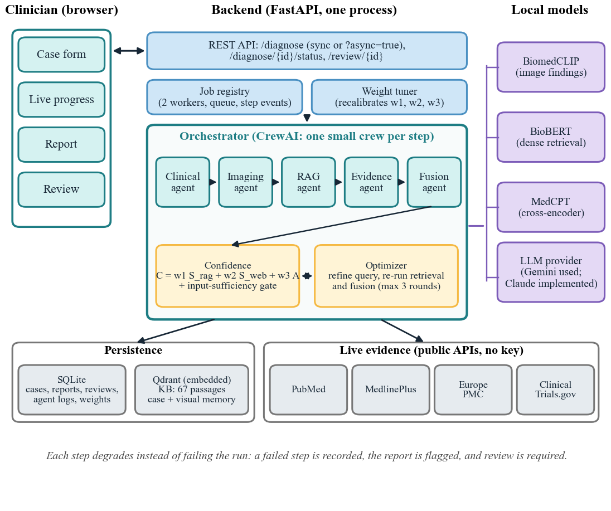
Figure 5.1: System architecture
Five principles shaped the design. (1) The language model reasons, but deterministic code scores: the model’s self-reported certainty is ignored. (2) Every diagnosis must cite evidence that was actually provided; invented citations are rejected. (3) Every step degrades instead of failing the run, and the degradation is visible. (4) A clinician stays in the loop, and review is mandatory below the threshold. (5) The system states its limits, such as unvalidated thresholds and unverified labels, wherever they apply.

Proposed approach and procedure

Pipeline overview
Figure 5.2 gives the workflow. Clinical extraction and imaging run first. Their output forms the retrieval query; offline retrieval and live evidence then run, and fusion produces the differential. A deterministic confidence follows. If it is below 0.65, or the case has no clinical anchor, the system either refines (at most three rounds) or hands the case to a clinician; a clinician’s decision is stored and may later recalibrate the weights.
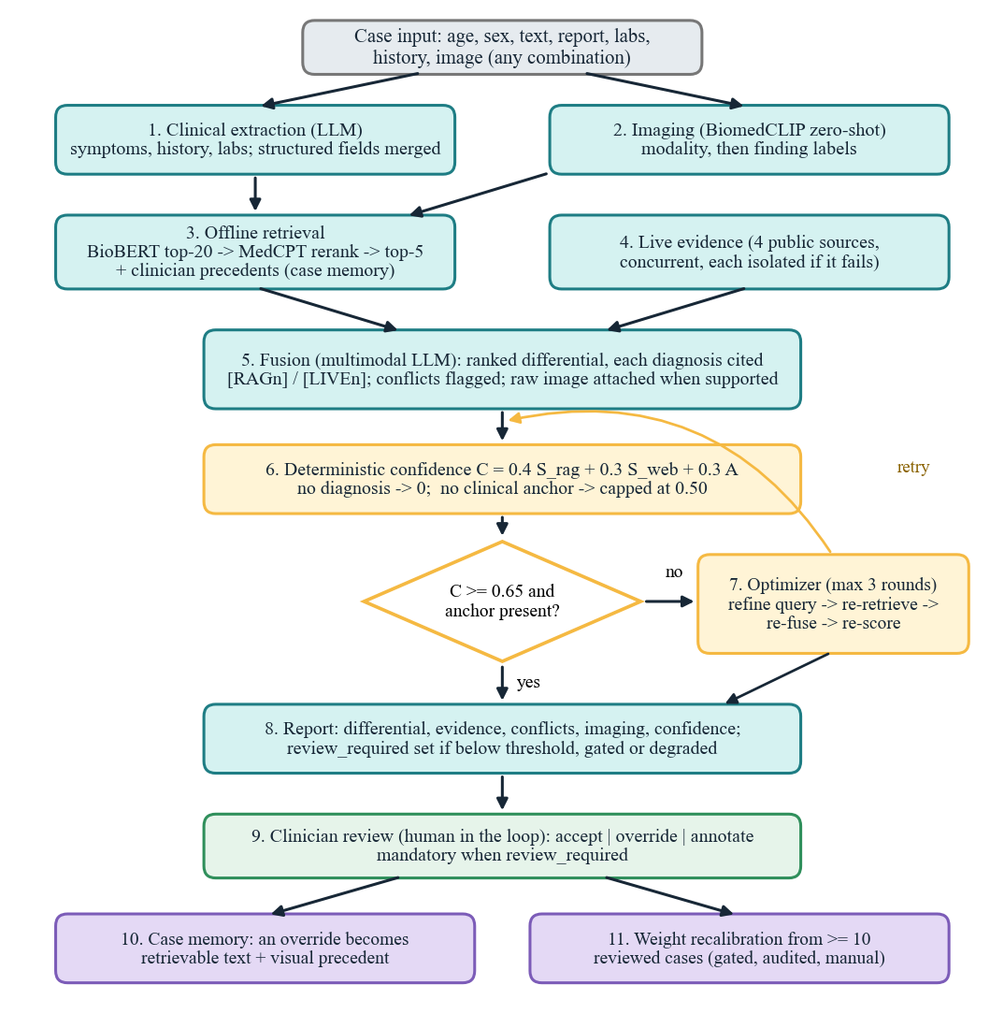
Figure 5.2: Pipeline workflow with the confidence-driven refinement loop and clinician review

Clinical extraction and structured fields
A language-model call extracts symptoms, history, laboratory values and imaging findings stated in the text into a schema-validated record, with one retry on malformed output. The case’s typed history and labs are then merged in: labs override same-named extracted values, and history is appended and de-duplicated ignoring case. This merge fixed a defect found during the project, in which the API stored these fields but the pipeline never used them (17 of the 31 test cases carry them).

Knowledge base, retrieval and reranking
The offline knowledge base holds 67 verbatim passages (47 from MedlinePlus and 20 from PubMed; Table D.1), built by a script that fetches each source, keeps the Symptoms section first, and limits a passage to 340 words so that one passage remains one chunk. The query joins symptoms, “history of …” and imaging findings. Stage 1 retrieves the twenty nearest passages (ten while the knowledge base held 42) by BioBERT sentence-embedding cosine similarity (768 dimensions) from Qdrant. Stage 2 scores each query-passage pair with the MedCPT cross-encoder [8] and keeps the top five (the BioBERT backbone is described in [13]). If all five scores fall below 0.3, the query is broadened once to the first two symptoms.
Table 5.1: Composition of the knowledge base
Source | Passages | Content
MedlinePlus Medical Encyclopedia | 22 | Condition articles: headache, hypertension, dementia, pneumonia, pulmonary edema, atelectasis, ...
MedlinePlus health topics | 25 | Topic overviews, e.g. hydrocephalus, heart failure, brain tumors, meningitis, chest pain
PubMed abstracts | 20 | Guidelines, consensus statements and reviews, e.g. BPPV (2017), normal pressure hydrocephalus (2021), chest pain (2021)
Total | 67 | 11 guideline-type and 56 symptom–disease passages; all verbatim and citable

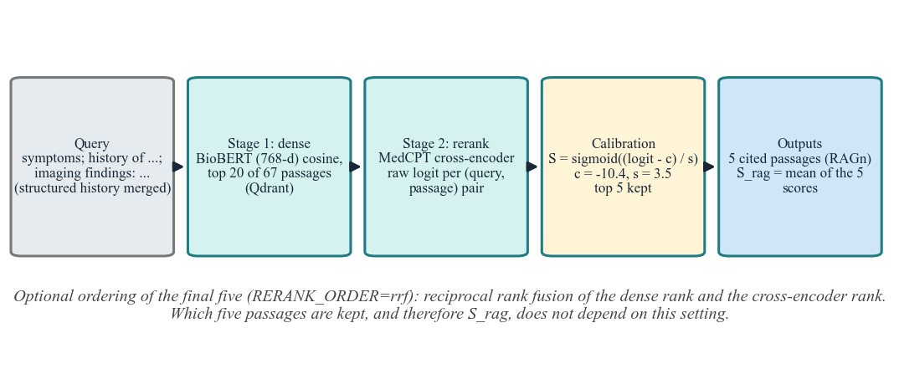
Figure 5.3: Two-stage retrieval and calibrated scoring

Score calibration
The confidence formula uses the reranker score as S_{rag}, so the raw logit must be mapped to 0–1. The mapping is a monotonic rescale, S = sigmoid((logit − c)/s), which never changes the ranking. For MedCPT the scale is s = 3.5 and the centre c was fitted by hand so that the mean S_{rag} over 14 real queries (0.659) matches the earlier model’s: c = −12.5 on the original 42-passage knowledge base, refitted to c = −10.4 when it grew to 67 passages and the candidate pool to 20 (off-topic queries: 0.284 before, 0.209 after). This is a prototype calibration, in the spirit of temperature scaling [10] but fitted to match averages, and it is not a validated probability. An optional ordering of the final five by reciprocal rank fusion [11] of the dense and cross-encoder ranks exists (RERANK_ORDER=rrf); it never changes which five passages are kept, so S_{rag} is unaffected.

Live evidence
PubMed, MedlinePlus, Europe PMC and ClinicalTrials.gov are queried concurrently with a 10 s per-request timeout, one retry and a 30 s per-source deadline; a failure is isolated and recorded, near-duplicate titles are dropped, and the report states “live evidence unavailable” only if all four fail. Each item receives an evidence level (high, moderate, low) from a keyword heuristic on its text and publication type, which feeds S_{web}. The heuristic is crude and unvalidated.

Imaging
BiomedCLIP [6] scores the image against four modality labels, then against a finding label set for the detected modality (13 labels for brain MRI, 10 for CT, 12 for chest X-ray) using a softmax over cosine similarities scaled by 100. The top label is always reported; another is reported only if it exceeds 0.15 and is at least 60% as strong as the top, which removed a spurious “rib fracture” that was seen on a real pneumothorax film. An image of any other modality is reported as “not assessed”, and no label from another modality is substituted. The finding labels are embedded as short descriptive captions (for example “head CT scan showing intracranial hemorrhage, hyperdense blood”) chosen by a held-out experiment (Section 6.3.4); the returned finding is still the plain label.

Fusion with citations
The fusion call receives the clinical findings, the imaging labels, the retrieved passages tagged [RAGn], live items tagged [LIVEn] and precedents tagged [MEMn] or [VISn]. It must return a ranked differential in which each diagnosis cites only IDs it was given, plus any conflicts between sources. The prompt treats imaging labels as hypotheses, forbids ranking a diagnosis on an imaging label alone, and forbids inventing a mechanism such as trauma. When an image is present, its modality is supported and the provider accepts images, the raw image is attached to the call; otherwise the path is text-only, and the choice is logged.

Confidence, the sufficiency gate and refinement
Confidence is computed outside the model as shown in Table 5.2:
C = w₁·S_{rag} + w₂·S_{web} + w₃·A (5.1)
Table 5.2: Parameters of the confidence score
Symbol | Meaning | Value and source
S_{rag} | Mean calibrated reranker score of the top five passages | sigmoid((logit + 10.4)/3.5); hand-fitted
S_{web} | Mean evidence-level weight of live items | high 1.0, moderate 0.6, low 0.3; 0 if none
A | Agreement: 1 − 0.25 per flagged conflict, floored at 0 | Fixed penalty; unvalidated
w₁, w₂, w₃ | Weights | 0.4, 0.3, 0.3 prototype defaults; recalibration possible
Threshold | Below it the case is refined, then reviewed | 0.65, fixed, never recalibrated
Gate | No diagnosis; no clinical anchor; or only general symptoms | Confidence 0; capped at 0.50; capped at 0.60 (the last two with review required)

The gate exists because the formula measures how much evidence was retrieved, not whether the case gave the system anything to reason from, and retrieval always returns something. A clinical anchor is at least one symptom, one laboratory value or one finding extracted from a report; history, demographics and the imaging model’s own findings do not count. Without an anchor, more retrieval cannot help, so the optimizer is skipped. A second, narrower rule applies when every symptom is a general one (tiredness, feeling unwell, lightheadedness) and there are no laboratory values or report findings: confidence is capped at 0.60, review is required and the optimizer is skipped. It matches whole symptom phrases against a small hand-written list, so “arm weakness” is not caught; it is a transparent heuristic, not a validated classifier, and the 0.60 cap is a chosen value. Otherwise, below the threshold, the optimizer picks a strategy (expand, narrow or paraphrase), refines the query, re-runs retrieval, live evidence, fusion and scoring, keeps the best result, and stops at the threshold or after three rounds, after which the case is flagged for review. The report returns the evidence of the round that produced the best result, because that round’s fusion cites its own numbered lists.

Clinician review, case memory and weight recalibration
The review screen offers accept, override and annotate with an optional one-to-five rating. An override is embedded and stored as a text precedent (retrieved on later cases only if BioBERT cosine similarity is at least 0.6) and, for supported images, a visual precedent (BiomedCLIP similarity at least 0.85, same modality only); both reach fusion framed as precedents to weigh, not as answers. Weight recalibration refits the three weights, with a floor of 0.1 and a sum of one, from accepted and overridden cases, only once ten distinct cases have been reviewed, writes an audit row, and is never run automatically.

Asynchronous API and interface
A case takes from about 30 seconds to several minutes, so POST /diagnose?async=true queues the run in a worker thread and returns at once, and the client polls GET /diagnose/{id}/status (Figure 5.4). The orchestrator reports each step, with its result and measured duration, and the optimizer reports each round; a failed step never carries the raw provider error. State is in the process’s memory, concurrency is capped at two, and the synchronous endpoint is unchanged. The interface (Figure 5.5) has four screens: case entry with history and lab fields, live progress, the report, and review. The report shows a confidence gauge with the 0.65 threshold marked, citation chips that jump to the cited evidence, and a notice when the sufficiency gate applied.
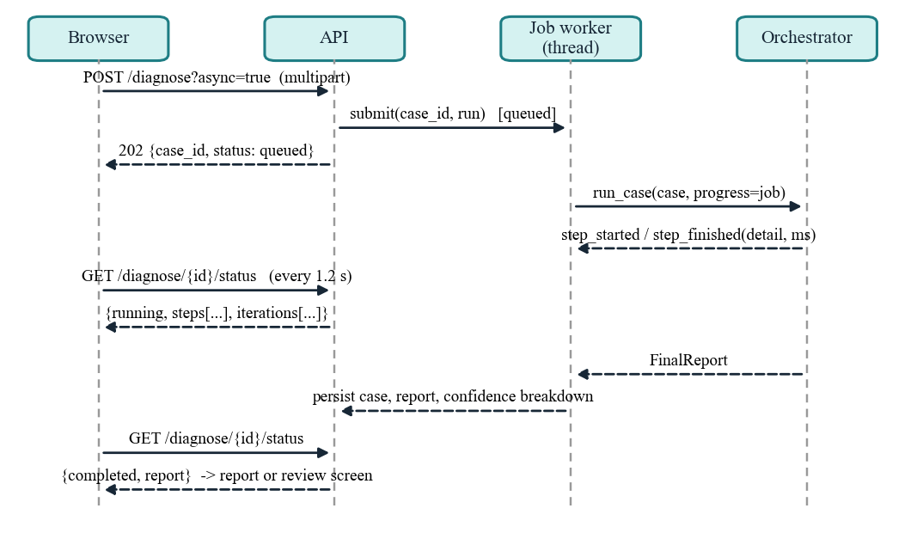
Figure 5.4: Asynchronous diagnosis: submit, progress events and polling
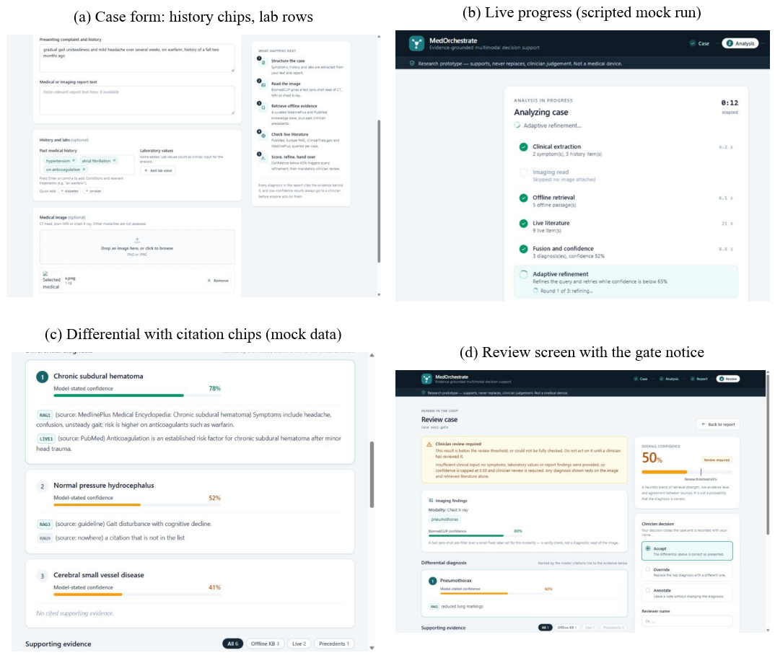
Figure 5.5: The interface: (a) case form with history and lab fields; (b)–(d) screens populated by a mock API, so their contents are illustrative and not system output

Results and Analysis

Evaluation setup
Six instruments were used. (1) The automated test suite. (2) A retrieval harness that runs the real BioBERT and reranker pipeline on an in-memory index of the committed corpus, over 14 queries recovered verbatim from the live run’s log, so they are the queries the agents actually built (not hand-written paraphrases). (3) A real-image benchmark of 62 films, later extended by two sets of fresh ones (17 and 9). (4) A held-out experiment on prompt wording. (5) A live run of 31 cases through the real pipeline with the Gemini model, in an isolated copy of the database and vector store so that the real case memory was untouched. (6) Browser verification of the interface.
Safeguards against invalid comparisons: the prompt experiment’s split, candidates and decision rule were committed before any result was seen (commit 9049e41), and its test half was evaluated once, with the script refusing a second run; every proportion carries a Wilson interval and a chance baseline; analyses exclude images flagged for possible training overlap or carrying annotations; and results that came from a degraded run (a provider-quota error) are marked invalid, not averaged in.

Evaluation criteria
Retrieval. hit@k is the share of queries with a relevant passage in the top k; MRR@5 is the mean of 1/rank of the first relevant passage (0 if none in the top five). Relevant passages are the developer’s judgement, not a clinician’s. Imaging. Top-1 and top-3 accuracy of the finding label given the true modality, modality-detection accuracy, the share of images for which the pipeline’s reported findings contain the truth or include a wrong finding, and sensitivity and specificity of normal versus abnormal. Proportions use the Wilson score interval [15], (p + z²/2n ± z√(p(1−p)/n + z²/4n²)) / (1 + z²/n) with z = 1.96; chance is the expected accuracy of a random ranking, and the majority baseline always predicts the commonest label. Paired comparisons use an exact McNemar test. System. Review rate, confidence, optimizer rounds, and whether input that should lead to abstention (an empty or image-only case) was sent for review.

Result

Automated tests
The backend has 611 automated tests and the frontend 115 (23 helper tests and 92 component tests). The backend test code is about 10,200 lines against about 6,800 lines of backend code; the frontend has about 2,500 lines of code and 1,200 of tests. They cover the agents, the confidence and gate logic, the orchestrator, the API and the job registry, storage, the weight tuner, retrieval and reranking, imaging and the evaluation tooling, with external services faked; the component tests (React Testing Library) cover the case form, report, review and progress screens with the API mocked, and not layout. Scoring and safety logic was checked by deliberate mutation: removing the confidence gate, the failure detection in progress reporting, the hiding of provider errors, the reranker ordering and the top-3 scorer each made a specific test fail. These tests show the code does what it was written to do. They are not evidence that the clinical behaviour is right.

Retrieval
Table 6.1: Retrieval on 14 real agent queries (hit@5, hit@1 and MRR@5); 42-passage knowledge base unless stated
Pipeline | hit@5 | hit@1 | MRR@5
Before: history and labs absent from queries; MS MARCO reranker | 13/14 | 7 | 0.685
+ structured history and labs merged into the findings | 14/14 | 8 | 0.768
+ reciprocal rank fusion ordering of the top five (MS MARCO) | 14/14 | 10 | 0.827
MedCPT reranker, cross-encoder order, 42-passage knowledge base | 14/14 | 11 | 0.863
MedCPT with reciprocal rank fusion ordering (not default) | 14/14 | 12 | 0.895
Reference: dense retrieval only, no reranker (42 passages) | 13/14 | 9 | 0.774
Knowledge base grown to 67 passages; candidate pool 20; score centre refit (current) | 14/14 | 9 | 0.764

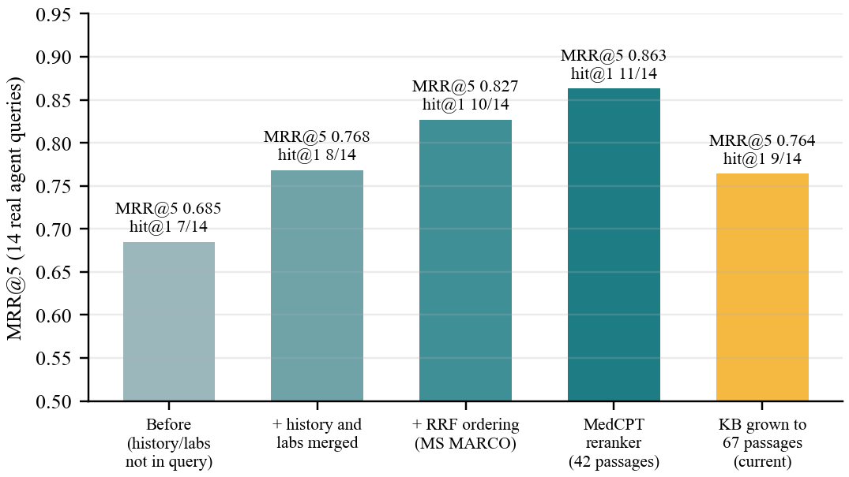
Figure 6.1: Retrieval quality as the pipeline was corrected, and after the knowledge base grew
Two corrections account for most of the gain. First, the API stored the typed history and labs but the pipeline never used them; merging them removed the one miss (a case whose query lacked its anaemia history) and lifted MRR@5 from 0.685 to 0.768. Second, MedCPT [8] replaced the general-domain MS MARCO cross-encoder: it stopped off-topic passages from topping generic queries (pulmonary tuberculosis had ranked first for a child’s headache) and lifted MRR@5 to 0.863. Reciprocal rank fusion [11] of the dense and cross-encoder ranks added a little with MedCPT (0.895) but moved the subdural-hematoma passage for the anticoagulated-fall case to the edge of the top five, so it is off by default. Earlier, a fault in the knowledge-base builder (it cut off the Symptoms section in 10 of 15 encyclopedia articles) had hidden that passage; fixing it took a hand-written 14-query check from 12/14 to 14/14.
Cost. MedCPT is not better everywhere: the cough-and-smoker case fell from first to fourth, and the subdural passage is third, not second. Replacing the reranker changes confidence, so the scale was refitted so that the mean S_{rag} over the 14 queries stayed 0.659; individual queries still moved by up to 0.29 (0.12 of confidence). Fourteen queries with developer-judged relevance are a regression check, not a benchmark.
Knowledge-base growth. The answer key and the 31 live reports named diagnoses with no passage behind them, and the imaging models can name findings (pulmonary edema, atelectasis, mediastinal widening, mass lesion, vascular malformation, midline shift, calcification) that the knowledge base did not cover. Twenty-five passages were added (MedlinePlus topics and articles, six PubMed abstracts and the 2021 AHA/ACC chest-pain guideline), taking it from 42 to 67. This helped coverage and hurt ordering. For 21 queries written for the new conditions (by the person who added the passages, so a coverage check and not an independent test), a relevant passage reached the top five for 18 against 3 on the original 42 passages; the misses were mediastinal widening, vertebrobasilar insufficiency and musculoskeletal chest pain. On the 14 original queries hit@5 stayed 14/14 but MRR@5 fell from 0.863 to 0.764 and hit@1 from 11 to 9, because new and plausibly related passages (long-COVID headache for a child with a cold, a posterior reversible encephalopathy review for a memory-and-gait case) now rank above the one the developer had marked relevant; those relevance sets were not changed. At the old pool of ten candidates the anticoagulated-fall case lost its subdural-hematoma passage altogether, so the pool is now twenty, and the score centre was refitted (−12.5 to −10.4) so that the mean S_{rag} of the 14 queries is 0.659 again. Confidence values from before this change are therefore comparable with later ones only on that average.

Real-image imaging benchmark
The earlier imaging benchmark scored BiomedCLIP on generated gradient pictures with an arbitrary intended label, so near-chance was guaranteed and it measured nothing; it was deleted. The replacement has 62 real images (32 chest X-ray, 18 head CT, 12 brain MRI) in 60 groups: 56 downloaded from Wikimedia Commons under open licences and 6 already in the repository. Each carries a finding label taken from its Commons caption, not from a radiologist. A contact-sheet review found and replaced about two dozen images with arrows, circles or boxes drawn on the film, composite panels, viewer screenshots, or visible patient-identification text.
Table 6.2: Zero-shot finding accuracy on real images (true modality given; Wilson 95% interval)
Modality | Images | Top-1, bare labels | Top-1, descriptive captions | Top-3, captions
Chest X-ray | 32 | 17/32 (53%; 36%–69%) | 20/32 (62%; 45%–77%) | 25/32 (78%; 61%–89%)
Head CT | 18 | 6/18 (33%; 16%–56%) | 8/18 (44%; 25%–66%) | 14/18 (78%; 55%–91%)
Brain MRI | 12 | 3/12 (25%; 9%–53%) | 7/12 (58%; 32%–81%) | 10/12 (83%; 55%–95%)
All images | 62 | 26/62 (42%; 30%–54%) | 35/62 (56%; 44%–68%) | 49/62 (79%; 67%–87%)

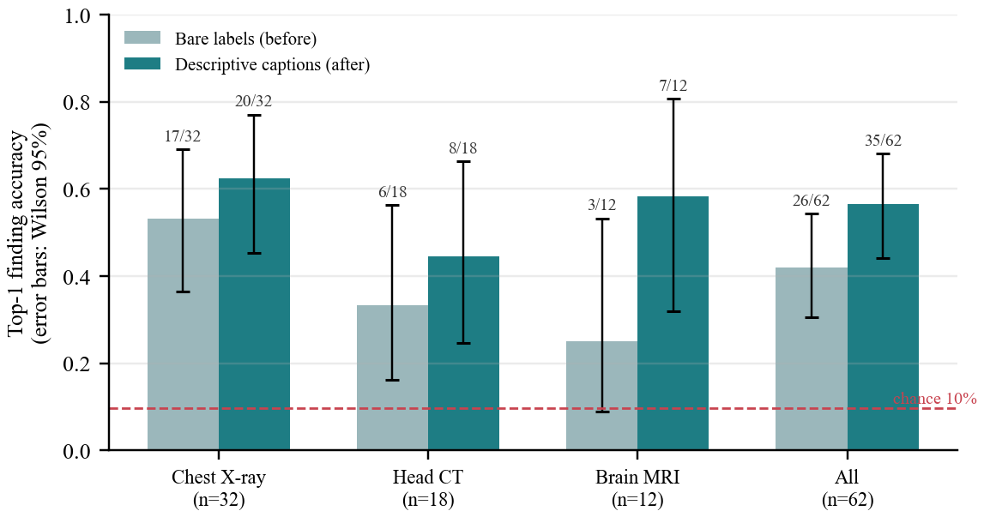
Figure 6.2: Top-1 finding accuracy before and after the caption change, with Wilson intervals
Against chance (10%) and an always-the-commonest-label baseline (21%), the zero-shot model is clearly better than random but not good: with the original labels about one chest film in two and one CT in three got the right top label. Modality detection was 58/62 (94%); four of 18 CTs were detected as MRI. The pipeline’s reported findings contained the truth for 28/62 (45%) of images and included at least one wrong finding for 39/62 (63%) (original labels). The most consequential failure was head-CT hemorrhage: four of five hemorrhage CTs were called acute infarct (three at scores of 0.95 or higher) and the fifth normal. Five abnormal images were called normal. The imaging read is therefore a coarse pre-filter, not a diagnostic result.

Held-out test of prompt wording
Because 62 images are too few to try several wordings and keep the best, the design was fixed first: a group-level split (37 development and 25 test images, seed 20261113), five finding-prompt and four modality-prompt candidates, selection by development MRR, and adoption only if the test half gained at least two top-1 images without lowering MRR. On the development half the caption “… showing …” scored 23/37 against 19/37 for the bare label. On the test half, used once, it scored 12/25 against 7/25 (MRR 0.61 against 0.49; seven images gained and two lost; exact McNemar p = 0.18, not significant). The rule therefore adopted it; modality wording gained one image, below the bar, and was not adopted.
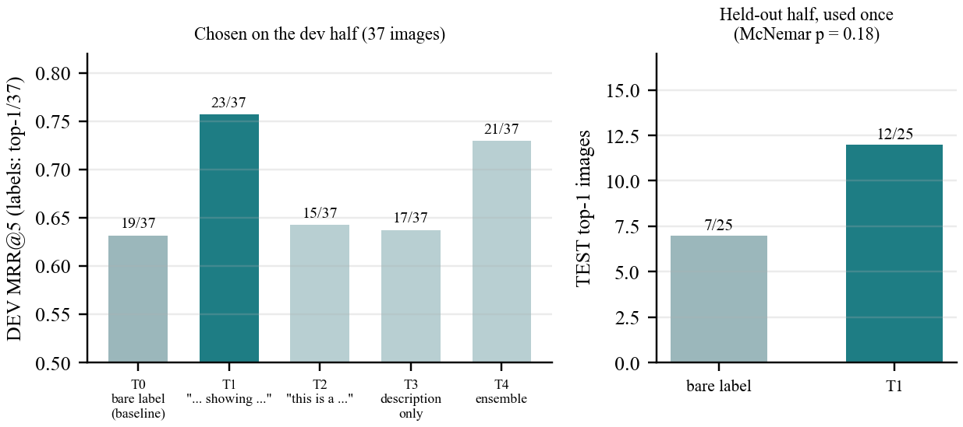
Figure 6.3: Prompt-wording experiment: development choice and the one-time held-out result
The change has a cost the adoption rule did not see. Specificity (normal called normal) fell from 7/9 to 5/9 and sensitivity rose from 48/53 to 51/53; the effect is concentrated in one failure mode, in which a “sinus abnormality” caption attracts normal brain images, and it appears on the development half and not on the held-out half (1/3 to 2/3, three normals). Hemorrhage CT improved from 0/5 to 3/5, no longer called infarct. With nine normal images from about six subjects, a real specificity cost is not excluded. The change is kept, with one environment variable to reverse it, and the trade-off is recorded in the project documentation. The next subsection tests it again on images that played no part in the choice.

Extension sets: further tests on fresh images
After the prompt choice was made and its held-out half spent, 17 more real images were added to fill gaps: four normal chest films, two CT films with midline shift, one more CT infarct, two more slices of the one normal head-CT subject, and eight brain MRIs (three slices of one vascular malformation, a chronic infarct, edema, white-matter hyperintensity and two normals). Their plan was written and committed before any of them was scored, they were kept out of the split and the frozen experiment, and nothing was re-tuned afterwards. Atrophy and CT calcification stay uncovered, because every usable candidate was a composite panel or had arrows drawn on it.
Table 6.3: The 17 fresh images under the current captions and the bare labels
Measure | Current captions | Bare labels
Top-1 finding accuracy | 10/17 (59%; 36%–78%) | 11/17 (65%; 41%–83%)
Top-3 | 15/17 | 12/17
Normal films called normal (specificity) | 6/8 | 8/8
Abnormal films flagged (sensitivity) | 8/9 | 6/9
Modality detected | 16/17 | 16/17

Chance is 11% and always predicting the commonest label gets 53%, so a top-1 near 60% is not impressive here. Paired image by image, the captions gained 3 and lost 4 (exact McNemar p = 1.0): on fresh images the captions were no better than the bare labels, and the advantage seen on the original held-out half was not reproduced. Neither result is significant, and 17 images cannot show a difference of this size in either direction. Two of the new images share a subject with the original normal head CTs, and the edema image is flagged for possible training overlap, so even this set is not fully independent.
A second set of nine images (plan again committed before scoring) targeted what was still missing: four CT calcification films, one MRI with cerebral atrophy, a second normal head CT, two normal brain MRIs and a lateral chest film. The captions got 5/9 top-1 against 3/9 for the bare labels (3 gained, 1 lost, p = 0.63). Calcification went three of four with the captions and none with the bare labels, the opposite of the expectation recorded beforehand; four films, two of them the same age-related pattern, are a signal and not a result. The normals went badly again: the normal head-CT slice through the orbits was called “sinus abnormality” at 0.98, a normal sagittal MRI “cerebral atrophy”, and the lateral chest film (a view the label set was not written for) “pneumothorax”. Atrophy is still covered by a single film and CT atrophy not at all, because every other candidate was a composite panel, carried arrows or showed the wrong kind of atrophy.
Over both fresh sets (26 images) the captions scored 15/26 against 14/26 (6 gained, 5 lost, exact McNemar p = 1.0). What holds is the trade-off: they flag more abnormal films (sensitivity 12/14 against 9/14) and call more normal films abnormal (specificity 7/12 against 10/12). Over all 88 images the top-1 totals are 50/88 against 40/88, but that figure includes the tuning set and is not an unbiased estimate. The captions therefore stay, with a weaker claim: more sensitive, less specific, and a net accuracy gain that fresh images did not confirm. Which wording is better for this project depends on whether a missed abnormality or a false alarm is the costlier error, which is a clinical judgement that 88 images cannot settle.

Live run of 31 cases
All 31 cases (24 synthetic and 7 real-image) returned a report through the real pipeline with gemini-3.5-flash-lite. This run used the version before the input-sufficiency gate, the history-and-labs fix, the MedCPT reranker and the new image captions, so it describes an earlier system. Mean confidence was 0.71 (excluding CASE007, which failed on a provider-quota error and is invalid); 3 of 31 cases were sent for review; optimizer rounds were 0 for 17 cases, 1 for 11, 2 for 1 and 3 for 2; live evidence was present for 28.
The run exposed two flaws, both visible in Figure 6.4. An empty case (CASE013) came back with no diagnosis and confidence 0.79, above the threshold, so it skipped review: the formula scored the evidence the optimizer had retrieved and not the absence of a diagnosis. And of the six cases whose correct behaviour is to abstain (empty or image-only input), only one was sent for review; the others reported confidence of 0.67 to 0.79. The agreement signal was 1.00 for almost every case, so about 0.30 of the score was free, and retrieval always returns something. Both were fixed (no diagnosis gives confidence 0; no clinical anchor caps it at 0.50 and skips the optimizer), with unit tests. The fix was not re-run live because the provider quota was exhausted again; four attempted cases failed safely (confidence 0, review required). A vague but non-empty case (CASE008) received 0.68; a later rule (Section 5.2.8) now caps a case whose only symptoms are general at 0.60 and sends it for review, with unit tests but no live re-run.
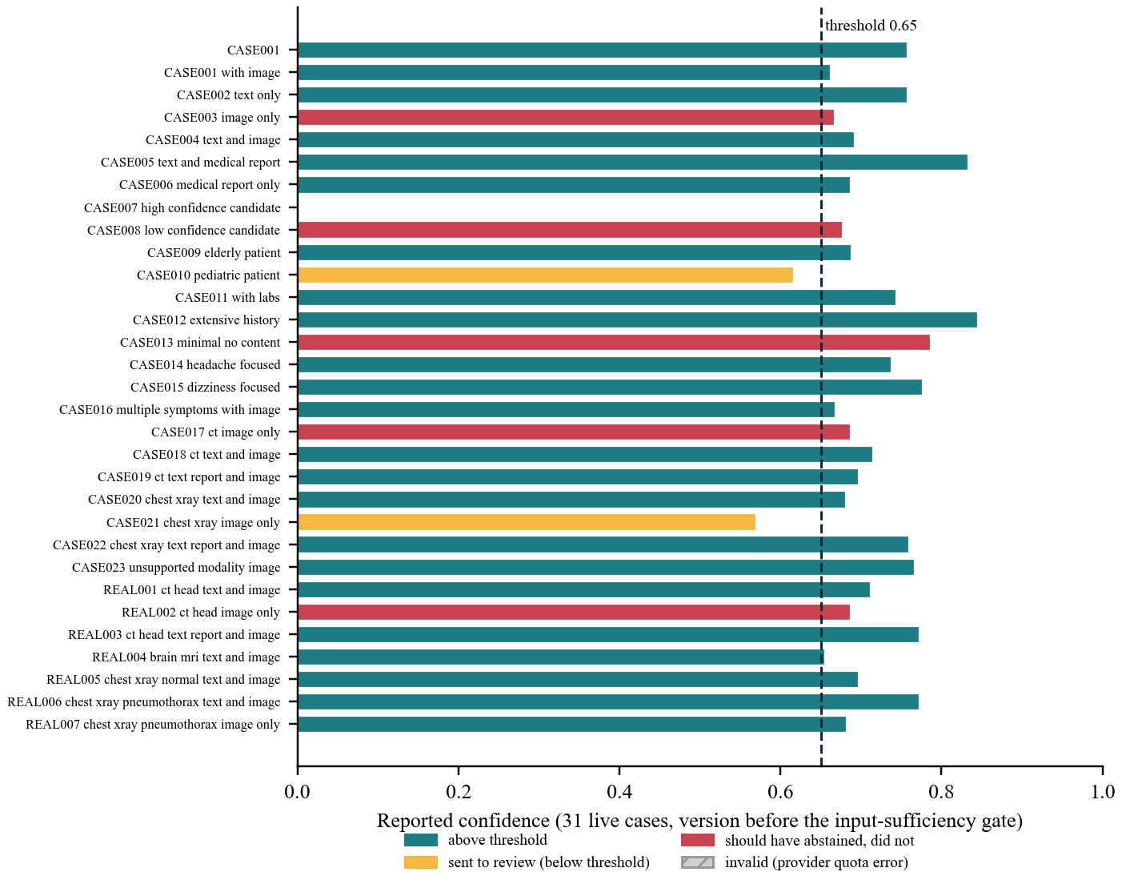
Figure 6.4: Reported confidence for the 31 live cases, before the input-sufficiency gate
Earlier single live runs show the wiring and not the quality: a first full run (CASE002) returned confidence 0.656 in 34 s; a chest X-ray case with its real image returned in 72 s with the raw image attached to fusion, a first-pass confidence of 0.623 and an optimizer sequence of 0.617, 0.458 and 0.660; and a real pneumothorax film ranked pneumothorax first (0.95) after a spurious “rib fracture” label was removed. One brain-MRI case took 505 s with three optimizer rounds, too slow for a live demonstration.

Review, case memory, recalibration and progress
With the real models and a temporary store, an override on an image case wrote one text and one visual precedent; a later similar case retrieved both, and an unrelated case retrieved neither. The round trip also exposed three defects that were fixed (the clinician’s diagnosis was not being stored, there was no relevance cutoff, and visual precedents ignored modality). Weight recalibration did not run on real data: only 3 of the 10 required reviewed cases exist, so it correctly does nothing. A labelled simulation (seven developer-written reviews) showed the mechanism only; its output weights reflect a rule in the script, not clinicians, and must not be quoted as learned. The asynchronous endpoint was run for real: it returned 202 at once and the steps moved with measured timings (clinical 4.2 s, retrieval 18.5 s, live evidence 4.2 s), but because the provider quota was exhausted every language-model step ended failed, so that run exercised failure reporting and not a healthy analysis.

Interface verification
The four screens were verified in a browser against a recording mock API and, for failure paths, against the real backend: the form sends exactly the fields the backend expects, validation messages appear for a half-filled lab row, a repeated lab name and history without input, citation chips jump to their evidence, starting a new case stops the polling loop, and there is no horizontal overflow at 375 px. This was functional verification. No usability study with clinicians was carried out.

Comparative analysis
Table 6.4: Results against baselines and expectations
Measure | Baseline or expectation | Result
Retrieval, MRR@5 | 0.685 before the fixes; 0.774 dense only | 0.863 on 42 passages; 0.764 on 67 (hit@5 14/14 for both; hit@1 11 then 9)
Imaging top-1, original 62 | Chance 10%; commonest-label 21% | 42% with bare labels; 56% with captions (held-out half 12/25 against 7/25)
Imaging top-1, 26 fresh images | Chance about 11%; bare labels 14/26 | Captions 15/26 (58%); 6 gained, 5 lost, p = 1.0
Imaging modality detection | Required for every image | 83/88 (94%)
Abstention on 6 empty or image-only cases | Review required in all six | 1/6 before the gate; gate and general-symptom cap unit-tested, not yet live
Retrieval benefit in the literature | Up to 18% accuracy gain over chain-of-thought [4] | Not comparable: different task and metric

The literature figures cannot be compared with these directly, since they measure answer accuracy on question-answering benchmarks while this project measures passage ranking and image findings on its own small sets. The honest comparison is each result against its own baseline, as in Table 6.4.

Discussion and Interpretation
The results support the engineering objectives (O1 to O3, O5, O6) and give only partial support to O4. The pipeline runs end to end under every input combination and under provider failure; retrieval can be measured and improved; and imaging can be characterised honestly. The most useful findings were negative or corrective: a confidence formula built on retrieval volume was blind to missing input, a regression reported on a hand-written query was not present on the query the agent really built, and a prompt change that looked better overall hid a loss on normal images. Each was found by evaluating on real inputs with baselines and intervals, which is what the project learned to do.
What the results do not support is any claim of clinical accuracy. The confidence threshold and weights are unvalidated, the imaging labels are not radiologist-verified, and the answer key is not clinician-verified. The contribution is a system that makes its evidence and its uncertainty visible and routes doubtful cases to a person, evaluated as far as the available quota and people allowed.

Limitations
- Small samples. 14 retrieval queries (relevance judged by the developer, for the 42-passage knowledge base), 88 images (21 normal, a single normal head-CT subject, one atrophy film), 25 held-out images, 26 fresh images, 31 live cases; intervals are wide and a McNemar test on 25 images can only detect very large effects.
- Unverified labels. The expected-diagnosis key, the retrieval relevance sets and the image labels are developer- or uploader-derived, and the key was drafted by an AI assistant. None is clinician-verified.
- Optimistic images. Wikimedia Commons holds clear teaching examples; real films are harder. BiomedCLIP was pretrained on published articles, so overlap with some images cannot be excluded (a keyword heuristic flagged only three).
- Stale live results. The 31-case run predates four changes; its numbers describe an earlier system. One case is invalid.
- Single provider. Every live run used one free-tier Gemini model whose quota repeatedly limited the work; the Claude path was not exercised end to end.
- In-process jobs. The asynchronous API assumes one server process; a restart drops running jobs; there is no cancel button.

Evaluation not yet performed
The following were planned or attempted and have no results: (1) re-running the 31 cases on the final system; (2) LLM-judged scoring of faithfulness and context precision, which was attempted but 70 of its 72 failed metric calls were provider-quota errors, so its output was discarded; even when it runs it is a model grading its own output, a known bias [12], and a consistency check at best; (3) evaluation by clinicians, of which only 3 reviews of the 10 required exist; (4) calibration of the 0.65 threshold and the weights; and (5) a measurement of the fusion step’s own reading of the image.

Conclusion

Conclusion
This project built and evaluated MedOrchestrate, a prototype that turns a mixed clinical input into a ranked, cited differential and decides, by a deterministic score, whether to refine its search or hand the case to a clinician. What was achieved and measured is an end-to-end system with 611 backend and 115 frontend tests; retrieval whose MRR@5 on 14 real agent queries rose from 0.685 to 0.863 through corrections found by measurement, and fell to 0.764 when a larger knowledge base closed coverage gaps (18 of 21 new-condition queries reached a relevant passage, against 3); the first measurement of BiomedCLIP’s behaviour on 88 real films in this setting, with intervals, baselines, a held-out test and two further tests on 26 fresh images that did not confirm the prompt change’s gain; and a live run whose findings led to a confidence gate that stops empty input from skipping review. The weakest results are also the most informative: zero-shot imaging is a coarse pre-filter, and a retrieval-based confidence needs an explicit check that the case contained something to reason from.
These conclusions are limited as Chapter 6 states. The system is a research prototype, not a validated clinical tool, and its contribution to Sustainable Development Goal 3 remains expected rather than demonstrated.

Future work
Table 7.1: Next steps, dependencies and proposed validation
Next step | Depends on | Proposed validation
Re-run the 31 cases on the final system; verify the gate live | Restored language-model quota | Compare review rate, abstention (target: 6 of 6) and confidence with Figure 6.4
LLM-judged faithfulness and context precision | Quota; a judge other than the generating model | Report beside clinician-reviewed samples; treat as a consistency check
Collect at least 10 real clinician reviews; verify the answer key and image labels | Clinician time | Weight recalibration on real outcomes; inter-rater agreement
Calibrate the 0.65 threshold, weights and agreement signal | The re-run and clinician reviews | Reliability curve of confidence against review decisions
Widen the image benchmark again (more atrophy films and any CT atrophy, a second normal head-CT subject with a full series, more normal films); have a clinician judge the retrieval relevance sets after the knowledge-base growth | More openly licensed images; clinician time | Same fresh-set design: plan fixed before scoring
Rebuild the container image with the 67-passage knowledge base; run the Claude path end to end | Docker; a Claude key | Compare providers on the same cases

References
[1] R. T. Sutton, D. Pincock, D. C. Baumgart, D. C. Sadowski, R. N. Fedorak, and K. I. Kroeker, “An overview of clinical decision support systems: benefits, risks, and strategies for success,” npj Digit. Med., vol. 3, Art. no. 17, 2020, doi: 10.1038/s41746-020-0221-y.
[2] K. Goddard, A. Roudsari, and J. C. Wyatt, “Automation bias: a systematic review of frequency, effect mediators, and mitigators,” J. Am. Med. Inform. Assoc., vol. 19, no. 1, pp. 121–127, 2012, doi: 10.1136/amiajnl-2011-000089.
[3] P. Lewis et al., “Retrieval-augmented generation for knowledge-intensive NLP tasks,” in Advances in Neural Information Processing Systems (NeurIPS), vol. 33, 2020, arXiv:2005.11401.
[4] G. Xiong, Q. Jin, Z. Lu, and A. Zhang, “Benchmarking retrieval-augmented generation for medicine,” arXiv:2402.13178, 2024.
[5] K. Singhal et al., “Large language models encode clinical knowledge,” Nature, vol. 620, no. 7972, pp. 172–180, 2023, doi: 10.1038/s41586-023-06291-2.
[6] S. Zhang et al., “A multimodal biomedical foundation model trained from fifteen million image–text pairs,” NEJM AI, vol. 2, no. 1, 2025, doi: 10.1056/aioa2400640 (preprint arXiv:2303.00915).
[7] C. Li et al., “LLaVA-Med: Training a large language-and-vision assistant for biomedicine in one day,” arXiv:2306.00890, 2023.
[8] Q. Jin, W. Kim, Q. Chen, D. C. Comeau, L. Yeganova, W. J. Wilbur, and Z. Lu, “MedCPT: Contrastive pre-trained transformers with large-scale PubMed search logs for zero-shot biomedical information retrieval,” Bioinformatics, vol. 39, no. 11, Art. no. btad651, 2023, doi: 10.1093/bioinformatics/btad651.
[9] A. Asai, Z. Wu, Y. Wang, A. Sil, and H. Hajishirzi, “Self-RAG: Learning to retrieve, generate, and critique through self-reflection,” arXiv:2310.11511, 2023.
[10] C. Guo, G. Pleiss, Y. Sun, and K. Q. Weinberger, “On calibration of modern neural networks,” in Proc. 34th Int. Conf. Machine Learning (ICML), 2017, arXiv:1706.04599.
[11] G. V. Cormack, C. L. A. Clarke, and S. Büttcher, “Reciprocal rank fusion outperforms Condorcet and individual rank learning methods,” in Proc. 32nd Int. ACM SIGIR Conf. Research and Development in Information Retrieval, 2009, pp. 758–759, doi: 10.1145/1571941.1572114.
[12] L. Zheng et al., “Judging LLM-as-a-judge with MT-Bench and Chatbot Arena,” in Advances in Neural Information Processing Systems (NeurIPS), Datasets and Benchmarks Track, 2023, arXiv:2306.05685.
[13] J. Lee et al., “BioBERT: a pre-trained biomedical language representation model for biomedical text mining,” Bioinformatics, vol. 36, no. 4, pp. 1234–1240, 2020, doi: 10.1093/bioinformatics/btz682.
[14] S. Es, J. James, L. Espinosa-Anke, and S. Schockaert, “Ragas: Automated evaluation of retrieval augmented generation,” arXiv:2309.15217, 2023.
[15] E. B. Wilson, “Probable inference, the law of succession, and statistical inference,” J. Am. Stat. Assoc., vol. 22, no. 158, pp. 209–212, 1927.
[16] United Nations, “Transforming our world: the 2030 Agenda for Sustainable Development,” General Assembly resolution A/RES/70/1, 2015.
- Source Code and Reproducibility
The code, tests, documentation and the benchmark data are in the repository https://github.com/hari18305/medorcha, version 76336fd at the time of writing. Secrets are not committed; an .env.example documents every setting.
- Setup and execution
python -m venv venv
venv\Scripts\activate
pip install -r requirements.txt
copy .env.example .env
(set LLM_PROVIDER and the matching API key in .env)
python -m backend.rag.build_knowledge_base
python -m backend.rag.ingest
uvicorn backend.main:app --host 127.0.0.1 --port 8000
cd frontend
npm install
npm run dev
(opens http://localhost:5173)

pytest -q backend
cd frontend && npm test
python -m scripts.eval_retrieval
python -m scripts.build_imaging_benchmark
python -m backend.tests.imaging_benchmark
python scripts/run_cases_live.py OUT_DIR
The first group starts the system, the second runs the 611 backend and 115 frontend tests, the retrieval harness (offline) and the image benchmark; the last command needs a provider key.
- Supporting material
The imaging benchmark contains 88 real images (62 original and 26 added later): 6 under CC BY, 63 under CC BY-SA, 14 under CC0, 5 under Public domain. Each Commons image keeps its own licence, was downscaled to at most 768 px wide (the only change), and is credited with its author and licence in data/benchmarks/imaging_real/ATTRIBUTION.md; the six earlier images are credited in data/images/real/ATTRIBUTION.md. The images are real people’s scans, unidentified, and none of them validates the system.
- Supporting Results
- Per-query retrieval results
Table B.1: Retrieval harness, final system: rank of the first relevant passage
Query (case) | Dense rank | Final rank | Top two passages returned
CASE001 headache+HTN | 1 | 1 | hypertension overview, giant cell arteritis
CASE009 elderly warfarin fall | 16 | 3 | tia overview, subarachnoid hemorrhag
CASE010 child headache+URTI | 3 | 3 | secondary headache red, long covid headache
CASE011 anemia dizzy standing | 8 | 1 | anemia overview, fainting
CASE014 migraine | 1 | 1 | migraine overview, vestibular migraine di
CASE015 BPPV | 1 | 1 | bppv, menieres disease
CASE018 head injury+anticoag | 3 | 1 | chronic subdural hemat, subarachnoid hemorrhag
CASE020 cough smoker nodule | 1 | 5 | chest xray overview, pleural effusion chest
CASE022 pneumothorax | 3 | 1 | pneumothorax collapsed, pleural effusion chest
REAL003 headache+blurred vision | 2 | 1 | migraine overview, long covid headache
REAL004 memory+gait+atrophy | 1 | 3 | chronic subdural hemat, head ct overview
REAL005 chest pain, normal CXR | 1 | 2 | chest pain guideline 2, chest xray overview
REAL006 pneumothorax text+img | 3 | 1 | pneumothorax collapsed, pleural effusion chest
REAL007 pneumothorax img only | 1 | 1 | pneumothorax collapsed, atelectasis

- Per-finding imaging results
Table B.2: Top-1 per finding on the original 62 images, before and after the caption change (counts of images)
Modality | Finding | n | Top-1 before | Top-1 after | Top-3 after
CT | acute infarct | 3 | 2 | 1 | 3
CT | hemorrhage | 5 | 0 | 3 | 4
CT | mass lesion | 3 | 0 | 0 | 1
CT | normal head CT, no acute findings | 3 | 3 | 1 | 3
CT | sinus abnormality | 2 | 0 | 2 | 2
CT | ventricular enlargement | 2 | 1 | 1 | 1
MRI | acute infarct | 2 | 1 | 2 | 2
MRI | hemorrhage | 2 | 0 | 1 | 1
MRI | mass lesion | 4 | 0 | 4 | 4
MRI | normal brain MRI, no acute findings | 2 | 1 | 0 | 2
MRI | ventricular enlargement | 1 | 0 | 0 | 0
MRI | white matter hyperintensity | 1 | 1 | 0 | 1
CXR | atelectasis | 3 | 2 | 0 | 1
CXR | cardiomegaly | 3 | 2 | 3 | 3
CXR | consolidation | 3 | 0 | 0 | 3
CXR | hilar or mediastinal widening | 1 | 1 | 1 | 1
CXR | hyperinflation consistent with emphysema | 2 | 0 | 2 | 2
CXR | normal chest X-ray, no acute findings | 4 | 3 | 1 | 1
CXR | pleural effusion | 3 | 2 | 3 | 3
CXR | pneumothorax | 4 | 3 | 3 | 3
CXR | pulmonary edema | 3 | 3 | 3 | 3
CXR | pulmonary nodule or mass | 3 | 0 | 2 | 3
CXR | rib fracture | 3 | 1 | 2 | 2

- Worked Example
This appendix follows one case through the system, using the saved output of the 31-case live run (the version before the input-sufficiency gate). It illustrates the shape of the result and does not measure quality.
- Input
Table C.1: Case CASE002 as submitted
Field | Value
Patient | 52-year-old woman
Clinical text | recurrent headache and dizziness over the past month, history of hypertension
History (typed) | hypertension
Laboratory values | none
Medical report and image | none

- Output
The pipeline returned three diagnoses at confidence 0.757 (above the 0.65 threshold), with no conflicts, no optimizer rounds and live evidence present; the report was not flagged for review. Confidence is the case score of Section 5.2.8; the per-diagnosis figures are the model’s own and are not combined into it.
Table C.2: Ranked differential for CASE002
Rank | Diagnosis | Per-diagnosis figure | Evidence cited
1 | Hypertensive emergency / malignant hypertension | 0.65 | [RAG2] knowledge-base passage: severe headache, nausea, confusion, vision changes in malignant hypertension
2 | Vestibular migraine | 0.55 | [RAG3] symptom passage on dizziness and nervous-system symptoms; [LIVE10] vestibular migraine abstract from the literature search
3 | Subarachnoid hemorrhage | 0.45 | [RAG1] subarachnoid bleeding is an emergency; high blood pressure is a risk factor

Each statement of support carries a tag that the interface turns into a link to its source. The first-ranked diagnosis rests on a general hypertension passage, not a guideline specific to this presentation, which the system leaves visible to the clinician.
- Knowledge Base Inventory
The knowledge base holds 67 passages: 47 MedlinePlus pages (22 encyclopedia articles and 25 health topics) and 20 PubMed abstracts, retrieved on 12 and 13 November 2026 (the last 25 were added on the 13th, to cover conditions and imaging findings the first 42 did not). Each passage is stored with its URL, so every citation resolves to its source.
Table D.1: Knowledge-base passages
# | Title | Source
1 | Red and orange flags for secondary headaches in clinical practice: SNNOOP10... | PubMed PMID 30587518
2 | Clinical Practice Guideline: Benign Paroxysmal Positional Vertigo (Update) | PubMed PMID 28248609
3 | The 2020 International Society of Hypertension global hypertension practice... | PubMed PMID 32972800
4 | Orthostatic Hypotension in Adults With Hypertension: A Scientific Statement... | PubMed PMID 38205630
5 | Hypertensive Emergency | PubMed PMID 28372707
6 | Vestibular migraine: diagnostic criteria | PubMed PMID 23142830
7 | Guidelines for Management of Incidental Pulmonary Nodules Detected on CT Im... | PubMed PMID 28240562
8 | Guidelines for Management of Idiopathic Normal Pressure Hydrocephalus (Thir... | PubMed PMID 33455998
9 | Idiopathic intracranial hypertension: consensus guidelines on management | PubMed PMID 29903905
10 | Vascular contributions to cognitive impairment and dementia: a statement fo... | PubMed PMID 21778438
11 | 2021 AHA/ACC/ASE/CHEST/SAEM/SCCT/SCMR Guideline for the Evaluation and Diag... | PubMed PMID 34756653
12 | Tension headache | MedlinePlus encyclopedia
13 | Migraine | MedlinePlus encyclopedia
14 | Benign positional vertigo | MedlinePlus encyclopedia
15 | Meniere disease | MedlinePlus encyclopedia
16 | High blood pressure in adults - hypertension | MedlinePlus encyclopedia
17 | Low blood pressure | MedlinePlus encyclopedia
18 | Anemia | MedlinePlus encyclopedia
19 | Transient ischemic attack | MedlinePlus encyclopedia
20 | Subdural hematoma | MedlinePlus encyclopedia
21 | Chronic obstructive pulmonary disease (COPD) | MedlinePlus encyclopedia
22 | Pleural effusion | MedlinePlus encyclopedia
23 | Head MRI | MedlinePlus encyclopedia
24 | Head CT scan | MedlinePlus encyclopedia
25 | Chest x-ray | MedlinePlus encyclopedia
26 | Alzheimer disease | MedlinePlus encyclopedia
27 | Dementia | MedlinePlus encyclopedia
28 | Subarachnoid hemorrhage | MedlinePlus encyclopedia
29 | Pulmonary tuberculosis | MedlinePlus encyclopedia
30 | Headache | MedlinePlus health topic
31 | Dizziness and Vertigo | MedlinePlus health topic
32 | Ischemic Stroke | MedlinePlus health topic
33 | Sinusitis | MedlinePlus health topic
34 | Pneumonia | MedlinePlus health topic
35 | Collapsed Lung | MedlinePlus health topic
36 | Hydrocephalus | MedlinePlus health topic
37 | Lung Cancer | MedlinePlus health topic
38 | Hemorrhagic Stroke | MedlinePlus health topic
39 | Traumatic Brain Injury | MedlinePlus health topic
40 | Chest Injuries and Disorders | MedlinePlus health topic
41 | Vestibular Neuritis: Recent Advances in Etiology, Diagnostic Evaluation, an... | PubMed PMID 30947184
42 | White matter hyperintensities associated with small vessel disease impair s... | PubMed PMID 28685621
43 | Is cardiomegaly on chest radiograph representative of true cardiomegaly: a... | PubMed PMID 29073657
44 | Pulmonary edema | MedlinePlus encyclopedia
45 | Atelectasis | MedlinePlus encyclopedia
46 | Cluster headache | MedlinePlus encyclopedia
47 | Brain abscess | MedlinePlus encyclopedia
48 | Heart Failure | MedlinePlus health topic
49 | Brain Tumors | MedlinePlus health topic
50 | Meningitis | MedlinePlus health topic
51 | Chest Pain | MedlinePlus health topic
52 | Fainting | MedlinePlus health topic
53 | Fatigue | MedlinePlus health topic
54 | Multiple Sclerosis | MedlinePlus health topic
55 | Giant Cell Arteritis | MedlinePlus health topic
56 | Concussion | MedlinePlus health topic
57 | Brain Aneurysm | MedlinePlus health topic
58 | Arteriovenous Malformations | MedlinePlus health topic
59 | Aortic Aneurysm | MedlinePlus health topic
60 | Long COVID | MedlinePlus health topic
61 | Refractive Errors | MedlinePlus health topic
62 | Pathophysiology and Diagnosis of Vertebrobasilar Insufficiency: A Review of... | PubMed PMID 28680502
63 | Long COVID headache | PubMed PMID 35915417
64 | Prevalence of musculoskeletal chest pain in the emergency department: a sys... | PubMed PMID 33838099
65 | Massive cerebral infarction | PubMed PMID 15860137
66 | Posterior reversible encephalopathy syndrome: evolving insights in diagnosi... | PubMed PMID 40818477
67 | Differential diagnosis of acute intracranial hemorrhage and calcification b... | PubMed PMID 37994049

- API and Configuration Reference
- HTTP interface
Table E.1: Endpoints
Method and path | Purpose
POST /diagnose | Run a case synchronously and return the final report
POST /diagnose?async=true | Accept a case, return 202 with a job identifier, run in the background
GET /diagnose/{id}/status | Step-by-step progress events and queue position for a running job
GET /diagnose/{id} | Return the stored report for a finished case
POST /review/{id} | Record a clinician decision (accept, override, annotate) and rating
GET /review/{id} | Return the stored review
GET /health | Liveness check

- Configuration
Table E.2: Settings read from the environment (documented in .env.example)
Setting | Default | Meaning
LLM_PROVIDER | gemini | Language-model provider: gemini, anthropic, bedrock, vertex or mistral
GEMINI_MODEL_ID | (set in .env) | Model used for every live run in this report: gemini-3.5-flash-lite
GEMINI_RPM_BUDGET | 12 | Client-side request budget per minute
RERANK_MODEL | ncbi/MedCPT-Cross-Encoder | Cross-encoder used to rerank the dense top twenty
RERANK_ORDER | ce | ce: cross-encoder order; rrf: reciprocal rank fusion with the dense rank
IMAGING_FINDING_PROMPTS | showing | Descriptive finding captions; set to bare to restore the bare labels
FINDING_RELATIVE_THRESHOLD | 0.6 | Secondary findings must reach this share of the top score
CASE_MEMORY_MIN_SCORE | 0.6 | BioBERT similarity floor for a past case to be retrieved
VISUAL_MEMORY_MIN_SCORE | 0.85 | BiomedCLIP similarity floor for an image precedent (same modality)
EVIDENCE_LLM_SUMMARIES | false | Summarise live evidence with the language model
DATABASE_URL | sqlite:///./medorchestrate.db | Case, review and weight storage
QDRANT_LOCAL_PATH / QDRANT_URL | embedded local store | Vector store location

- Test Inventory and Live-Case Results
- Automated tests by module
Table F.1: Backend tests collected by pytest
Module | Covers | Tests
test_answer_key | answer key integrity | 5
test_api | HTTP endpoints, async jobs, validation | 24
test_case_memory | text and visual case memory | 18
test_clinical_agent | clinical extraction, history and lab merge | 12
test_confidence | formula, gate, threshold, weights | 48
test_embeddings | BioBERT embedding wrapper | 2
test_errors |  | 17
test_evidence_agent | four live sources, timeouts, retries, deduplication | 48
test_fixture_cases | the 27 case fixtures run through the pipeline | 48
test_fusion_agent | citations, no invented sources, image attachment | 24
test_imaging_agent | modality and finding logic, unsupported modality | 29
test_imaging_benchmark | benchmark scoring, intervals, baselines | 25
test_imaging_prompt_experiment | split, selection rule, one-time test guard | 23
test_ingest | knowledge-base ingest | 17
test_integration | end-to-end flows with faked services | 28
test_jobs | job registry, queue, pruning | 15
test_llm_client | four provider clients, retries, errors | 36
test_llm_judge | judge metric parsing | 26
test_logging | tracing and redaction | 14
test_optimizer_agent | query refinement rounds and gate | 16
test_orchestrator | step order, skips, progress events, failures | 35
test_rag_agent | dense retrieval, rerank, calibration | 14
test_reranker | reranker models and ordering | 14
test_retrieval_harness |  | 4
test_review_flow | accept, override, annotate, rating | 15
test_run_evaluation | evaluation runner | 14
test_storage | SQLite persistence | 27
test_weight_tuner | recalibration rules | 13
Total |  | 611

- The 31 live cases
Table F.2: Per-case results of the live run (version before the input-sufficiency gate)
Case | Input | Confidence | Review | Rounds | Live evidence
CASE001 | text only | 0.76 | no | 0 | yes
CASE001 with image | text and image | 0.66 | no | 0 | yes
CASE002 text only | text only | 0.76 | no | 0 | yes
CASE003 image only | image only | 0.67 | no | 1 | no
CASE004 text and image | text, image | 0.69 | no | 1 | yes
CASE005 text and medical report | text, report | 0.83 | no | 0 | yes
CASE006 medical report only | report only | 0.69 | no | 0 | yes
CASE007 high confidence candidate | text | invalid (quota error) | yes | 0 | no
CASE008 low confidence candidate | text | 0.68 | no | 1 | yes
CASE009 elderly patient | text | 0.69 | no | 1 | yes
CASE010 pediatric patient | text | 0.62 | yes | 3 | yes
CASE011 with labs | text | 0.74 | no | 1 | yes
CASE012 extensive history | text | 0.84 | no | 0 | yes
CASE013 minimal no content | empty input | 0.79 | no | 1 | no
CASE014 headache focused | text | 0.74 | no | 1 | yes
CASE015 dizziness focused | text | 0.78 | no | 0 | yes
CASE016 multiple symptoms with image | text, image | 0.67 | no | 2 | yes
CASE017 ct image only | CT, image only | 0.69 | no | 0 | yes
CASE018 ct text and image | text, image | 0.71 | no | 0 | yes
CASE019 ct text report and image | text, report, image | 0.70 | no | 0 | yes
CASE020 chest xray text and image | text, image | 0.68 | no | 0 | yes
CASE021 chest xray image only | chest X-ray, image only | 0.57 | yes | 3 | yes
CASE022 chest xray text report and image | text, report, image | 0.76 | no | 0 | yes
CASE023 unsupported modality image | image of an unsupported modality | 0.77 | no | 1 | yes
REAL001 ct head text and image | text, image | 0.71 | no | 1 | yes
REAL002 ct head image only | CT, image only | 0.69 | no | 0 | yes
REAL003 ct head text report and image | text, report, image | 0.77 | no | 1 | yes
REAL004 brain mri text and image | text, image | 0.65 | no | 1 | yes
REAL005 chest xray normal text and image | text, image | 0.70 | no | 0 | yes
REAL006 chest xray pneumothorax text and ima | text, image | 0.77 | no | 0 | yes
REAL007 chest xray pneumothorax image only | chest X-ray, image only | 0.68 | no | 0 | yes

Input labels are inferred from the case names. CASE013 (empty) shows the gate defect described in Section 6.3.6: confidence 0.79 with no diagnosis. CASE007 is invalid because the provider returned quota errors, and its row is excluded from every mean in this report.

