This page was left empty

 1

Server Power Up check List 4

Initial checks 4

Network Connectivity’s 4

TFTP installation check 6

FTP installation check 6

NFS installation check 7

VNC installation check and Student account startup 9

VNC start session on student laptop 11

Verify the global downloads 14

Verify the git connection 14

# Server Power Up check List

## Initial checks

1. Login as super-user directly on the server. Login name and password will be given by the training team
2. Check to see that all 10 students are configured:

For N goes from 1 to 10 do the following:

su - studentN (where N is 1, 2, 3, … ,10), the dash guarantees that each student starts with no left over from the previous user.

password wsN (again, N is the same as in the student name)

cd ~

pwd

verify that the directory is /home/studentN directory

1. Verify that each student has file system directory /opt/filesys/studentN
2. Verify that each student has tftp directory /var/lib/tftpboot/studentN
3. Note, if any of the above directories is missing, create it.
4. In each student window run the startup script as follows

source /usr/local/studentStartScript.sh

**Note: Depends on the external Network access, the script might be changed. See the yellow comments below**

## Network Connectivity’s

1. Make sure that the server is connected to the local network and to the external network by using ifconfig command. For example, in the following screen shot the local network is connected to eth0 and the local IP address of the server in the screen is 192.168.0.100. The external network is connected to eth1 and the external IP address of the server is given by the network. In these screen shots, the external IP address is 158.218.109.187

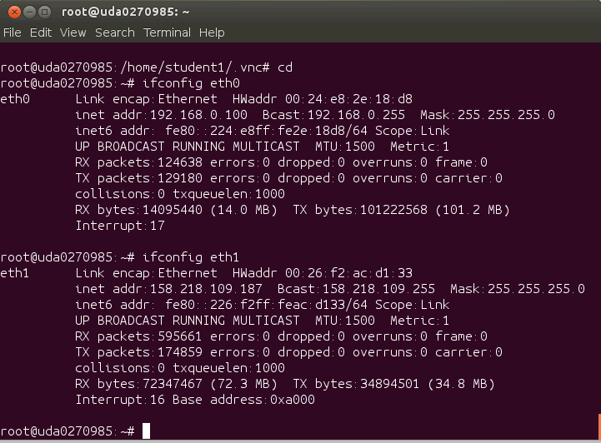

1. All students Laptops and EVMs are connected to the local network.
2. To connect Laptops and EVM to the local network, DHCP server must run. To start DHCP server on the Ubuntu server -> sudo service isc-dhcp-server restart
3. Note – if a DHCP server runs already on a local network switch, it is not necessary to run DHCP on the Ubuntu.
4. Note – the above external IP address is TI address. It Is used ONLY if ALL students are TI employees. For open enrollment session we will use either TI Guest network (if the training is in TI office) or any other local network. The local IT person will help to set up the external network and the correct proxy.
5. The file /usr/local/studentStartScript.sh must be modified and correct proxies must be loaded. The local IT must provide proxy information.
6. Verifying the local connection by connecting another laptop to the local network and ping the server
7. Verifying the external network by open a browser or by ping a global address. This will verify the proxy setting as well.

## TFTP installation check

1. To verify that the TFTP was install look at the file /etc/xinetd.d/tftp The file should show the server location as /usr/sbin/in.tftpd and the server arguments (server_args that defines the root directory of the tftp server) should be var/lib/tftpboot -s
2. As was already mention, the directory /var/lib/tftpboot should have a sub-directory for each student
3. To re-start the tftp server do

*sudo service xinetd stop*

*sudo service xinetd start*

Verify the TFTP is running correctly:

*netstat -na | grep LIST | grep 69*

You should see A LINE THAT LOOKS something like this:

*tcp 0 0 0.0.0.0:69 0.0.0.0:* LISTEN*

## FTP installation check

1. Verify that the FTP is installed. Look at the file /etc/vsftpd.config and make sure that the not-comment out lines look like the following screen shot. Note, there will be many commented out lines between these lines. Ignore commented out lines.

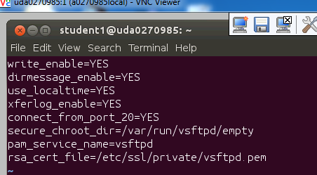

## NFS installation check

1. Verify the NFS server installation. First look at the file /etc/default/nfs-kernel-server and make sure that the RPCMOUNTDOPOTS is set to some port number (that is not used by other applications) such as 13025, for example RPCMOUNTDOPOTS=-p13025 (no blank between the characters =, -, p and the number). The file should be looked like the following:

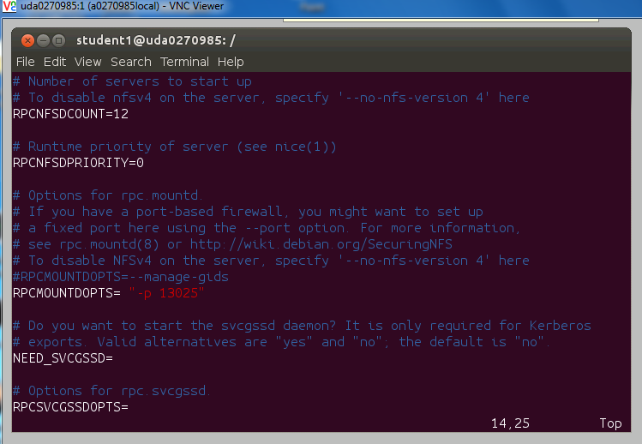

1. The root directory for NFS is /opt/filesys. Each student has a sub-directory studentN where N is 1, 2, 3, …,10
2. Next verify that the export file /etc/exports has the following line that gives non-password mounting read-write access to any root to the NFS root directory

/opt/filesys *(rw, subtree_check, no_root_squash,no_all_squash,sync)

The file /etc/exports looks like the following:

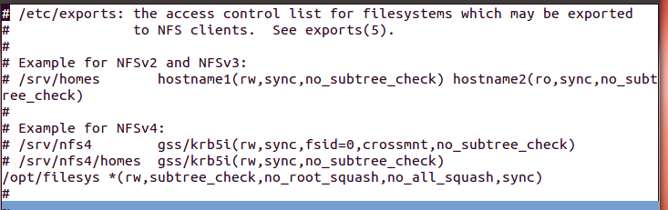

Start the nfs server -> “sudo /etc/init.d/nfs-kernel-server restart “

## VNC installation check and Student account startup

The following procedure should be done **FOR EACH STUDENT ACCOUNT** and any other user.

1. Do the following for all student accounts and all other users (instructor, root)
   1. su - studentN ** the dash is important to start with a clean user configurations **
   2. vncserver ** start the server for each student **
   3. vncserver will ask for password. Student password is ***vncserve***
   4. ***If the vncserver DOES NOT ask for password, it means that the following steps were already done.***
   5. ***The process may take couple of minutes since the server may look for authentication and send warning message. Ignore the warning message.***
   6. Next the password must be verified. The following screen shot shows the process

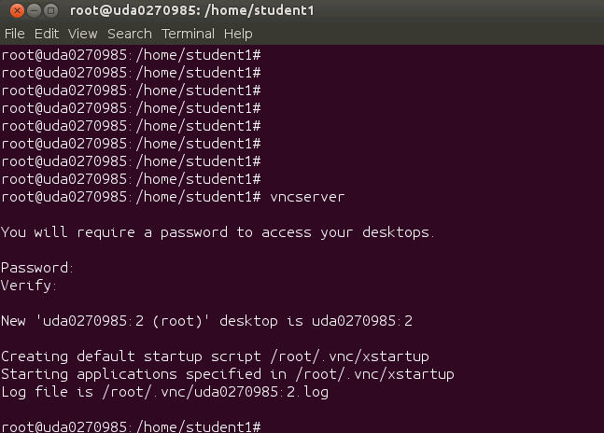

1. Notice the instance number of the vnc. In the above example it is 2. This number will be used to login into the VNC viewer from the Laptop. Make sure that student 1 has the first instance, student 2 has instance number 2 and so on.
2. The server generates a default xstartup script at the user root directory . For studentN the xstartup script will be in directory /home/studentN/.vnc and a log file (xx.log) is generated in the same directory
3. The default script for each user must be replaced by the correct script. The correct script must be in directory /usr/local.
   1. Kill the vnc instance -> vncserver –kill :N where N is the instance number. In the above example N=2
   2. Copy the new script to ~/.vnc/xstartup -> The xstartup script is located in /usr/local/ directory
   3. Restart the vnc instance vncserver
   4. The following screen shot shows the above operation for instance 2

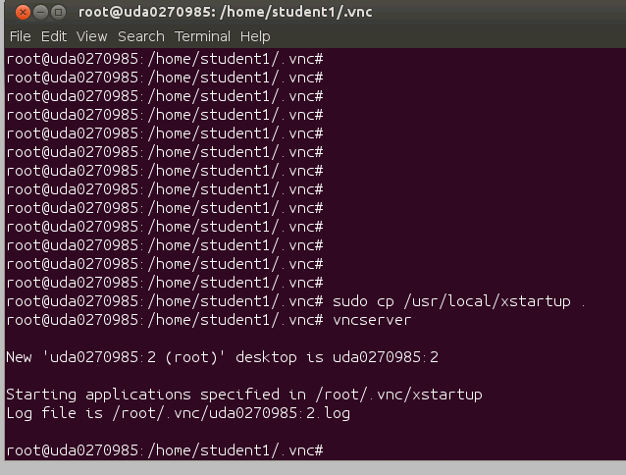

## VNC start session on student laptop

Though this document is dedicated to the server setting, to confirm that the VNC is working a VNC connection with Laptop should be establish. Here are the instructions for the remote VNC viewer

1. The following procedure is needed on each remote terminal that needs to VNC into the server.:
   1. Load VNC viewer either from TI site or from other sites
   2. Double click on the VNC icon (or start VNC from the start menu)
   3. Enter the IP address and the instance number, in the screen shot the ip address is 158.218.109.150 and the instance number is 4. In Lab environment the IP will be 192.168.0.100 and the instance number is the student number
   4. Let VNC server chose the encryption (no encryption is needed in the lab local network) and click connect

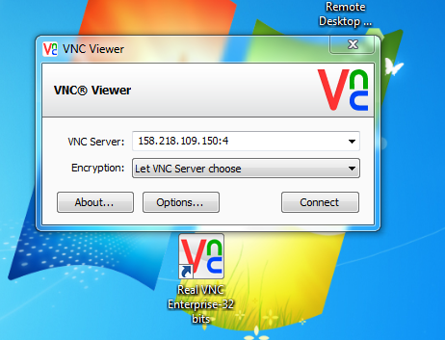

An encryption warning will appear:

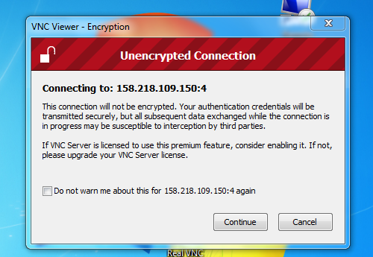

Click on continue, a dialogue box will ask for the password:

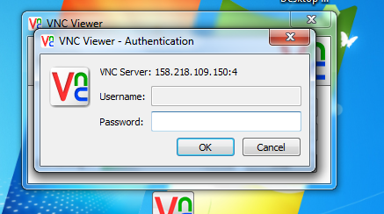

Enter the password (vncserve) and OK. A window like the following will be opened:

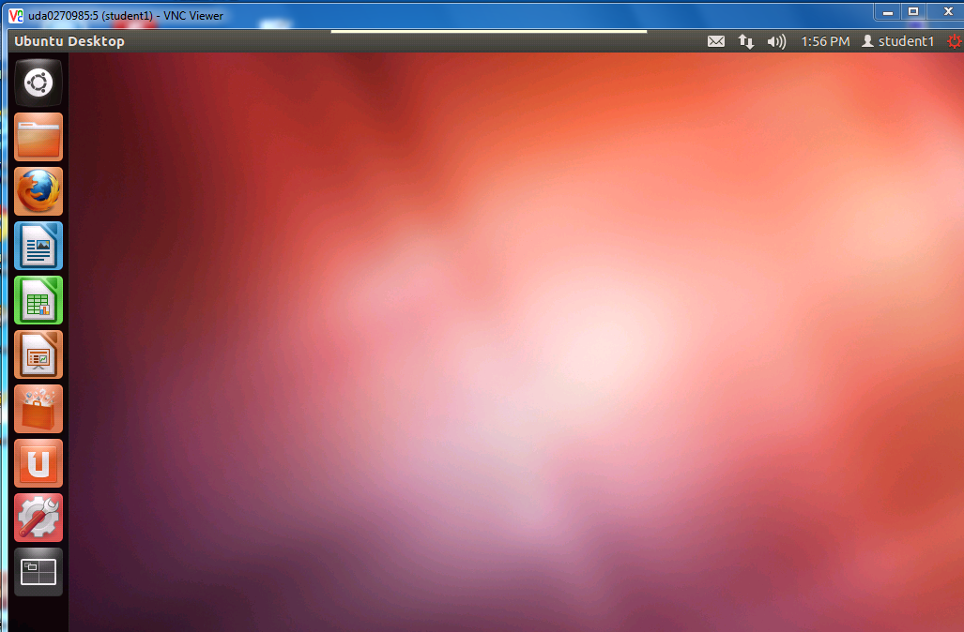

Selecting the dash home (the top square on the left) and left click will open a search tab. Chose Terminal to open a terminal into the user account.

Note, if the VNC is unable to connect, make sure that the Note in the VNC instructions was followed.

Note – if the user error is no authentication, you must start the ypbind server -> sudo restart ypbind

## Verify the global downloads

## 

1. The following list the global downloads that are supposed to be installed and their locations.
   1. CCS v5.4 - location in /opt/ti/CCS5_4. The execution should be called from /opt/ti/CCS5_4/ccs5/eclipse/ccstudio
   2. MCSDK – location in /opt/ti/MCSDK_3_XX
   3. Linaro toolchain – location in /usr/local. To use the tools, the following lines must be added to the environment. They should be part of the script studentStartScript.sh
      1. export CROSS_COMPILE=arm-linux-gnueabihf-
      2. export ARCH=arm
      3. PATH=/usr/local/gcc-linaro-arm-linux-gnueabihf-4.7-2013.03-20130313_linux/bin:$PATH

## Verify the git connection

1. To support git for each user, a new script should be added to the /usr/local directory. The git-proxy-ubuntu.sh script has the following lines:
   1. #!/bin/bash
   2. exec /usr/bin/corkscrew webproxy.ext.ti.com 80 $*
   3. chmod +x git-proxy-ubuntu.sh
   4. export GIT_PROXY_COMMAND=/usr/local/git-proxy-ubuntu.sh
2. The git-proxy-ubuntu.sh script is called by the studentStartScript.sh script. It depends on the network and should be changed before each session based on the local IT instructions
3. Next git need to be installed and configured. Please copy and paste the second line
   1. sudo apt-get install git-core to install git (if it is already installed it will report so)
   2. sudo apt-get install build-essential subversion ccache sed wget cvs coreutils unzip texinfo docbook-utils gawk help2man diffstat file g++ texi2html bison flex htmldoc chrpath libxext-dev xserver-xorg-dev doxygen bitbake uboot-mkimage libncurses5-dev
4. To verify that the git connection is working, vnc into one of the students account home page and do the following:
   1. git clone git://arago-project.org/git/projects/u-boot-keystone.git
   2. cd u-boot-keystone
   3. git reset --hard DEV.MCSDK-2013-01.10 Note – this tag will be changed when a new TI Linux release is added.
5. ???? -END