# Define a custom Platform in CCS

## Step 1 – allocate the directory where platforms reside and define a new platform

1. From the Debug prospective click on tools->RTSC Tools->Platform->Edit/View

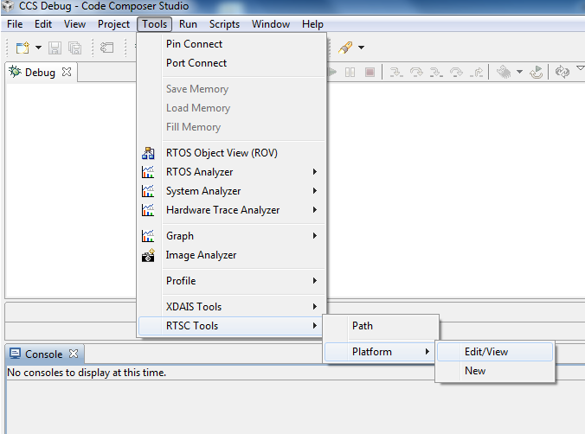

1. In the open window, make sure that you see multiple platforms including TCI6638K2K. Record the repository location, in my case, it is C:\ti\MCSDK_3_0_4_18\xdctools_3_25_05_94\packages

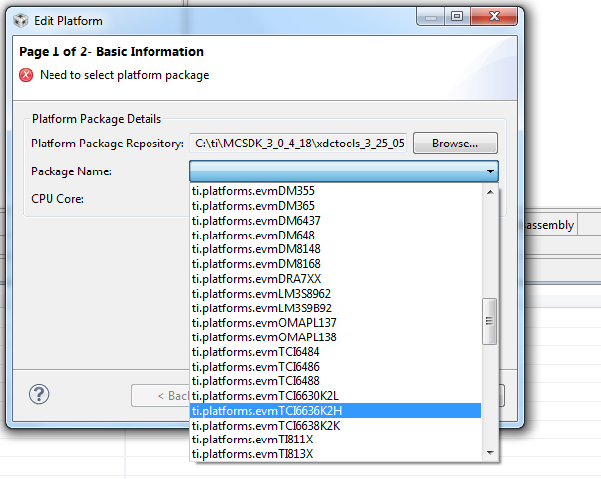

1. Click cancel, return back to the Debug prospective and click on tools->RTSC Tools->Platform->new. In the window that is opened set the name of the new platform, in my case it is newCustomPlatform, and clock on Browse and set the path to the same path that you recorded before
2. Set the device family C6000, and the Device name TMS320C66AK2H12 and click next

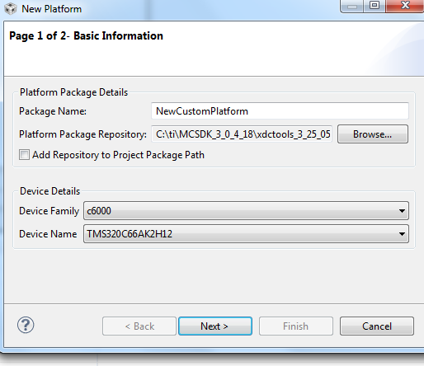

1. The platform window is opened.

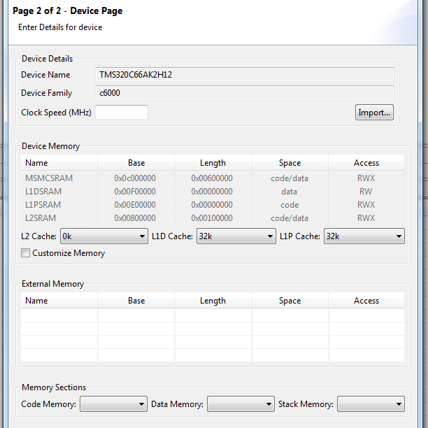

1. Import a known platform by click on import and choose. Choose a similar platform to the one you want to define

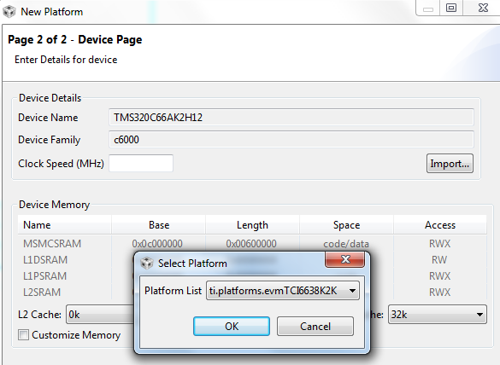

1. Click OK, accept the values that were entered and click finish

## Step 2 – Extract the new platform and modify it

1. Open a window explorer and change directory to the repository directory that were defined above (in my case it is C:\ti\MCSDK_3_0_4_18\xdctools_3_25_05_94\packages). Do search on the new platform that you defined (newCustomPlatform)

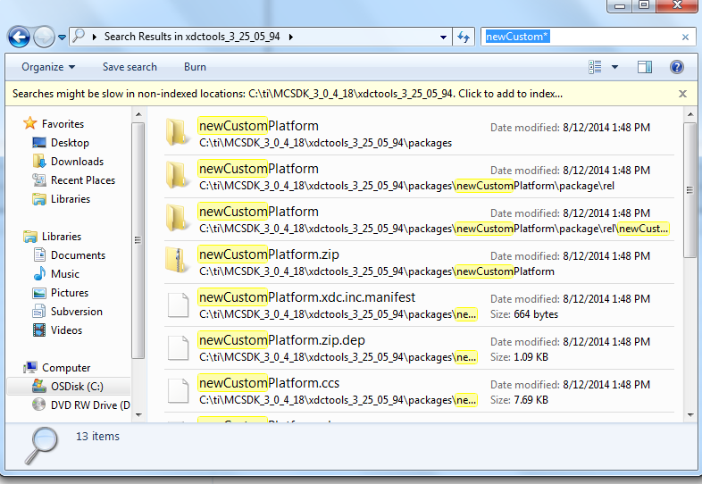

1. Select newCustomPlatform and open the directory. Unzip the file newCustomPlatform and move the resulted directory to the same directory where all other platforms are, in my case it is C:\ti\MCSDK_3_0_4_18\xdctools_3_25_05_94\packages\ti\platforms
2. Back in CCS go back to Debug prospective click on tools->RTSC Tools->Platform->Edit/View and this time look for newCustomPlatform

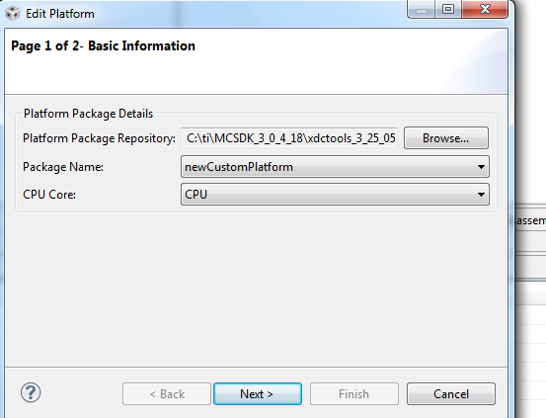

1. Click Next. In the memory window you can delete rows and add rows by setting the mouse next to a line and right click

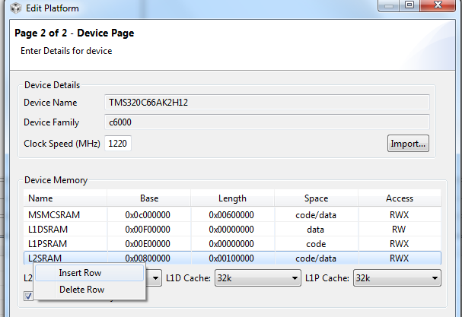

1. Manipulate the memory. For example, DDR_3 was partitioned into DDR3 and DDR3_1

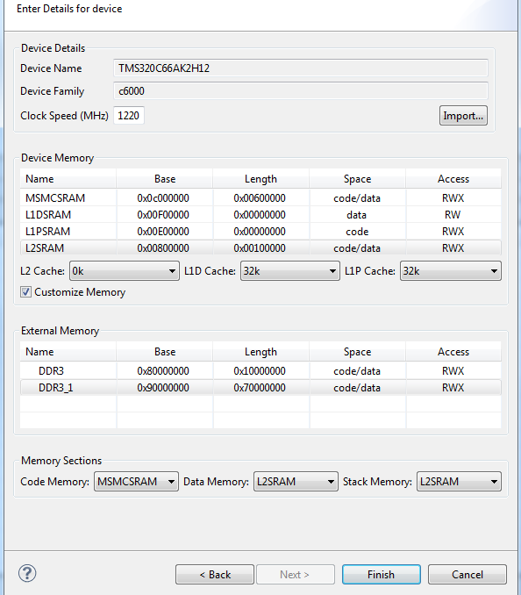

1. Click finish

## Step 3- Verify that the project sees the New Platform

1. Return to CCS edit prospective, select a RTSC project, and open the properties
2. Navigate to the RTSC tab
3. Add a repository to the location where the new platform was copied to. In my case it was C:\ti\MCSDK_3_0_4_18\xdctools_3_25_05_94\packages\ti\platforms

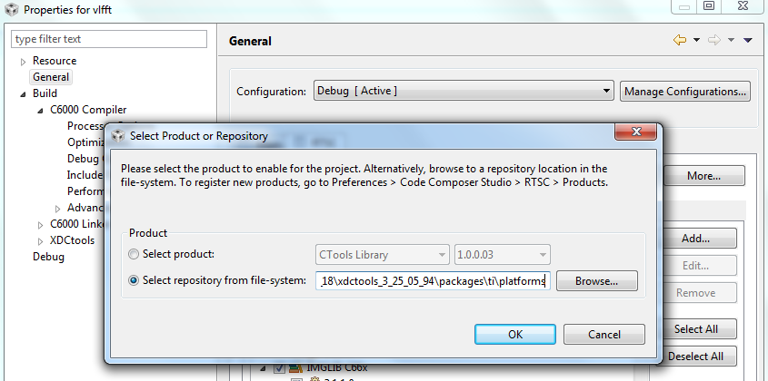

1. Click OK
2. Click on the platform. After few minutes a list of platforms will appear. Make sure that the new platform is on the list

