Resume

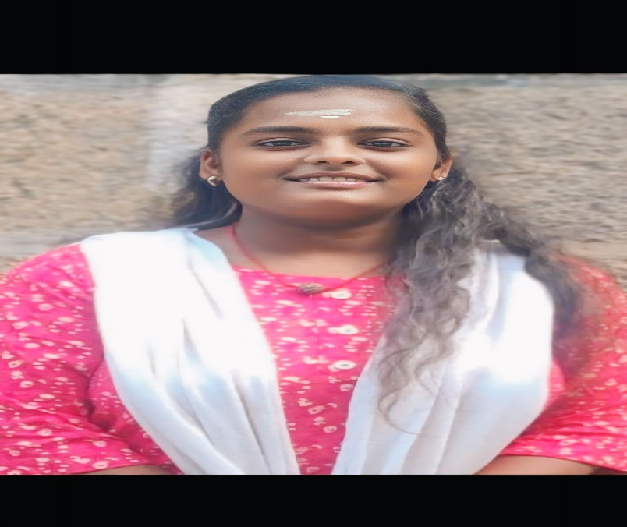

D.Harini

Email ID : [harinidhayalan2006@gmail.com](mailto:harinidhayalan2006@gmail.com)

Phone number: 917134xxxx

Address no: 59/15 kanaga durga nagar thiruverkadu chennai -77

CAREER OBJECTICA :

Recent Graduate with a Bachelors in computer application seeking an entry level position in IT industry to leverage my Skills and contribute to a dynamic team.

ACADEMIC QUALIFICATIONS

10th from ramakrishna vidhya nikrathan higher secondary school

11th from ramakrishna vidhya nikrathan higher secondary school

12th from ramakrishna vidhya nikrathan higher secondary School

SKILLS:

● Communication

●Problem Solving

●Basic Knowledge of computer

●Easy to adapt in environment

KNOW PROGRAMMING LANGUAGE:

●HTML

●PYTHON

●JAVA

WORK EXPERIENCE:

● Fresher

PERSONAL DETAILS:

D.O.B: 24 : 07 : 2006

Gender: Female

Nationality: Indian

Father’s name: dhayalan .N

Mother’s name: lakshmi.D

Languages Known: Tamil & English

Hobbies: Reading books,Drawing

Place: thiruverkadu

Date: 20-03-2025