**Steps to prepare Peanut Butter and Jelly Sandwich**

Peanut butter and Jelly sandwich (popularly known as PB&J sandwich) is one of the most commonly prepared sandwiches in US households. The whole procedure to prepare this sandwich is divided into specific tasks with specific goals and outcomes, which can be achieved by following the steps listed under each of them. Small enough tasks might not have any steps listed under them. Pictures from various sources are also provided, in the case of any instruction in a particular step or task being unclear.

**Task 1: Gather all the required materials**

Gather the following materials:

* A clean cutting board or a plate.
* Two butter knives which are neatly washed.
* Peanut butter – Please check the expiry date of your butter before using the same. If the date has passed, please use a new product.
* Jelly – Any flavor of your choice. Be sure to check the expiry date before using.
* Two slices of bread – Make sure your bread slices are fresh and do not have any mold or fungus growing on it. It is recommended not to use the first or last slice of the loaf.

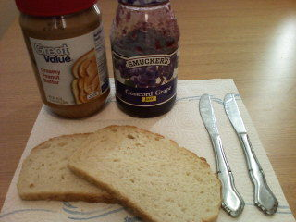

*Fig1 (©instructables.com)*

**Task 2: Using one of the knives, spread the peanut butter evenly on one of the slices of bread by following the below mentioned steps. Refer Fig 2a and 2b for further help.**

* Heat the knife with a mild flame on the stove if the butter was stored in cold conditions, and is a bit hard.
* Open the lid of the peanut butter container.
* If you are a right-handed person, hold the knife by the handle (generally the thicker end) with your right hand and scoop around half to one ounce of butter from the jar on the other side of the knife. If you are a left-handed person, perform the same step with your left hand.
* Hold the slice gently on your other palm (the hand not holding the knife with butter).
* 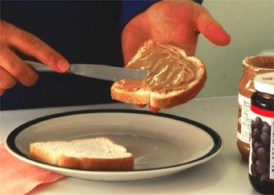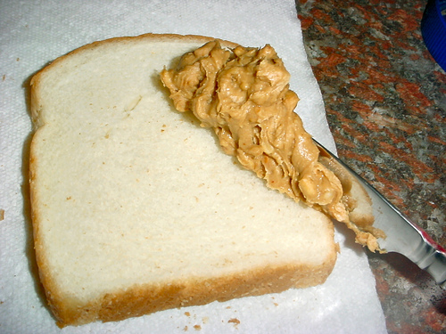Gently apply the butter on the bread. Now, flip the knife and start evenly spreading out the butter throughout the surface of the slice in your hand. Please be sure not to tear the bread by using too much force. You can use your index finger to modify the force being applied, and wrists to spread the butter evenly. Refer Fig 2a and Fig 2b below.

*Fig 2a (©sometimesigetangry.wordpress.com) Fig 2b (©sometimesigetangry.wordpress.com)*

**Task 3: Keep aside the slice with peanut butter prepared using the above step. Pick up the other slice and the other knife. DO NOT HEAT THIS KNIFE. Use your stronger hand to hold the knife in a similar way to the previous step.**

**Task 4: Using the knife in your hand right now, spread jelly evenly on the other slice of bread. Please follow the following steps to complete this task. Refer fig 4a and 4b for further help.**

* Keep the knife down momentarily, open the lid of the jelly container.
* Pick up the knife you kept down in the previous step.
* If you are a right-handed person, hold the knife by the handle (generally the thicker end) with your right hand and scoop around half to one ounce of jelly from the jar on the other side of the knife. If you are a left-handed person, perform the same step with your left hand.
* Hold the slice gently on your other palm (the hand not holding the knife with butter).
* Repeat the last step of the previous task, only this time you will be spreading jelly on the other slice instead of butter. The procedure to evenly spread it across the surface is the same.

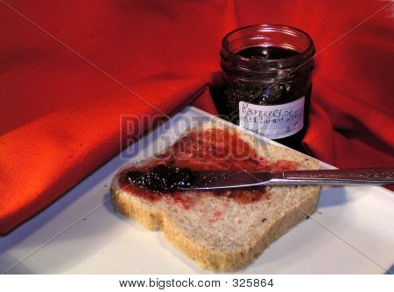[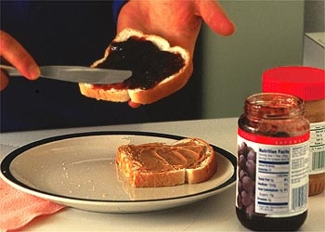](https://www.google.com/url?sa=i&rct=j&q=&esrc=s&source=images&cd=&ved=&url=http://www.ehow.com/video_1323_make-peanut-butter.html&bvm=bv.136811127,d.cWw&psig=AFQjCNH9M4P9p7_swDCyRVE3wEQqmatXXg&ust=1477644100922441&cad=rjt)

*Fig 4a (©bigstock.com) Fig 4b (©ehow.com)*

**Task 5: Press both the slices of bread against each other in such a way that both the sides of the slices which have jelly and butter applied are facing each other. Please follow the following steps to complete this task. Refer to Figure 5a and 5b if instructions are unclear or if you require further help.**

* Pick up the slice on which peanut butter is applied in one hand using your palm, with the side which has the butter applied facing towards you.
* Pick up the slice on which jelly is applied in the other hand using your palm, with the side which has the jelly applied facing towards you.
* Gently press the slices against one another, such that the faces with peanut butter and jelly are facing each other. Be sure to press it gently, failing which the sandwich might become soggy. Refer Figure 5a for further help.
* Once the slices are together, you have your sandwich. Keep the sandwich back on the plate, with the slices intact from the previous step.

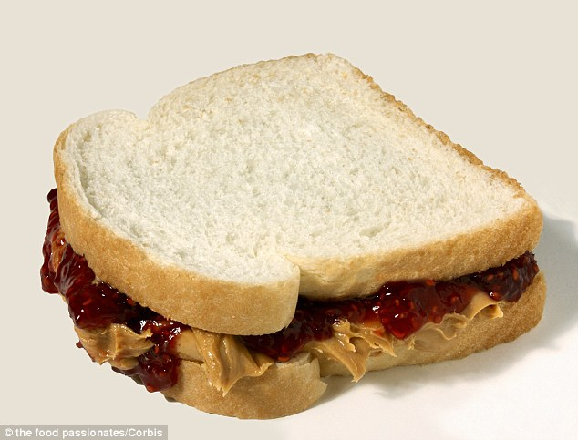[](http://www.tildee.com/uploads/15-01-2015/AA417485-5D51-4933-977B-B5FE0BF725E6.jpg)

*Fig 5a (©tildee.com) Fig 5b (©dailymail.co.uk)*

**Task 6: The hard work is now over! Enjoy your sandwich!! ☺**

**References:**

1. [*"How to make a peanut butter and jelly sandwich?"*](http://www.wikihow.com/Make-a-Peanut-Butter-and-Jelly-Sandwich). wikihow.com*. Retrieved 2016-10-24*.
2. [*“How to make the perfect peanut butter and jelly sandwich?”*](http://www.instructables.com/id/How-To-Make-a-Perfect-Peanut-Butter-and-Jelly-Sand/). instructables.com. *Retrieved 2016-10-24.*
3. [*“How to make a peanut butter and jelly sandwich?”*](http://www.tildee.com/JIxQGh)*. tildee.com. Retrieved 2015-10-25.*
4. [*“Peanut butter and jelly. Sometimes I get Angry”*](https://sometimesigetangry.wordpress.com/2011/06/23/peanut-butter-and-jelly/)*. sometimesigetangry.wordpress.com. June 2011*
5. [*“How to make a peanut butter and jelly sandwich”*](http://www.ehow.com/video_1323_make-peanut-butter.html)*. ehow.com. Retrieved 2016-10-25*

Word Count: 887