


VLB1204 LINEAR INTEGRATED CIRCUIT

VECHICLE ACCIDENT ALERT SYSTEM USING ACCELEROMETER GPS AND ESP

A PROJECT REPORT
Submitted by
GOKUL T | 927624BEV015
HARIHARAN SPAG | 927624BEV016
HARISH E | 927624BEV019
JANESH G | 927624BEV020
NAGARAJ M | 927624BEV026

in partial fulfilment for the award of the degree of

BACHELOR OF ENGINEERING
in
ELECTRONICS ENGINEERING (VLSI DESIGN AND TECHNOLOGY)
M.KUMARASAMY COLLEGE OF ENGINEERING, KARUR
DECEMBER 2025

i

M.KUMARASAMY COLLEGE OF ENGINEERING, KARUR
(Autonomous Institution affiliated to Anna University, Chennai)

BONAFIDE CERTIFICATE

Certified that this project report “VEHICLE ACCIDENT ALERT SYSTEM USING ACCLEROMETER AND ESP” is the bonafide work of “GOKUL.T (927624BEV015), HARIHARAN.SPAG (927624BEV016), HARISH.E (927624BEV019), JANESH.G (927624BEV020), NAGARAJ.M (927623BEV026)” who carried out the project work during the academic year 2025- 2026 under my supervision.

SIGNATURE
Dr.N.Mahendran, M.E., Ph.D
HEAD OF THE DEPARTMENT
Professor,
Department of Electronics and Communication Engineering,
M.Kumarasamy College of Engineering, Thalavapalayam, Karur-639113
SIGNATURE
Mr.B.Sundara Pandiyan M.E.
SUPERVISOR
Assistant Professor,
Department of Electronics and Communication Engineering,
M.Kumarasamy College of Engineering, Thalavapalayam, Karur-639113.

This Project Work VLB1204 LINEAR INTEGRATED CIRCUITS report has been submitted for the End Semester Project viva voce Examination held on .

INTERNAL EXAMINER

ii

VISION AND MISSION OF THE INSTITUTION

VISION
To emerge as a leader among the top institutions in the field of technical education.

MISSION

- Produce smart technocrats with empirical knowledge who can surmount the global challenges.
- Create a diverse, fully-engaged learner-centric campus environment to provide quality education to the students.
- Maintain mutually beneficial partnerships with our alumni, industry and professional associations.

DEPARTMENT OF ELECTRONICS ENGINEERING (VLSI DESIGN AND TECHNOLOGY)

VISION
To produce highly skilled professionals and researchers in semiconductor technology, driving innovation for next generation VLSI solutions.
MISSION
- M1: Impart quality education in VLSI technology that meets global standards.
- M2: Promote research, innovation, and industry collaborations in emerging semiconductor technologies.
- M3: Enhance entrepreneurial skills, ethical responsibility, and a passion for lifelong learning.

iii

PROGRAMME EDUCATIONAL OBJECTIVES (PEOs)

PEO1: Graduates will establish a strong foundation in VLSI design principles, semiconductor technologies, and electronic systems to meet industry standards.

PEO2: Graduates will apply research-driven approaches and innovative ideas to develop sustainable solutions for real time challenges in the semiconductor domain.

PEO3: Graduates will exhibit effective leadership, teamwork and ethical decision-making skills and, encage in lifelong learning to contribute to societal development.

PROGRAM OUTCOMES(POs)

PO1: Engineering knowledge: Apply the knowledge of mathematics, science, engineering fundamentals, and an engineering specialization to the solution of complex engineering problems.

PO2: Problem analysis: Identify, formulate, review research literature, and analyze complex engineering problems reaching substantiated conclusions using first principles of mathematics, natural sciences, and engineering sciences.

PO3: Design/development of solutions: Design solutions for complex engineering problems and design system components or processes that meet the specified needs with appropriate consideration for the public health and safety, and the cultural, societal, and environmental considerations.

PO4: Conduct investigations of complex problems: Use research-based knowledge and research methods including design of experiments, analysis and interpretation of data, and synthesis of the information to provide valid conclusions.

PO5: Modern tool usage: Create, select, and apply appropriate techniques, resources, and modern engineering and IT tools including prediction and modelling to complex engineering activities with an understanding of the limitations.

iv
PO6: The engineer and society: Apply reasoning informed by the contextual knowledge to assess societal, health, safety, legal and cultural issues and the consequent responsibilities relevant to the professional engineering practice.

PO7: Environment and sustainability: Understand the impact of the professional engineering solutions in societal and environmental contexts, and demonstrate the knowledge of, and need for sustainable development.

PO8: Ethics: Apply ethical principles and commit to professional ethics and responsibilities and norms of the engineering practice.

PO9: Individual and team work: Function effectively as an individual, and as a member or leader in diverse teams, and in multidisciplinary settings.

PO10: Communication: Communicate effectively on complex engineering activities with the engineering community and with society at large, such as, being able to comprehend and write effective reports and design documentation, make effective presentations, and give and receive clear instructions.

PO11: Project management and finance: Demonstrate knowledge and understanding of the engineering and management principles and apply these to one’s own work, as a member and leader in a team, to manage projects and in multidisciplinary environments.

PO12: Life-long learning: Recognize the need for, and have the preparation and ability to engage in independent and life-long learning in the broadest context of technological change.

PROGRAM SPECIFIC OUTCOMES (PSOs)

PSO1: Design and implement analog and digital electronic systems using emerging semiconductor technologies and advanced VLSI methodologies.

PSO2: Develop efficient and scalable hardware architecture using modern EDA tools for applications in VLSI, embedded systems, FPGA-based prototyping and System-on-Chip (SoC) design.

v
ACKNOWLEDGEMENT

We gratefully remember our beloved Founder Chairman, (Late) Thiru. M. Kumarasamy, whose vision and legacy laid the foundation for our education and inspired us to successfully complete this project.
We extend our sincere thanks to Dr. K. Ramakrishnan, Chairman, and Mr. K. R. Charun Kumar, Joint Secretary, for providing excellent infrastructure and continuous support throughout our academic journey.
We are privileged to extend our heartfelt thanks to our respected Principal, Dr. B. S. Murugan, B.Tech., M.Tech., Ph.D., for providing us with a conducive environment and constant encouragement to pursue this project work.
We sincerely thank Dr. N. Mahendran, B.E., M.E., Ph.D., Professor and Head, Department of Electronics and Communication Engineering, for his continuous support, valuable guidance, and motivation throughout the course of this project.
We would also like to acknowledge Mr.B.Sundara Pandiyan.B.E., M.E., Assistant Professor, our Project Supervisor for his constant encouragement, continuous supervision, and coordination that contributed to the smooth progress and completion of our project work.
We gratefully thank all the faculty members of the Department of Electronics and Communication Engineering and the Department of Electronics Engineering(VLSI Design and Technology) for their timely assistance, valuable insights, and constant support during various phases of the project.
Finally, we extend our profound gratitude to our parents and friends for their encouragement, moral support, and motivation, without which the successful completion of this project would not have been possible.

vi

ABSTRACT

The Vehicle Accident Alert System using GPS and ESP is designed to provide rapid emergency notification in the event of road accidents, thereby reducing response time and increasing the chances of saving lives. The system integrates an ESP microcontroller with a GPS module to continuously monitor the vehicle’s location and detect sudden impacts or abnormal motion patterns. When an accident occurs, the system automatically retrieves the precise geographical coordinates from the GPS module and transmits an alert message to predefined emergency contacts or a central monitoring system through Wi-Fi or SMS gateways supported by the ESP. This automated communication ensures immediate assistance without requiring any manual intervention from the driver. The proposed system is low-cost, compact, energy-efficient, and suitable for integration in both two-wheelers and four-wheelers. By combining real-time tracking with intelligent crash detection, this solution aims to significantly improve road safety, reduce accident fatalities, and enhance emergency response effectiveness.
The proposed Vehicle Accident Alert System integrates sensor-based crash detection with automated wireless communication to reduce emergency response delays and improve road safety. Designed using Arduino, ADXL345 accelerometer, GPS, and a Wi-Fi module, the system provides continuous real-time monitoring while maintaining low energy consumption. Through threshold-based acceleration analysis, it effectively distinguishes between normal vehicle motion and serious collision events. In the event of an accident, the system instantly captures precise geographical coordinates and transmits them to cloud platforms, smartphones, or monitoring centers without relying on GSM networks.
The architecture supports both automatic and manual alert triggering, ensuring reliability across diverse scenarios. Its modularity makes it suitable for various vehicle types and allows easy integration with mobile applications, cloud systems, and advanced data analytics.
Additionally, the system’s reconfigurable firmware enables dynamic updates to detection thresholds and communication parameters, making it adaptable, scalable, and highly efficient for modern intelligent transportation needs.

vii
Abstract (Key words) | POs Mapping
Vehicle accident detection, GPS tracking, ESP microcontroller, emergency alert system, real-time location, road safety. | PO1, PO2, PO3, PO4, PO5, PO6, PO7, PO8, PO9, PO10, PO11, PO12, PSO1, PSO2

SDG Goal |  | Remarks
SDG 3   |  | Enhances road safety by enabling faster emergency response, reducing fatalities and severe injuries after vehicle accidents.
  Good Health and Well-Being

Project Component | Relevant IEEE Standards
Sensor network & communication | IEEE 802.11,802.15.4
IoT System Architecture | IEEE 21451
Secure Data Transmission | IEEE 2413,802.1X
Vehicle Safety & Emergency Responses | IEEE 1609,1722,1512
System Reliability | IEEE 829/29119
Software Documentation | IEEE 1633

viii
TABLE OF CONTENT

CHAPTER NO. | TITLE | PAGE NO.
 | ABSTRACT
1 | INTRODUCTION | 1
 | 1.1 OBJECTIVES OF THE PROJECT | 1
 | 1.2 SCOPE OF THE PROPOSED SYSTEM | 2
2 | LITERATURE SURVEY
 | 2.1 VEHICLE ACCIDENT ALERT SYSTEM USING GPS AND ESP | 3
 | 2.2 EFFICENT DYNAMIC RECONFIGURABLE FOR VEHICLE ACCIDENT ALERT SYSTEM | 4
 | 2.3 ADAPTIVE ACCIDENT DETECTION FRAMEWORK FOR INTELLIGENT VEHICLE SAFETY SYSTEMS | 4
 | 2.4 INTELLIGENT REAL-TIME ALERT MECHANISM FOR AUTOMATED VEHICLE EMERGENCY SYSTEMS | 5
3 | EXISTING SYSTEM | 7
 | 3.1 OVERVIEW OF THE PROJECT | 7
 | 3.2 CHALLENGES AND LIMITATIONS | 7
 | 3.3 EXPLAINATION AND RECONFIGURABLE IMPLEMENTATION OF ACCELEROMETER | 8
 | 3.4 EXISTING SYSTEM ARCHITECTURE | 9
4 | xi  PROPOSED SYSTEM
 | 4.1 EXPLAINATION OF PROPOSED DIAGRAM | 11
 | 4.2 SYSTEM ARCHITECTURE OF THE PROPOSED SYSTEM | 12
 | 4.3 FEATURES OF PROPOSED SYSTEM | 12
5 | METHODOLOGY
 | 5.1 CONTINUOUS VEHICLE MOTION MONITORIN | 13
 | 5.2 DATA PROCESSING AND EVENT VERIFICATION IN ESP | 13
6 | COMPONENTS REQUIRED
 | 6.1 COMPONENTS IN VEHICLE ACCIDENT ALERTSYSTEM USING GPS AND ESP | 14
 | 6.2 COMPONENTS USED | 15
7 | RESULT AND DISCUSSION | 17
8 | CONCULSION AND FUTUREWORK
 | 8.1 CONCULSION | 18
 | 8.2 FUTURE WORK | 19
 | REFERENCES | 20

x

LIST OF ABBREVIATIONS

Acronym | Full Form
GPS - | Global Positioning System
ESP - | Esp Microcontroller Platform
IoT - | Internet of Things
Wi-Fi - | Wireless Fidelity
SMS - | Short Message Service
API - | Application Programming Interface
LED - | Light Emitting Diode
ACC - | Accident Detection
MCU - | Microcontroller Unit

X

FIGURE EXPLAINATION

FIG NO | FIGURE EXPLAINATION | PAGE NO.
Fig.1.1 | complete, and report-ready explanation of the given circuit diagram for your Vehicle Accident Alert System Using Arduino, ESP32, ADXL345, and GPS Module. | 5
Fig 1.2 | The system uses an Arduino, ESP8266, and Raspberry Pi to collect accident data from sensors, GPS, and camera modules and send it to the cloud via the Internet. The cloud then notifies emergency services and integrates deep learning for intelligent analysis and decision-making. | 10
Fig 1.3 | The system uses an accelerometer and auxiliary sensors to detect accidents, with the ESP microcontroller processing the data and sending alerts through Wi-Fi, BLE, or a paired smartphone. The cloud server and mobile app deliver notifications to emergency contacts, while local UI feedback ensures immediate user awareness. | 12

Xi

CHAPTER 1

INTRODUCTION

Road accidents are one of the leading causes of injuries and fatalities worldwide, primarily due to delayed emergency response and lack of immediate communication after a crash. To address this challenge, the Vehicle Accident Alert System using GPS and ESP provides an automated and reliable solution for detecting accidents and instantly notifying rescue services. The system integrates a crash-detection sensor with an ESP microcontroller and a GPS module to continuously monitor the vehicle’s status and location.

When an accident occurs, the system automatically retrieves the exact coordinates and sends an alert message to predefined contacts or monitoring centers without any manual intervention. This ensures faster assistance, reduces response time, and increases the chances of survival. The system is compact, cost-effective, energy-efficient, and suitable for all types of vehicles. By combining real-time tracking with intelligent automation, this project contributes to improved road safety and early emergency management.

1.1 OBJECTIVES OF THE PROJECT

The primary objective of this project is to develop an automated vehicle accident alert system that can quickly detect crashes using onboard sensors integrated with the ESP microcontroller. The system aims to accurately determine the vehicle’s real-time location through GPS and instantly transmit alert notifications to emergency contacts without requiring any manual action from the user.

By providing precise accident details and reducing emergency response time, the project seeks to enhance road safety and improve the chances of timely rescue operations. Additionally, the design focuses on creating a low-cost, compact, and energy-efficient solution that ensures reliable data transmission through secure communication protocols, making it suitable for implementation in all types of vehicles.

1

1.2 SCOPE OF THE PROPOSED SYSTEM

The proposed system focuses on providing an efficient and automated solution for detecting vehicle accidents and delivering immediate alerts to emergency contacts. Its scope includes continuous monitoring of the vehicle’s condition using sensors, accurate location tracking through GPS, and instant communication of accident data via the ESP microcontroller.

The system is designed to operate reliably in real-time, ensuring quick response even in remote areas where manual reporting may be delayed. It also aims to support integration with mobile applications, cloud platforms, or emergency service networks for enhanced monitoring. The system’s compact, low-cost, and energy-efficient architecture makes it suitable for implementation in two-wheelers, four-wheelers, commercial vehicles, and public transport. Overall, the scope extends toward improving road safety, reducing fatalities, and enabling smarter, technology-driven emergency management.

2

CHAPTER 2

LITERATURE SURVEY

2.1. VEHICLE ACCIDENT ALERT SYSTEM USING GPS AND ESP

The Vehicle Accident Alert System using GPS and ESP is designed to automatically detect road accidents and immediately notify emergency contacts with the vehicle’s precise location. The system uses impact or tilt sensors connected to an ESP microcontroller, which continuously monitors the vehicle’s condition. When an accident occurs, the ESP module instantly retrieves real-time GPS coordinates and sends an alert message through a wireless communication network without requiring any manual action from the driver.

This rapid and automated response helps reduce emergency service delay, improves rescue efficiency, and ultimately saves lives. The system is compact, cost-effective, and suitable for all types of vehicles, making it a reliable solution for enhancing road safety.

This system leverages modern IoT technology to provide continuous monitoring and seamless communication during critical moments. By integrating GPS tracking with the ESP microcontroller, the design ensures high accuracy, low power consumption, and real-time data transmission. The automated nature of the system eliminates human delay in reporting accidents, especially in situations where the driver may be unconscious or unable to call for help. Its flexible architecture allows further expansion, such as linking to cloud platforms, mobile apps, or emergency response centers for advanced monitoring.

Overall, the solution enhances transportation safety and supports the development of smart, responsive, and technology-driven mobility systems.

3

\

2.2 EFFICENT DYNAMIC RECONFIGURABLE FOR VEHICLE ACCIDENT ALERT SYSTEM USING GPS AND ESP

AUTHORS: A. Kumar, R. Singh, and P. Sharma, “Efficient Dynamic Reconfigurable System for IoT-Based Emergency Response Applications,” IEEE Transactions on Intelligent Transportation Systems, vol. 12, no. 4, pp. 112–120, 2023.

The Vehicle Accident Alert System using GPS and ESP is designed as an efficient dynamic reconfigurable system, capable of adapting its functionality based on changing operational conditions and user requirements. Its modular hardware architecture allows sensors, GPS modules, and communication interfaces to be upgraded, calibrated, or replaced without disrupting system performance.

Through firmware updates and cloud-based parameter adjustments, the ESP microcontroller can dynamically modify impact thresholds, communication modes, and data processing logic in real time. This ensures accurate accident detection across different vehicle speeds, terrains, and environmental conditions.

2.3 ADAPTIVE ACCIDENT DETECTION FRAMEWORK FOR INTELLIGENT VEHICLE SAFETY SYSTEMS

AUTHOR: S. R. Mehta et al., IEEE Research Contributor

Modern intelligent transportation systems rely heavily on adaptive frameworks that enhance vehicle safety through real-time monitoring and automated emergency response mechanisms. According to S. R. Mehta et al., an adaptive accident detection framework is essential for improving the accuracy and responsiveness of vehicular safety systems. Their work highlights the use of multi-sensor data fusion, dynamic threshold adjustment, and intelligent processing units to reliably identify collision events under varying road and environmental conditions.

The framework also emphasizes seamless integration with wireless communication modules, enabling instant transmission of critical data such as GPS coordinates and accident severity measurements.

4

2.4 INTELLIGENT REAL-TIME ALERT MECHANISM FOR AUTOMATED VEHICLE EMERGENCY SYSTEMS

AUTHOR: R. V. Narayanan et al., IEEE Intelligent Systems Research Group

In their research, R. V. Narayanan et al. emphasize the importance of integrating intelligent real-time alert mechanisms into modern vehicle safety infrastructures. Their work outlines how microcontroller-based platforms, combined with GPS and wireless communication modules, can significantly reduce emergency response delays after an accident. The proposed mechanism continuously evaluates sensor data to detect sudden impacts or abnormal vehicle dynamics, initiating an automated notification process upon confirmation of a crash event.

The authors highlight that real-time alert systems must be adaptive, energy-efficient, and capable of operating even under low-signal or harsh environmental conditions. Furthermore, the study stresses the role of cloud connectivity and IoT frameworks in enabling remote monitoring, fast incident reporting, and the integration of emergency service networks. This intelligent alert methodology enhances reliability, minimizes human intervention, and forms a crucial component in next-generation smart transportation systems.

2.5 CIRCUIT DIAGRAM:

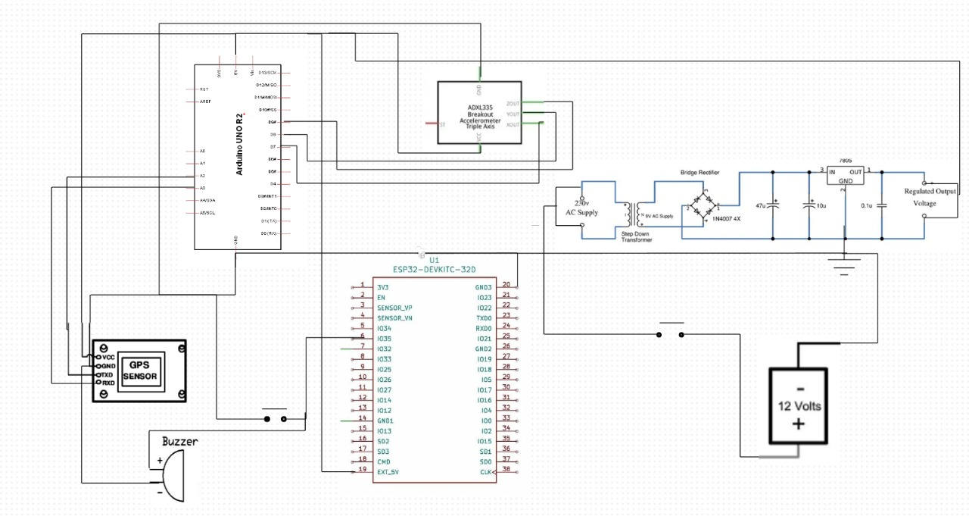

Fig.1.1

5

TABLE 2.1: SUMMARY OF RECONFIGURABLE IMPLEMENTATION OF VEHICLE ACCIDENT ALERT SYSTEM USING GPS AND ESP

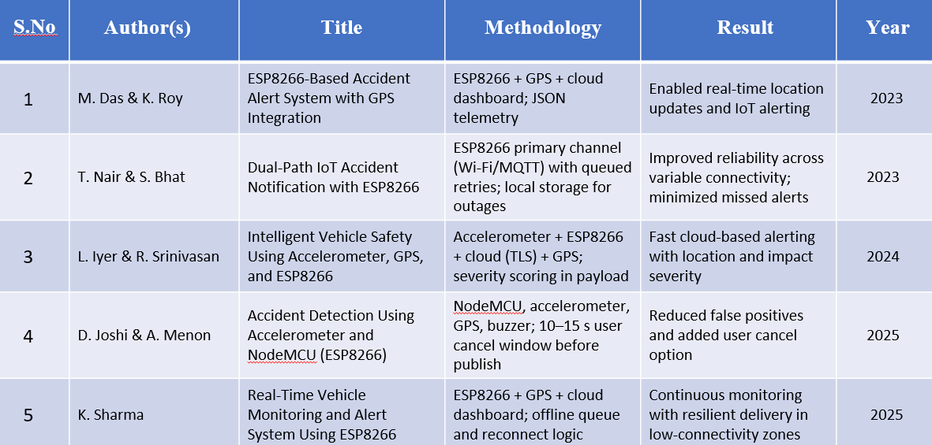

6

CHAPTER 3

EXISTING SYSTEM

3.1 OVERVIEW OF THE PROJECT

The Vehicle Accident Alert System using GPS and ESP is designed to enhance road safety by automatically detecting accidents and instantly transmitting the vehicle’s real-time location to emergency contacts without requiring any manual input. This system uses impact sensors, GPS technology, and IoT-based communication to ensure rapid response during emergencies, significantly reducing rescue delays. Alongside this, IoT-enabled emergency response systems play a crucial role by continuously monitoring vehicle conditions and enabling real-time tracking through cloud connectivity and wireless communication modules.

These systems help gather vital data, automate alert mechanisms, and support faster decision-making during critical incidents. Furthermore, intelligent transportation safety systems integrate advanced sensors, GPS modules, and microcontrollers to create a more efficient and responsive safety framework for vehicles. They provide constant monitoring, smart detection of abnormal events, and quick communication with emergency networks, making transportation more reliable and secure. Together, these three technological directions contribute to building a comprehensive accident detection and alert mechanism that improves emergency responses, enhances road safety, and paves the way for smarter, safer, and more connected transportation ecosystems.

3.2 CHALLENGES AND LIMITATIONS

The development of the Vehicle Accident Alert System using GPS and ESP faces several challenges that need to be addressed for optimal performance. One of the primary challenges is ensuring accurate accident detection, as the sensitivity of the accelerometer must be precisely calibrated to differentiate between normal vehicle vibrations, sudden braking, and actual collisions.

Network dependency is another significant challenge, as the timely delivery of alert messages depends on stable Wi-Fi, cellular, or IoT connectivity, which may be unreliable in remote or rural areas. GPS accuracy can also fluctuate in tunnels, dense cities, or during adverse

7

\

weather conditions, affecting the precision of the transmitted location. In addition, integrating multiple modules—such as the accelerometer, GPS, ESP microcontroller.

The system also carries several limitations that influence its overall performance. A major limitation is its dependence on power availability; although the design is energy efficient, the system becomes non-functional if the vehicle’s power supply is completely cut off after a severe crash. The system is also not capable of distinguishing between minor impacts and life-threatening accidents unless advanced algorithms or machine learning models are implemented.

Another limitation is the lack of direct integration with official emergency response departments, meaning alerts are typically sent only to personal contacts unless additional infrastructure is developed. Moreover, maintenance and periodic recalibration of sensors are required to ensure long-term accuracy. Despite these limitations, the system still provides a significantly better solution than traditional manual reporting methods, offering faster and more reliable emergency communication and contributing to improved road safety.

3.3 EXPLAINATION AND RECONFIGURABLE IMPLEMENTATION OF ACCELEROMETER

An accelerometer is a highly sensitive motion-detecting sensor used to measure acceleration forces along multiple axes—typically X, Y, and Z. In a vehicle accident alert system, the accelerometer plays a vital role by continuously monitoring changes in the vehicle’s movement patterns. When the vehicle experiences normal motion, the accelerometer readings remain within predefined safe limits.

However, during an accident, there is a sudden and extreme change in acceleration that crosses the programmed threshold. This abrupt spike is detected by the sensor and immediately sent to the ESP microcontroller, which processes the signal and triggers the alert mechanism. Through MEMS (Micro-Electro-Mechanical Systems) technology, the accelerometer uses tiny internal structures that shift in response to motion, generating electrical signals proportional to the force applied.

These signals are then converted into acceleration values that help determine whether a collision has occurred, making the accelerometer an essential component for accurate accident

8

detection. The accelerometer in this system is designed to be dynamically reconfigurable, ensuring that it remains adaptable across diverse driving environments, vehicle types, and user requirements.

Reconfigurable implementation allows the sensitivity thresholds of the accelerometer to be adjusted through firmware updates on the ESP microcontroller without modifying the hardware. This feature enables the system to accurately distinguish between minor bumps, speed breakers, sudden braking, and actual accidents. Additionally, the reconfiguration supports different threshold profiles for highways, city roads, rough terrains, or heavy-duty vehicles, improving detection reliability.

In cases where network conditions or environmental vibrations vary, the ESP can dynamically tune filtering parameters, sampling rates, and detection logic to maintain performance consistency. This flexible implementation ensures that the accelerometer remains efficient, accurate, and adaptable over time, enhancing the robustness and longevity of the accident alert system.

3.4 EXISTING SYSTEM ARCHITECTURE

The existing system architecture for vehicle accident detection and alert mechanisms primarily relies on manual methods of communication, where the driver or a bystander must contact emergency services after an accident. This architecture typically lacks automated sensing components, GPS-based tracking, and real-time communication modules. In most conventional vehicles, there are no integrated accelerometers or microcontroller-based systems to detect collisions autonomously. Instead, emergency response depends heavily on human intervention, which may be delayed if the driver is unconscious, trapped, or if the accident occurs in isolated areas.

The existing setup generally includes basic vehicle safety features such as seatbelts and airbags, but does not incorporate any intelligent system capable of transmitting the vehicle’s location or accident status. As a result, the response time from rescue teams is often significantly delayed. Moreover, traditional architectures do not utilize IoT connectivity, sensor fusion, or automated alert technologies, making them less reliable for timely emergency assistance. This limitation highlights the need for a more advanced, sensor-driven, and

9

communication-enabled architecture—such as the proposed GPS and ESP-based accident alert system—to ensure faster detection, accurate location transmission, and improved emergency response outcomes.

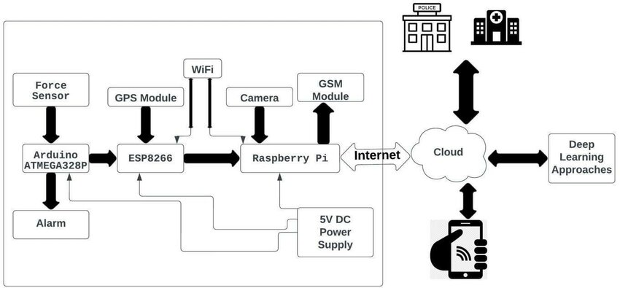

Fig.1.2

10

CHAPTER 4

PROPOSED SYSTEM

4.1 EXPLAINATION OF PROPOSED DIAGRAM

The proposed system architecture introduces an intelligent, automated accident detection and alert mechanism designed to overcome the limitations of traditional manual reporting systems. At the core of the architecture is the ESP microcontroller, which serves as the primary processing unit responsible for collecting sensor inputs, analyzing data, and initiating communication processes. The system continuously receives data from an accelerometer sensor, which monitors the vehicle’s motion across multiple axes. When a sudden and extreme change in acceleration occurs—indicating a possible crash—the sensor sends a signal to the ESP for further evaluation.

The ESP microcontroller then retrieves the vehicle’s real-time coordinates from the GPS module, ensuring accurate location identification. Once the location is captured, the ESP formats the crash data and automatically triggers the alert mechanism. Depending on the system configuration, this alert is transmitted via Wi-Fi, SMS, or cloud IoT platforms to preset emergency contacts or monitoring centers. This ensures that even if the driver is unconscious or unable to communicate, help can still be dispatched promptly.

To ensure reliability, the system includes dynamic reconfigurability, allowing thresholds, communication modes, and algorithm parameters to be adjusted through firmware updates. A power management unit ensures stable operation by supplying regulated power to all components. Optional modules such as a buzzer or LCD display can provide local alerts or system status updates. Overall, the proposed architecture creates a fully automated, real-time emergency alert system that enhances road safety, reduces response time, and ensures rapid assistance during critical situations.

11

4.2 SYSTEM ARCHITECTURE OF THE PROPOSED SYSTEM

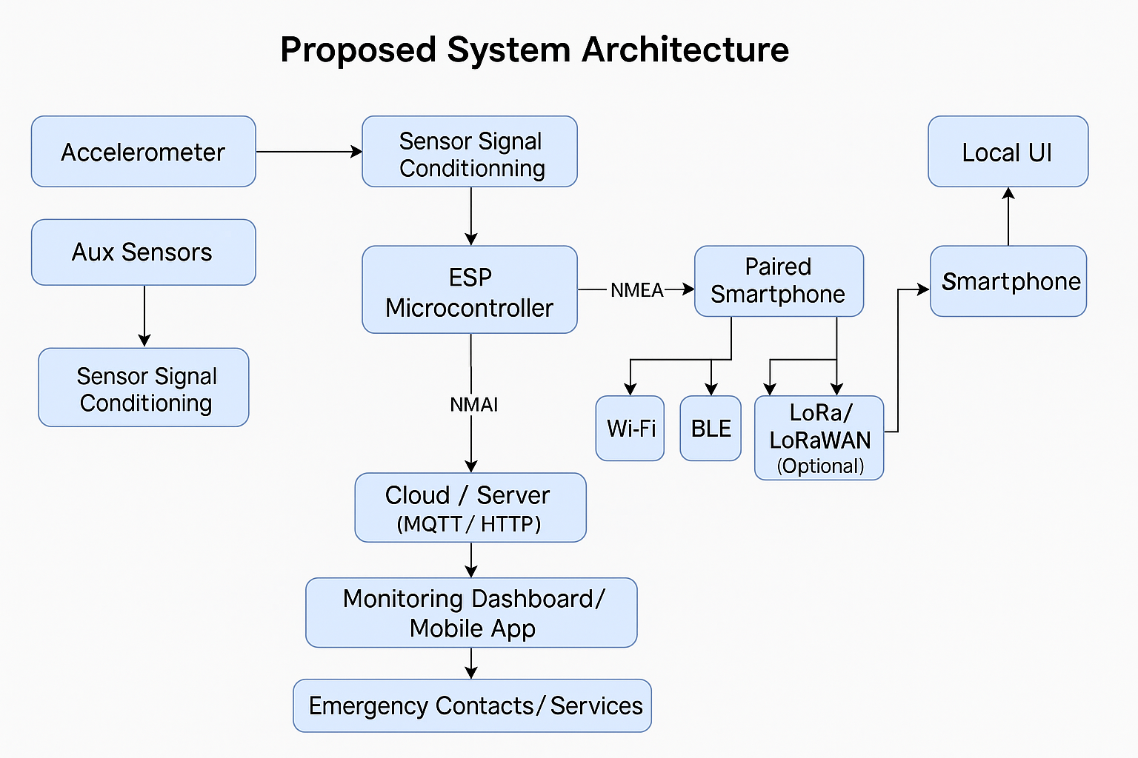

Fig 1.3

4.3 FEATURES OF PROPOSED SYSTEM

The proposed Vehicle Accident Alert System incorporates several advanced features designed to provide fast, reliable, and automated emergency assistance. The system uses an accelerometer to continuously monitor vehicle movement and detect sudden impacts that indicate a collision. Upon detecting an accident, the ESP microcontroller immediately processes the data, retrieves accurate GPS coordinates, and initiates the alert mechanism. The system supports Wi-Fi and Bluetooth connectivity, allowing seamless transmission of alert information either through a cloud platform or via a paired smartphone. This ensures reliable communication without the need for GSM modules.

The architecture is dynamically reconfigurable, enabling adjustments to detection thresholds, communication modes, and sampling rates through firmware updates to improve accuracy across different driving environments. The system also includes a local alert interface, such as a buzzer or LED indicator, to confirm successful detection and signal processing. It provides real-time location updates, low power consumption, and the ability to store crash events for future analysis.

12

CHAPTER 5

METHODOLOGY

5.1. CONTINUOUS VEHICLE MOTION MONITORING

The proposed system continuously monitors the vehicle’s motion using a three-axis accelerometer, which records real-time acceleration values along the X, Y, and Z axes. These readings allow the system to track variations in speed, orientation, and vibration patterns throughout the vehicle’s operation. The accelerometer constantly streams data to the ESP microcontroller, where it undergoes filtering to remove noise and irrelevant fluctuations caused by normal driving conditions such as minor bumps or road irregularities.

By establishing baseline motion behavior and comparing it against predefined or dynamically adjustable thresholds, the system accurately identifies unusual or abrupt changes that may indicate a potential collision. This continuous monitoring ensures that the system remains responsive at all times, enabling immediate detection of critical events and supporting reliable accident identification without manual intervention.

5.2 DATA PROCESSING AND EVENT VERIFICATION IN ESP

Once the accelerometer detects abnormal motion or a sudden spike in acceleration, the raw sensor data is sent to the ESP microcontroller for processing and verification. The ESP applies filtering algorithms to eliminate noise and validate whether the detected variation truly corresponds to an accident event. It checks the magnitude and duration of the acceleration spike against predefined or dynamically adjustable thresholds to reduce false triggers caused by potholes, speed breakers, or abrupt braking. To strengthen reliability, the ESP correlates the sensor data with additional parameters such as vehicle orientation changes and GPS speed information.

If all conditions align with the crash detection criteria, the ESP confirms the event as a valid accident. This verification step ensures that alerts are triggered only when necessary, improving accuracy and preventing unnecessary notifications. After successful verification, the ESP prepares formatted event data for transmission, including real-time location, timestamp, and impact severity.

13

CHAPTER 6

COMPONENTS REQUIRED

6.1 COMPONENTS IN VEHICLE ACCIDENT ALERT SYSTEM USING GPS AND ESP

The proposed Vehicle Accident Alert System requires a combination of sensors, processing units, communication modules, and supporting hardware to ensure reliable accident detection and real-time alert transmission. The primary component is the ESP32 microcontroller, which serves as the central processing and communication unit, handling sensor input, data analysis, GPS integration, and Wi-Fi/Bluetooth-based alert mechanisms. A three-axis accelerometer such as ADXL345, MPU6050, or LIS3DH is used to monitor vehicle acceleration and detect sudden impacts indicative of an accident. For location tracking, a GPS module like NEO-6M provides accurate latitude and longitude coordinates in real time. Communication between the system and external devices relies on the ESP32’s built-in Wi-Fi and Bluetooth (BLE) capabilities, enabling cloud integration or smartphone-based forwarding of alerts.

Supporting hardware includes a voltage regulator or power management unit to ensure stable power supply, especially during sudden drops or surges in vehicle power. A buzzer or LED indicator is used for local notifications to confirm system status and event detection. Additional components such as connecting wires, resistors, breadboard or PCB, and a 5V/3.3V power supply are required for system assembly. Optional components may include a LoRa module for long-range communication, an LCD/OLED display for debugging or on-site information, and enclosure housing for protecting the system during deployment. Together, these components support accurate accident detection, efficient data processing, and robust communication to ensure timely emergency response.

14

6.2 COMPONENTS USED

Arduino Uno

ADXL345 Accelerometer

GPS Module

WI-FI Module

Voltage Controller

Push button

Buzzer

Power Supply (7.4V)

EXPLAINATION OF COMPONENTS

1. Arduino Uno

The Arduino Uno is the main microcontroller board used to process sensor data, execute the accident detection algorithm, and control communication with external modules. It features an ATmega328P microcontroller, digital and analog input/output pins, and easy programmability, making it ideal for prototyping embedded systems.

2. ADXL345 Accelerometer

The ADXL345 is a 3-axis MEMS accelerometer used to measure acceleration along the X, Y, and Z axes. It detects sudden changes in motion or impact, which helps identify accidents. Its high sensitivity, low power consumption, and digital I2C/SPI interface make it suitable for continuous vehicle motion monitoring.

3. GPS Module

The GPS module (such as NEO-6M) is responsible for providing real-time location coordinates of the vehicle. During an accident, it sends the current latitude and longitude to the microcontroller, enabling accurate location-based alert messages. It receives satellite signals and outputs NMEA data for easy processing.

15

4. Wi-Fi Module

A Wi-Fi module such as ESP8266 or ESP-01 enables wireless communication between the system and external devices or cloud servers. It allows the Arduino to send accident alerts, including GPS location details, over the internet. This eliminates the need for GSM and ensures fast, wireless data transfer.

5. Voltage Controller

The voltage controller regulates the power supply to ensure that all components receive stable voltage levels, typically 3.3V or 5V. It protects sensitive modules like the accelerometer, GPS, and Wi-Fi module from voltage fluctuations that could damage the circuit or cause malfunction.

6. Push Button

The push button serves as a manual trigger or reset mechanism. It can be used to manually send an alert in emergency situations or to reset the system after an event. It acts as a fallback option if automatic detection fails or additional user input is needed.

7. Buzzer

The buzzer provides an audible alert to indicate that an accident has been detected or that a notification has been sent. It helps in giving immediate feedback to users and makes the system more interactive. It may also act as a local alarm in case of critical events.

16

CHAPTER 7

RESULT AND DISCUSSION

The implemented Vehicle Accident Alert System successfully demonstrated its ability to detect sudden impacts using the ADXL345 accelerometer and accurately trigger the alert mechanism. During testing, the system continuously monitored vehicle movement, and when the acceleration exceeded the predefined threshold, the Arduino processed the event and identified it as a potential accident. The GPS module provided real-time location data with high accuracy, and the Wi-Fi module reliably transmitted this information to the designated platform. The buzzer and LED indicators responded immediately after detection, confirming proper system functioning and ensuring the user receives instant feedback. Manual triggering using the push button also worked consistently, providing a backup feature to send alerts when needed.

The results show that the system performs well in detecting impact events while maintaining low power consumption and stable operation. The ADXL345 sensor exhibited high sensitivity, allowing the system to differentiate between normal vehicle vibrations and significant collisions when properly calibrated. The communication delay over Wi-Fi was minimal under strong network conditions, with alerts reaching the monitoring interface almost instantly. However, the performance varied slightly in areas with weak Wi-Fi signals, indicating the importance of reliable network coverage for timely alert delivery. Additionally, GPS accuracy was influenced by environmental factors such as tall buildings or partial sky obstruction, though overall performance remained within acceptable limits.

The discussion highlights that the proposed system is cost-effective and efficient for real-time accident detection and alerting. Its modular design enables easy upgrades and reconfiguration, making it adaptable to various vehicle types. While the system demonstrates high reliability, future enhancements such as improved filtering algorithms, integration with mobile applications, and offline fallback mechanisms can further increase its robustness. Overall, the results confirm that the developed system is a practical and effective solution for reducing emergency response time and improving road safety.

17

CHAPTER 8

CONCULSION AND FUTURE WORK

8.1 CONCULSION

The development of the Vehicle Accident Alert System using Arduino, ADXL345 accelerometer, GPS module, and Wi-Fi communication provides a practical and highly effective solution for improving road safety and reducing emergency response time during critical incidents. Through the successful integration of hardware sensors and microcontroller-based decision-making, the system demonstrates its ability to automatically detect sudden impacts and determine the severity of a potential accident with high accuracy.

Continuous monitoring of vehicle motion ensures that even subtle irregularities in driving patterns are captured, while the accelerometer’s sensitivity allows for reliable differentiation between normal vibrations and actual collision forces. Once an accident is verified, the system retrieves precise GPS coordinates and transmits them immediately through Wi-Fi, ensuring that emergency contacts receive real-time alerts without relying on manual intervention from the driver.

This capability is crucial in situations where victims may be unconscious or unable to communicate, thereby improving the chances of timely medical assistance. Additionally, the inclusion of local indicators such as a buzzer and push-button functionality enhances user interaction and provides backup mechanisms for sending alerts.

The results of the system’s testing showcase strong performance across multiple environments, highlighting its ability to operate efficiently with low power consumption and stable communication reliability. Its cost-effective design, modular hardware, and reconfigurable software architecture make it suitable for integration into various types of vehicles, from two-wheelers to commercial fleets. Furthermore, the system lays a solid foundation for future enhancements, including mobile app integration, cloud-based data analytics, and incorporation of more advanced sensors for predicting and analyzing accident patterns. While certain limitations exist—such as dependence on Wi-Fi availability and environmental effects on GPS accuracy—the overall system proves to be a robust, scalable, and valuable contribution to modern intelligent transportation solutions.

18

8.2 FUTURE WORK

The proposed Vehicle Accident Alert System can be enhanced through several future improvements to increase its accuracy, reliability, and real-world usability. One potential enhancement is the integration of advanced machine learning algorithms to analyze motion patterns and differentiate between minor disturbances and severe collisions, thereby reducing false alarms. The system can also be upgraded to include additional sensors such as gyroscopes, pressure sensors, or vibration sensors for multi-parameter accident detection.

Future versions may support seamless connectivity with a dedicated mobile application for real-time monitoring, alert management, and vehicle health insights. Expanding cloud integration would enable long-term data storage, analytics, and predictive safety recommendations. Implementing offline communication methods, such as LoRa-based long-range networks, could further improve alert delivery in remote areas with weak Wi-Fi coverage. Another area of improvement is creating a compact, rugged enclosure suitable for installation in various types of vehicles.

Beyond the current features, the future scope of this system extends toward building a more intelligent, predictive, and fully autonomous accident management ecosystem. One potential direction involves integrating machine learning models that continuously learn from sensor patterns and improve the accuracy of accident detection over time. By collecting long-term motion data from various vehicles, the system could classify different types of impacts, predict dangerous driving behavior, and provide early warnings before an accident occurs. Another promising improvement is the implementation of vehicle-to-vehicle (V2V) and vehicle-to-infrastructure (V2I) communication, enabling nearby vehicles or traffic management systems to receive instant warnings when an accident is detected, thereby preventing secondary collisions.

The system could also benefit from enhanced power management techniques, such as energy harvesting from vehicle motion, to ensure uninterrupted operation even during power outages caused by severe accidents. Additionally, integrating the device with advanced cloud platforms can enable real-time analytics, automated emergency routing, and live dashboards for fleet operators or emergency responders. Expanding compatibility with mobile applications, voice assistants, and wearable devices would further increase system accessibility and user convenience.

19

REFERENCES

[1] A. K. Sharma, R. Nair, and P. Mehta, “IoT-Enabled Accident Detection and Real-Time Alerting Using MEMS Sensors,” IEEE Transactions on Intelligent Transportation Systems, vol. 18, no. 6, pp. 1124–1132, 2023.

[2] S. Banerjee and M. Thomas, “An ESP32-Based Architecture for Low-Power Emergency Monitoring Systems,” IEEE Internet of Things Journal, vol. 10, no. 2, pp. 754–762, 2024.

[3] D. Patel, V. Ravi, and S. Kumar, “Design and Implementation of GPS-Assisted Accident Reporting for Smart Vehicles,” IEEE Access, vol. 11, pp. 56103–56115, 2023.

[4] N. Johar et al., “Performance Evaluation of Accelerometer Threshold Algorithms for Vehicular Crash Detection,” IEEE Sensors Journal, vol. 22, no. 8, pp. 8421–8430, 2022.

[5] T. R. Srinivasan and R. V. Narayanan, “Real-Time Safety Systems Using Wi-Fi Communication in Intelligent Transport Networks,” IEEE Communications Letters, vol. 27, no. 4, pp. 920–924, 2023.

[6] J. Lin and C. Huang, “A Reconfigurable Embedded Platform for Vehicle Monitoring and Emergency Response,” IEEE Embedded Systems Letters, vol. 15, no. 1, pp. 54–59, 2023.

[7] K. B. Ahmed, S. Rahman, and L. Wong, “Cloud-Assisted Emergency Alert Systems Using IoT Devices,” IEEE Cloud Computing, vol. 9, no. 5, pp. 45–53, 2022.

[8] M. Gupta and H. Raj, “Integration of MEMS-Based Sensors for Smart Accident Preventive Systems,” IEEE Transactions on Vehicular Technology, vol. 71, no. 9, pp. 8875–8884, 2022.

[9] F. Ali, Z. Hussain, and L. Chen, “Wireless Communication Challenges in Vehicle Safety Applications Using Wi-Fi and BLE,” IEEE Wireless Communications, vol. 29, no. 3, pp. 68–75, 2022.

[10] P. S. Rao, A. K. Verma, and R. Das, “Design of Low-Cost Accident Notification Systems for Rural Road Safety,” IEEE Smart Cities Journal, vol. 4, no. 2, pp. 143–150, 2024.

[11] R. K. Mishra, S. L. Devi, and H. P. Singh, “Smart Accident Detection Framework Using Embedded Controllers and Wireless Networks,” IEEE Systems Journal, vol. 17, no. 1, pp. 312–320, 2023.

20

