assignment_5

Harinath Reddy

2022-11-16

library(cdcfluview); library(dplyr)

##   
## Attaching package: 'dplyr'

## The following objects are masked from 'package:stats':  
##   
## filter, lag

## The following objects are masked from 'package:base':  
##   
## intersect, setdiff, setequal, union

library(tsibble); library(lubridate)

##   
## Attaching package: 'tsibble'

## The following objects are masked from 'package:base':  
##   
## intersect, setdiff, union

## Loading required package: timechange

##   
## Attaching package: 'lubridate'

## The following object is masked from 'package:tsibble':  
##   
## interval

## The following objects are masked from 'package:base':  
##   
## date, intersect, setdiff, union

library(fable);library(ggplot2)

## Loading required package: fabletools

library(feasts)

# Prepare the data  
usflu.raw <- ilinet("national", years = 2010:2018)  
names(usflu.raw)

## [1] "region_type" "region" "year" "week"   
## [5] "weighted_ili" "unweighted_ili" "age_0_4" "age_25_49"   
## [9] "age_25_64" "age_5_24" "age_50_64" "age_65"   
## [13] "ilitotal" "num_of_providers" "total_patients" "week_start"

usflu <- usflu.raw %>%  
 mutate(  
 date = as.Date(paste0(year, sprintf("%02d", week), "00"),  
format="%Y%W%w"),  
dec_date = decimal_date(week_start),  
week = yearweek(week_start),  
time_in_year = dec_date%%1)%>%  
 dplyr::filter(!is.na(dec_date))

## Warning in strptime(x, format, tz = "GMT"): (0-based) yday 368 in year 2014 is  
## invalid

usflu.ts <- as_tsibble(usflu, index = week)

autoplot.weighted_ili<- usflu.ts %>% autoplot(weighted_ili) + theme_minimal() +   
 labs(title="autoploy weight",  
 x="", y="weight ")  
autoplot.weighted_ili

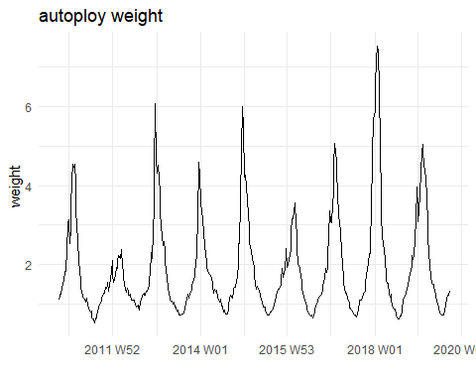

gg_season.weight <- usflu.ts %>% gg_season(weighted_ili) + theme_minimal() +   
 labs(title="seasonal weight ", x="season", y="weight ")  
gg_season.weight

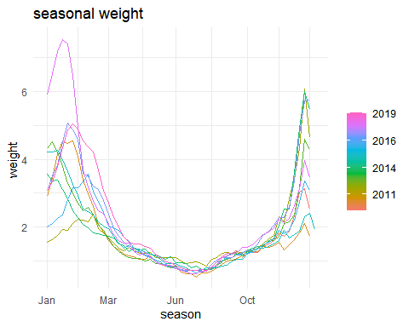

acf.weight<- usflu.ts %>% ACF(weighted_ili) %>%  
 autoplot() + theme_minimal() + labs(title="Daily new death ACF",  
 x="ACF", y="weight")  
acf.weight

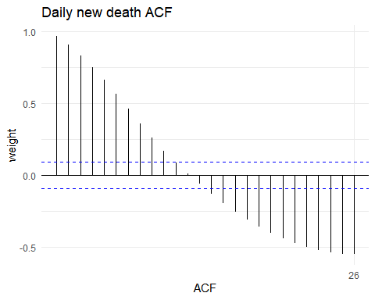

pacf.weight<- usflu.ts %>% PACF(weighted_ili) %>%  
 autoplot() + theme_minimal() + labs(title="Daily new death ACF",  
 x="PACF", y="weight")  
pacf.weight

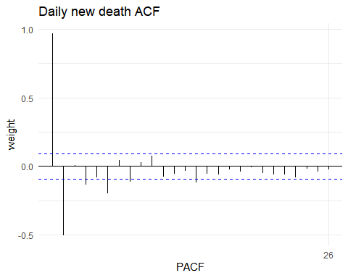

** (a) AR(1) model with ϕ1 = 0.9 and σ2 = 1.

tsibble(idx = seq_len(200), sim = 1 + arima.sim(list(ar = c(0.9)), n = 200), index = idx) %>%  
autoplot(sim) + ylab("") + ggtitle("AR(1)")

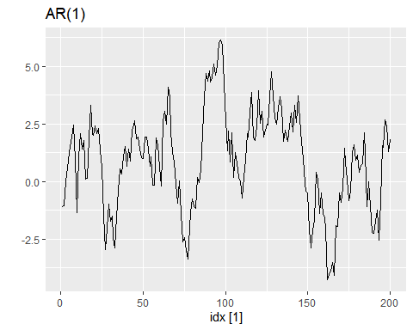

** (a) AR(1) model with ϕ1 = 0.9 and σ2 = 1.

tsibble(idx = seq_len(200), sim = 1 + arima.sim(list(ar = c(0.8)), n = 200), index = idx) %>%  
autoplot(sim) + ylab("") + ggtitle("MA(1)")

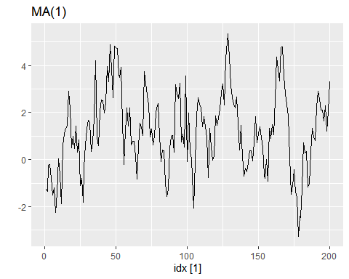

tsibble(idx = seq_len(200), sim = 1 + arima.sim(list(ar = c(0.3,-0.4)), n = 200), index = idx) %>%  
autoplot(sim) + ylab("") + ggtitle("MA(2)")

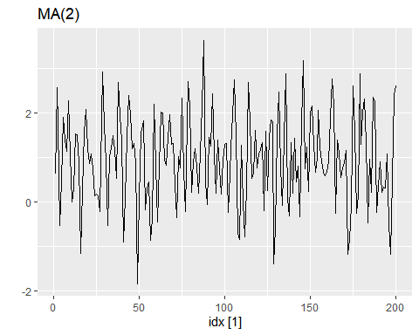

library(IDDA)  
data("state.long")

va_state<- IDDA::state.long%>%  
 filter(State=="Virginia")  
  
va_state

## # A tibble: 345 × 7  
## State Region Division pop DATE Infected Death  
## <chr> <fct> <fct> <int> <date> <int> <int>  
## 1 Virginia South South Atlantic 8517685 2020-12-31 349584 5032  
## 2 Virginia South South Atlantic 8517685 2020-12-30 344343 4982  
## 3 Virginia South South Atlantic 8517685 2020-12-29 340297 4918  
## 4 Virginia South South Atlantic 8517685 2020-12-28 336173 4857  
## 5 Virginia South South Atlantic 8517685 2020-12-27 333570 4850  
## 6 Virginia South South Atlantic 8517685 2020-12-26 329575 4833  
## 7 Virginia South South Atlantic 8517685 2020-12-25 327990 4816  
## 8 Virginia South South Atlantic 8517685 2020-12-24 323913 4788  
## 9 Virginia South South Atlantic 8517685 2020-12-23 319131 4757  
## 10 Virginia South South Atlantic 8517685 2020-12-22 314479 4701  
## # … with 335 more rows

*** splitting the data into training and testing sets also seperating data from dependent variable***

state.ts <- as_tsibble(state.long, key = State) %>%  
group_by(State) %>%  
mutate(Infected = Infected/1000) %>%  
mutate(YDA_Infected = lag(Infected, order_by = DATE)) %>%  
mutate(YDA_Death = lag(Death, order_by = DATE)) %>%  
mutate(Y.Infected = Infected - YDA_Infected) %>%  
mutate(Y.Death = Death - YDA_Death) %>%  
mutate(cum_infected = cumsum(Infected))%>%  
mutate(cum_death = cumsum(Death)) %>%  
dplyr::filter(!is.na(Y.Infected)) %>%  
dplyr::filter(!is.na(Y.Death)) %>%  
dplyr::select(-c(YDA_Infected, YDA_Death))%>%  
filter(State=="Virginia")

## Using `DATE` as index variable.

Virginia.ts <- state.ts %>%  
dplyr::filter(State == "Virginia") %>%  
dplyr::select(Infected, Death, cum_infected, cum_death, Y.Death, Y.Infected)

## Adding missing grouping variables: `State`

arima.fit <-Virginia.ts %>%  
 model(arima = ARIMA(Y.Death ~ PDQ(0,0,0)))  
report(arima.fit)

## Series: Y.Death   
## Model: ARIMA(0,1,2)   
##   
## Coefficients:  
## ma1 ma2  
## -0.6529 -0.2045  
## s.e. 0.0510 0.0500  
##   
## sigma^2 estimated as 164.6: log likelihood=-1361.58  
## AIC=2729.15 AICc=2729.22 BIC=2740.67

## Selected Model is ARIMA(0,1,2) with Log-likelyhood estimator of -1361.58 which is infact very poor.

arima.fit %>% gg_tsresiduals(lag=36)

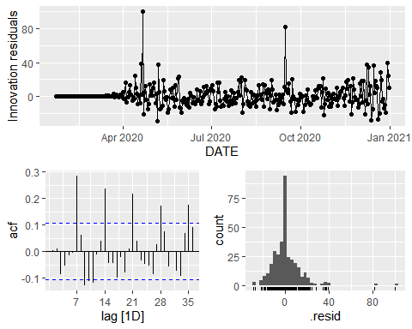

## The resudials plot seems obvious that the error terms are normally distributed.