PROJECT 2

STM32F407 Bare-Metal
Low-Power Sensor Node
RTC-triggered wake-up, accelerometer sampling and measured power behaviour
Project detail | Value
Author | R S Hari Naveen
Target board | STM32F407 Discovery, MB997-F407VGT6-E01
MCU | STM32F407VGT6
Sensor | On-board LIS3DSH accelerometer
Implementation | Bare-metal C
Report date | 3 October 2026

Project outcome
The completed firmware wakes periodically from Stop mode, takes one fresh acceleration sample, classifies orientation and tilt, sends a UART record, and returns to Stop mode. Logic-analyser and JP1 current measurements were used to verify the timing and quantify the improvement over continuously active operation.

1. Project objective and result
The goal was to build a low-power sensing cycle on the STM32F407 without hiding the hardware behind HAL calls. The application therefore configures the RCC, PWR, RTC, EXTI, NVIC, GPIO, SPI and USART registers through custom bare-metal drivers. The design was developed step by step: the RTC interrupt was first verified while the CPU was running, then normal Sleep was tested, followed by Stop mode, sensor integration, sensor power-down and finally timing and current measurements.

Completed behaviour
- The internal LSI oscillator clocks the RTC wake-up timer.
- The MCU enters Stop mode with the low-power regulator and Flash power-down enabled.
- The RTC wake-up event reaches the core through EXTI line 22 and the RTC_WKUP NVIC interrupt.
- After wake-up, the LIS3DSH is started at 100 Hz and the first sample is deliberately discarded.
- The second fresh sample is converted to mg and passed through orientation and tilt logic.
- The sensor returns to power-down, a UART line is transmitted, and the MCU re-enters Stop mode.
- PE0 is high only during application processing, providing a clean timing marker for PulseView.

Measured headline results
Metric | Measured result | Meaning
Stop current | 1.752 mA average | MCU current through JP1 while waiting
Active current | 9.63 mA average | Continuously running reference test
Active interval | 28.064 ms average | PE0-high time per wake-up
Wake period | 9.74848 s | Measured RTC interval using LSI
Duty cycle | 0.288% | Fraction of time spent active
Estimated average | 1.775 mA | Current weighted by measured duty cycle

The result is an estimated 81.6% lower MCU-domain average current than leaving the processor continuously active. The remaining average is close to the Stop-current floor, so future improvements must mainly reduce the waiting-state current rather than only increase the wake interval.

2. Hardware and firmware architecture

Hardware used
Item | Role
STM32F407VGT6 | Executes the application and enters Stop mode
LIS3DSH | Provides three-axis acceleration over SPI1
Internal LSI | Provides an always-available low-speed RTC clock
External USB-to-UART | Receives USART2 telemetry at 115200 baud
Logic analyser | Measures the PE0 active pulse and wake period
Multimeter at JP1 | Measures the MCU supply current

Key pin assignments
Function | Pin | Notes
USART2 TX | PA2 | Connect to USB-to-UART RX
USART2 RX | PA3 | Optional for this transmit-only demonstration
SPI1 SCK/MISO/MOSI | PA5/PA6/PA7 | On-board accelerometer interface
LIS3DSH chip select | PE3 | Software-controlled active-low CS
MCU active marker | PE0 | High while awake, low in Stop mode
User LEDs | PD12 to PD15 | Status/error indication

Firmware layers
- Application layer: `Src/Project2.c` owns the wake-sense-report-sleep state sequence.
- Sensor and processing layer: `lis3dsh.c`, `orientation.c` and `motion_detection.c` provide acquisition, conversion and classification.
- Board layer: `board.c` maps peripherals and pins to the Discovery hardware.
- Register-driver layer: custom GPIO, SPI, USART, RCC, RTC and PWR drivers operate directly on peripheral registers.
- Startup and linker files: provide the vector table, reset path and STM32F407 memory layout.

3. Low-power execution flow
- Initialization configures USART2, board LEDs, SPI1, the LIS3DSH, the orientation and tilt filters, and PE0 as a push-pull output.
- The LIS3DSH is placed in power-down mode before the first wait interval.
- The backup domain is unlocked, LSI is enabled and selected as the RTC clock, and the wake-up timer is loaded.
- The RTC wake-up event is unmasked on EXTI line 22, rising-edge detection is enabled, pending flags are cleared, and RTC_WKUP is enabled in the NVIC.
- The application sets SLEEPDEEP and executes WFI. The core and high-speed clocks stop while the RTC continues from LSI.
- The RTC event sets WUTF and EXTI pending state. RTC_WKUP_IRQHandler clears the flags and increments the shared wake counter.
- Execution continues after WFI. The main loop detects the changed counter and raises PE0.
- The accelerometer is restarted at 100 Hz. The first sample is read and discarded, then the next data-ready sample is used.
- Orientation and tilt are calculated, the sensor is powered down, and one formatted UART record is sent.
- PE0 is driven low and the loop enters Stop mode again.

Why EXTI line 22 is involved
On the STM32F407, the RTC wake-up source is internally connected to EXTI line 22. This is not a physical GPIO pin. The RTC can set its wake-up flag, but the event reaches the interrupt controller only after the EXTI interrupt mask and edge selection are configured. The vector-table handler name must be `RTC_WKUP_IRQHandler` because that exact symbol is referenced by the device startup file.

Stop-mode entry sequence
PWR->CR &= ~PWR_CR_PDDS; // Select Stop, not Standby
PWR->CR |= PWR_CR_LPDS; // Use the low-power regulator
PWR->CR |= PWR_CR_FPDS; // Power down Flash in Stop
SCB_SCR |= SCB_SCR_SLEEPDEEP; // Make WFI enter deep sleep
__asm volatile ("dsb" ::: "memory");
__asm volatile ("wfi");
__asm volatile ("isb" ::: "memory");
`DSB` ensures that earlier memory operations finish before sleep. `WFI` waits for an enabled interrupt and performs the low-power entry. `ISB` makes the processor discard prefetched instructions and continue with the correct execution context after wake-up. SLEEPONEXIT remains clear because the program must return from the handler to the main loop and run the sensor-processing work.

4. RTC timing and sensor data quality

Wake-up timer calculation
The code selects `RTCCLK/16` as the wake-up timer clock and writes 19999 to WUTR. With a nominal 32 kHz LSI, the timer clock is approximately 2 kHz. The counter period is therefore approximately `(19999 + 1) / 2000 = 10 seconds`. The measured period was 9.74848 seconds because LSI is an internal RC oscillator and its actual frequency varies with device, voltage and temperature.

Why the first accelerometer sample is discarded
The accelerometer is powered down between wake-ups. When its output data rate is enabled again, the first available output can reflect the restart transient or old pipeline state. Reading and discarding that value, waiting for the next data-ready event, and then using the second value gives the application a fresh sample without weakening the orientation filter.

Orientation and tilt processing
Raw 16-bit axis readings are converted to milligravity units before classification. Orientation uses the dominant gravity axis and magnitude checks. A small two-sample filter was selected so the result becomes stable quickly after each isolated wake-up. Tilt uses separate activate and release thresholds, which creates hysteresis and prevents a direction from rapidly switching near its boundary. When the sample is classified as moving, tilt is reported as level because a reliable gravity direction is not available during motion.

Data-ready protection
Both sample waits use a finite timeout. This avoids a permanent lock-up if the sensor does not assert data-ready. Initialization, RTC programming and sensor power-down are also checked. A failure lights the red LED, reports an error when possible, and stops the normal sequence so that a hardware or configuration problem is visible rather than silently ignored.

Example UART record
Wake=14, X=-296 mg, Y=-21 mg, Z=935 mg, O=FACE UP, T=RIGHT
The wake counter proves that repeated RTC interrupts are occurring. X, Y and Z show the converted acceleration values. `O` is the stable orientation classification and `T` is the tilt direction. USART2 runs at 115200 baud with 8 data bits, no parity and one stop bit.

5. Timing verification
PE0 was connected to logic-analyser channel 0 and named `MCU_ACTIVE`. The pin is set high immediately after a new RTC wake count is detected and is cleared after acquisition, processing and UART transmission. The low interval therefore represents the time spent waiting in Stop mode, while the high pulse represents the useful active work.
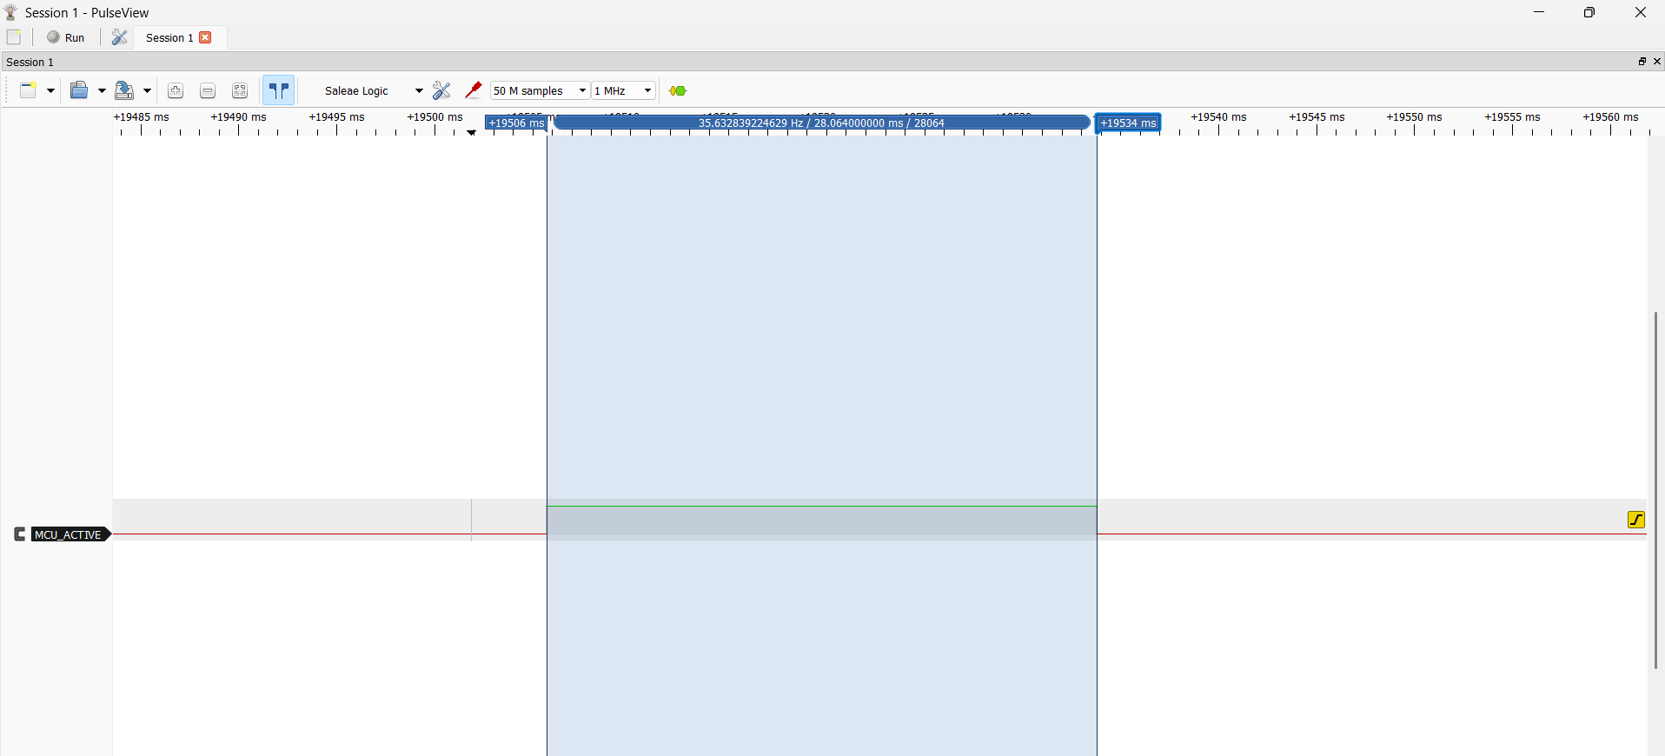
Figure 1. Representative PE0 active pulse: 28.064 ms.
Capture | Active time
1 | 28.064 ms
2 | 28.048 ms
3 | 28.080 ms
4 | 28.064 ms
5 | 28.064 ms
Average | 28.064 ms

The five captures are tightly grouped within 0.032 ms. This is consistent with a deterministic bare-metal path: the same sensor waits, conversions and blocking UART transmission are performed during every successful wake-up.

6. Wake-period and current results
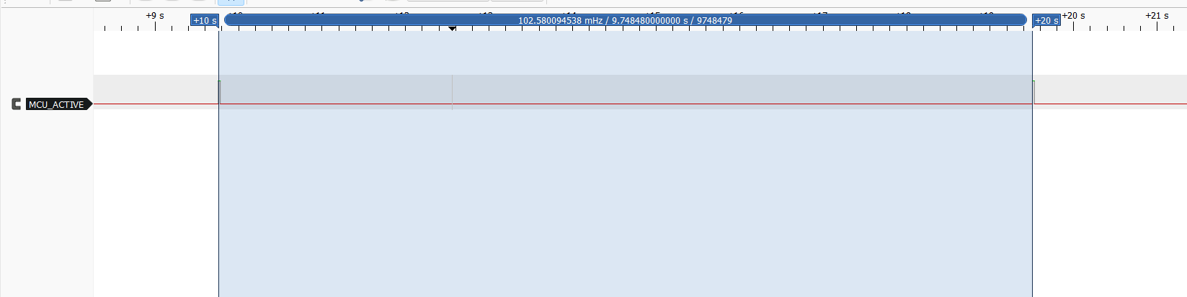
Figure 2. Measured interval between active pulses: 9.74848 s.

Raw current readings
Test | Readings | Average
Stop mode | 1.75, 1.76, 1.75, 1.75, 1.75 mA | 1.752 mA
Continuously active | 9.62, 9.64, 9.63, 9.62, 9.64 mA | 9.63 mA

Duty cycle and weighted average
Duty cycle = 0.028064 s / 9.74848 s = 0.002879 = 0.288%
Iavg = 1.752 + (9.63 - 1.752) x 0.002879 = 1.775 mA
Reduction = (9.63 - 1.775) / 9.63 x 100 = 81.6%
The calculation uses the measured period rather than assuming exactly ten seconds. Since the MCU is active for only 0.288% of the cycle, the weighted average is only slightly higher than the measured Stop current.

Simplified battery-life comparison
Operating case | Estimated MCU current | Ideal life with 2000 mAh
Continuously active | 9.63 mA | 8.65 days
1 s wake interval | 1.973 mA | 42.2 days
5 s wake interval | 1.796 mA | 46.4 days
Measured 9.748 s interval | 1.775 mA | 46.9 days

At 80% usable battery capacity, the measured case corresponds to about 37.5 days. This is a comparison model, not a complete board prediction: regulator losses, battery self-discharge and all current outside the JP1 MCU path are excluded. The comparison also shows diminishing returns beyond about five seconds because the Stop-current floor dominates.

7. Functional evidence and validation
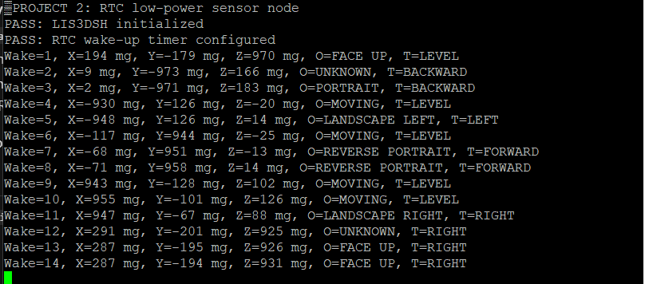
Figure 3. UART output showing repeated wake counts, acceleration, orientation and tilt.

Validation checklist
Check | Result
LIS3DSH identity and initialization | Passed
RTC wake-up while CPU is running | Passed
Normal Sleep wake-up | Passed
Stop-mode wake-up | Passed
Repeated RTC interrupts | Passed
Fresh sensor sample after wake | Passed
Orientation and tilt output | Passed
Sensor power-down between samples | Passed
PE0 timing measurement | Passed
Stop and active current measurements | Passed

8. Practical lessons and limitations

What required the most care
- RTC wake-up needs four pieces to agree: RTC WUTF generation, EXTI line 22, the NVIC enable, and the exact vector-table handler name.
- A pending flag must be cleared at the source and at EXTI. Clearing only one can cause one-shot behaviour or repeated immediate entries.
- Live Expressions show meaningful peripheral values only while the target is halted and the debugger can read the core; values can appear as zero or fail to evaluate while the core is sleeping or running.
- A multimeter must replace the JP1 jumper in series. If that connection opens while JP1 is removed, the MCU simply loses its supply path; secure clips are safer than holding probes by hand.
- The logic-analyser marker should be a dedicated pin. Leaving PE0 in the final build has negligible conceptual impact and makes the project easy to demonstrate and profile again.

Known limitations
- LSI is not a precision timebase, so the nominal ten-second interval varies. LSE or calibration should be used when accurate long-term timing matters.
- UART transmission is blocking and remains inside the active window. DMA or buffered transmission could reduce CPU involvement.
- The measured Stop current is much higher than the STM32's best-case silicon figure because this is a Discovery-board experiment and the firmware does not yet disable every board-level leakage path or unused peripheral clock.
- The battery estimate uses JP1 MCU current. It is not a full-system energy measurement and does not include all board components.
- The sensor is sampled periodically, so activity that starts and finishes between wake-ups can be missed. A sensor interrupt would be more appropriate for continuous event capture.

Possible next improvements
- Measure the complete board current with a source-measure unit or current profiler.
- Disable unused clocks and place unused GPIO pins into an explicitly low-leakage state.
- Use LSE for more accurate intervals if a 32.768 kHz crystal is fitted and verified.
- Use the LIS3DSH interrupt engine for motion-triggered wake-up and keep periodic RTC wake-up as a health check.
- Replace blocking UART output with a shorter binary packet or DMA-backed transmission.

9. Technical Project Summary
I built a bare-metal low-power sensor node on an STM32F407 Discovery board. The MCU normally stays in Stop mode with the low-power regulator and Flash power-down enabled. The internal LSI clocks the RTC wake-up timer. About every 9.75 seconds, the RTC generates a wake event through EXTI line 22 and the RTC_WKUP interrupt. The handler clears the RTC and EXTI flags and increments a counter, then execution returns to the main loop after WFI.
During the active window, I raise PE0 so I can measure the work with a logic analyser. I restart the LIS3DSH at 100 Hz, discard the first sample after power-up, wait for the next data-ready event, and use that fresh sample for orientation and tilt classification. I then return the sensor to power-down, send one UART record and drive PE0 low before entering Stop mode again.
I measured an average active window of 28.064 ms and a 9.74848-second cycle, giving a duty cycle of 0.288%. The MCU current was 1.752 mA in the Stop interval and 9.63 mA in the active reference test. Weighting those measurements by the duty cycle gives about 1.775 mA average, which is 81.6% below continuous operation. The result also taught me that after the active time becomes very small, the Stop-current floor matters more than making the interval longer.

Design Decisions and Rationale
Design question | Technical explanation
Why use WFI? | It lets the core enter the selected sleep state and resume only for an enabled interrupt.
Why is SLEEPDEEP set? | Without it, WFI enters normal Sleep rather than Stop mode.
Why is EXTI line 22 used? | The RTC wake-up source is internally routed to that EXTI line on STM32F407.
Why clear WUTF and EXTI PR? | They are separate pending indications; both must be acknowledged for reliable repeated wake-ups.
Why discard the first sample? | The sensor has just restarted, so the next completed conversion is a safer fresh measurement.
Why does 19999 mean about 10 s? | At nominal 32 kHz LSI and RTCCLK/16, the counter sees about 2 kHz and counts 20,000 ticks.
Why is the measured period not exactly 10 s? | LSI is an untrimmed RC oscillator and its actual frequency differs from the nominal value.
What dominates average current? | The Stop-current floor, because active duty is only 0.288%.

10. Reproducing the demonstration
- Import the repository as an existing STM32CubeIDE project and build it.
- Keep `ACTIVE_CURRENT_TEST` at `0U` for the final low-power firmware.
- Flash the board through the on-board ST-LINK and terminate the debug session.
- Connect PA2 to the USB-to-UART adapter RX and connect grounds. Use 3.3 V logic and 115200-8-N-1.
- Connect logic-analyser channel 0 to PE0 and label the channel MCU_ACTIVE.
- Capture several cycles. Measure high-pulse width for active time and rising-edge spacing for the wake period.
- For JP1 current measurement, disconnect power, remove JP1, connect the ammeter securely across the two JP1 pins, select the mA range, and reconnect power.
- Record multiple stable readings. Do not change the meter range or move leads while the circuit is powered.
- Restore the JP1 jumper after the measurement so the MCU supply path is not accidentally left open.

Repository map
Path | Purpose
Src/Project2.c | Final wake-sense-report-sleep application
Src/lis3dsh.c | Accelerometer configuration, sampling and power-down
Src/orientation.c | Orientation filter and names
Src/motion_detection.c | Tilt detection with hysteresis
drivers/Src/stm32f407xx_rtc_driver.c | LSI, RTC wake timer, EXTI and interrupt handling
drivers/Src/stm32f407xx_pwr_driver.c | Sleep and Stop entry
docs/MEASUREMENTS.md | Raw measurements and calculations

Primary references
- STMicroelectronics, RM0090: STM32F405/415, STM32F407/417, STM32F427/437 and STM32F429/439 reference manual.
- STMicroelectronics, STM32F407xx datasheet.
- STMicroelectronics, UM1472: Discovery kit with STM32F407VG MCU user manual.
- STMicroelectronics, LIS3DSH MEMS digital output motion sensor datasheet.

Conclusion
The project is complete as a working and measured bare-metal low-power demonstration. It does more than enter Stop mode: it proves repeated RTC wake-up, manages the accelerometer around each sample, produces understandable telemetry, and connects the firmware behaviour to real timing and current measurements.

