STM32F407 Motion Logger Project Report
Bare Metal and FreeRTOS Implementations
R.S. Hari Naveen
STM32F407 Discovery and LIS3DSH
October 2026

Project Summary
I developed a motion logger for the STM32F407 Discovery board in two stages. The first version uses a bare-metal superloop. The second keeps the same sensor, motion-processing and communication features but divides the work into FreeRTOS tasks. The application reads the onboard LIS3DSH over SPI, reports acceleration and orientation through USART2, drives the four board LEDs according to tilt, and uses the sensor hardware state machine for double-tap detection.
The main goal was to practise peripheral drivers and asynchronous communication first, then understand how queues, semaphores, mutexes and task scheduling change the structure of an embedded application. I validated the final FreeRTOS design with an approximately one-hour variable-rate soak test and captured SPI and UART activity using PulseView.

Project Specifications
Item | Implementation
Microcontroller | STM32F407VGT6 Cortex-M4F
Development board | STM32F407 Discovery
Motion sensor | Onboard LIS3DSH three-axis accelerometer
Sensor interface | SPI1 mode 3
Terminal interface | USART2 at 115200 8-N-1
UART data movement | Interrupt-driven RX and queued DMA TX
Supported ODR | 25, 50, 100 and 400 Hz
Firmware versions | Bare-metal superloop and CMSIS-RTOS2 FreeRTOS

Hardware Connections
Function | STM32 pin | Purpose
LIS3DSH chip select | PE3 | Selects the onboard sensor
SPI1 clock | PA5 | Sensor serial clock
SPI1 MISO | PA6 | Sensor data to MCU
SPI1 MOSI | PA7 | MCU command data to sensor
LIS3DSH INT1 | PE0 | Double-tap event through EXTI0
USART2 TX | PA2 | Telemetry and CLI responses
USART2 RX | PA3 | CLI commands
Board LEDs | PD12 to PD15 | Tilt direction and tap indication

Shared Firmware Modules
The sensor and communication modules were designed so that most of them could be reused in both scheduling models.
Module | Responsibility
lis3dsh | Register access, XYZ burst reads, mg conversion, ODR changes and tap-state-machine setup
orientation | Filtering and face-orientation classification
motion_detection | Tilt thresholds, direction flags and display names
cli | Line parsing, runtime commands and formatted responses
uart_async | RX ring buffer, framed TX queue and DMA completion handling
board | LED and board-level setup
Custom drivers | Register-level RCC, GPIO, SPI and USART support

Bare Metal Implementation
The bare-metal program initializes USART2, DMA, SPI1, the LEDs, LIS3DSH and EXTI0 before entering one cooperative superloop. Each pass consumes available CLI bytes, processes pending tap events and checks the sensor data-ready flag. When a sample is ready, the program reads and converts it, updates orientation and LEDs, and periodically queues a telemetry frame.
I kept the interrupt routines short. The MEMS interrupt records an event, the UART interrupt stores an incoming byte, and the DMA interrupt completes one frame and starts the next. The main loop performs the SPI register access needed to clear the sensor interrupt.

Bare Metal Runtime Sequence
- Initialize the asynchronous UART path and SPI sensor interface.
- Configure the LIS3DSH hardware double-tap state machine and EXTI0.
- Consume all UART bytes currently available to the CLI parser.
- Clear each pending LIS3DSH tap source and update the tap indication.
- Poll data-ready, read XYZ, convert to mg and update orientation.
- Queue telemetry at approximately ten frames per second.

FreeRTOS Implementation
The FreeRTOS version separates acquisition, processing, telemetry and command handling. It uses CMSIS-RTOS2 objects generated through STM32CubeIDE.
Task | Priority | Stack | Responsibility
Sensor | Normal | 1,024 B | Read LIS3DSH, queue samples and service tap events
CLI | Normal | 2,048 B | Consume UART RX bytes and execute commands
Processing | Below normal | 1,024 B | Convert samples, update state and drive LEDs
Telemetry | Below normal | 2,048 B | Format and queue frames every 100 ms
Default monitor | Low | 1,024 B | Record heap and task stack headroom

Synchronization
Sensor queue. The sensor task sends complete raw XYZ samples through an eight-element queue. The processing task blocks on the queue, converts each sample and updates the shared application state. A failed non-blocking put increments the queue-drop counter.
Tap semaphore and thread flag. EXTI0 releases a binary semaphore instead of performing SPI access in the callback. The sensor task takes the semaphore, clears the sensor source and sets a tap flag for the processing task, which controls the all-LED indication.
Sensor mutex. The CLI and acquisition task can both access the LIS3DSH. The mutex protects register reads and ODR/tap-timing updates from overlapping normal acquisition.
UART mutex. The CLI and telemetry tasks both submit complete frames to the asynchronous TX queue. The mutex gives the queue one producer at a time while the DMA interrupt advances completed frames.

UART and Command Interface
USART2 runs at 115200 baud. RXNE interrupts copy bytes to a 256-byte ring buffer. A task or the superloop removes those bytes and passes them to a line-oriented parser. TX messages are copied into an eight-entry frame queue and sent by DMA1 Stream 6. Counters record received bytes, overflow, queued frames, completed DMA transfers, errors and queue-full events.

Available Commands
help
read
status
rate 25|50|100|400
monitor on
monitor off
clear
The rate command changes the LIS3DSH ODR and the timing values used by the hardware tap state machine. During the update, the firmware disables EXTI0, waits for the new settings, clears the latched sensor source and pending interrupt state, and then enables EXTI0 again. This removed the false tap that previously appeared after reset or an ODR change.

Build Verification
The warning-cleanup pass resolved naming collisions between the register-level driver definitions and CMSIS/HAL definitions by applying a CUSTOM prefix to the custom peripheral and bit-position macros. Include paths and source locations were then corrected independently for Debug and Release.
Firmware | Configuration | Final build
FreeRTOS | Debug | 0 errors and 0 warnings
FreeRTOS | Release | 0 errors and 0 warnings
Bare metal | Release | 0 errors and 0 warnings

One Hour Soak Test
The FreeRTOS firmware ran for approximately one hour while continuous telemetry, CLI access, orientation processing and hardware tap detection remained active. The sensor rate changed during the run to exercise normal and high-load conditions.
Interval | ODR | Activity
0 to 10 min | 25 Hz | Telemetry, CLI checks and five accepted tap events
10 to 20 min | 50 Hz | Telemetry, CLI checks and five accepted tap events
20 to 35 min | 100 Hz | Normal operation and ten accepted tap events
35 to 55 min | 400 Hz | High acquisition load, movement and ten accepted tap events
55 to 60 min | 100 Hz | Recovery, final commands and five accepted tap events

Final Soak Test Results
Measurement | Result | Interpretation
Sensor reads | 506,818 | Samples read from LIS3DSH
Samples delivered and processed | 506,816 | Queue send, receive and processing counts agree
Sensor queue drops | 2 | Two reads were not accepted by the RTOS queue
UART frames queued | 33,475 | Application and CLI frames accepted
UART DMA completions | 33,475 | Every accepted frame completed
Telemetry frames dropped | 0 | No application telemetry loss
DMA errors and queue full | 0 and 0 | No transmit-path fault
UART RX overflow | 0 | RX ring buffer remained within capacity
Current and minimum free heap | 6,864 B | No observed heap erosion
Stack overflow and malloc failure | 0 and 0 | Both diagnostic hooks remained clear
Tap ISR and processed count | 35 and 35 | All recorded tap events reached task processing

The counter relationship was 506,818 sensor reads = 506,816 processed samples + 2 queue drops. The resulting queue delivery rate was approximately 99.9996 percent. These two upstream sample drops are different from UART telemetry-frame drops, which remained at zero.
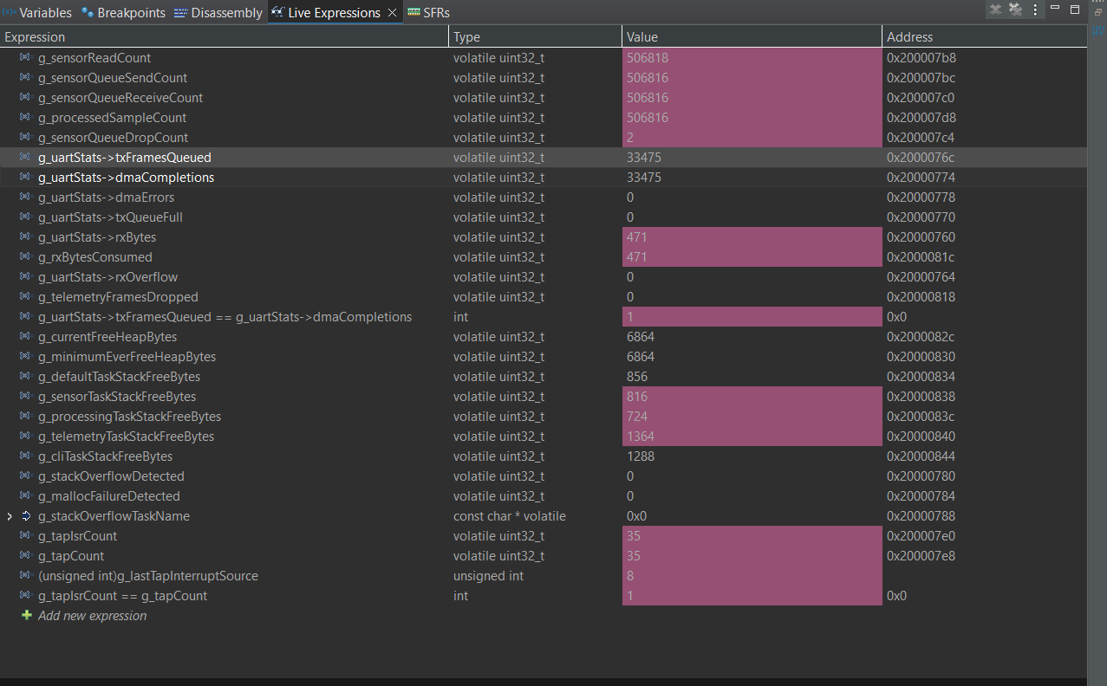
Figure 1 Final FreeRTOS live-expression counters after the soak test

Task Memory Headroom
Task | Free stack at final checkpoint
Default monitor | 856 bytes
Sensor | 816 bytes
Processing | 724 bytes
Telemetry | 1,364 bytes
CLI | 1,288 bytes

All monitored task stacks retained headroom. Current and minimum-ever free heap both remained at 6,864 bytes, and neither the stack-overflow hook nor the allocation-failure hook fired.

Manual Double Tap Test
I performed a separate short manual test after the soak run and recorded the number of physical attempts. No false-positive tap was observed during normal manual use.
ODR | Detected | Attempts | Rate | Misses
25 Hz | 10 | 19 | 52.6% | 9
50 Hz | 10 | 14 | 71.4% | 4
100 Hz | 15 | 17 | 88.2% | 2
400 Hz | 15 | 16 | 93.8% | 1
Total | 50 | 66 | 75.8% | 16

Detection improved at 100 and 400 Hz, where the sensor samples the tap waveform more frequently. At 25 and 50 Hz, taps needed to be slower and more distinct. Since force, position and timing were not controlled, these values are practical observations rather than a laboratory characterization.

Logic Analyzer Evidence
PulseView recordings were made for both implementations at an 8 MHz sampling rate. SPI was decoded in mode 3 and UART at 115200 8-N-1. The raw recordings and decoder setup files are included with the repository.
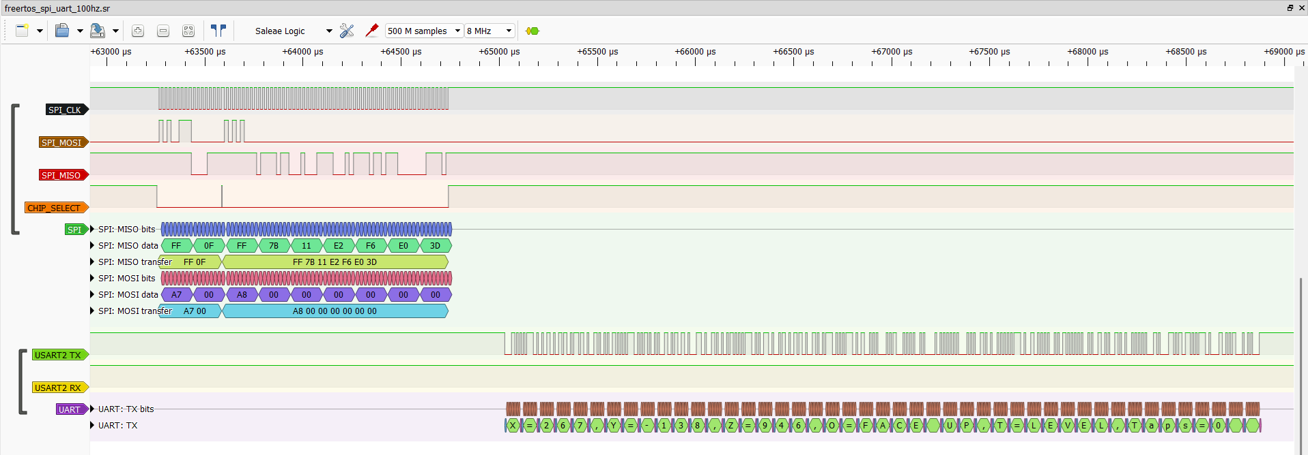
Figure 2 FreeRTOS SPI sensor access and UART telemetry in the same acquisition
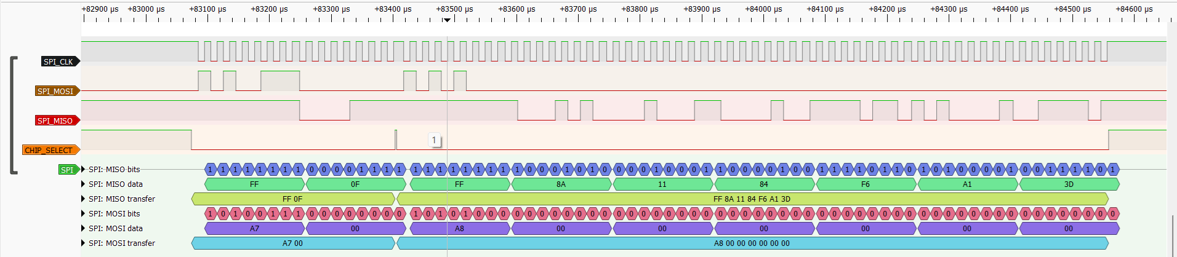
Figure 3 FreeRTOS LIS3DSH register and XYZ burst transfers

Bidirectional UART Capture
The RX close-up shows the word read sent from PuTTY to the STM32. The TX close-up shows the formatted acceleration response returned by the firmware. Capturing both pins confirms that the interface is bidirectional rather than telemetry-only.
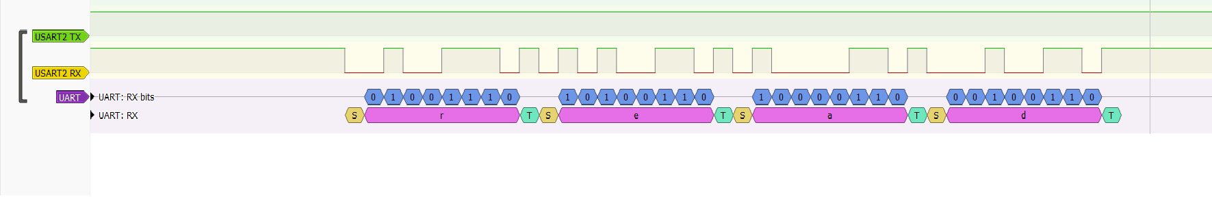
Figure 4 USART2 RX decoding of the read command
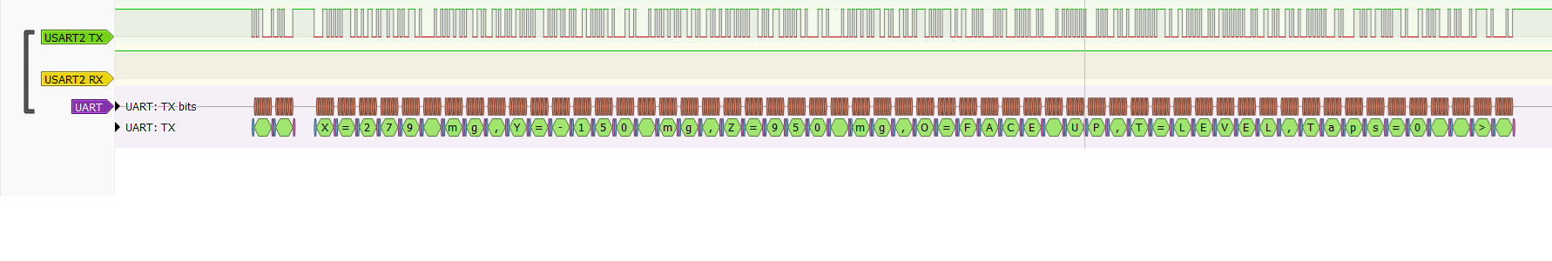
Figure 5 USART2 TX decoding of the sensor response

Bare Metal Capture
The bare-metal session was captured with the same pin mapping and 8 MHz sampling. The supplied close-up shows an 0xA7 status-register read, while the complete raw session retains the surrounding sensor and UART traffic.
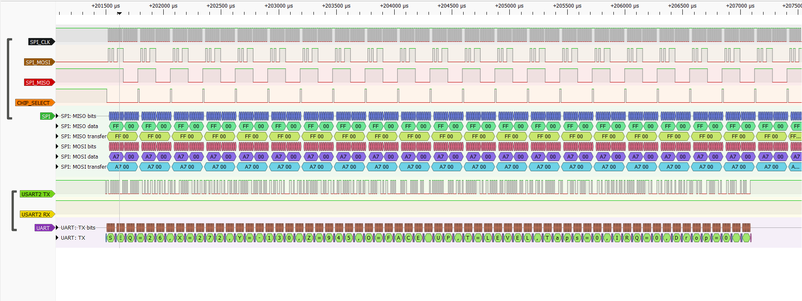
Figure 6 Bare-metal SPI polling and UART telemetry at 100 Hz ODR

Discussion
The conversion to FreeRTOS did not require a new sensor algorithm. The important work was assigning ownership. The sensor task became the normal owner of SPI, the processing task owned conversion and LED output, and the telemetry and CLI tasks shared the UART queue through a mutex. The semaphore and thread flag kept interrupt work short while still delivering the tap event to the correct task.
The validation counters were as important as the scheduling objects. They showed that both ends of the sensor queue agreed, every accepted UART frame reached a DMA completion, and memory headroom remained stable. They also exposed the two sensor queue drops, which would not have been visible from the terminal output alone.

Limitations and Future Work
- Repeat the tap test with a controlled mechanical fixture so force, spacing and contact position are consistent.
- Investigate the two queue drops around variable-rate or high-load operation and evaluate whether queue depth or task scheduling should change.
- Add automated host-side tests for orientation thresholds, CLI parsing and telemetry formatting.
- Measure end-to-end sample latency with an extra timing GPIO if the application is extended toward real-time control.

Conclusion
The project produced working bare-metal and FreeRTOS versions of the same motion-logging application. Both versions use asynchronous UART communication and LIS3DSH hardware double-tap detection. The FreeRTOS version adds explicit task separation, queue-based sample transfer and synchronized peripheral access. The final evidence supports warning-free builds, stable UART operation, bounded memory use and processing of all but two of more than half a million sensor reads during the long-run test.

