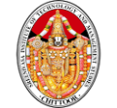 

**SREENIVASA INSTITITUE OF TECHNOLOGY AND MANAGEMENT STUDES**

**(SITAMS)**

**“A” GRADE – AUTONOMOUS – NAAC ACCREDITED**

**Approved by AICTE, New Delhi**

Permanently Affiliated to JNTU, Ananthapuramu **Dr.D.K.Audikesavulu Marg (Bangalore-Tirupathi Bye-pass Road) Murukambattu, Chittoor –517 127. (A.P.) Ph.: 08572-246298 / 246299;**

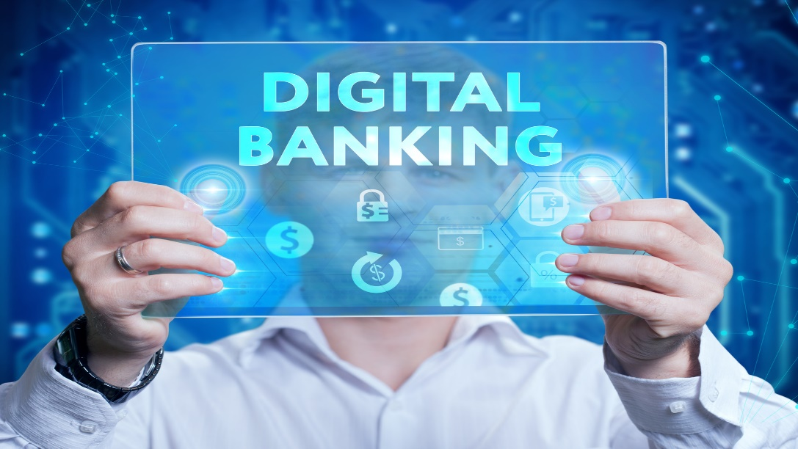

**NATIONAL SEMINAR ON**

**“DIGITAL BANKING : ISSUES AND CHALLENGES”**

**on 30th March, 2019**

**Sponsored by ICSSR, Hyderabad**

**ABOUT THE COLLEGE:**

Sreenivasa Institute of Technology and Management Studies (SITAMS) was established in the year 1998-99 under Sreenivasa Trust by a prominent industrialist late Dr.D.K. Audikesavulu, Ex.M.P, Former TTD Chairman. Over the last 19 years, SITAMS has made a remarkable progress in teaching, research and consultancy in the field of technical education and management studies under the Chairperson Smt. D.A.Sathyaprabha (W/o Late Dr.D.K.Audikesavulu), MLA, Chittoor. SITAMS, a pioneer of value based education, offers both U.G. (ECE, CSE, EEE, Civil, & Mechanical) and P.G. (MBA, MCA & M.Tech.), courses under JNTUA, Ananthapuramu and is approved by AICTE, New Delhi. The college got 2(f) and 12(b) status by the UGC in the year 2013, Autonomous in the year 2013-14 and NAAC accredited. The Institute is headed by the able administrator Dr.P.Ramesh Kumar, M.E., Ph.D., Principal

**Location and Access:**

SITAMS is located at a distance of 5 Kms. from Chittoor Town,

near Murukambattu in Banglore-Tirupati By-pass road.

**Who should attend?**

Students from MBA

**THEME**

**(a) Background:**At presenttechnology and banking are inseparable now in India. The transformation from brick and mortar banking to technology driven banks has been fairly rapid during the last twenty-eight years. Economic liberalization and the integration with international best practices in banking and finance gave the much needed push to a largely stagnating computerization programme.

Digital Banking may be viewed as adoption of various existing and emerging technologies by the banks with associated changes in internal operations as well as external relationships for providing superior customer services and experiences effectively and efficiently. Today in a digital world, the chaiwala accepts wallet payment without a fuss and a man buys a note books worth about Rs.200 for his son using a credit card. The new innovative digital technologies and futuristic thought processes have given birth to whole new businesses and social dimensions. Projects such as Make in India and Digital India are now the buzzwords to a bright and sustainable industrial and financial progress of our nation. As part of its impetus for Digital Transformation (DT) in India, Government also encourages technology adoption/upgradation while providing connectivity with high speed bandwidth to each and every region of India. This has exposed the full potential of the hitherto untapped market in India. Latest technology and service offerings in the new age Digital Payments space by the Banks, such as UPI including BHIM, BPSS, mobile money, e-wallets, payment aggregation etc. have created a revolution by themselves. At present, transition and Interoperability related issues viz. from traditional banking to state of the art digital banking such as data integrity, authentication (including third party authentication) and trust factors in a digital banking environment are gaining importance. Digital banking provides mission critical solutions to bankers for their short term and long term business and technological requirements. Today, aspects such as enhanced customer satisfaction and value through unified customer experiences, faster output, infinite banking volumes, financial inclusion, operational efficiencies, scale of economy etc. are being sought after, by leveraging digital banking and mobile technologies. Becoming a digital bank can improve efficiency and provide a better customer experience

E-commerce and M-commerce success is largely attributed to the phenomenal growth of various digital payment technologies such as card payments, electronic fund transfers, payment gateways, e-payments, smart cards, mobile money wallets etc. Pivotal to embracing such new age payment systems are the people, technologies, and processes that have together created vast, robust and dependable networks and seamless systems that guarantee humongous transactional volumes at breakneck speed, with dependable security and counterchecks built around them. All these and rest are taking India to the threshold of the big league and to make the country battle ready to compete with the most influential industrial and financial powers of global businesses. With digital banking and mobility, the need is no longer to “leapfrog” but to “deep-dive” into the future. Today’s challenging digital payments ecosystem has become a burgeoning marketplace. Banks have already started evaluating the reduction in number and size of branches. In addition, the investment in digital technology to replace more expensive human interactions is also being considered. This includes, but not limited to, tablets for universal bankers, ATMs and digital kiosks to facilitate account opening and customer inquiries. To be successful in a digital environment, banks focus on improving their digital maturity across various dimensions of customer service.

Banks are now increasingly worrying about their very bastions being co-shared by a string of new age players. And the end-customer is the single largest beneficiary – with a bouquet of services and service providers to choose from and along with hugely competitive pricing models. Banks will have to increase their operational efficiency and improve the customer experience by meeting the customers’ expectations swiftly in order to keep their position in core markets. The level of automation and digitalization of the account opening and on-boarding process has become very vital. The most important aspect is to improve the ability for consumers to open any new account using digital channels and to efficiently on board the new customer digitally. In this area, traditional banks still differ strikingly from the new market players who offer a convenient end to end online process. Banks are forced set a goal to improve the individual customer experience. The level of enhanced security available to protect identity and funds access is equally important. Identity protection and account security will continue to be the focus area as hacking incidents become more sophisticated and widespread.

Cyber security risks, device and account level fraud, adoption of technology and convincing the customers to opt for self-service modes of banking, renewed skills development of workforce and investments into training and manpower development are the challenges of digitalization in Indian banking.

The current trends are quite comforting the customer, but it does pose threats and problems to banks. As we find information technology invading the banking sector, only banks, which use the right technology, could come out with success. Banks are required to restructure, re-invent and re-engineer themselves to reach the improved performance and record the competitive edge due to the introduction of information technology. Digital banking being an important output of information technology has ushered in an era which is transforming function of banks. The tilt in the banking sector from traditional to digital banking is a welcoming sign due to multifarious advantages. But, in India banks are taking time to get rooted. It is hoped that the banks, in the future will offer more digital banking services to keep pace with the growing needs and demands of potential customers.

**Objectives:**The following are the objectives of the seminar:

To review the origin and development of digital banking in India;

To know the impact of digital banking in Indian economy;

To debate on the digital banking and cyber security of banks and their impact on the development of banks;

To scan the problems of digital banking and offer suggestions to tone up the digital banking in Indian banking sector.

**The research questions being addressed in the seminar:**

What is the development of banking sector through digital banking in India?

How far the customers are satisfying with the digital banking?

What is the impact of digital banking on Indian economy?

What are the issues and challenges of digital banking?

**Main Themes:**

Channels of digital banking in India

Impact of digital banking on Indian economy

Risks in digital banking

Issues and challenges of digital banking

Suggestions to tone up the digital banking

**The sub-themes:**

Origin and growth of digital banking

Digital Banking – It’s future trends/ a boon (or) bane

Innovative products/services in banking

Retail payments

Customer’s perception about digital banking products

Impact of digital banking on Indian economy

Impact of digital banking on MSMEs

Risks in digital banking

Cyber Security in digital banking

Effect of digital banking on bank performance/efficacy

Impact of digital banking on e-commerce

Impact of demonetization on digital banking

Status of digital banking in commercial banks

Impact of reforms on digital banking development

Frauds in digital banking

Plastic cards

Cripto currency and

Any other relevant themes on the subject

**Possible contribution of the Seminar outcome to the existing body of social science research/policy relevance:**

Development of banking sector through digital banking in India;

Customers’ satisfaction with the digital banking;

Impact of digital banking on Indian economy;

Issues and challenges of digital banking; and

Offer suggestions to tone up the digital banking in Indian banking sector.

The deliberations and outcome of the proposed national seminar will certainly form a significant guiding factor for bankers, Reserve Bank of India (RBI), administrators, academicians and general public. No doubt, this seminar will definitely be useful to policy makers to examine the advantages and barriers of digital banking operations and find out feasible and possible ways to come out from them.

**ADVISORY COMMITTEE**

Chief Patron:**Smt D.A. Sathya Prabha,** Chairperson, MLA, Chittoor

Patron:**Sri.K. Ranganatham,** Trustee, Srinivasa Trust & Advisor to

Principal Secretary, Energy, Govt. of A.P

**Prof.D. Himachalam,** RBI Bank General Manager (Retd.) &Department of Commerce, S.V. University, Tirupathi.

**Prof.S.Ramakrishna**, Dean Examination, HOD-MCA, S.V.University, Tirupathi.

Conference Chair: **Dr.P. Ramesh Kumar,** Principal.

Conference Co-Chairs**: Prof.S. Sreekanth**, Vice-Principal, Director of MCA Department, COE.

**Prof. R.M.Sulthani,** Vice-Principal, Placements

Convener: **Dr.K.Sudarasan**, Associate Professor, MBA Department.

**ORGANISING COMMITTEE**

**Dr.D. Jagadesan**, Professor, CSE Department.

**Dr.P.V.Pavan**, Professor, CSE Department**.**

**Mr.Y. Sreeraman,** Associate Professor, CSE Department.

**Dr.V. MuraliKrishna**, Associate Professor, MBA Department.

**Dr.K. Reddy Praneeth,** Assistant Professor, MBA Department.

**Dr. Jyotsna,**MBA Department.

**Mr.J. Sheik Mohamed,** Assistant Professor, MCA Department.

**Ms.R. Padmaja,** Assistant Professor, MCA Department.

**SUPPORT COMMITTEE**

**Prof.M.E. Palanival,** HOD, MCA Department.

**Prof.J.V. Balasubramaniyan,** HOD, MBA Department.

**Dr. Nagaraj,** HOD, CSE Department.

**Registration Form**

**Name:**……………………………….………………….…………………………………………………………….

**Qualification:**……………………….………………….………………………………………………………...**Institution:**………………………………………………………………………………………………………….

**Address:** …………………………………………………………………….…………………………………………………………………….................................................................................................................................................................................................................................

**Email id:**………………………………………………………………………………………………………………

**Mobile No.:**…………………………………………………………………………………………………………

**Signature of the Head of the Institution with Seal**