ERP**LITE** P**RO** FEATURES

download ERPlite Pr

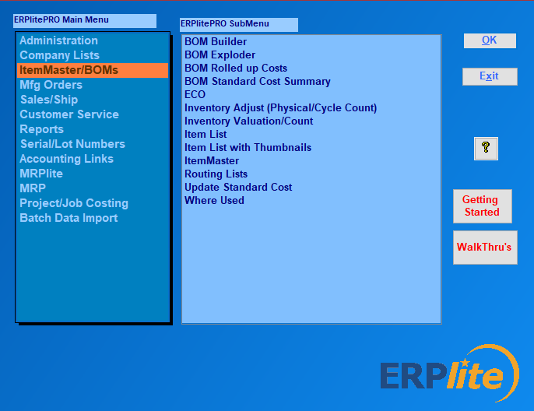o free trial.

* Track inventory in multiple locations and bins
* Track inventory by serial/lot number by location
* barcode reading/writing
* Quickbooks integration

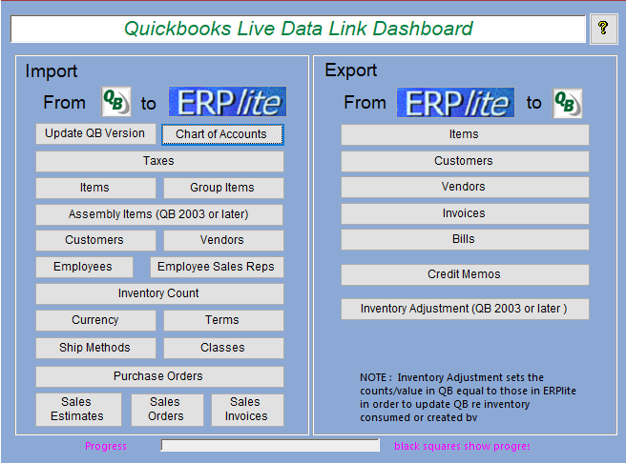

* Multi-user in Windows PCs or in the Cloud
* unlimited Bill of Materials levels
* multiple units of measure
* multi-currency
* Shipping Automation

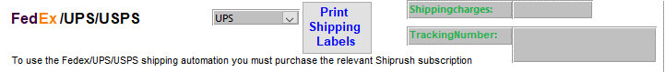

* Open Source….. so, you can customize
* Manufacturing Requirements Planning

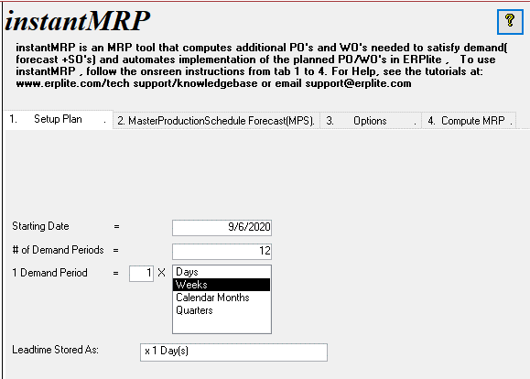

* routing lists
* Add users as needed
* Cycle Counting
* RMA (Return Materials Managment
* Repair Serice Order
* Customize easily...using MS Access
* autocreate PO's from shortages list
* barcode data entry
* MS Access, SQL Server or MYSQL
* Desktop installation or Terminal Services
* install in cloud host (Azure, AWS, Cloud9, ACE etc)
* Auto-populate Excel Template Reports
* QuoteWerks Integration

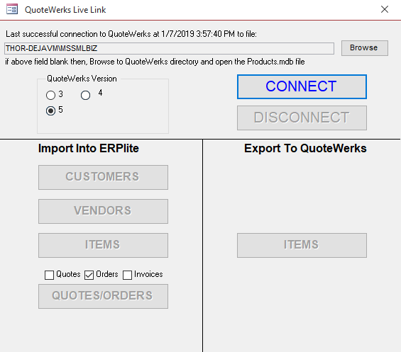

* Parts&Vendors Integration

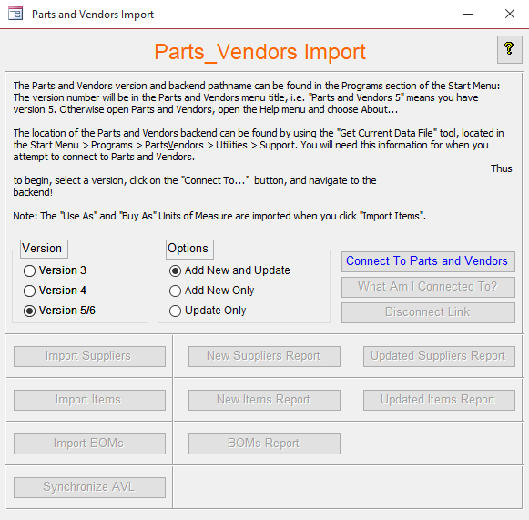

* Import Multiple Bills of Material

