Gettinggg

Started!


ERPlite: Getting Started Tutorial 4
1.0 Introduction 4
1.1 MAKE TO STOCK AND MAKE TO ORDER 4
1.2 INSTALLATION of ERPlite Evaluation Software 5
1.3 NOMENCLATURE 5
1.4 Note to Accountants 6
1.5 OPTIONS 7
1.6 STARTING THE DEMO 7
1.7 On-Line HELP 7
1.9 ERPlite Support Subscription 7
1.10 System Conventions 8
1.11 Date Data Entry ( and Y2K) 8
1.12 Tutorial Workbook Conventions 8
1.13 Menu Conventions 10
1.14 PC MULTI-LEVEL BOM 12
1.15 Starting the Demo Over 12
2.0 Demo Overview 13
2.1 Product BOM 14
2.2 Product Materials Cost (COGS) 15
2.3 Material Requirements Planning(MRP) 16
2.4 Quotation 16
2.5 Sales Order Estimate 18
2.6 Entering a Sales Order 19
2.7 Ding-Ding !!!! 22
2.8. Purchase Orders 23
2.9 Receiving Ordered Parts 25
2.10 Manufacturing Process (managed via Work Orders) 28
2.11 Releasing Work Orders 28
2.12 Picklists 31
2.13 Issuing of Components by Stores 32
2.14 Receiving Finished Assemblies 32
2.15 Inventory Counts and Valuation 33
2.16 Shipping 34
2.17 Automated Shipping Documents 35
2.18 Shipping Labels 37
2.19 SHIP and INVOICE 37
3.0 CUSTOMIZING THE DEMO WITH YOUR COMPANY DATA 39
3.1 Deleting the Sample Data 39
3.2 Adding Your Data 39
3.3 Optional Modules Enabled 39
3.4 Multi-User Installation 40
3.5 Open Source (Customization) 40
3.6 Other Tutorials 40

ERPlite: Getting Started Tutorial

1.0 Introduction
This tutorial was created for two distinct purposes: to be included with an Evaluation Demo to companies in the process of evaluating ERPlite, and for new ERPlite users for the purpose of familiarizing themselves with ERPlite before starting implementation in their company. In either case, whether you are evaluating ERPlite or if you are a new user of the system, we welcome you and thank you for your interest in ERPlite.

This Tutorial Workbook is intended to walk you through the basic ERPlite system step-by-step so that you become familiarized with the ERPlite process. During this demo, you will be pretending to be Dorothy Gayle, the logistics manager for Wiz Inc. Wiz manufactures a PC called: XL Computer System, which you will come to know as "Item PRD1000". While we understand that a very small portion of the ERPlite market will be building computers this tutorial will show you the features of ERPlite so that you will get a feel for the system, regardless of your product. After building computers through this tutorial, you may want to customize the demo data with your own products so that people from your company can work through this same format, but with products familiar to them (see the Appendix for custom data entry instructions).

1.1 MAKE TO STOCK AND MAKE TO ORDER

ERPlite was built both for the make to stock (discrete) and the make to order (job shop) environments. Erplite.com inc.'s existing customer base is almost evenly split between discreet manufacturers, job shops, and companies that manufacture some parts discreet and some parts to order.

The complete ERPlite system is shown in this tutorial. You will encounter some features that are not applicable to your environment; keep in mind that almost no ERPlite user uses every aspect of the software. Through this tutorial and through ERPlite classes, should you choose to attend, you will determine your needs for the software and you will begin to establish which features you will use and which you will not.

1.2 INSTALLATION of ERPlite Evaluation Software

To install ERPlite, follow the latest installation instructions stored on the Download page of www.erplite.com until the following screen is shown on your display.

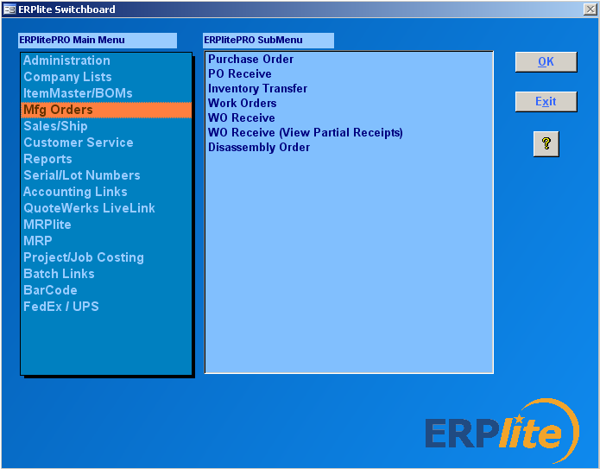

Congratulations!! ERPlite is now installed and you are ready to continue with the tutorial.

1.3 NOMENCLATURE

ERPlite is an affordable solution, containing all features of an MRPII system required by small manufacturers, as well as many additional features. If you do not see the feature you are looking for, there is a very good possibility that the feature does exist within the system, but is under a different name. As you know, there are many names for functions in manufacturing. For example, ERPlite's Bill of Materials (BOM) for making an assembly is defined as:

A listing of all the subassemblies, intermediates, parts, and raw materials that go into a parent assembly showing the quantity of each required to make 1 assembly. It is used in conjunction with the master production schedule to determine the inventory for which purchase requisitions and production orders must be released
.
With ERPlite, we have stayed with the American Production and Inventory Control Society (APICS) definitions.

The BOM may also be called the formula, recipe, or ingredients list. The BOM for the erplite.com inc. PC is shown via ERPlite
below:

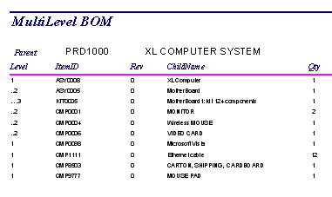

If you do not see the function for which you are looking, please use the menu selections and the online Help to assist you find it. Click the “FAQ” to search our Frequently Asked Questions and Knowledgebase, and the open forum where other customers may have had the same question. If that does not work, please always feel free to contact www.erplite.com .

1.4 Note to Accountants

ERPlite facilitates transfer of data to/from the company financial system via: Microsoft Excel, or dynamic ODBC links or text file transfers. Automated links are available for Quickbooks , Peachtree, Microsoft Accounting and Simply Accounting

1.5 OPTIONS

If you are using this tutorial workbook with an evaluation demo instead of a fully licensed system, you will have permissions for all fully released ERPlite options. If you have purchased the full system, your password will give you permissions to access those options that you have licensed.

1.6 STARTING THE DEMO

We hope that you enjoy working with ERPlite. Use this tutorial as a guide and as a jumping-off point for exploring the functionality of ERPlite on your own. Thank you for using ERPlite; whether it be the Evaluation Demo or the full system, we are looking forward to working with you in the near future.

1.7 On-Line HELP

CONTEXT SENSITIVE HELP is used to display instructional information for each field in every form, report, and operation. The fields are generally intuitive, thus even the forms without help instructions should be quite useable.

Microsoft Help is available online for all Microsoft applications being used (Windows, Access, Excel, Word etc).

1.8 Self-Service Support

The ERPlite Forum provides the following self service support:

- Frequently Asked Questions (FAQ).
- Knowledge Base : Detailed tutorials on more complex topics.
- Technical Discussions: Questions from customers, with answers from other customers (and the Forum Moderator)

The Forum is accessed via : www.erplite.com > Click “FAQ”

1.9 ERPlite Support Subscription
The Context Sensitive Help and Web self-service support options will generally get you the answer your looking for the fastest.

Your ERPlite purchase comes with 30 days unlimited free support from our Tech Support team. Emailing questions to support@erplite.com will get your answer usually within 30 minutes, and thus is much faster than telephone requests (call back within 1 day). Email support has the added advantage, that you will get step by step instructions that you can print.

1.10 System Conventions

ERPlite uses normal Windows conventions, including mouse movement, scroll bars, drop-down menus, hot keys, etc. If you are familiar with any Windows product, then you are familiar with the basic conventions used by ERPlite.

Throughout ERPlite forms, there are three types of fields: required fields, standard fields, and read-only (gray) fields. Required fields (have an orange/yellow background) must have data entered in them before the form may be accepted. ERPlite detects that required fields are missing data and generates a message to the user. Standard fields are optional fields, and data entry is not required. Gray fields are for your reference, and are not data-entry fields.

1.11 Date Data Entry ( and Y2K)

Dates can be entered in any of the Access standard formats:(ie 27-Apr-99, 99/04/27, 4/27/99). Todays date can always be entered via the shortcut "CTRL;".
Once entered, dates are displayed in long form (ie 27 April, 1999)

1.12 Tutorial Workbook Conventions

Throughout the tutorial instructions, all Menus and Command Buttons are shown in bold, Form, Report, and Operation names are italicized, and data that should be entered by the user are underlined.

When you have completed entering data into a form, close the form by pressing the Windows CLOSE WINDOW button.

The [x] button at the top right hand of the form or report, as shown above.

Whenever a report is generated, it can be viewed on screen by clicking the PREVIEW button. It may be printed by using the Access File-Print menu option while the report is in Preview mode.

The Tutorial is updated less often than ERPlite, thus some screens and functionality may differ slightly from this document. The intent will always be that the changes are intuitive.

1.13 Menu Conventions
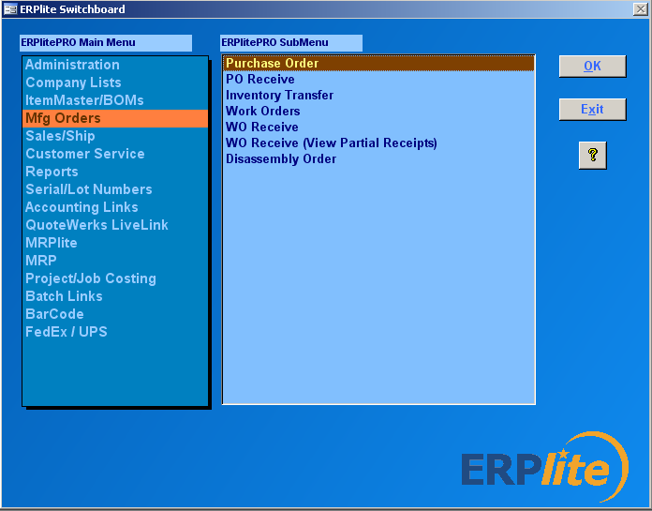

The ERPlite menu system is organized into multiple levels to make the menu easy to use. The switchboard (see figure below) consists of a window of Main Menu choices used to access the modules for each of the ERPLITE forms and reports via the SubMenu.

Clicking one of the Main Menu items on the Switchboard will bring up the SubMenu containing all the forms and reports for that function (Administration, Mfg Orders, MRPlite, BOM’s, etc.). For example, click on Mfg Orders on the Main Menu. You can now see the forms for Orders on the SubMenu (Inventory Transfer, PO Receiving, etc) listed in alphabetical order.

DoubleClick on the Purchase Order form to bring up the form for entering Purchase Orders for inventory or expense items.

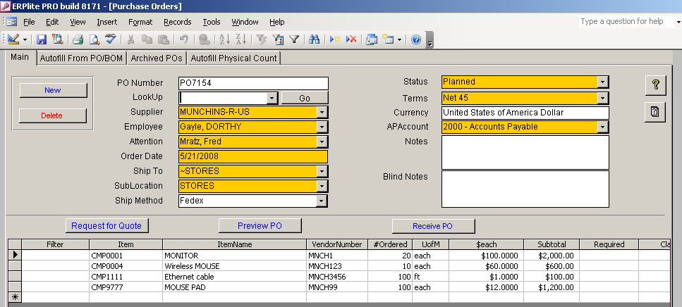

Once in the Purchase Order form, you will see the fields available for creating and printing a Purchase Order. Clicking the Close button will return you to the Switchboard, if desired.

The ERPlite Switchboard shows the list of all Orders SubMenu forms. Please doubleclick on Inventory Transfer, PO Receiving etc on the righthand menu to see how the screen fills with only the forms associated with those functional areas. This popular feature speeds both the learning process and the day-to-day operation of the system. Each of the other menus function in much the same manner.

Please take a few minutes to work with both the Main Menu and the SubMenu, until you are comfortable maneuvering through ERPlite's menus. As you proceed through this tutorial, you will be instructed to open functions through a specific menu.

1.14 PC MULTI-LEVEL BOM

The multi-level BOM of the Wiz PC, Item PRD1000 is shown below. This BOM has 3 levels, but a BOM can have any number of levels. This BOM shows visually the bill of material for the item you will be building and shipping in this tutorial.

Note: You will generate this report later in the demo.

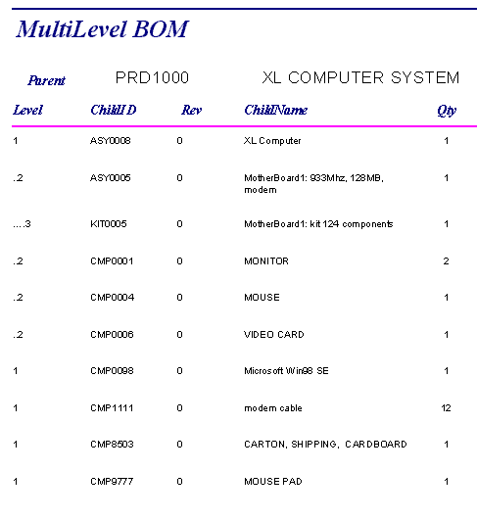

1.15 Starting the Demo Over

The demo data that is supplied with the software includes everything required to run a complete demonstration. As you become familiar with the software, you may wish to customize the demo with your own set of items, customers, vendors, etc. (See the Appendix: Customizing the Demo With Your Data.).

2.0 Demo Overview

Note: As you progress through the demo, you will create much of the data that will be used later in the demo. For that reason, it is important to work through the demo in the sequence outlined in these instructions.

The demo will simulate all the steps in a common business transaction, filling a customer order for an existing product( item number PRD1000):

- Current Cost
- Parts Availability
- Quotation
- Customer Purchase Order
- Sales Order
- Work Order
- MRP shortages calculation
- Purchase Orders(for shortages)
- PO Receiving
- WO Pick
- WO Receipt of finished product.
- Shipment

Doing these 12 steps will familiarize you with the basic ERPlite functionality.

It is important to realize that there is no must order of steps. Any form can be used at any time to change the underlying data in the database. For example, in a build to stock scenario, the first form used would probably be the Work Order creation form.

In order to minimize the time to learn the basic ERPlite functionality, the demo database contains some basic data:
Employees list, vendors list, customers list, purchase parts list, product structures (BOM) etc. This data can be changed to include sample data from your company after finishing the basic demo (see Appendix A).

But, for the demo let’s continue to follow the 12 steps listed above.

2.1 Product BOM
Before you start processing the potential order, we will first print out the PC Bill of Materials.

First, open BOM Exploder form from the ItemMaster/BOMs SubMenu on the ERPlite switchboard.

Enter: the Number of Levels = 6
Pulldown and select the parent item: PRD1000.

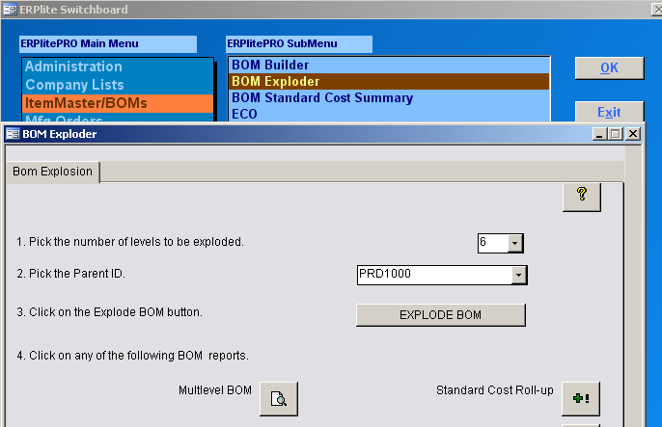

Click Explode BOM and then the click MultiLevel BOM command button and compare report displayed on the next page.

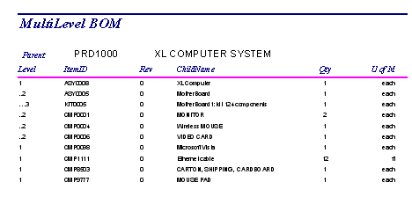

Click Print on the Print button of the Access floating Menubar to send this report to a printer (or select File > Print from the top toolbar). Click Close on the MultiLevel BOM report.

This report displays an indented, multi-level bill of material which displays the exact materials required to build that parent item. All subassemblies and raw materials that are part of the finished good are listed on the Multi-Level BOM report.

2.2 Product Materials Cost (COGS)

The BOM Exploder form also provides a multilevel BOM cost report. This report rolls up the costs for all levels in a BOM. Thus, to calculate the materials cost of the PRD1000 item, we first:
Enter: the Number of Levels = 6
Pulldown and select the parent item: PRD1000
Click the Explode button.
Click Standard Cost command button to display the cost report.

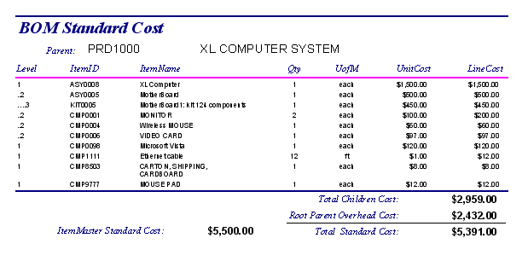

The standard cost report rolls up the standard costs from the itemmaster for each part or assembly. Note that most manufacturing companies manage inventory based on Standard Costs, because Standard Costs include value added overhead costs like labor in addition to the average or FIFO costs of Purchased Parts.

2.3 Material Requirements Planning(MRP)

The heart of ERPlite is MRPlite, the Material Requirements Planning (MRP) process. This planning process calculates the demand for all finished goods, subassemblies, and raw materials needed to make a product to sell to your customers. MRPlite simplifies the purchasing and shop floor planning to facilitate your meeting commitments made to all customers.

MRPlite is a sufficient MRP calculator for most small companies. If you need Master Production Scheduling or Capacity Planning, then try out our optional tools instantMRP and pullPlan on the MRP menu.

2.4 Quotation

In order to quote a delivery time to the customer, we will now use MRPlite to check whether the needed component parts are in stores.

The customer is interested buying 5 PRD1000 systems.

First we check for parts shortages:

First, open MRP Whatif? from the MRPlite SubMenu on the ERPlite switchboard.

- Pulldown and select the parent item: PRD1000.
- Enter: the desired build quantity 5.
- Pulldown and select the location ~STORES

NOTE: ERPlite has substantial default functionality that assumes that “Non-defective” inventory, available to promise to orders, is stored in the inventory location ~STORES. STORES can have sublocations (often called bins), but we will not use bins for this demo.

In a similar manner, inventory that is moved to the shop floor to fulfill a specific order is by default assumed to be in the location ~WIP.

These defaults can be overridden, but remember that will require you to do some functionality steps manually, that otherwise will be done automatically (and will increase the chances of human error).

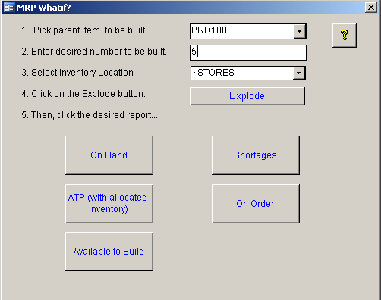

Then, click the Shortages button:

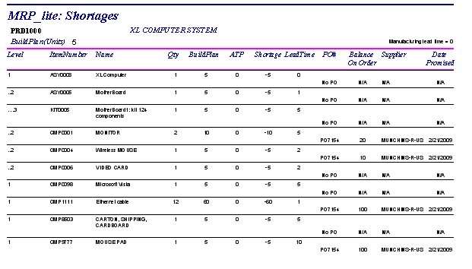
The shortages report lists the parts with insufficient quantities in Stores to complete the order. If existing Purchase Orders have delivery schedules, then the balance on-order and due date are listed.

Thus, we see that the longest lead time part (10 days, from the Shortages report) not available is the MousePad (CMP9777). We also note that sufficient ordered MousePads are overdue to be received, and need to be expedited. The remaining shortages (KIT0005, CMP0006, CMP0098, CMP8503) all have lead times of less than 1 week, and thus can be ordered in time and delivered in time.

The quote can now be sent to the customer, promising delivery 3 weeks after receipt of order (assuming 1 week to receive all short parts, 1 week for assembly after all parts are received, and 1 week cushion for the unknown).

Often, if there is confidence that the sale will close, the purchasing agent would be instructed to order the short parts. But for the demo, we will do that after the order is received (since a delivery date was quoted taking the purchasing and manufacturing time into account).

Note: MRPlite has other reports that you will find useful at times: On hand and Available to Promise inventory counts for all parts in the BOM; an Order Report.

2.5 Sales Order Estimate

The customer, The TinMan, wants a quotation. The next step is to complete the Sales Order entry. This will allow automatic generation of the Work Order and the Shipping documents.

2.6 Entering a Sales Order

Note: ERPlite's Sales Order Entry functions allow the quick and easy entry of sales orders with multiple lines and multiple deliveries per line.

Open the Sales Order (Quote) form from the Sales/Ship Menu.

Note: the

Enter the following values to the main form:

Ship To: (Customer Name) = The Tin Man
Employee: = Dorothy Gayle

Enter a line item to the subform:

Note: type “xl” in the “Filter” field, and then click on the ItemID pulldown button (click on the downward arrow icon at the right of the field). You should then see only items that have the word “computer” in their description. Use of this filter feature is optional.

Choose ItemID = PRD1000
Enter QtyRequired = 5
Scroll over and enter: DueDate = 13-Mar-09

The Due date is the target date that the shipment should arrive at the customers loading dock.

Some other fields are filled in automatically by ERPlite, such as the customers address (from data previously entered) and the autonumbered SO Tracking number.

Note: The tracking number is automatically incremented by ERPlite. Thus, the number assigned may be different than the number in this tutorial document.

Note: Sales List Price, Rate% and Tax % are auto-entered from the data in the itemmaster. You can override these default values.

Any number of line items could be entered to the Sales Order, but for the demo we will use only one.

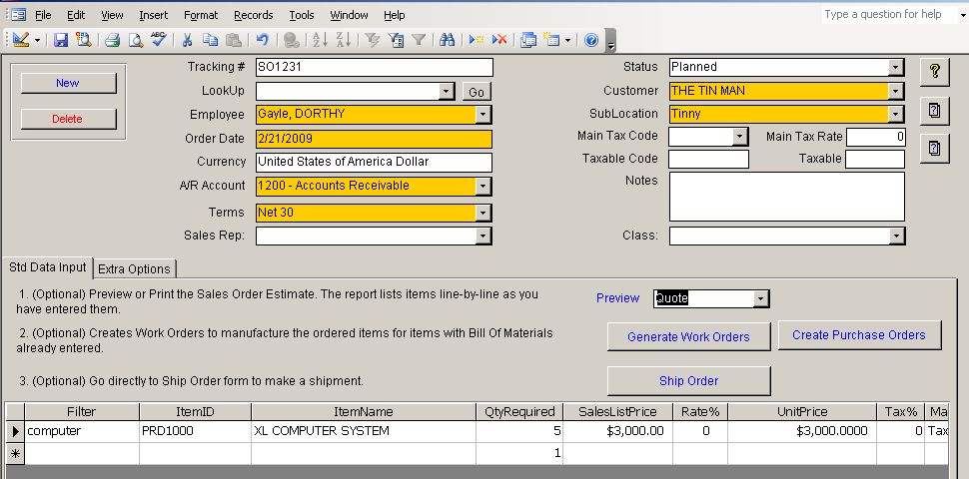

When the order is as the customer wants it, then select “quote” from the pull down list….

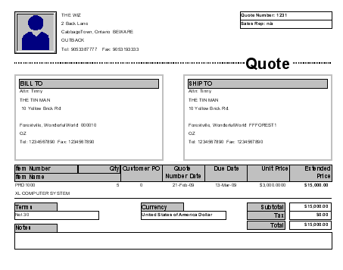

Then, email or fax the quote to the customer.

To email:: click “File” from the top toolbar and then “Send To” . If you want to email a PDF copy, then you can purchase an add-in like “Win2pdf” from their internet website.

2.7 Ding-Ding !!!!
The customer has issued a PO for the order.

Now check the availability of the components required to fill the order by clicking the Shortages? button on the MRP What if? form from the MRPlite main menu.

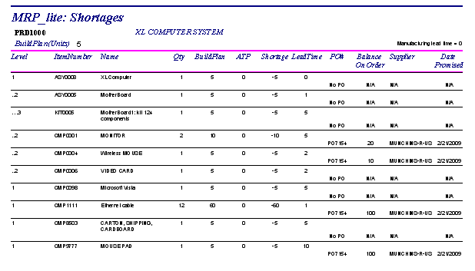

Clearly, some of the components needed to complete the WO have yet to be purchased. Send the Purchasing Agent a copy of the shortage list, with a rush request to get the missing parts.

2.8. Purchase Orders
2.8.1 Receiving Existing PO

Good News. The shipment just arrived satisfying the existing open PO7154.

To receive, and thus upcount Inventory available to promise to the SO::

1. Open the “PO Receive” Form on the “Mfg Orders” submenu.
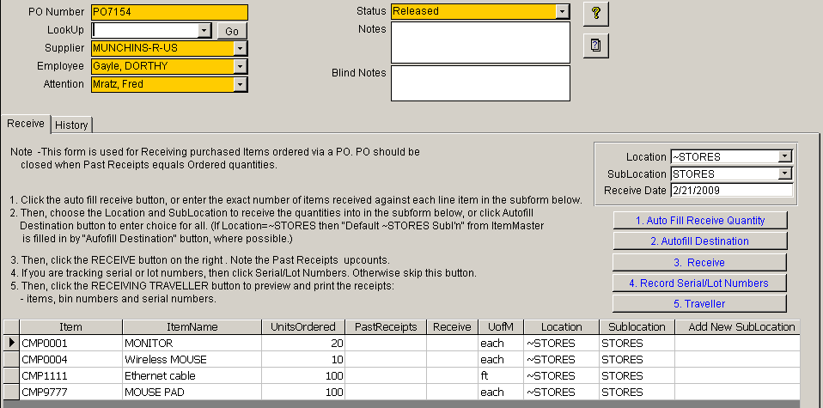

2. Click “Auto Fill Receive Quantity” to receive all quantities ordered. If partial
Quantities are being received then, enter the quantities in the Receive column
3. Click Receive to upcount the Past Receipt quantities (which upcounts the inventory count in ERPlite). You can print a traveller if needed.

2.8.2 Placing New PO

Now, issue a PO for the other shortages.

Open the Purchase Order form from the Mfg Orders SubMenu on the switchboard.
Click the NEW button to generate a new Purchase Order.

Enter the following values:

Supplier = MUNCHKINS_R_US
Employee = Dorothy Gayle
Attention = Fred Mratz
Terms = Net 45

Continue entering the items from the shortage list: Shipping Carton, Win98, modem cable, etc:: entering the appropriate economic order quantities for each.

Note that if you know the item partnumber, then you can start typing it and the pulldown list will scroll to partnumbers starting with the typed letters.

Also, if the partnumber has this vendor listed in its Approved Vendors List (AVL), then the vendors partnumber will be auto-populated.

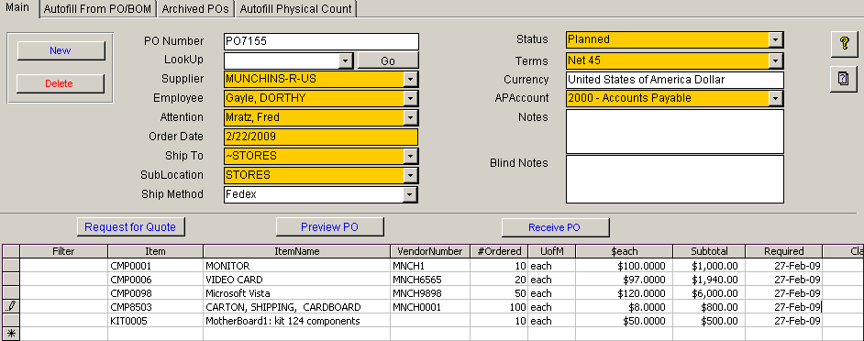

Preview the Purchase Order by clicking the "Preview PO" button.

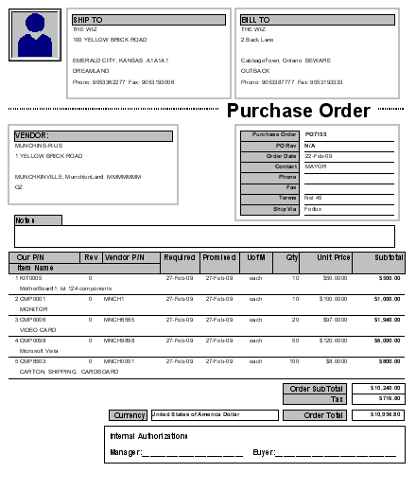

In real use, this PO could now be authorized and faxed or emailed to the vendor.
Change the status = planned
Close the Purchase Order form.

2.9 Receiving Ordered Parts

A truck arrives at the loading dock bringing the order from MUNCHKINS-R-US. In Order to receive the parts, open the PO Receiving form in the Mfg Orders SubMenu and navigate to the appropriate PO.

Enter the quantities received in the Received column.

Click the " Receive" button. This will upcount STORES inventory counts by the received amount.
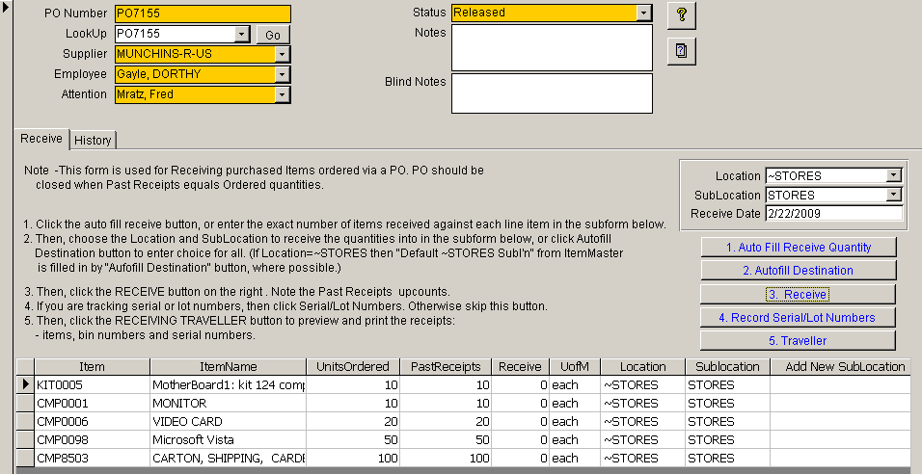
Print the Receiving Traveller

Note: Receiving Traveller includes the bin numbers in STORES that the received parts should be placed in. Also, any serial/lot numbers entered are listed (but none were entered in this tutorial).

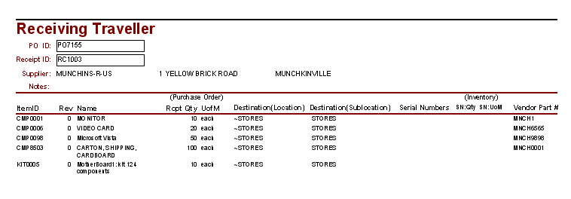

Let’s check the ~STORES Inventory Counts now via double-clicking the Inventory Valuation/Count report on the Itemmaster/BOMs menu (or the Reports menu). This report is configurable , but for this run just click the Report Preview button:

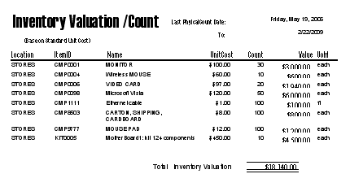

2.10 Manufacturing Process (managed via Work Orders)

The Manufacturing process is the area in which work orders are created, material and labor are assigned to the work order, finished goods are received and inspected.

2.11 Releasing Work Orders

There are two ways to enter work orders into the system: converting an existing Sales Order into a work order, and creating a new build to stock work order. In this demo, we have created a work order using the Sales/Shipping Order process.

Open the Sales Order and click the Create Work Order button:

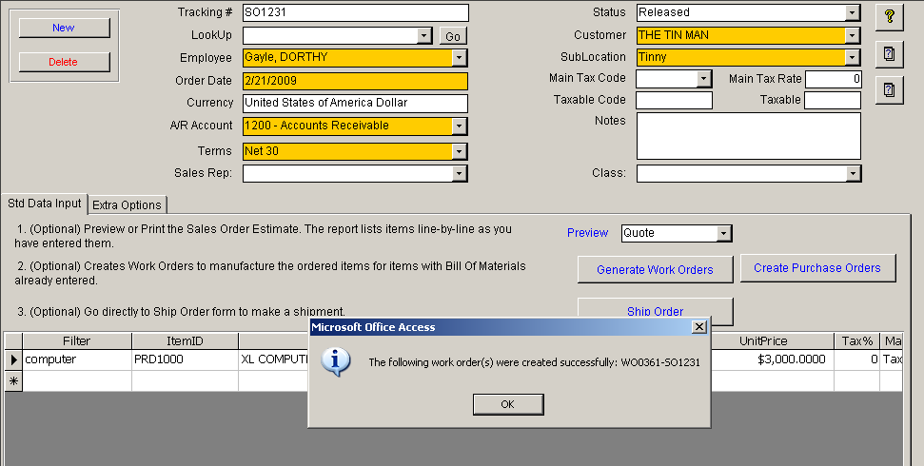

The form used to convert planned orders into work orders is Work Orders . Open this form from the SubMenu of Mfg Orders on the Main Menu. All planned orders that have been generated will be available to be converted into actual work orders through this form.

Open the Work Order form from Mfg Orders on the Main Menu.

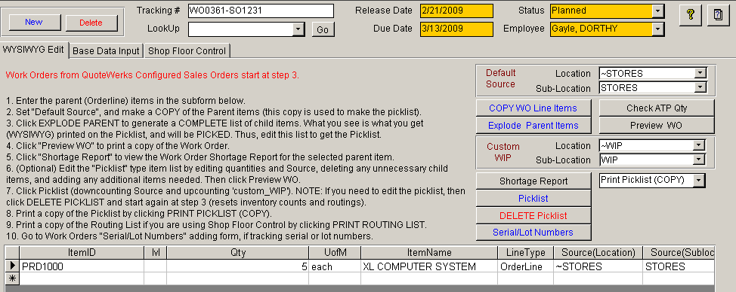

Use the WYSIWYG tab in order to edit the Picklist as follows:

Press the COPY WO Line Item button, to generate a copy of the Order line from the SO.
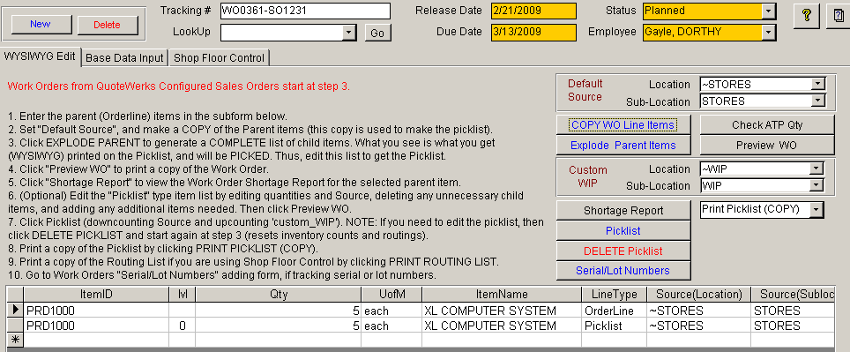

If you only had enough parts to build say 3 of the ordered 5, then you could change the build quantity to 3 and do another WO later for the additional 2. We will build all 5 in this tutorial.

Click on the Explode Parent Items button. All of the component materials required to fulfill this order computed by multiplying the order quantity by the quantity in the BOM.
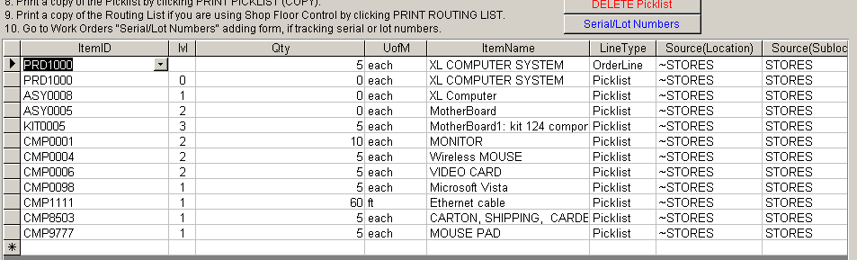

For example the picklist quantity for the CMP0001 is 5*2 = 10. Note that the default assumption is that you are building all assemblies from their component parts. Thus, the quantities of the assemblies “in the picklist” are set to 0. You can manually change any of the quantities in this What You See is What You Get (WYSIWYG) draft picklist. For example, you might know that 20% of the Video Cards have been defective this week, so you decide to pull 6 from STORES rather than the 5 from the BOM.

The objective is to edit the parts list to generate the correct quantities that need to be picked from STORES in order to complete the order.

Click Preview WO and Print the WO traveller to inform the shop floor what to build and when:

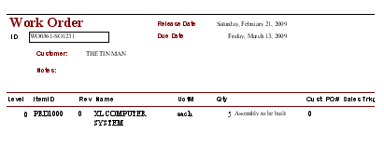

2.12 Picklists

Picklists may be printed for each work order. This report will give you a pick sheet listing all of the required components.

Click the "PickList" button.

This will result in the Picklist quantities being moved from STORES to WIP.
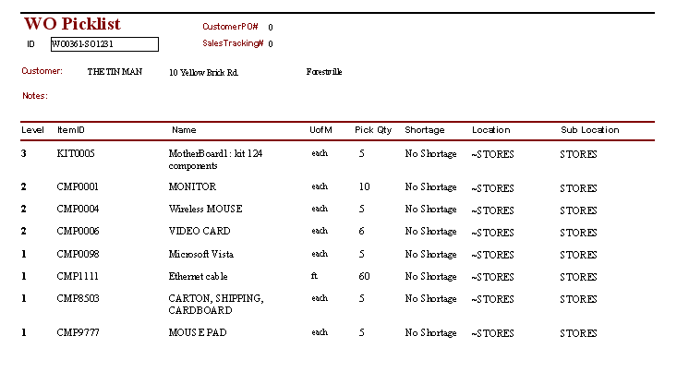
Note, that if any parts had been short, a warning message would have been displayed, giving the user the option of continuing or aborting the pick. Often, work can start on the Work Order and be completed once the short parts arrive.

You have now created a released work order for the 5 PC’s ordered by TinMan.

2.13 Issuing of Components by Stores

Component materials are issued to work orders based on the Picklist. The inventory manager in ERPlite downcounts STORES and upcounts WIP inventory as soon as the Picklist is generated. This simple process reduces bureaucratic paper work and is complementary to the backflush process used to receive finished assemblies back into Stores(this concept will be explained in the next section).

If human error occurs or changes are necessary, corrections to inventory counts can always be made deleting the Picklist , editing and Picking again.

2.14 Receiving Finished Assemblies

Once materials are completely manufactured and inspected, they are received through the form WO Receiving on the Mfg Orders SubMenu. Click AutoFill Receive Quantity and then Receive Work Order

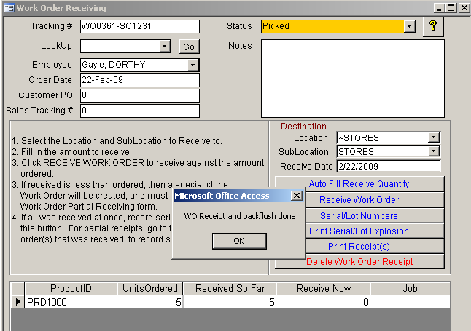

The 5 PRD1000 PC’s that you just accepted are now reflected in the available quantity for this item in STORES. They may now be shipped to the customer. The components used to make the PRD1000’s have been downcounted (backflushed) from WIP. This downcounting process is called backflush, because it flushes out the quantities based on the edited WYSIWYG picklist.

Note: Partial receipts can be done for Work Orders: see the tutorial at www.erplite.com > tech support > knowledgebase.

2.15 Inventory Counts and Valuation

Accounting just phoned to remind you that today is month end and they need inventory valuation reports.

Open the Inventory Valuation/count form on the Reports SubMenu and click Report Preview.

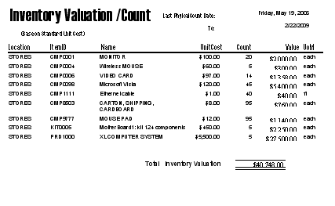
Wait a minute: shouldn’t there be 30 CMP0001’s.??

To find out, run Inventory Transactons History Report for CMP0001::

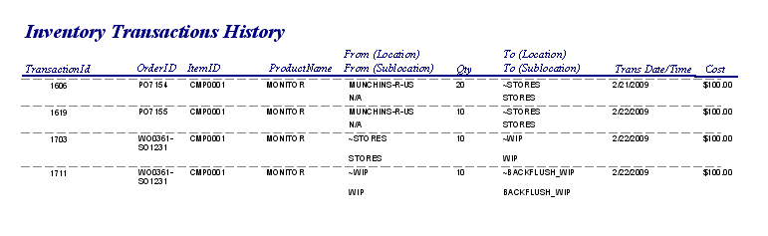

Thus,

1. Received 20 on PO7154 = 20 in STORES
2. Received 10 on PO7155 = 30 in STORES
3. Moved 10 to WIP WO0361-SO1231 = 20 in STORES + 10 in WIP
4. Backflushed 10 out of WIP = 20 in STORES + 0 in WIP

Thus, the Inventory Valuation/Count is correct.

Email or fax the inventory valuation report off to accounting. Now, let’s ship this order to the customer to ensure it arrives on time, as ordered.

2.16 Shipping

After the finished goods have been manufactured and moved into STORES inventory, you are ready to ship the product to the customer who placed the order. This section covers kitting, shipping, shipping documents etc.

Open the Shipping Order Form on the Sales/Ship menu and navigate to the appropriate SO tracking number.
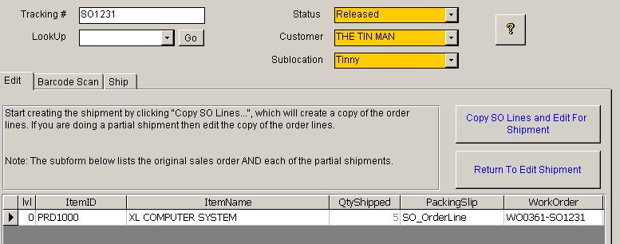
Click the Copy SO lines and Edit for Shipment button, which opens the Shipment Editor:

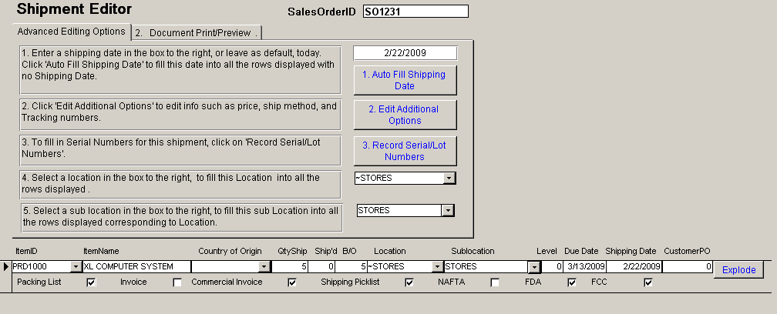

2.17 Automated Shipping Documents

Click on the white square beside a document name to select this shipment line to print on the document.

A major productivity feature of ERPlite, is the automated printing of needed shipping documents, with all necessary data supplied from the database. These documents are printed from the Document Preview tab on the Shipment Editor form.

Click on the appropriate command button to preview the packing list and invoice.

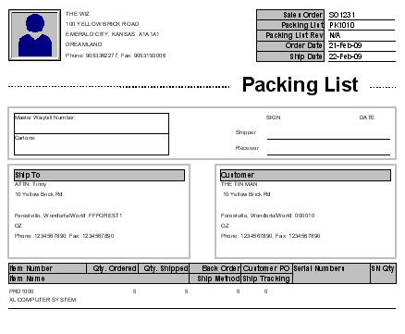
Note that if Serial/Lot numbers were recorded , they will print on the packing list (Ditto for the Customer PO number, Ship Tracking Number, and Ship Method), but not on the Invoice

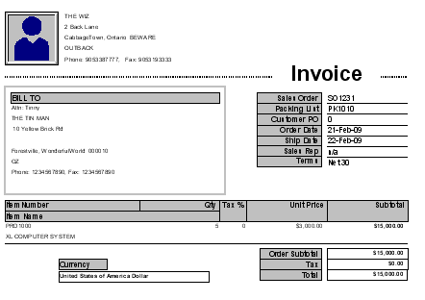

2.18 Shipping Labels

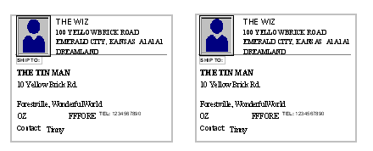

2.19 SHIP and INVOICE
Now, we have arrived at the finish line.

The shipment has just left on the truck to the customer.

Click on the Ship button on the Ship tab of the Shipping Order to downcount the shipped items from inventory.
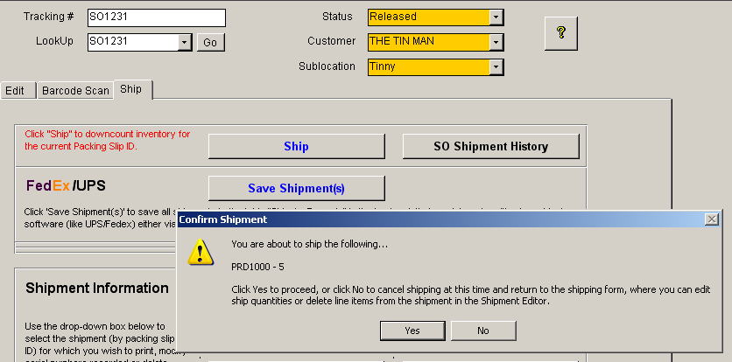

Note that a warning message comes up to give you one last chance to catch an error (say you meant to ship 10 PRD1000’s).

The customer can now be invoiced.

If you are using the Field Service module, these shipped items can be tracked by serial number and revision on the customer site. This is very useful for warranty management, service contract management and customer service in the field.

Congratulations, you are now finished the “Getting Started” tutorial.

There are many more forms and reports available via the switchboard. Their use is very similar to the methods that you learned during this tutorial. Please experiment with them, to investigate how they might be useful in your company. For more details, see the knowledgebase at www.erplite.com > tech support.

Next, you may want to enter data typical of that used in your own company. Then, you can demonstrate the software to other potential users in your company.

CUSTOMIZING THE DEMO WITH YOUR COMPANY DATA

Deleting the Sample Data
Once you are finished working through the tutorial and you wish to enter your own data, you can delete the sample data by opening the Check Data Quality form on the Administration Menu and clicking on the Delete ERPlite Sample Data form.

Adding Your Data
The following static data may be added to the tutorial so that future tutorials will include your data, and not the just the demo PC data:

My Company Information
Employees
Customers
Vendors
Items (Parts)
Product Structures (Bills of Material)

You can import this data from your Accounting software using the links on the Accounting menu.

ERPlite has tools for importing the above list data from csv files in the Batch Links menu. Note that if your data exists in Excel spreadsheets, then export it to a csv file and then import into ERPlite.

Your data may be incomplete in some ways for use in ERPlite. ERPlite has a data diagnostic tool called Check Data Quality on the Administration Menu that will identify needed corrections. Run this tool after every data import, and correct any errors reported.

Optional Modules Enabled
The following optional modules are enabled in the evaluation version:

Quickbooks Link
Peachtree Link
Simply Accounting Link
QuoteWerks Link
Parts & Vendors Link
InstantMRP

You can evaluate all of these optional modules before you buy. Or, if you decide to defer purchase of the options, you can add them at any time in the future.

Multi-User Installation
ERPlite supports multi-user several environments.

Peer-to-Peer : ERPlite client application (frontend) on each users PC, and the backend database on a server. The default backend database is MS Access. You can upsize the MS Access backend to SQL Server or MySQL
Terminal Services : ERPlite frontend and backend on Windows Server 200x. Users connect via remote desktop from any internet connected PC.

For installation instructions see the knowledgebase at www.erplite.com

Open Source (Customization)
ERPlite has open source for the user interface and the 1st level of VBA business logic. Feel free to customize any of the functionality.

After any customization, be sure to do full corruption cleaning using the procedure in the knowledgebase at www.erplite.com

Other Tutorials
There are about 2 dozen screen shot tutorials (with text annotation) to help you learn how to import and enter your own data, and to do some of the more complex workflows (like serial/lot number tracking) on our website:

www.erplite.com > “2 minute tours”

Many of your questions are answered on our website:

www.erplite.com > tech support > knowledgebase

Feel free to contact support@erplite.com with any questions.

with any questions.

