June 26, 2018

INSTALLATION :: multiuser ERPLITE 10 IN Windows Server RDS

- OVERVIEW

In this guide, we document the major steps (with screen shots) for installing multiuser ERPlite 10 in Windows Server 2003/8/12/16+ Terminal Services (now called Remote Desktop Services) .

In general, more concurrent users of ERPlite, and larger ERPlite datasets can be hosted in Terminal Services than in client/server installations, with fewer crashes and response times will be dramatically better.

This is primarily due to the ERPlite front and backend running in the same C: Drive and the same RAM memory.

The installation in AWS, Microsoft Azure, Citrix , VMware is very similar.

.

Note: sample data will be used for IP addresses, Usernames , Product Keys etc. Yours will be different.
2.0 INSTALL ERPLITE Free Trial

Download and install the free trial version of ERPlite from www.erplite.com using a Windows Server user with Administrator permissions. Note that the last step of this installation procedure converts the 14 day free trial license to perpetual.

ERPlite will install Microsoft Access runtime. If you need the features of a retail copy of Access to do advanced administrative tasks ( like Direct Table viewing/editing , design changes to Reports etc), then install a full copy of Microsoft Access or Microsoft Office that includes Access (note this can be done later, when needed).

ERPlite Client will open to the following page…..

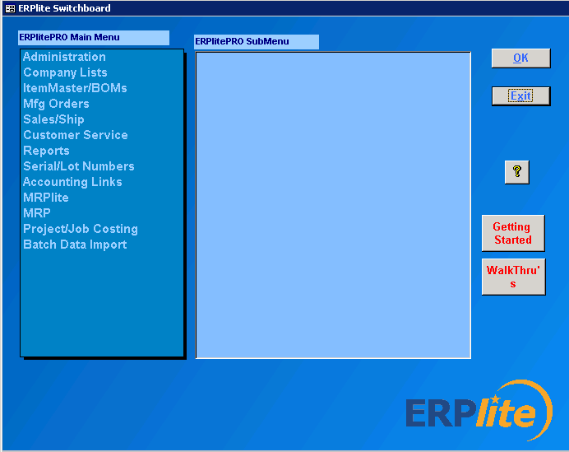

3.0 DO NOT (at this time)

Do not click OK on any windows or OK at this time. Click x to close.

OK, OK…..if you have clicked the OK’s, then….

Do not use any ERPlite features (ie don’t click on anything in the Switchboard submenu’s) until step 5.

That is close the ERPlite client front end.

3.1 UPDATE Location of the ERPlite Frontend and Desktop Icon

ERPlite installs in the C:\ERPlite folder. The frontend installs as

C:\ERPlite\DbM_fe.mdb

…. because the installer assumes a single user installed in WinXP,7,8,1,10.

For Windows Server, each user requires their own frontend. Thus the installation process is….

- Delete the single user ERPlite desktop icon (right click on the Desktop Icon and select delete
- For each user, create a subfolder …eg C:\ERPlite\UserX
- Copy/Paste C:\ERPlite\DbM_fe.mdb into the user subfolder…. resulting in C:\ERPlite\UserX\DbM_fe.mdb
- Create a desktop shortcut by right clicking on C:\ERPlite\UserX\DbM_fe.mdb…and selecting Create Shortcut.
- Rename the Shortcut by right clicking on the file, and changing the file name from “DbM_fe.mdb – Shortcut” to something like “ERPlite UserX”.
- Paste the shortcut on the Desktop.** ( often to C:\Users\Public\PublicDesktop )
- Repeat steps 2 thru 6 for each user.

** Note that the above method is straightforward, but will have Users ERPliteX Desktop Icon’s visible to all users. Depending on your version of Windows Server, your IT staff can configure so that each user has their own desktop…which only shows their ERPlite desktop Icon OR they can have their ERPlite frontend open directly.

4.0 Add Users to the “Remote Desktop Users Group”

Creating a Local User on Windows 2003 server
- From the Windows Start menu select Administrative Tools | Computer Management. If this menu item does not exist, you are either not an administrator for the computer or the server is a domain controller and you need to create a domain user instead.
- From the Computer Management dialog, navigate to System Tools | Local Users and Groups | Users on the left panel; right click on Users and select New user from the popup menu.
- In the New User dialog, enter User name User1 (for example), Full name and Description, respectively (latter 2 fields are optional).
- Uncheck box User must change password at next login and then check box Password Never Expires.
- Click the Create button to create the user and then click Close button.
- Repeat 2 thru 5 for each additional user.
5.0 Add users to the Remote Desktop Users Group

To add users to the Remote Desktop Users group
- Open Computer Management.
- In the console tree, click the Local Users and Groups node.
- In the details pane, double-click the Groups folder.
- Double-click Remote Desktop Users, and then click Add....
- On the Select Users dialog box, click Locations... to specify the search location.
- Click Object Types... to specify the types of objects you want to search for.
- Type the name you want to add in the Enter the object names to select (examples): box.
- Click Check Names.
- When the name is located, click OK.
- Repeat these steps to add each user.

6.0 Login via Client PC
The Remote Desktop Connection is usually located in Start > Programs >Accessories one of its subfolders.

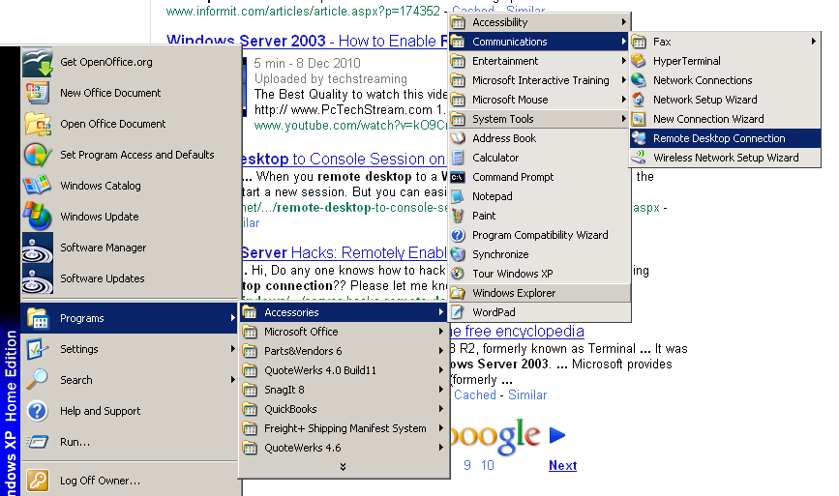

Enter the IP address of Windows Server 2003
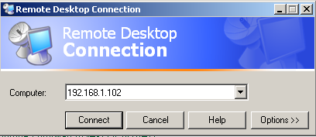

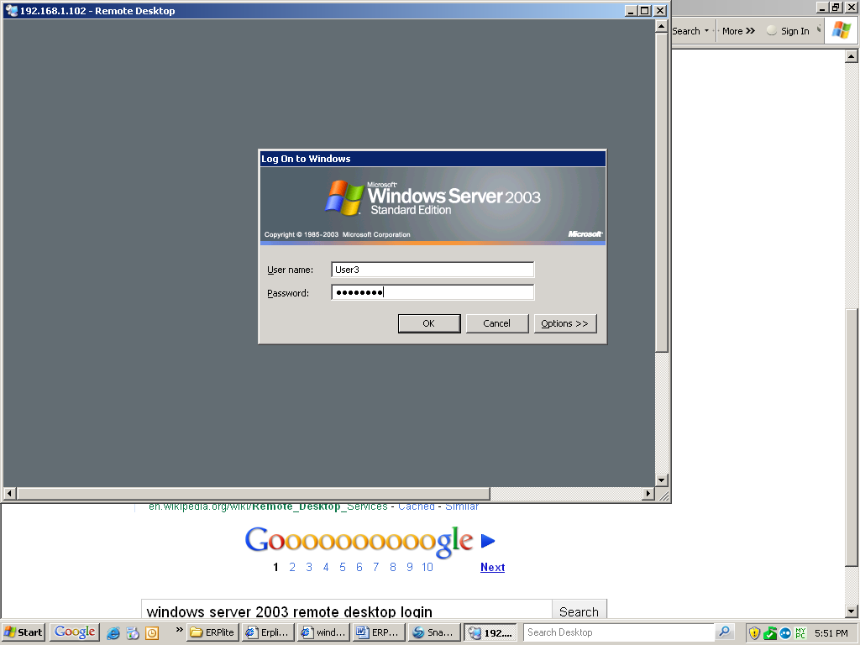

Open ERPlite by clicking on the Desktop Icon .

Note1: If the Desktop Icon doesn’t work, then open ERPlite by double clicking on C:\ERPlite\DbM_fe.mdb in Windows Explorer. Make a new desktop icon .

Note2: Sometimes the permissions of the C:\ERPlite folder are too restrictive. Make sure
Each user has “Full Control” permissions for this folder.

After clicking OK on the configuration screens ( if not already clicked), the normal ERPlite Switchboard appears.….

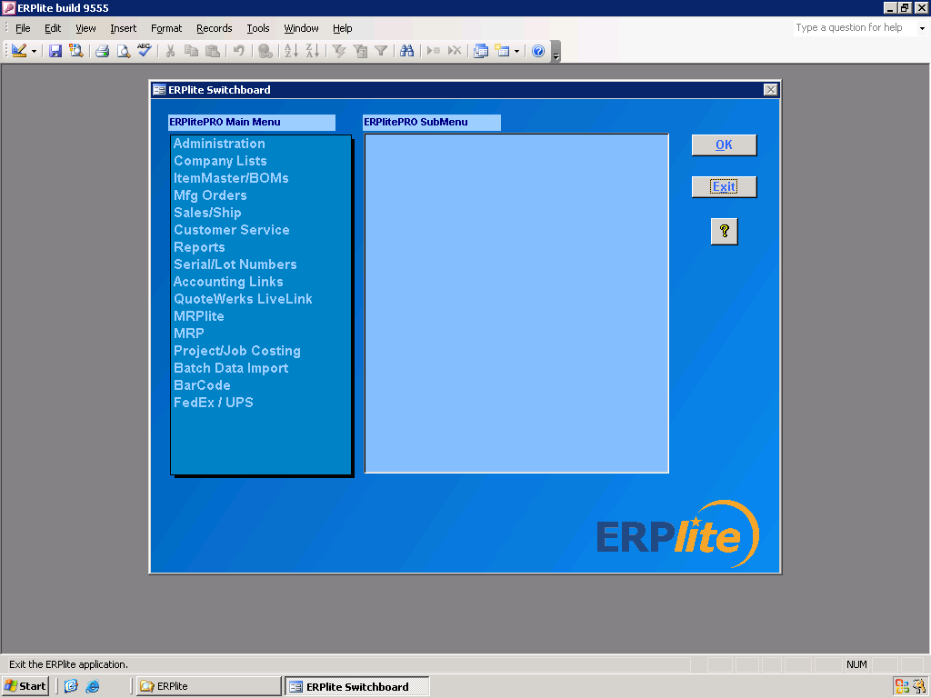

ERPlite will look and operate the same as if it was installed on your local PC, but in fact it is running on the server. This means that very little data is being sent over the network to the local PC, which results in much faster response times.

7.0 Request Permanent License

Email support@ erplite to request the conversion of the 14 day free trial license to permanent.

Appendix : Trouble Shooting/Support

7.1 if you get an error message “C:\ERPlite\DbM_fe.mdb…already in use”, you need to edit the Desktop Icon as in section 3.1

7.2 . If the users Desktop Icon goes missing, paste a copy into C:\Users\Public\PublicDesktop (this is usually a hidden folder, so unhide it if necessary).

SUPPORT

Email support@erplite.com with

- attached screens shots to help define your issue.
- version of ERPlite (eg 10123).
- version of Windows Server

