**EMS Request: (Exit Request)**

Due to my parents critical health issues I am unable to concentrate on my work,job responsibilities, which is also affecting my physical health and increasing stress levels

Same has been shared with my RM,HR but they are saying that I am giving fake excuses and trying to corner me They purposefully initiated show-cause notice on me by which I got offended by this approach and I have copied all my next level managers tried to let them know what is happening on me Hence I like to resign for my job

-------------------------------------------EMS-----------------------------------------------------------

Screen1:

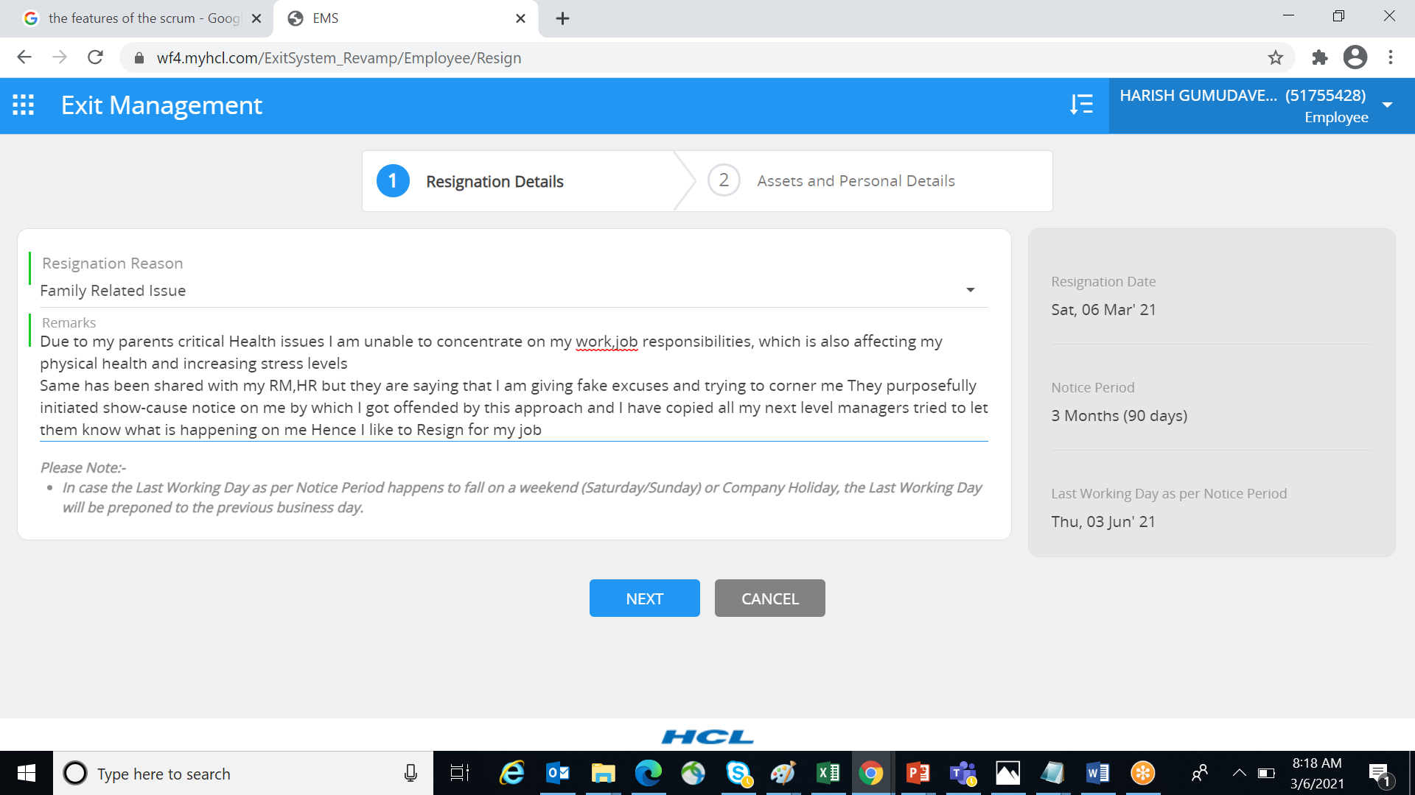

**Screen2:**

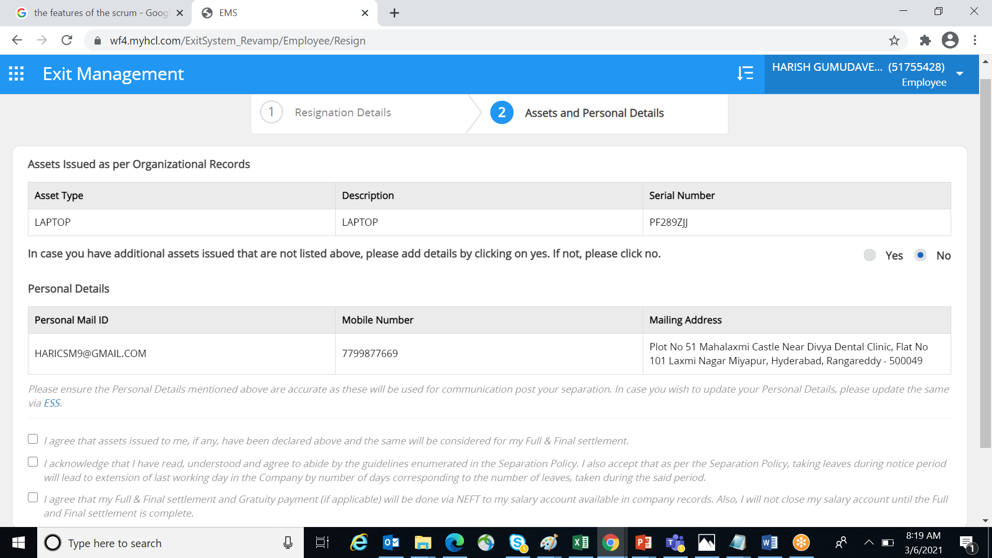

**Screen3:**

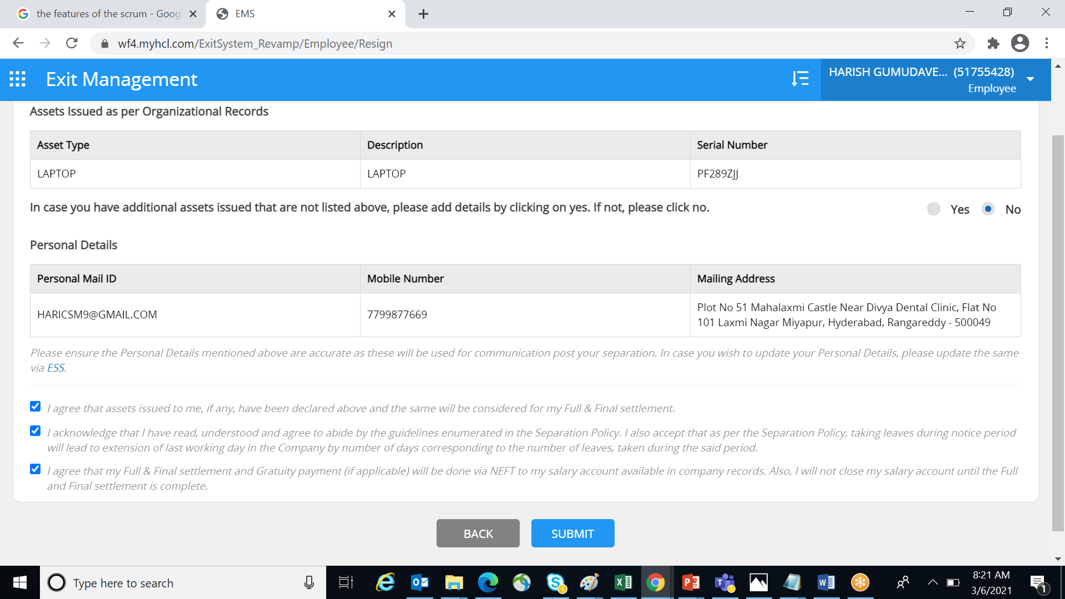

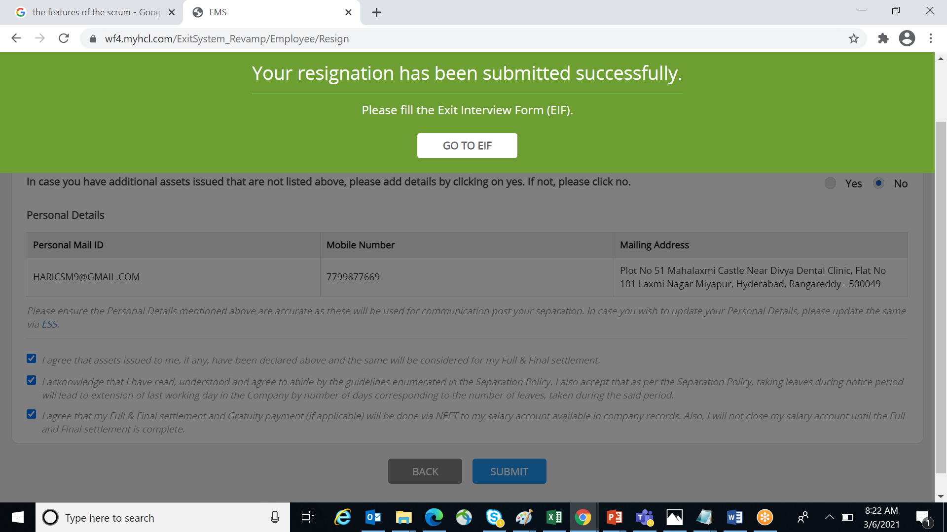

**EIF Form:**

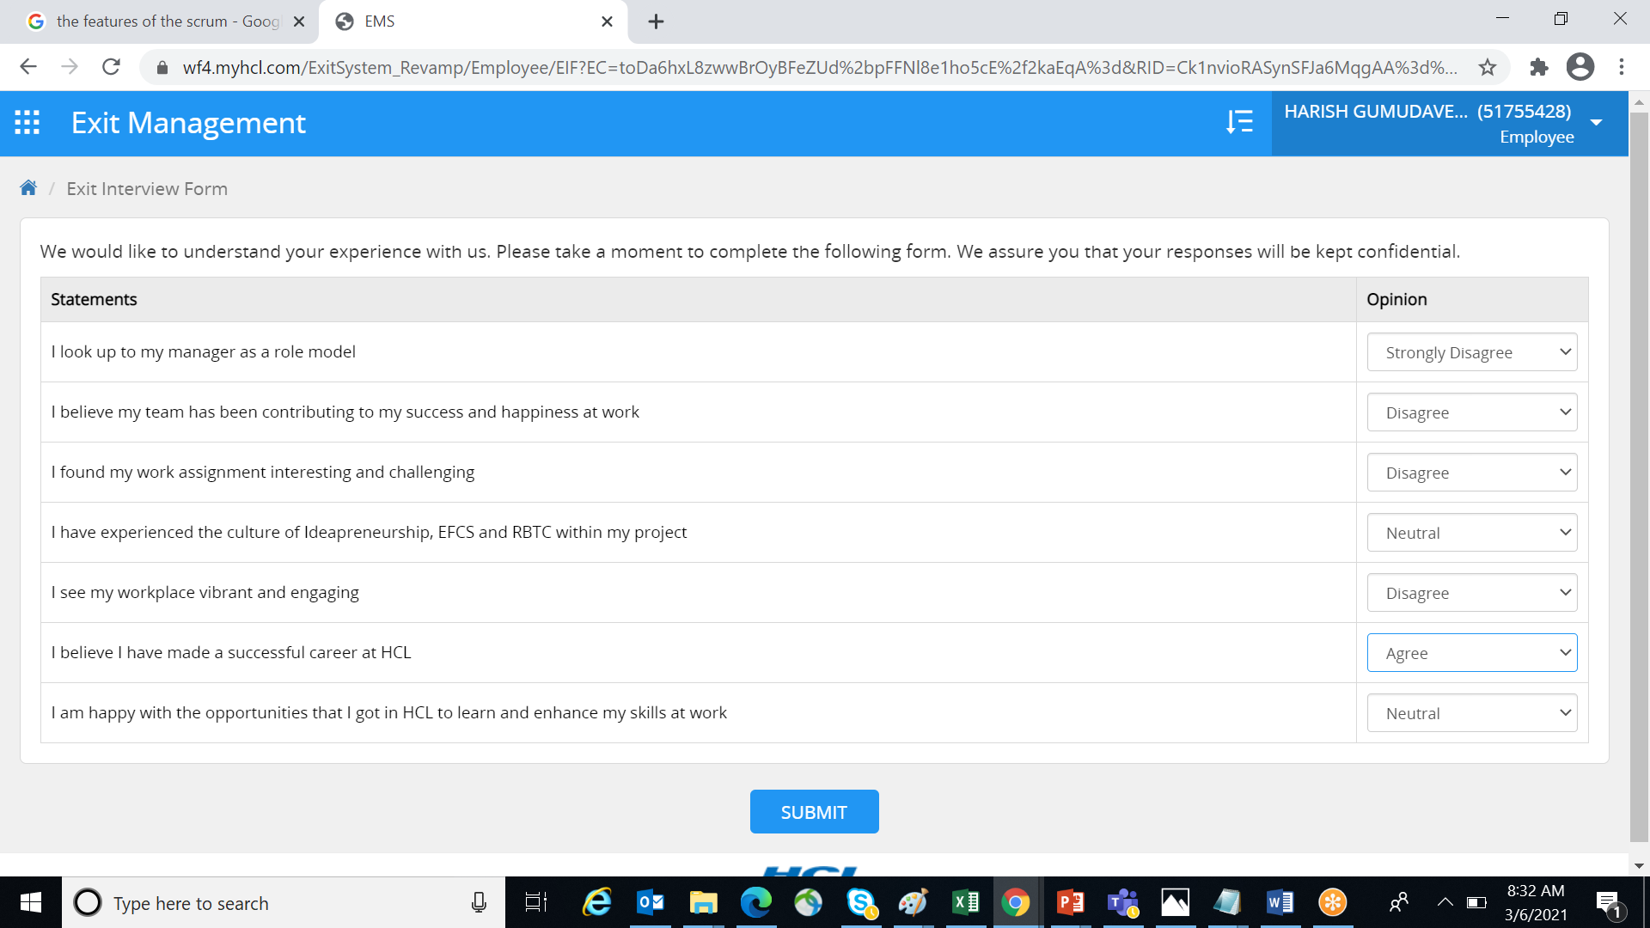

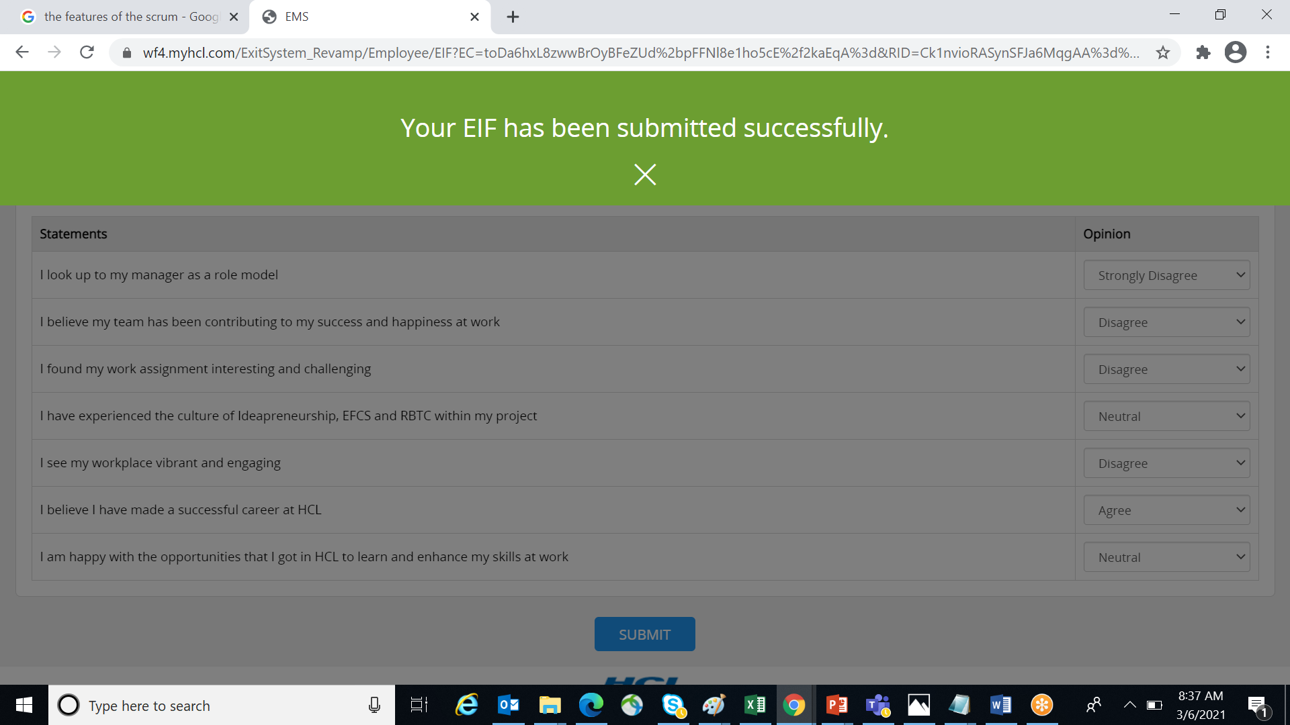

**Approval Status:**

