|  |
| --- |
| < Timesheet Web Service > |

High Level Design

Aricent:500300105

Revision 1.1

ARICENT™ CONFIDENTIAL

|  |
| --- |
| **Copyright** © **2006 Aricent Inc. All Rights Reserved.** No part of this document may be reproduced,stored in a retrieval system or transmitted, in any form, or by any means, electronic or otherwise, including photocopying, reprinting, or recording, for any purpose, without the express written permission of Aricent.  **Printed in ________**  **TRADEMARKS** ARICENT and THE ARICENT LOGO are trademarks of Aricent Inc. in the U.S. and other countries. The use of any of these trademarks without Aricent prior written consent is strictly prohibited. Other trademarks and trade names may be used in this document to refer to either the entities claiming the marks and names or their products. Aricent Inc. disclaims any proprietary interest in the trademarks and tradenames other than its own.  **DISCLAIMER** The information in this book is provided “as is”, with no warranties whatsoever, including any warranty of merchantability, fitness for any particular purpose or any warranty otherwise arising out of any proposal, specification or sample. This document is provided for informational purposes only and should not be construed as a commitment on the part of Aricent. Information in this document is subject to change without notice.  **REQUESTS** For information or obtaining permission for use of material of this work, please submit a written request to: Corporate Mareting and Legal, 3460 Hillview Avenue, Palo Alto, Ca. 94304.  **DOCUMENT No.: ARICENT** |
| **ARICENT™ Ltd.** Plot 31, Electronic City Sector 18, Gurgaon – 122015 Haryana (INDIA) Tel: +91-124-2346666/2455555 Fax: +91-124-2455100/2455101 E-mail: info@aricent.com Visit us at: <http://www.aricent.com> |

Contents

1. 1. Introduction 1

1.1 Purpose 1

1.2 Scope 1

1.3 Audience 1

1.4 Document Organization 1

1.5 Acronyms and abbreviations 2

1. Background 3

Overview 3

Project Requirements 3

1. Solution Architecture 5

Solution Overview 5

Solution Architecture and Design 9

Flow Diagram 14

Sequence Diagram 15

Error Messages: 16

1. A Alternate Architectures 17

Your Opinion Matters 19

Revision History 20

Figures

Figure 3‑1: Web Service Overview 5

Figure 4‑1: Solution Diagram 9

Figure 4‑2: SOAP request for getTimesheetDetails 10

Figure 4‑3: SOAP response for getTimesheetDetails 11

Figure 4‑4: SOAP request for updateTimesheetEntry 12

Figure 4‑5: SOAP response for updateTimesheetEntry - Success Case 13

Figure 4‑6: SOAP response for updateTimesheetEntry - Failure Case 13

Figure 4‑6: Flow Diagram 14

Figure 4‑7: Sequence Diagram 15

Tables

Table 1‑1: Chapter Description 1

Table 1‑2: Acronyms and abbreviations used in this template 2

Table 4‑1: Table containing Error Messages 15

Chapter

1

# Introduction

## Purpose

This document explains the high level design of the Timesheet web service. Timesheet web service will expose web methods that will be consumed by the clients. Methods will be created based on the requirement received from IT separately.

## Scope

The scope of this document is to give high level design of timesheet web service. It doesn’t talk about LLD.

## Audience

Primarily this document is targeted for development team & others would involve maintenance.

## Document Organization

The document is organized as follows:

Table ‑1: Chapter Description

| Chapter | Name | Description |
| --- | --- | --- |
| 1 | Introduction | Provides a brief project introduction |
| 2 | Background | Gives an overview of Timesheet web service |
| 3 | Solution Architecture | Describes overview of solution approach |
| 4 | Flow Diagram | It explains application flow of Web Service. |
| 5 | Sequence Diagram | It explains the flow of logic involved in web service. |
| 6 | References | References used to create this document |
| 7 | Document History | Document History |

## Acronyms and abbreviations

The acronyms and abbreviations explained in Table 1‑2 are fundamental to the information in this document.

Table ‑: Acronyms and abbreviations used in this template

| Acronym | Description |
| --- | --- |
| SOAP | Simple Object Access Protocol |
| WSDL | Web Service Description Language |
| XML | Extensible Markup Language |
| HTTP | Hyper Text Transfer Protocol |
| XSD | XML Schema Definition |
|  |  |

Chapter

2

# Background

## Overview

Aricent IT has many internal applications. Timesheet is one of the applications, which is used by Aricent employees to submit their week long effort spent on project activities. They would like to have a web service as an interface, which will provide functionalities to external world, so that it can be used / accessed by various interfaces for different purpose. Currently they need a web service that will help them to approve submitted timesheets via mobile and other smart devices to enhance the approval process. The new web service & this document will focus on functionalities that are required for approving timesheets that are submitted.

This document describes the high-level design of Timesheet web service.

## Project Requirements

Please refer API List document received from IT via mail on 16th April, 2012.

Chapter

3

# Solution Architecture

## Solution Overview

Web service will be designed to expose web methods based on the requirement. These web methods will be consumed by clients. Basically this web service will be developed on .NET framework. Web Service will receive a SOAP request and in return it will send back the corresponding SOAP response. Web service will perform required validations & business logics on each method call before placing the DB call. Web service will perform necessary DB operation based on the business logic.

**Service Consumer / Receiver**

**Service Provider / Sender**

**SOAP Req / Res**

**Web Service**

**Client**

**Data Service**

Figure 3‑1: Web Service Overview

**Web Service:**

A Web service is a software system designed to support interoperable machine-to-machine interaction over a network. It has an interface described in a machine-process able format (specifically WSDL). Other systems interact with the Web service in a manner prescribed by its description using SOAP messages, typically conveyed using HTTP with an XML serialization in conjunction with other Web-related standards.

**Service Consumers and Providers:**

The purpose of a Web service is to provide some functionality on behalf of its owner -- a person or organization, such as a business or an individual.

A requester entity is a person or organization that wishes to make use of a provider entity's Web service. It will use a requester agent to exchange messages with the provider entity's provider agent.

The provider entity is the person or organization that provides an appropriate agent to implement a particular service.

**Service Description:**

The mechanics of the message exchange are documented in a Web service description (WSD). The WSD is a machine processable specification of the Web service's interface, written in WSDL. It defines the message formats, data types, transport protocols, and transport serialization formats that should be used between the requester agent and the provider agent. It also specifies one or more network locations at which a provider agent can be invoked, and may provide some information about the message exchange pattern that is expected. In essence, the service description represents an agreement governing the mechanics of interacting with that service.

**SOAP:**

Simple Object Access Protocol is a protocol specification for exchanging structured information in the implementation of Web Services in computer networks. It relies on Extensible Markup Language (XML) for its message format, and usually relies on other Application Layer protocols, most notably Hypertext Transfer Protocol (HTTP) and Simple Mail Transfer Protocol (SMTP), for message negotiation and transmission.

A SOAP message is an ordinary XML document containing the following elements:

* An Envelope element that identifies the XML document as a SOAP message
* A Header element that contains header information
* A Body element that contains call and response information
* A Fault element containing errors and status information

**Data Service:**

Data as a Service brings the notion that data quality can happen in a centralized place, cleansing and enriching data and offering it to different systems, applications or users, irrespective of where they were in the organization or on the network. As such, Data as a Service solution provide the following advantages:

* Agility – Customers can move quickly due to the simplicity of the data access and the fact that they don’t need extensive knowledge of the underlying data. If customers require a slightly different data structure or has location specific requirements, the implementation is easy because the changes are minimal.
* Cost-effectiveness – Providers can build the base with the data experts and outsource the presentation layer, which makes for very cost effective user interfaces and makes change requests at the presentation layer much more feasible.
* Data quality – Access to the data is controlled through the data services, which tends to improve data quality because there is a single point for updates. Once those services are tested thoroughly, they only need to be regression tested if they remain unchanged for the next deployment.

Chapter

4

Solution Architecture and Design

Windows Machine

**Web Service Provider**

(.NET 4.0 Framework, IIS 6.0+, SOAP,C# ADO.NET)

**Web Service**

**Method 1**

**Method 2**

**Method n**

**Internet / Intranet**

**Consumer**

**SOAP Req / Res**

**Data Base**

ORACLE

Figure 4‑1: Solution Diagram

The figure above depicts the logical flow/interaction between the consumer and web service

|  |  |
| --- | --- |
| **Consumer** | * Consumer request for web service via soap request according to the WSDL |
| **Web Methods** | * Web method – **getTimesheetDetails**, **UpdateTimesheetEntry** implemented in .NET framework using c# language ,ADO.NET and the web service is deployed to the web server – IIS 6.0+   getTimesheetDetails : function is used to read the database using the transaction ID (input parameter) and required timesheet information is retrieved from the database and returned to the consumer as soap response  updateTimesheetEntry : functionality is to update the header table and detailed table of the database based on the business logic & input parameter from consumer soap request and returns success/failure status code and error message accordingly |
| **SOAP Req/Res** | SOAP message act as medium for sending request from consumer to web service(SOAP request – body consist input parameters) and sending response from web service to consumer(SOAP response – body consist output parameters) |
| **Database** | * Oracle database as backend(data source) and connection to the database established by connection string which is configured in web.config |

**Soap Request : getTimesheetDetails**

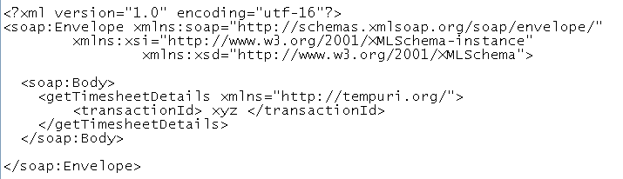

Figure 4‑2: SOAP request for getTimesheetDetails

**Soap Response: getTimesheetDetails**

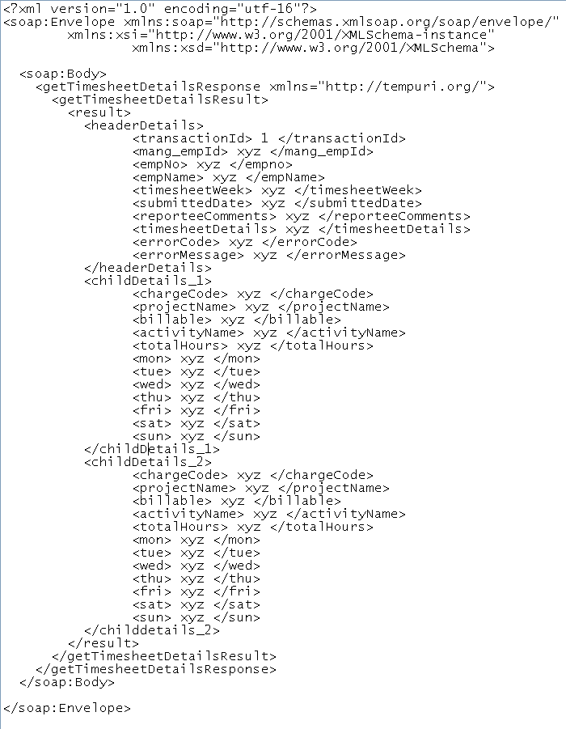

Figure 4‑3: SOAP response for getTimesheetDetails

**Soap Request: updateTimesheetEntry**

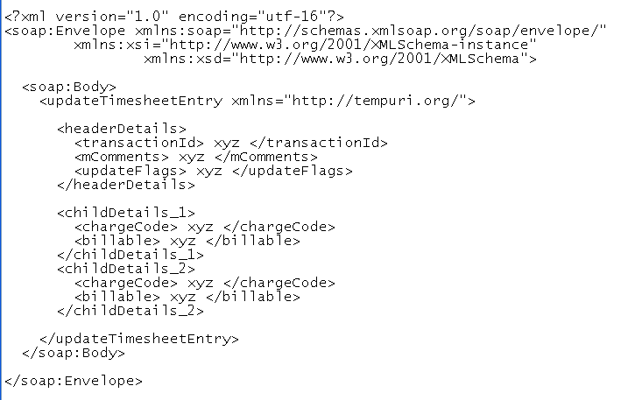

Figure 4‑4: SOAP request for updateTimesheetEntry

**Soap Response: updateTimesheetEntry**

1. **Success Scenario**

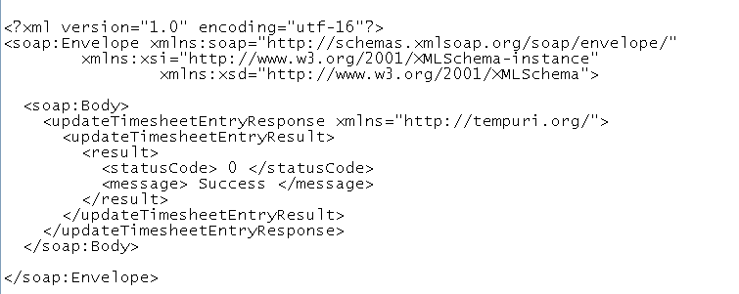

Figure 4‑5: SOAP response for updateTimesheetEntry - Success Case

1. **Failure Scenario**

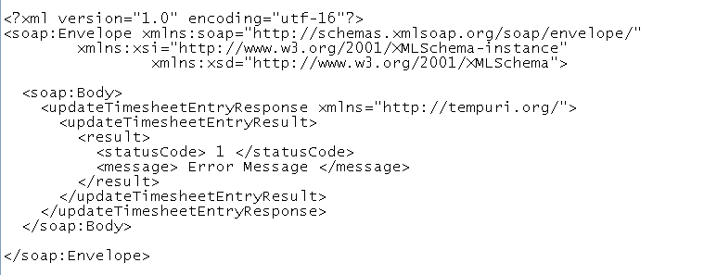

Figure 4‑6: SOAP response for updateTimesheetEntry - Failure Case

Flow Diagram

1. Initiates SOAP Request

2. Fire wall Validation

F

I

R

E

W

A

L

L





**IIS 6.0**

6. SOAP

Message returned

7. Successful response to client

3. Request received at IIS which identifies the web service & forwards the call to respective method

5. SOAP response

**Web Service Methods**

4. Database call for data transaction.



Figure 4‑6: Flow Diagram

Sequence Diagram

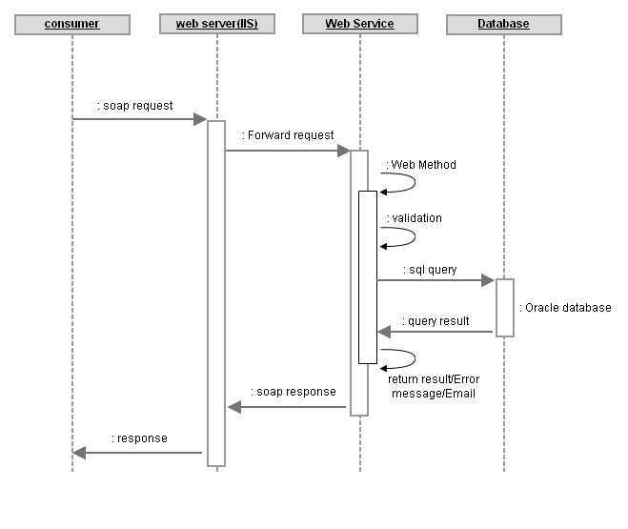

Figure 4‑7: Sequence Diagram

Error Messages:

Table 4‑1: Table containing Error Messages

|  |  |
| --- | --- |
| **ERROR Codes** | **Error Description** |
|  |  |
| XXX | Timesheet already submitted |
| XXX | Timesheet already approved |
| XXX | Timesheet already rejected |
| XXX | Invalid Employee ID |
| XXX | Failed to connect to the DB |

Appendix

A

###### Alternate Architectures

None.

Your Opinion Matters

Dear Reader:

We aspire to provide you with important information, delivered efficiently. If this guide has been informative, useful, and effective, your satisfaction is our reward. If not, tell us how it can be improved. Your valuable input will help us understand your information needs better.

Please fill up the form provided below and mail it to us at the address provided on the Copyright page.

|  |  |  |  |  |  |  |  |
| --- | --- | --- | --- | --- | --- | --- | --- |
| **Did you find the INFORMATION provided in this guide:** | | | | | | | |
| Complete | Y |  | N | Accurate | Y |  | N |
|  |  |  |  |  |  |  |  |
| Relevant | Y |  | N | Well-organised | Y |  | N |
| Other: | | | | | | | |
|  | | | | | | | |
| **Did you find the LANGUAGE used in this guide:** | | | | | | | |
| Easy to understand | Y |  | N | Correct | Y |  | N |
|  |  |  |  |  |  |  |  |
| Consistent | Y |  | N | Professional | Y |  | N |
| Other: | | | | | | | |
|  | | | | | | | |
| **Did you find the TONE used in the delivery:** | | | | | | | |
| Appropriate | Y |  | N | Professional | Y |  | N |
| Other: | | | | | | | |
|  | | | | | | | |
| **Did you find the ILLUSTRATIONS provided in the guide:** | | | | | | | |
| Relevant | Y |  | N | Easy to understand | Y |  | N |
| Other: | | | | | | | |
|  | | | | | | | |
| **Did you find the PAGE LAYOUT:** | | | | | | | |
| Aesthetically pleasing | Y |  | N | Crowded | Y |  | N |
| Other: | | | | | | | |
|  | | | | | | | |

What improvements do you recommend for this document?

____________________________________________________________________________________________________________________________________________________________

Document No.

Thank you for participating in our quest for total customer satisfaction.

Revision History

|  |  |  |  |  |  |  |  |  |  |  |
| --- | --- | --- | --- | --- | --- | --- | --- | --- | --- | --- |
| Author: | | | 1st Reviewer | | | Kumaresan Ettiyannan | | | | |
| Hari Haran Venugopal | | | 2nd Reviewer | | | Sujith Subrahmanya | | | | |
| 3rd Reviewer | | |  | | | | |
|  | | | | | | | | | | |
| Document Status: | | Initial | | | Internal | Draft | Approved | | Obsolete | Other |
| X | | |  |  |  | |  |  |
|  | | | | | | | | | | |
| Version | Date | | | Author | | | | Comments | | |
| 1.0 | 04/19/2012 | | | Hari Haran Venugopal | | | | Initial Draft | | |
|  |  | | |  | | | |  | | |
|  |  | | |  | | | |  | | |
|  |  | | |  | | | |  | | |
|  |  | | |  | | | |  | | |
|  |  | | |  | | | |  | | |
|  |  | | |  | | | |  | | |
|  |  | | |  | | | |  | | |
|  |  | | |  | | | |  | | |
|  |  | | |  | | | |  | | |
|  |  | | |  | | | |  | | |
|  |  | | |  | | | |  | | |

|  |  |  |  |  |
| --- | --- | --- | --- | --- |
| Rev | Date of Issue | Author | Approver | Scope |
|  |  |  |  |  |