**Assignment 11.2**

**Problem Statement**

**Perform incremental load in Hive**

**Read from MySQL Table and load it in Hive table.**

**Create hive table if it does not exist.**

**If it exists, perform the incremental load.**

**CREATE TABLE IN MYSQL**

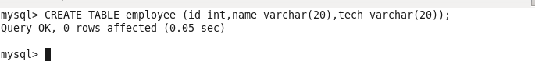

**INSERTING SOME DATA IN OUR NEW TABLE**

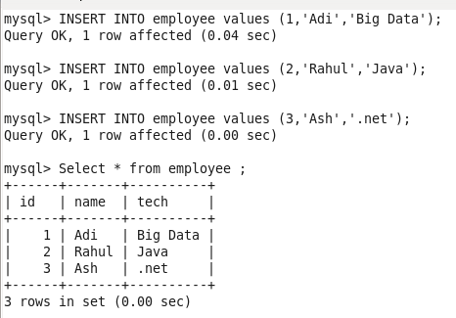

**LOAD DATA FROM MYSQL TO HIVE**

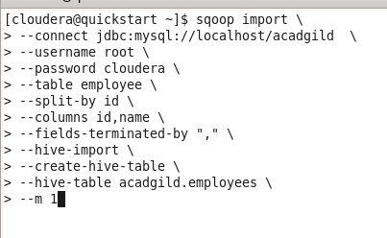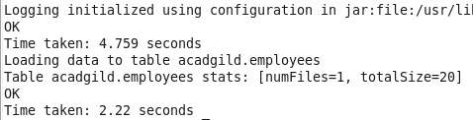

**VALIDATING THE DATA**

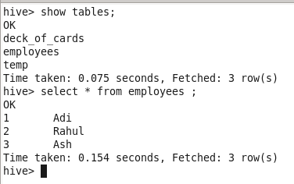

**INSERTING NEW VALUES**

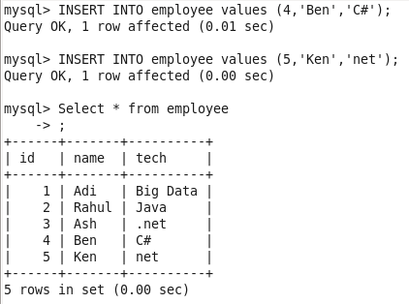

**INCREMENTAL LOAD IN HIVE USING SQOOP**

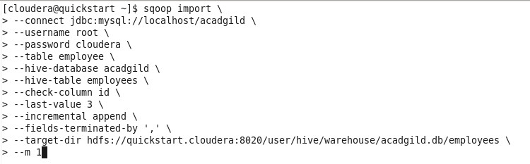

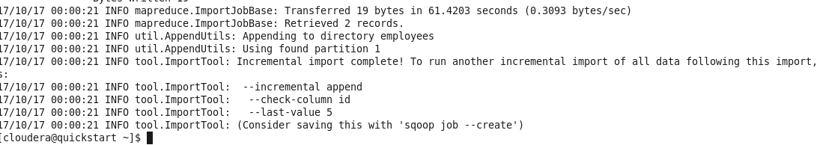

**VALIDATING THE DATA**

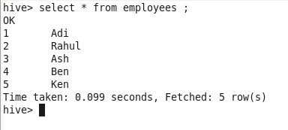

**NEW DATA IS ADDED**