PWD :

pwd command (print working directory) writes the full pathname of the current working directory to the standard output. The command is a shell built-in in most UNIX shells.

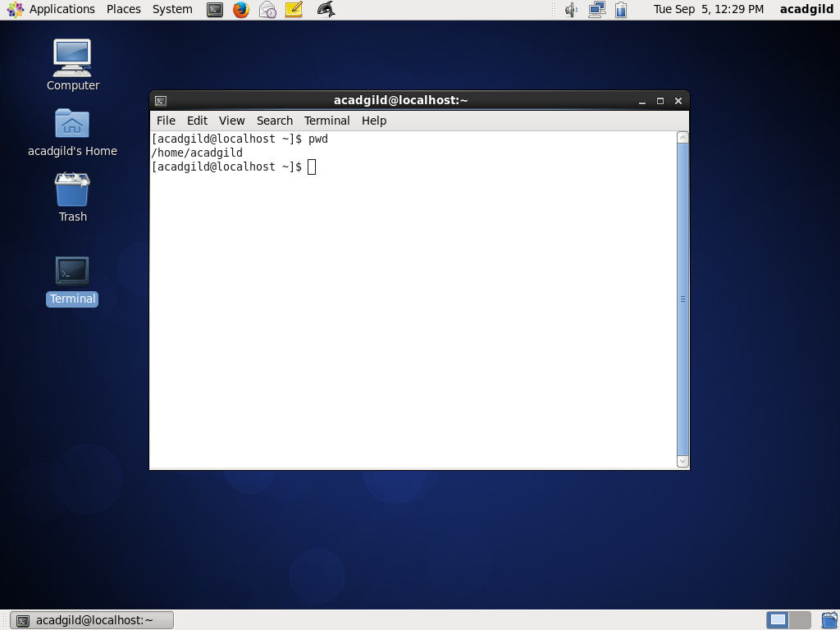

VI:

Vi is a screen editor for Linux, Unix and other Unix-like operating systems. Pronounced (vee-aye), vi stands for visual instrument. It is a widely-used default text editor for Unix-based systems and is shipped with vitually all versions of Unix.

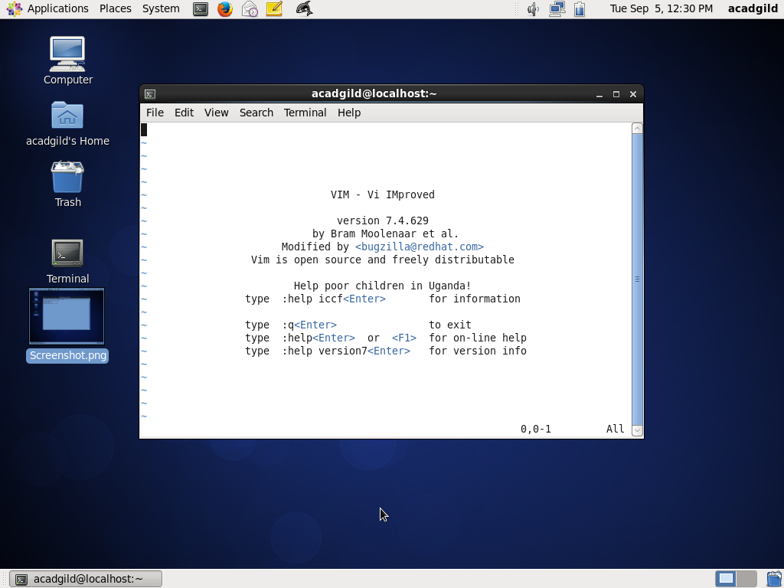

Touch:

The touch command is the easiest way to create new, empty files. It is also used to change the timestamps

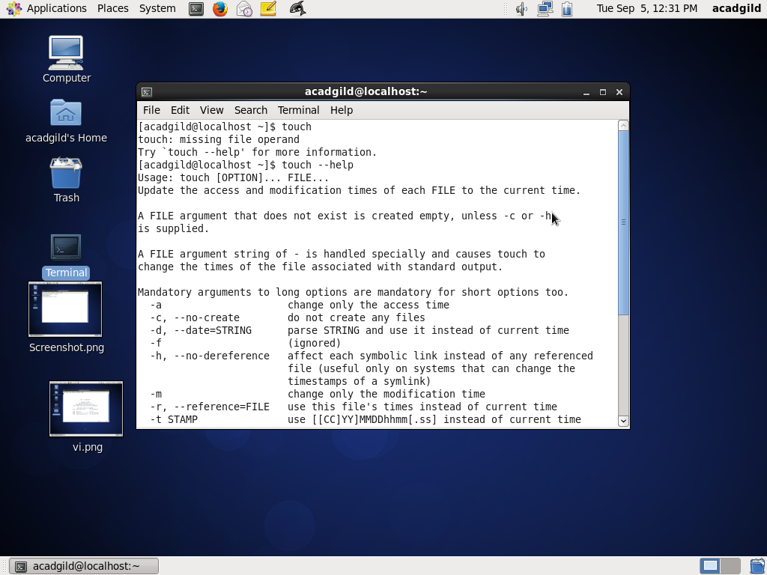

Mkdir:

The **mkdir** command is is used to create new directories. A directory, referred to as a folder in some operating systems, appears to the user as a container for other directories and files.

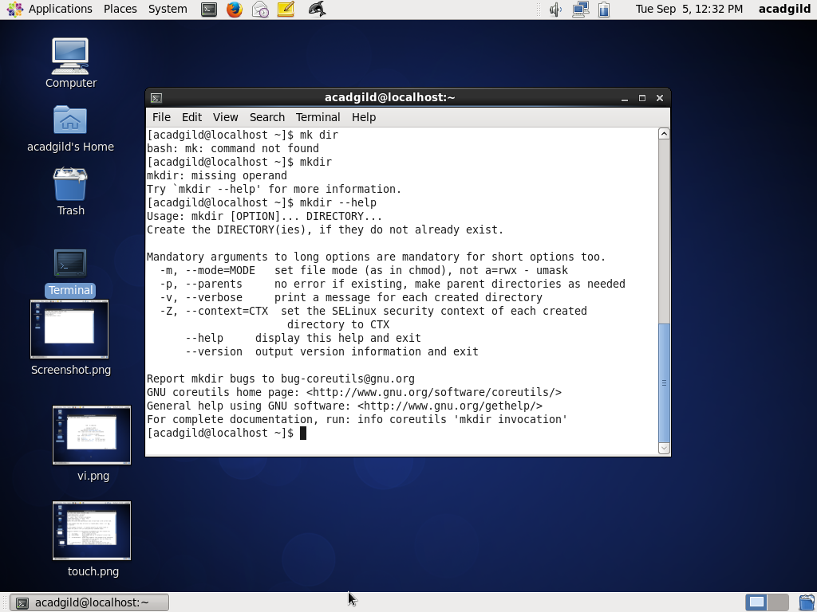

Rm:

The **rm** (i.e., remove) command is used to delete files and directories on **Linux** and other Unix-like operating systems. The general syntax for **rm** is: **rm** [options] [-r directories] filenames

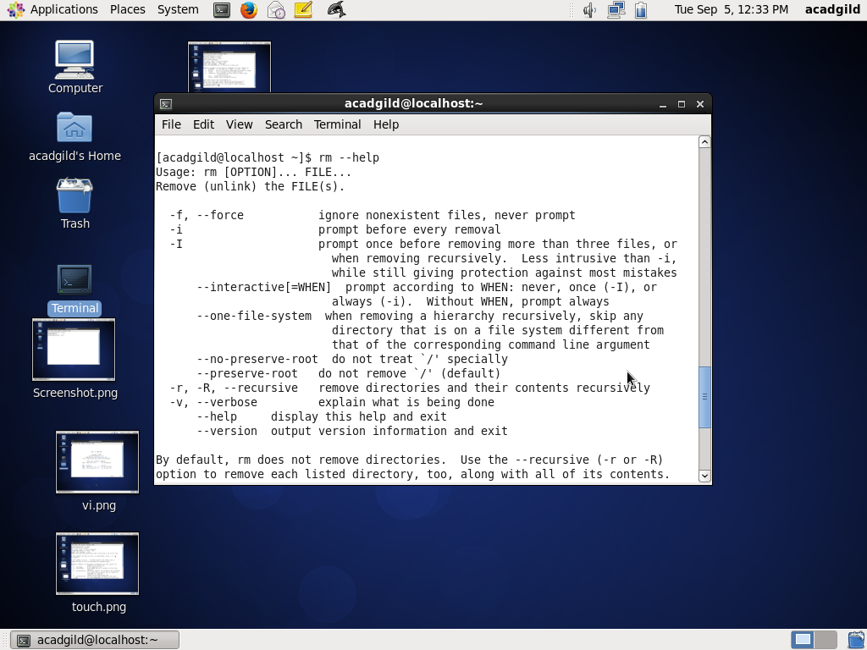

Ls:

In computing, **ls** is a command to list files in Unix and Unix-like operating systems. **ls**is specified by POSIX and the Single UNIX Specification. When invoked without any arguments, **ls** lists the files in the current working directory.

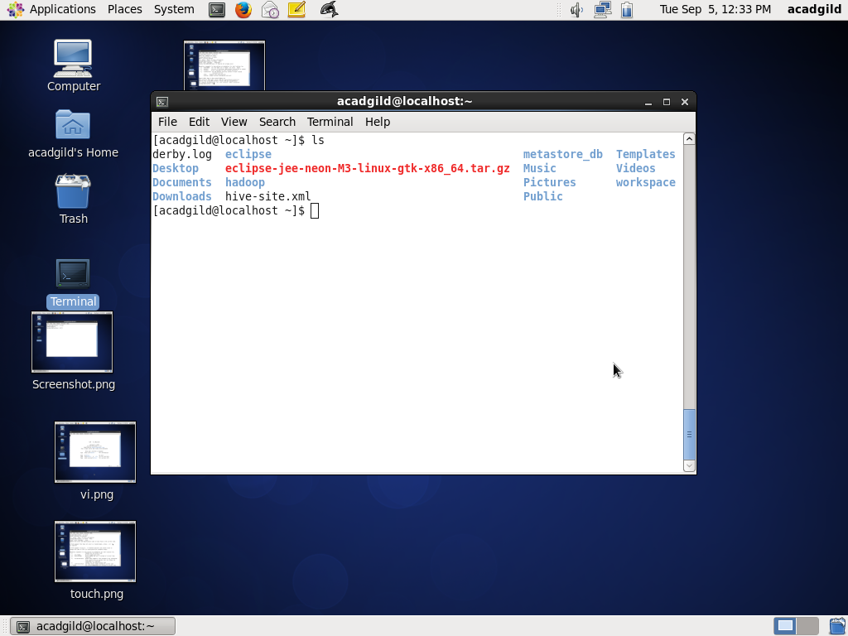

Echo:

The **echo** Command. **echo** is a built-in command in the bash and C shells that writes its arguments to standard output. A shell is a program that provides the command line (i.e., the all-text display user interface) on **Linux** and other **Unix**-like operating systems.

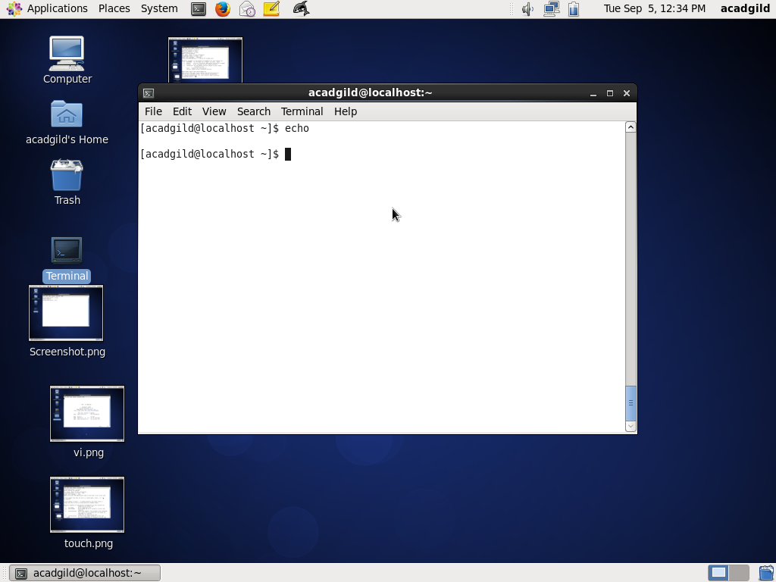

Cat:

The **cat** (short for “concatenate“) **command** is one of the most frequently used **command** in **Linux**/Unix like operating systems. **cat command** allows us to create single or multiple files, view contain of file, concatenate files and redirect output in terminal or files.

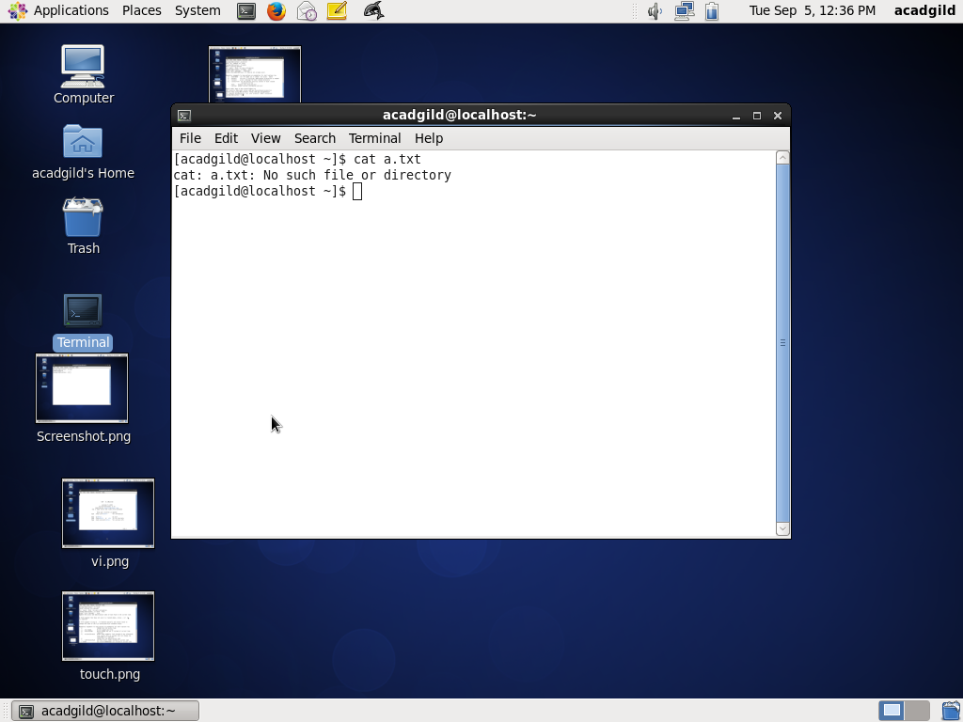

Who:

The **who** command prints information about all users who are currently logged in.

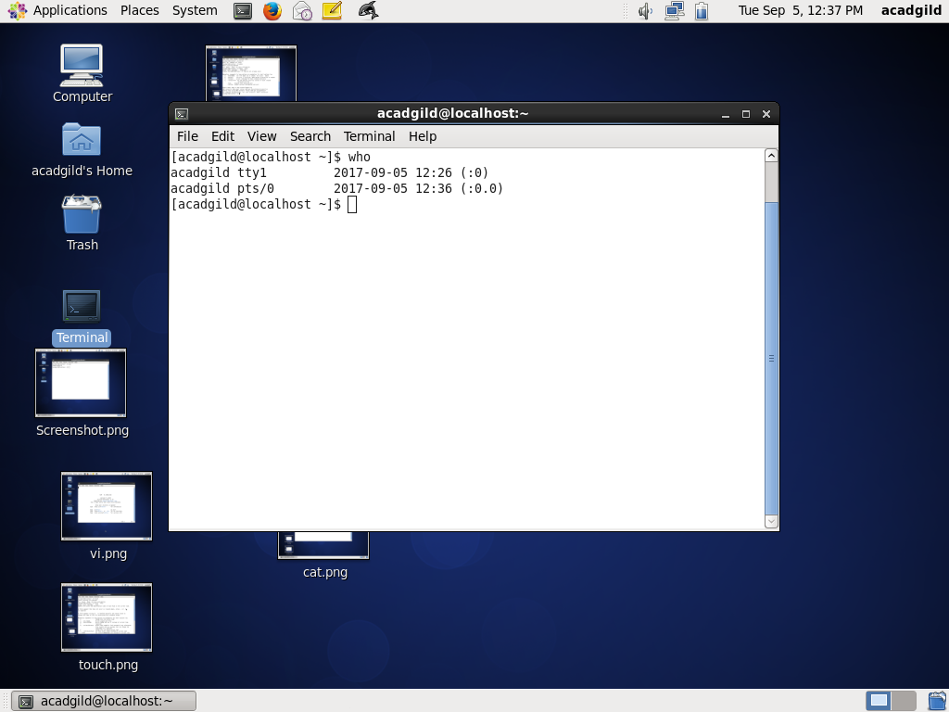

Cd:

The **cd** command is used to change the current directory (i.e., the directory in which the user is currently working) in **Linux** and other Unix-like operating systems. It is similar to the **CD** and CHDIR commands in MS-DOS. **cd's** syntax is. **cd** [option] [directory] The items in square brackets are optional.

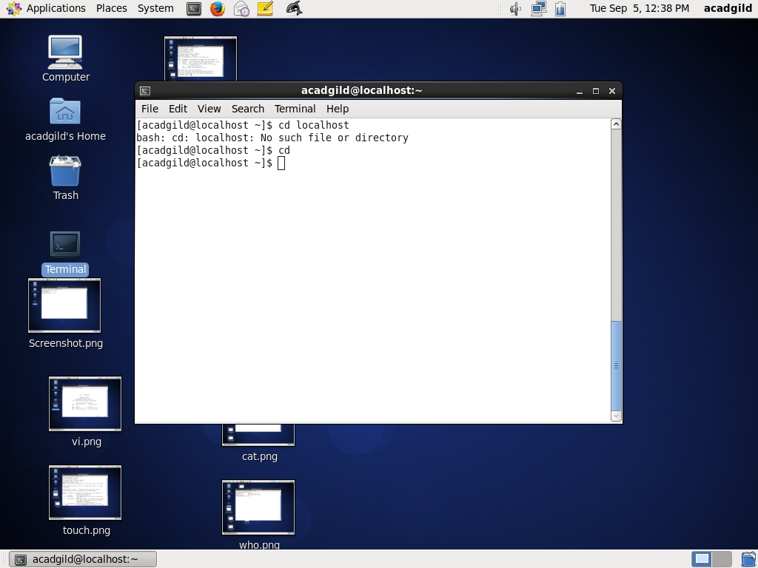

Date:

Contribute on GitHub. The **date command** displays the current **date** and time. It can also be used to display or calculate a **date** in a **format** you specify. The super-user (root) can use it to set the system clock

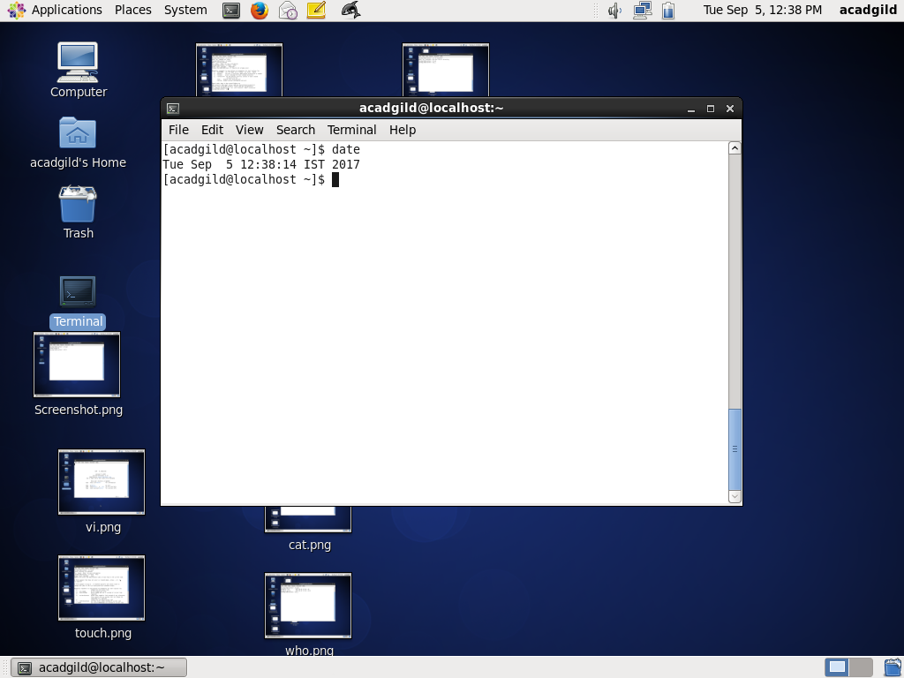

Cal:

**cal** is a standard program on **Unix** and **Unix**-like operating systems that prints an ASCII calendar of the given month or year. If the user does not specify any**command**-line options, **cal** will print a calendar of the current month.

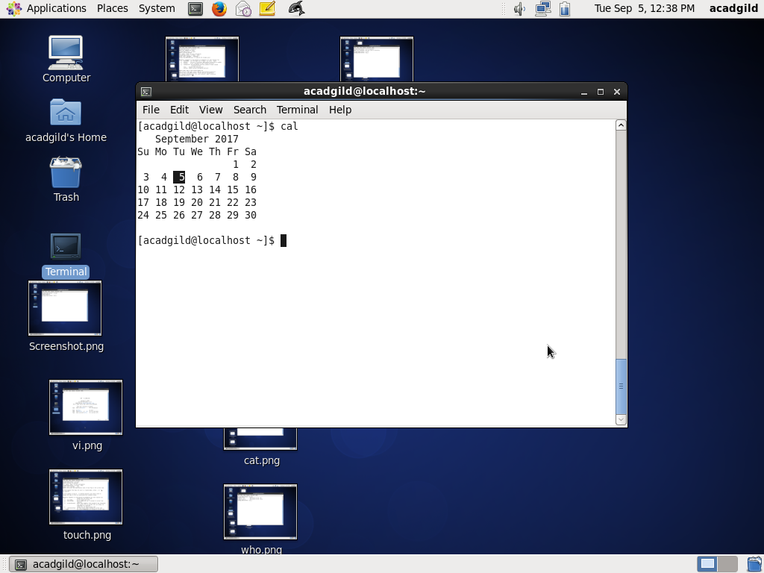

Mv:

**mv** (short for **move**) is a **Unix command** that moves one or more files or directories from one place to another. ... Using **mv** requires the user to have write permission for the directories the file will **move** between.

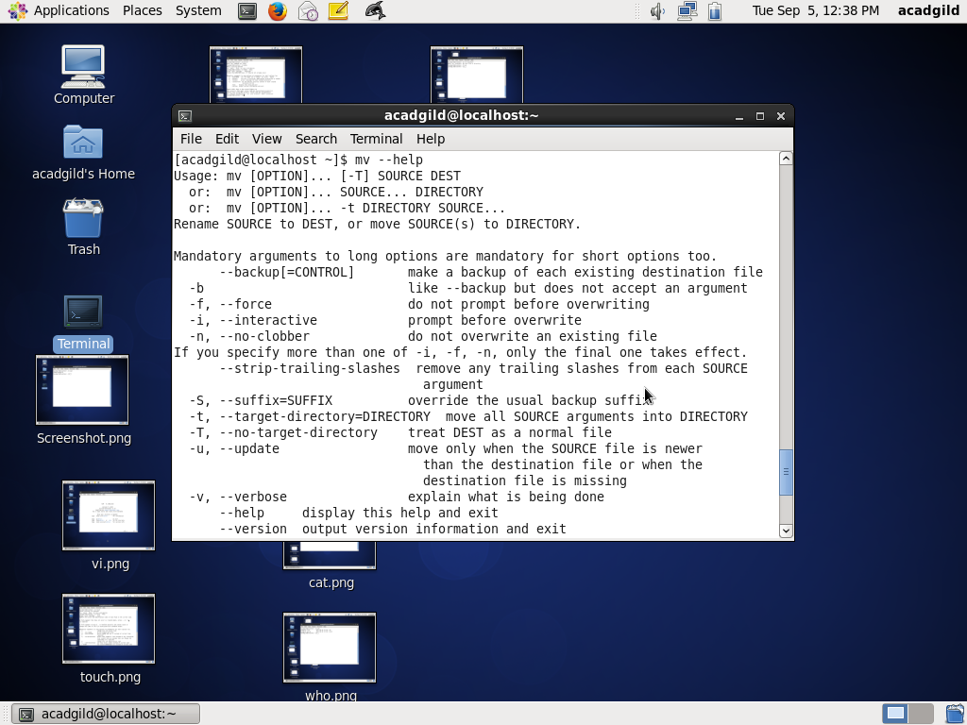

Cp:

**cp command in Linux**/Unix. **cp** is a **Linux** shell **command** to copy files and directories.

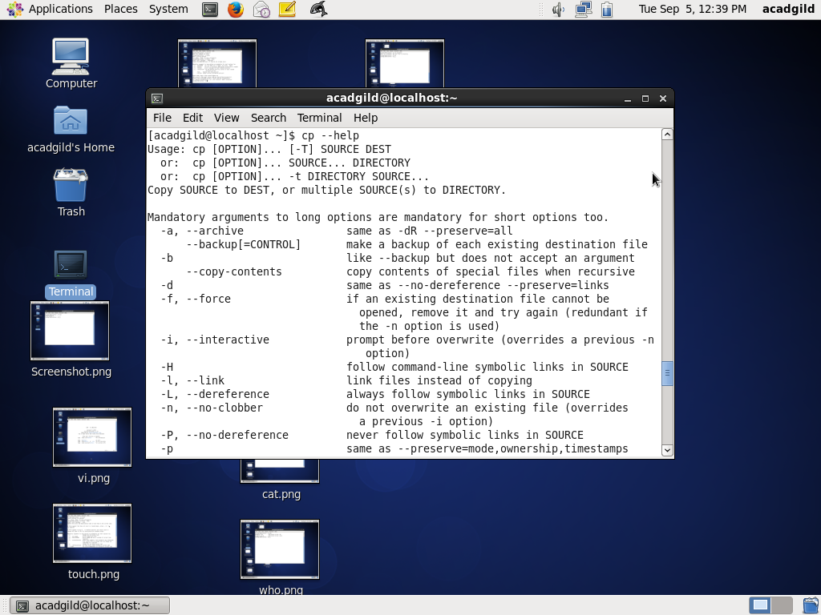

Which:

**Linux** which **Command**. Which **command** is very small and simple **command** to locate executables in the system. It allows user to pass several **command** names as arguments to get their paths in the system. “which” **commands** searches the path of executable in system paths set in $PATH environment variable.

