EXP NO:
DATE:

ATM – Withdraw Money System and taking receipt

1.CLASS DIAGRAM
Objective:
The Class Diagram represents the structure of the ATM Withdraw Money system by showing the classes, their attributes, methods, and the relationships between them.

CLASSES USED:

1. ATM
Attributes: atmId, location, bankName, availableCash
Methods: verifyCard(), enterPIN(), selectAmount(), displayBalance(), printReceipt()
2. Bank
Attributes: bankID, bankName, branch, address
Methods: updateDetails(), processTransaction(), addATM()
3. Account
Attributes: accountNumber, accountHolder, accountType, balance
Methods: checkBalance(), debit(amount), credit(), update()
4. Transaction
Attributes: transactionID, accountID, transactionType, transactionDate
Methods: createTransaction(), cancelTransaction(), getTransactionDetails()
5. Receipt
Attributes: transactionID, amount, date, type
Methods: createTransaction(), saveTransaction(), cancelTransaction()
6. User
Attributes: userId, name, address
Methods: insertCard(), enterPIN(), viewDetails()

RELATIONSHIPS:
User is associated with Account.
ATM is connected to Bank
Account performs Transaction.
Transaction generates Receipt.Blocks
Used in Class Diagram:
Class block (rectangle divided into three parts: class name, attributes, methods)
Association line .

WORKING OF CLASS DIAGRAM:
The user inserts the card into the ATM and enters the PIN.
The ATM communicates with the bank to verify the card and account details.
The bank checks the account balance.
If sufficient balance is available, a transaction is created.
The amount is debited from the account and a receipt is generated.
Finally, the ATM dispenses cash to the user.

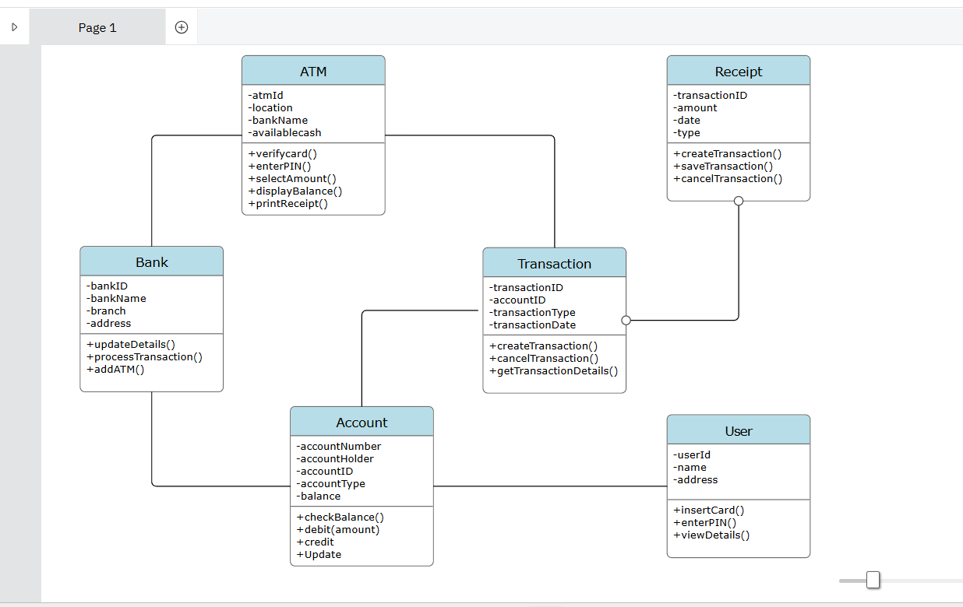

2.SEQUENCE DIAGRAM
The Sequence Diagram shows the order of interaction between objects involved in the ATM withdrawal process.

OBJECTS USED:
User, ATM, Bank, Account, Transaction, Receipt

SEQUENCE OF OPERATIONS:
1. User → ATM : insertCard()
2. User → ATM : enterPIN()
3. ATM → Bank : verifyCard()
4. Bank → Account : checkBalance()
5. User → ATM : enterAmount()
6. ATM → Bank : processTransaction(amount)
7. Bank → Transaction : createTransaction()
8. Bank → Account : debit(amount)
9. Transaction → Receipt : printReceipt()
10. ATM → User : dispenseCash()

BLOCKS USED IN SEQUENCE DIAGRAM:
Actor block (User)
Object lifeline
Activation bar
Message arrow
Return message

WORKING OF SEQUENCE DIAGRAM:
The user inserts the card into the ATM and enters the PIN.
The ATM sends a request to the bank to verify the card.
The bank checks the account balance.
After the user enters the withdrawal amount, the ATM sends the transaction request to the bank.
The bank debits the amount from the account and creates a transaction.
A receipt is generated and the ATM dispenses cash to the user.

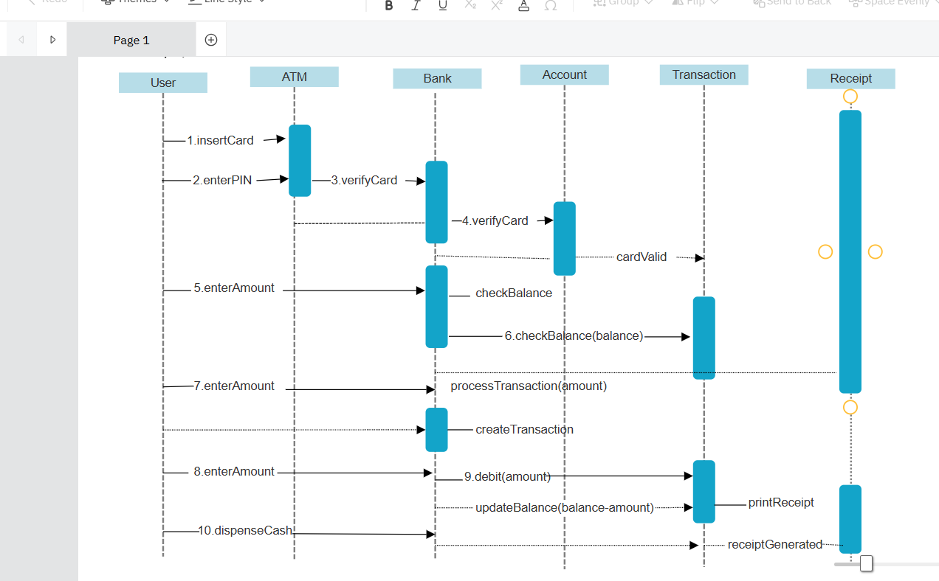

CONCLUSION:
The ATM Withdraw Money system is modeled using Class Diagram and Sequence Diagram.
The Class Diagram shows the system structure, while the Sequence Diagram shows the flow of operations.
Both diagrams together help in understanding the complete working of the ATM withdrawal process.

