SMART SAFETY COMPANION
DESIGNER:
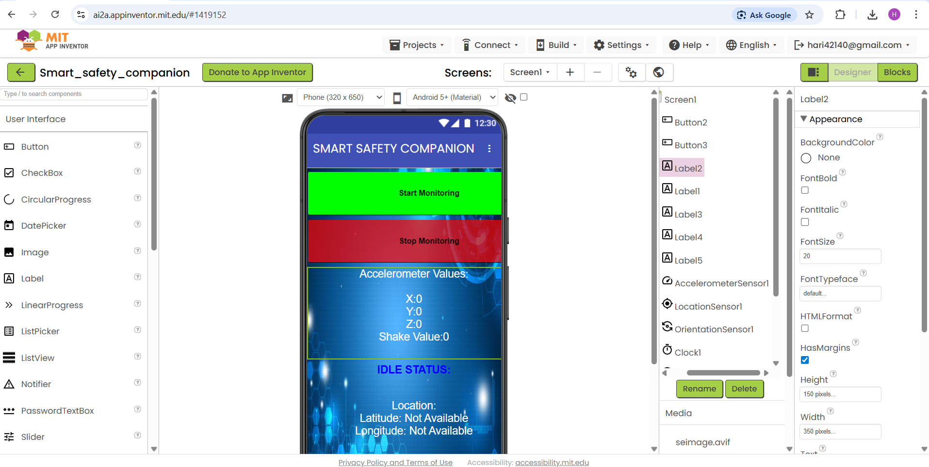
BLOCKS: 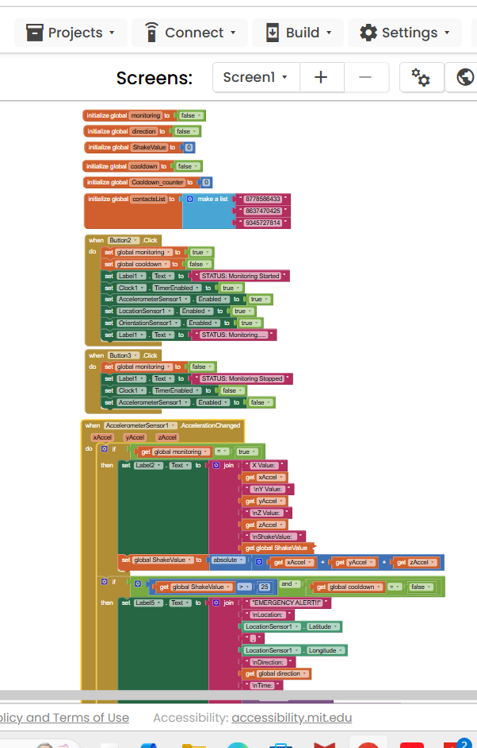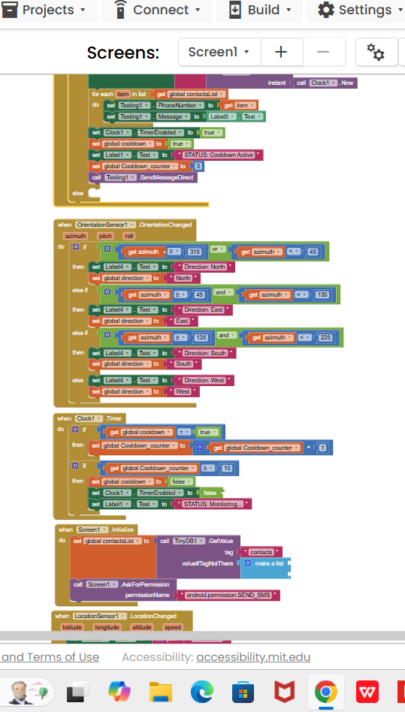

Introduction
Smart Safety Companion is a mobile safety application developed using MIT App Inventor. The app continuously monitors the user’s phone sensors and automatically sends an emergency alert message to predefined contacts when a strong shake is detected. The alert includes the user’s location (latitude & longitude), current direction, and time, and is also displayed inside the app for confirmation.

Objective of the Application
- To provide quick emergency assistance without manual interaction
- To automatically detect danger situations using motion (shake detection)
- To send SOS alerts to trusted contacts
- To display real-time sensor data and emergency status inside the app

Components Used
User Interface Components
Buttons: Start Monitoring, Stop Monitoring
Labels: Display sensor values, status, direction, location, and emergency alert
Vertical Arrangement: Organizes UI components over the background image

Non-Visible Components
AccelerometerSensor – Detects shake/motion
LocationSensor – Gets latitude and longitude
OrientationSensor – Detects phone direction (North, East, South, West)
Clock – Used for cooldown timing and time display
Texting – Sends SMS alerts
TinyDB – Stores emergency contact numbers

App Interface Design
A safety-themed image is set as the Screen background
All buttons and labels are placed inside a Vertical Arrangement so they appear on top of the background image
Color coding is used:
Green: Start Monitoring
Red: Stop Monitoring / Emergency Alert
Blue/White: Status and direction display

Global Variables Used
Monitoring – Indicates whether monitoring is active or not
ShakeValue – Stores calculated shake intensity
Direction – Stores current phone direction
Cooldown – Prevents repeated SMS alerts
Cooldown_counter – Tracks cooldown time
ContactsList – Stores predefined emergency contact numbers

Start Monitoring Process
When the Start Monitoring button is clicked:
Monitoring is enabled
Accelerometer, Location, and Orientation sensors are activated
Clock timer is enabled
Status label is updated to Monitoring Started
This allows the app to continuously track motion and location.

Stop Monitoring Process
When the Stop Monitoring button is clicked:
Monitoring is disabled
All sensors are turned off
Clock timer is stopped
Status label is updated to Monitoring Stopped
This prevents further sensor readings and SMS alerts.

Shake Detection Logic
The AccelerometerSensor continuously reads X, Y, and Z values
ShakeValue is calculated using the absolute sum of these values
If ShakeValue exceeds a defined threshold (e.g:25), it is considered an emergency shake
This method ensures accidental small movements do not trigger alerts.

Emergency Alert Generation
When a strong shake is detected:
The app checks if cooldown is inactive
An emergency message is created containing:
Emergency alert text
Current latitude and longitude
Detected direction
Current time
The message is displayed in Label5 inside the app

Sending SMS to Emergency Contacts
The app loops through the predefined contact list
The same emergency message is sent to all contacts automatically
No manual contact selection is required
This ensures fast alert delivery during emergencies.

Cooldown Mechanism
After sending an alert, cooldown is activated
Clock timer counts cooldown duration
During cooldown, no new alerts can be triggered
Once cooldown ends, monitoring resumes normally
This prevents SMS spamming due to continuous shaking.

Direction Detection
OrientationSensor reads azimuth value
Direction is determined based on angle ranges:
315°–45° → North
45°–135° → East
135°–225° → South
Else → West
The detected direction is shown on the screen and included in the alert.

Location Tracking
LocationSensor continuously updates latitude and longitude
Latest values are displayed in the app
Same values are included in the emergency SMS

Permissions Handling
On app start, SMS permission is requested automatically
Permission is mandatory for sending emergency messages

Output and Result
Real-time sensor values are displayed
Emergency alerts are automatically sent on shake detection
Alert details are shown clearly inside the app

Before Shaking After Shaking
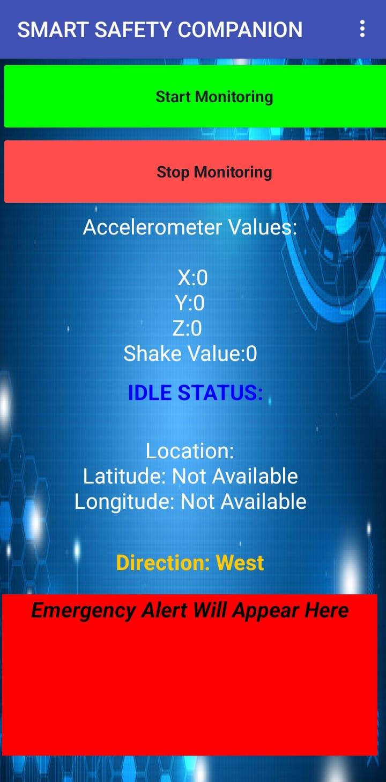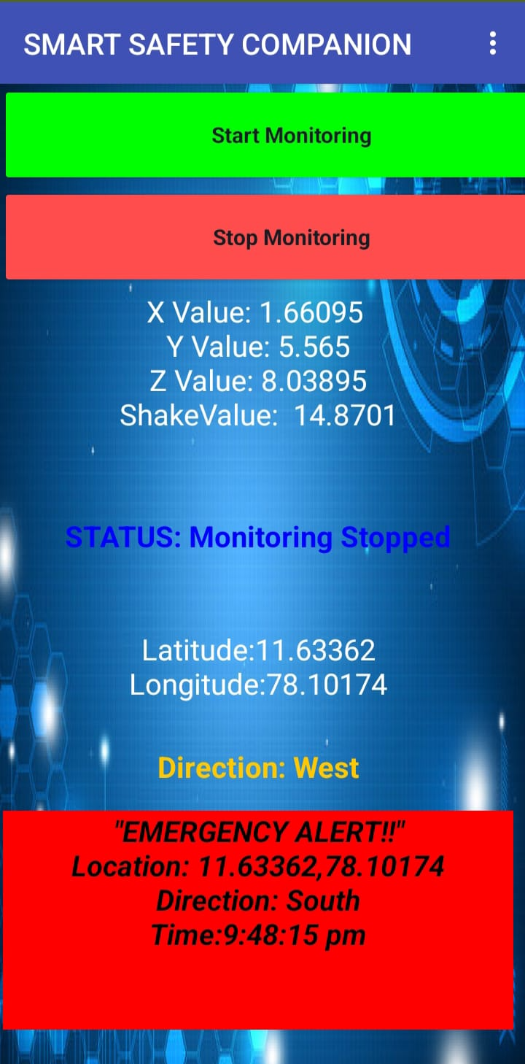

Conclusion
The Smart Safety Companion application provides an efficient and reliable emergency alert system using mobile sensors. By combining shake detection, GPS tracking, direction sensing, and automatic SMS alerts, the app ensures quick assistance during dangerous situations. The system is user-friendly, responsive, and suitable for personal safety applications.

