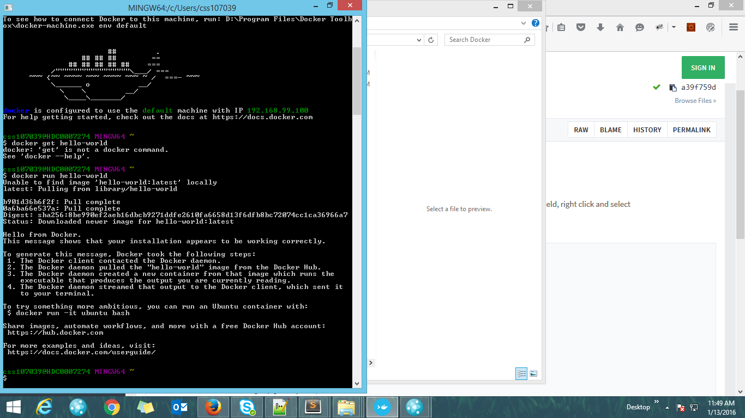

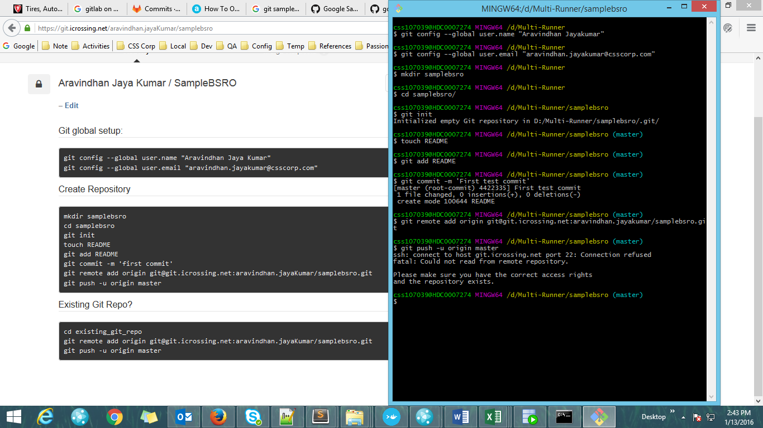

[git@git.icrossing.net:aravindhan.jayaKumar/samplebsro.git](mailto:git@git.icrossing.net:aravindhan.jayaKumar/samplebsro.git)